PULSE Instrument Cluster
Cybersecurity Concept, preliminary (ISO/SAE 21434, UNECE R155)
Ahmed Abdelghany
2026-09-23
Table of Contents

Document control
Field | Value
Document ID | PULSE-SEC-001
Title | Cybersecurity Concept, preliminary
Version | 0.9.5
Status | Skeleton for sprint 1 review; not security-reviewed
Date | 2026-10-02
Author | Ahmed Abdelghany
Reviewer | Security manager, not yet assigned
Review gate | Sprint 1 review for structure; sprint 2 review for content
Parent | PULSE-SyRS-001
Related | PULSE-StRS-001, PULSE-SAD-001, PULSE-SAF-001, PULSE-RTM-001

Change log
Version | Date | Author | Change
0.9 | 2026-09-03 | A. Abdelghany | First skeleton: item and trust boundaries, assets, preliminary TARA, controls, development-configuration deviations, update concept outline, CS-1 to CS-11 with status
0.9.1 | 2026-09-03 | A. Abdelghany | Threat map and update-flow diagrams added; trust-boundary diagram moved to draw.io
0.9.2 | 2026-09-03 | A. Abdelghany | CS-9 and CS-11 status updated for the regression suite
0.9.3 | 2026-09-08 | A. Abdelghany | Section 8 check list turned into a table. CS-1 and CS-10 reworded. CS-8, the asset table and threat T-6 updated: the broker image is pinned, so only the SBOM gap remains. Glossary pointer added
0.9.4 | 2026-09-23 | A. Abdelghany | Sprint 2 controls landed: TLS and token authorisation (CS-3, CS-4), HMI-side range check (CS-5), SBOM with OSV scan (CS-8), privacy trace (CS-6), CI (CS-11). Deviation from mutual TLS recorded in section 5
0.9.5 | 2026-10-02 | A. Abdelghany | CS-6 to Implemented after its first real run. Finding recorded in section 5: MediaPipe’s built-in usage logger, held on the host. CS-8 extended to the full resolved Python set (constraints.txt)

1. Purpose and proportionality
The stack is a broker on an internal network with two consumers, two providers and one camera-based sensor. The security work is proportionate to that. The goal is the same as for safety: produce the artefacts a programme would need under ISO/SAE 21434 and UNECE R155, and remove the shortcuts that only exist because this runs on a desk.
Nothing in this document has been reviewed by a security manager. Ratings are the project engineer’s proposals.
Abbreviations used here are defined in the glossary, PULSE-StRS-001 section 8.

2. Item and trust boundaries (CS-2)
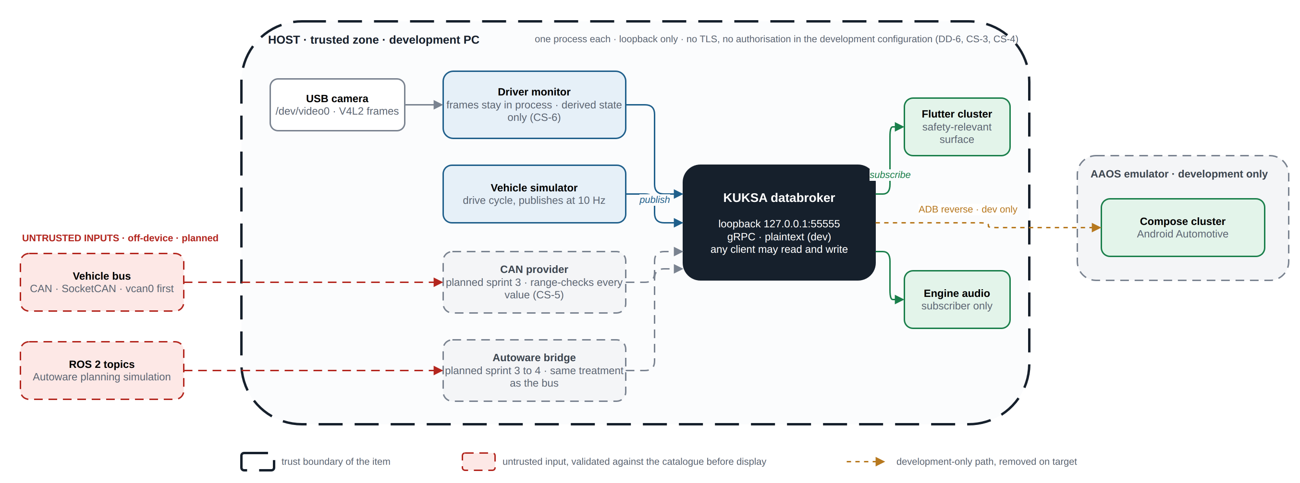
Item and trust boundaries in the development configuration, with the planned untrusted inputs.
Source: docs/diagrams/pulse-trust-boundaries.drawio (edit in draw.io, re-export with scripts/build-docs.sh).
Boundary | On-device or off-device | Trust today | Trust target
Broker gRPC endpoint | On-device, loopback only | Anyone on the host can read and write | Mutual TLS, per-client write authorisation (CS-3, CS-4)
Camera | On-device | Trusted input; frames stay in process | Same; add tamper and covering detection as backlog
Vehicle bus | Off-device (planned) | Not present | Untrusted; every decoded value range-checked (CS-5)
Autonomy stack | Off-device (planned) | Not present | Untrusted; same treatment as the bus
ADB reverse to the emulator | Development only | Trusted | Removed on target; the Android surface reaches the broker over an authenticated channel
Container image registry | Off-device | Pinned to the 0.7.0 tag and digest | Signature verification (CS-8)

3. Assets
Asset | Property to protect | Damage scenario
Safety-relevant signals (speed, gear, alert, intervention) | Integrity, availability | Driver misled; unintended manoeuvre
Signal catalogue (vss_agl.json) | Integrity | Broker serves a tampered tree; range checks bypassed
Camera frames | Confidentiality | Driver surveillance; privacy breach
Driver-state signals | Confidentiality, integrity | Personal data leakage; spoofed drowsiness
Broker configuration and credentials | Confidentiality, integrity | Unauthorised control of the signal path
Software artefacts (bundle, APK, container image) | Integrity, authenticity | Malicious update
Third-party dependencies | Integrity | Supply-chain compromise

4. Preliminary threat analysis and risk assessment (CS-1)
Attack feasibility per ISO/SAE 21434 annex: high, medium, low, very low. Impact: severe, major, moderate, negligible. Risk 1 to 5 from the standard’s matrix.
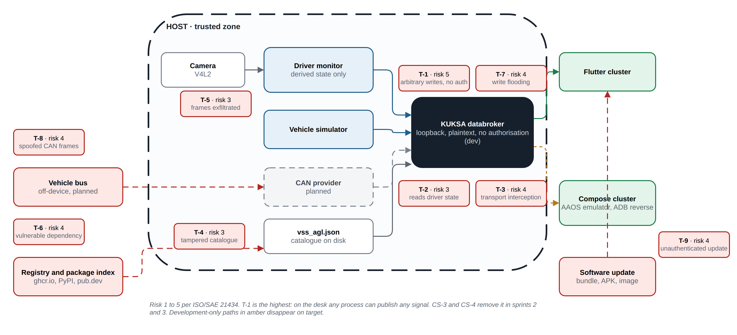
The nine threat scenarios placed on the architecture, with their risk values.
Source: docs/diagrams/tara-map.drawio.
ID | Threat scenario | Asset | Feasibility today | Impact | Risk | Treatment
T-1 | A process on the host publishes arbitrary values for speed or alert state to the broker | Safety-relevant signals | High (no authentication, no authorisation) | Severe | 5 | CS-3, CS-4: authenticate clients, authorise writes per client
T-2 | A process on the host subscribes to driver-state signals | Driver-state signals | High | Moderate | 3 | CS-3: authenticated transport; read scoping is backlog
T-3 | Interception or modification of gRPC traffic | Signals | Low on loopback; high once off-device | Severe | 4 at target | CS-3: mutual TLS before any off-device client
T-4 | Tampered signal catalogue mounted into the broker | Catalogue | Medium (file on disk, read-only mount) | Major | 3 | CS-8, CS-9: catalogue checksum in the regression suite; FR-3 reproducibility
T-5 | Camera frames exfiltrated or persisted by a modified driver monitor | Camera frames | Low | Severe (privacy) | 3 | CS-6: code review and a test that no file is written; process has no network beyond loopback
T-6 | Malicious or vulnerable dependency (Python package, Dart package, container image) | Dependencies | Medium (no SBOM) | Major | 4 | CS-8: pinned digests, SBOM, vulnerability check
T-7 | Flooding the broker with writes to starve subscribers | Availability | High | Major | 4 | CS-4 limits writers; rate limiting is backlog; staleness detection (SR-4) keeps the display honest
T-8 | Spoofed CAN frames on the bus once the CAN provider exists | Safety-relevant signals | Medium on a physical bus | Severe | 4 | CS-5: range and plausibility checks; bus-level security is outside the item
T-9 | Unauthenticated software update replaces the cluster bundle | Artefacts | Medium | Severe | 4 | CS-10: signed packages, rollback on failure

5. Controls and the development-configuration deviations
Control | Requirement | State today | Removal of the shortcut
Transport encryption and client authentication | CS-3 | TLS to a development certificate; every client presents a signed token. Plaintext only on request, with a warning (DD-6 closed) | Sprint 2: enable TLS in the databroker with development certificates under certs/dev/ marked non-production; start-up prints a red warning whenever --insecure is used
Per-client write authorisation | CS-4 | Token scopes: consumers read only, providers limited to their own signals | Sprint 3: KUKSA JWT authorisation with one token per provider scoped to its signal set; consumers get read-only tokens
Catalogue validation of incoming values | CS-5 | Broker rejects on set; both HMIs refuse out-of-restriction values as defence in depth | Sprint 2: HMI-side check as defence in depth; test that an out-of-range publish is refused
Camera data stays local | CS-6 | Driver monitor never writes frames and publishes derived state only; MediaPipe’s usage logger is held on the host; dms-privacy proves both | Sprint 2: test asserting no file output and no socket other than the broker
Security event logging | CS-7 | None | Sprint 3: broker and provider logs for authentication failure, refused write, client disconnect; timestamped; no personal data
Dependency pinning and SBOM | CS-8 | Everything pinned, the full Python set through constraints.txt; CycloneDX SBOM in docs/sbom/, scanned against OSV by the suite | Sprint 2: pin the image digest; generate a CycloneDX SBOM per component; run a vulnerability check in the regression suite
No secrets in the repository | CS-9 | Development PKI generated into git-ignored .run/pki/; suite scans every tracked file | Sprint 2: secret scan in the regression suite; development certificates clearly named and gitignored where private
Update concept | CS-10 | None | Sprint 4: section 6 completed
Finding: usage telemetry inside a dependency (T-5, T-6). The first run of dms-privacy with the driver monitor executing, on 2 October, found that the process resolved play.googleapis.com and opened HTTPS connections to it. The source is MediaPipe itself: in 0.10.35 and 1.0.1, the versions tested, every task runner starts a libcurl client that posts session statistics (task type, timings) to Google. No camera frame or derived driver state is in those reports, but CS-6 says no socket except the broker, and the library offers no switch to turn the logger off. The driver monitor therefore sets the proxy variables, which libcurl honours, to a closed local port before MediaPipe loads, and exempts the broker through NO_PROXY, which gRPC also honours. The trace shows the logger’s attempts ending on the host and the broker connection unchanged. This is a workaround, not a configuration option: a MediaPipe upgrade must be re-checked by the suite, and a production target would enforce the same rule at the platform level (for example a per-service network policy that allows loopback only). The finding also shows why the check must run where the monitor runs: on the reference VM it had only ever skipped.
Deviation from CS-3 as written. CS-3 names mutual TLS. KUKSA databroker 0.7.0 can present a server certificate but cannot verify client certificates; it has no option for a client CA. Clients are therefore authenticated by a signed token carried over the TLS session, which the broker verifies against jwt.pem. The security goal, that only known clients reach the broker and that the link is encrypted and server-authenticated, is met; the mechanism is not the one the requirement names. Either the requirement text is changed at the sprint 2 review, or a broker with client-certificate support is adopted later. Recorded as DD-12 in PULSE-SAD-001.

6. Update concept (CS-10)
Outline, to be completed in sprint 4. UNECE R155 and R156 make this a type-approval matter, so the concept is written now and executed later.
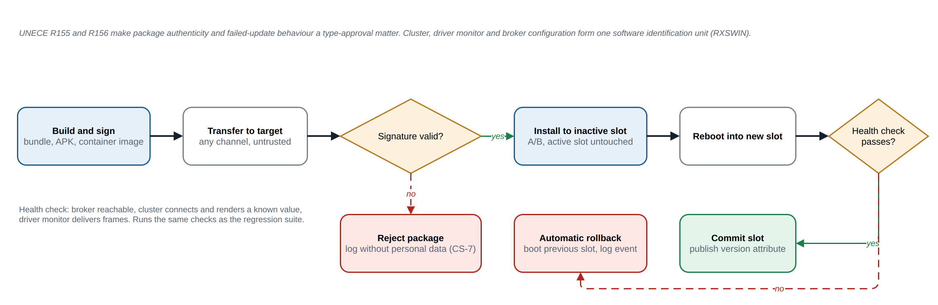
Update concept: signed package, A/B slot install, health check, automatic rollback.
Source: docs/diagrams/update-flow.drawio.
- Package authenticity: every deliverable (Linux bundle, APK, container image) is signed; the target verifies the signature before installation.
- Version identification: the cluster displays and publishes its software version as a VSS attribute so a fleet can be audited.
- Failed update: A/B slots on the Linux target; a failed boot after update reverts to the previous slot automatically; the Android side relies on the platform’s own A/B mechanism.
- Scope of RXSWIN: the cluster, driver monitor and broker configuration form one software identification unit for R156 purposes.

7. Cybersecurity requirements
ID | Requirement | Verification | Status (W3) | Evidence
CS-1 | A threat analysis and risk assessment (TARA) shall be recorded for the signal path, covering the broker, both HMI clients, the telemetry provider and the camera input. Each threat scenario shall carry an attack feasibility rating, as ISO/SAE 21434 clause 15 requires. | I | Partial | Section 4, nine scenarios
CS-2 | The item boundary and its trust boundaries shall be documented, distinguishing on-device interfaces from anything reachable off the device. | I | Implemented | Section 2
CS-3 | Broker communication shall support authenticated, encrypted transport (mutual TLS). Running without it shall be a configuration reserved for local development and flagged at start-up. | T | Implemented | TLS with a development certificate and a signed token per client, secure by default in scripts/start-databroker.sh; plaintext only with PULSE_INSECURE=1 and a boxed warning. Suite check transport-security. Deviation: token authentication rather than client certificates, section 5
CS-4 | Write access to the signal tree shall be authorised per client. A consumer shall not be able to publish, and no client shall write outside its declared signal set. | T | Implemented | Token scopes from scripts/dev_pki.py: consumers read only; each provider may provide only the signals its source declares. Suite check transport-security proves a consumer cannot publish and a provider is refused outside its set
CS-5 | Signal values received from any provider shall be range- and type-validated against the catalogue before display, so a compromised provider cannot drive arbitrary content onto the cluster. | T | Implemented | Broker refuses out-of-catalogue values (suite check range-refusal); both HMIs read the catalogue restrictions from the broker at connect and refuse values outside them, tested in range_check_test.dart and FreshnessTest.kt
CS-6 | Camera frames shall not leave the device and shall not be persisted. Only derived state, such as the drowsiness level, shall be published. | I | Implemented | emulator/dms.py publishes six derived signals. Suite check dms-privacy traces every file and socket call for 12 s. Its first run with the monitor actually executing (2 October, a host with AVX) found the MediaPipe usage logger described in section 5; with that held on the host the check passes: no file left behind, no socket except the broker
CS-7 | Security-relevant events, including authentication failure, unauthorised write attempt and client disconnection, shall be logged with a timestamp and without personal data. | T | Planned S3 | Section 5
CS-8 | All third-party dependencies shall be pinned and inventoried as a software bill of materials, and the inventory shall be checkable against published vulnerabilities. | T | Implemented | scripts/sbom.py writes a CycloneDX inventory of 85 components across Python, Dart, Android and the broker image; suite check sbom fails on drift or on any OSV advisory. First run found 36 Pillow advisories, fixed by moving to Python 3.11 and Pillow 12.3
CS-9 | No credential, key or certificate shall be committed to the repository; the development configuration shall use clearly marked non-production material. | T | Implemented | Suite check secrets; the development CA, keys and tokens are generated into git-ignored .run/pki/ with NOT FOR PRODUCTION in every subject, never committed
CS-10 | An update concept shall be described for the cluster and monitor software. It shall cover package authenticity and the behaviour on a failed update, as UNECE R155 and R156 require for type approval. | I | Planned S4 | Section 6 outline
CS-11 | Cybersecurity requirements shall be verified as part of the sprint regression suite, not as a separate end-of-project activity. | T | Implemented | 16-check suite in scripts/regression.sh, run before each demo and on every push by .github/workflows/regression.yml; each check names the requirements it evidences

8. Verification in the regression suite (CS-11)
From sprint 2 the regression suite runs before every demo. It carries these checks:
Check | What it asserts | Covers
Catalogue checksum | The compiled signal tree is the one that was reviewed | T-4
Range check | The broker refuses a publish outside the catalogue range | CS-5
Monitor isolation | The driver monitor writes no file and opens no socket except the broker | CS-6
Dependency scan | No component has a known vulnerability, checked against the SBOM | CS-8
Secret scan | No key or credential appears in any tracked file | CS-9
Plaintext refusal | The broker refuses an unencrypted or tokenless client; a consumer cannot publish; a provider cannot publish outside its own signals (transport-security) | CS-3, CS-4, IR-5
Toolchain pin | The Flutter SDK in use is the pinned one (toolchain-pin) | NFR-8
Live contract | Every catalogue path in appendix A delivers a correctly typed datapoint from the running broker (live-contract) | FR-11, FR-13, IR-2

