nuScenes Scene Reconstruction — Code Flow
Reference for nuscenes_scene_reconstruction.py: what each function does, and how the pieces connect. Two flowcharts: the overall pipeline in main(), and the Layer 0 ego-estimation chain inside it.

Overall pipeline
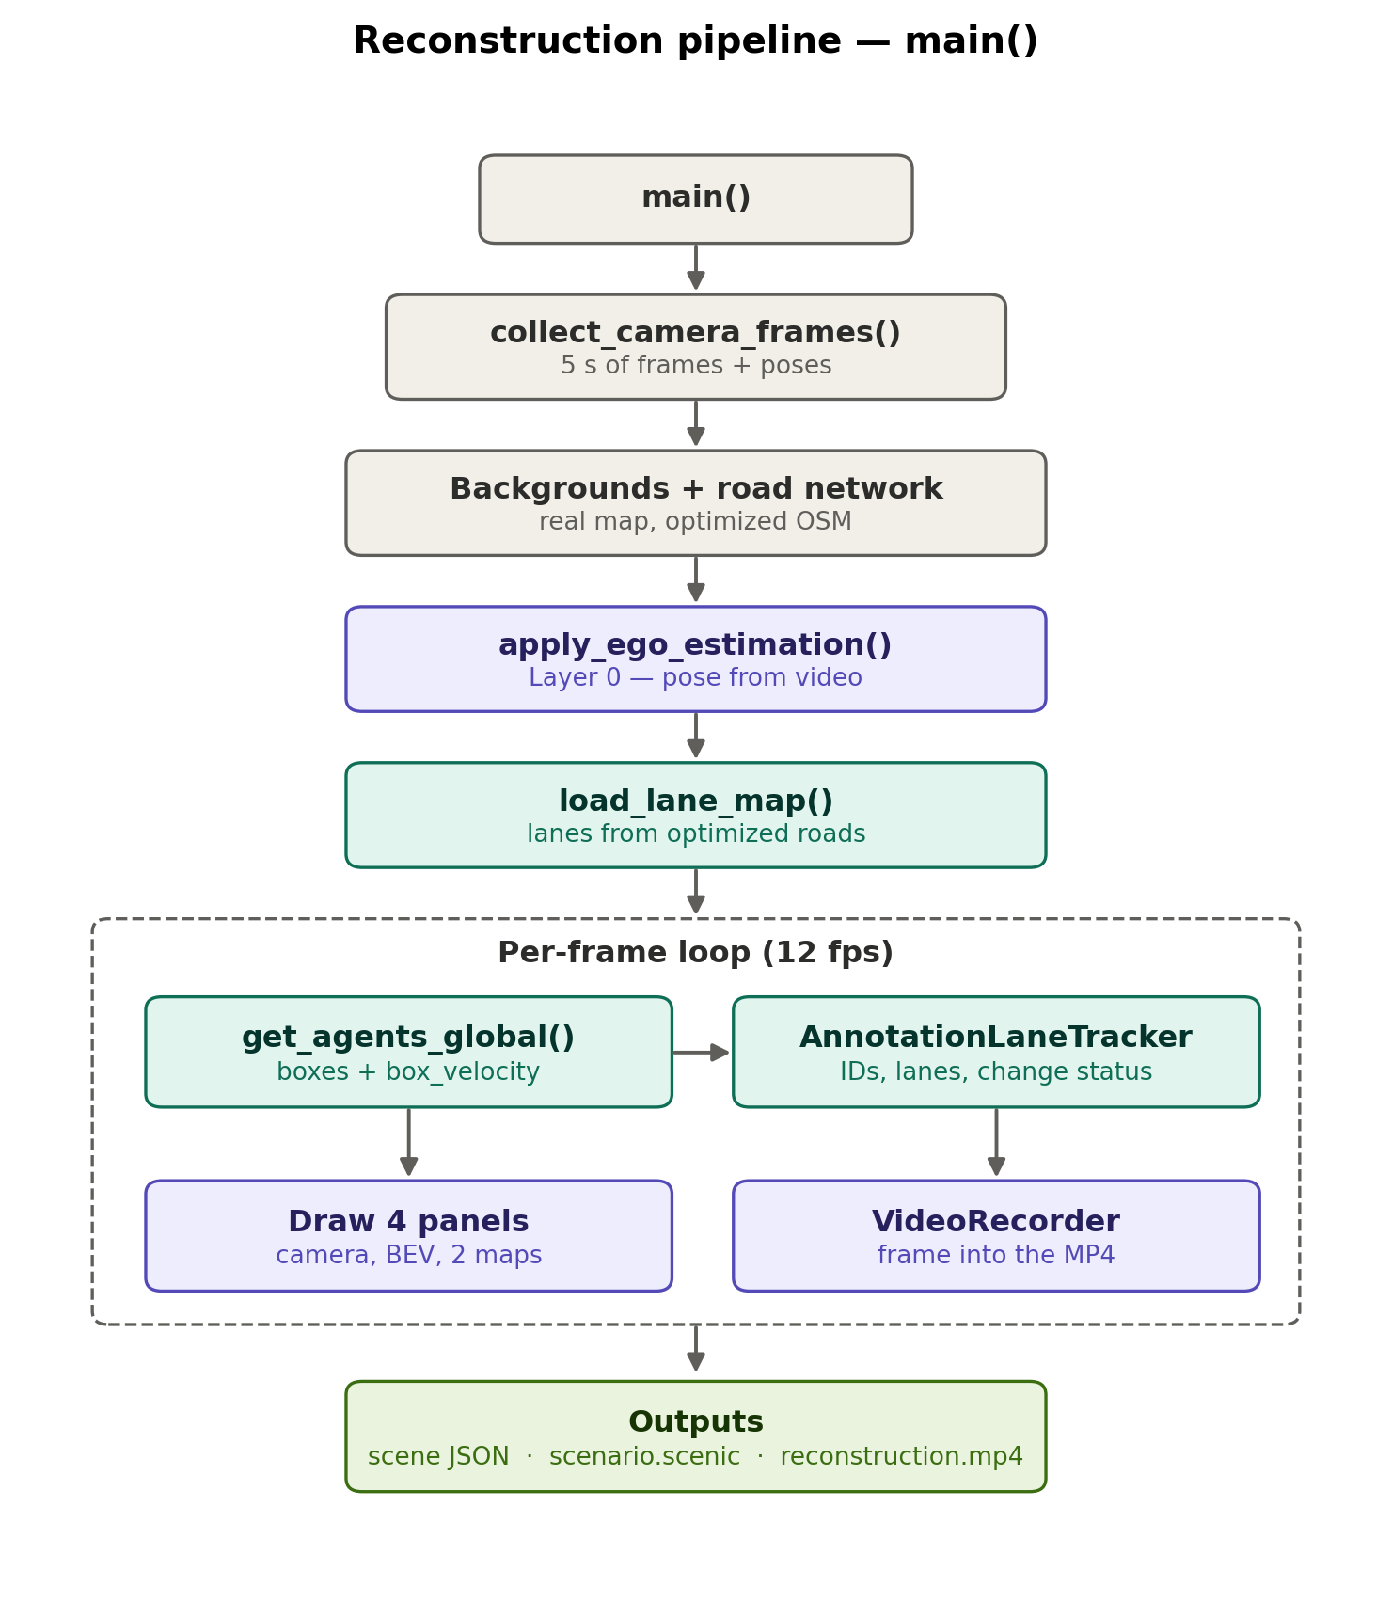
main() loads 5 seconds of camera frames with their poses, prepares the two map backgrounds and the road network from the optimized OSM map, estimates the ego pose from the video (Layer 0), and builds the lane model. The 12 fps loop then lays annotated objects down at their global positions, computes each vehicle's lane state, draws the four panels, and records every frame. Outputs: one scene-description JSON per keyframe, a Scenic program, and the MP4.

Layer 0 — ego pose from the video
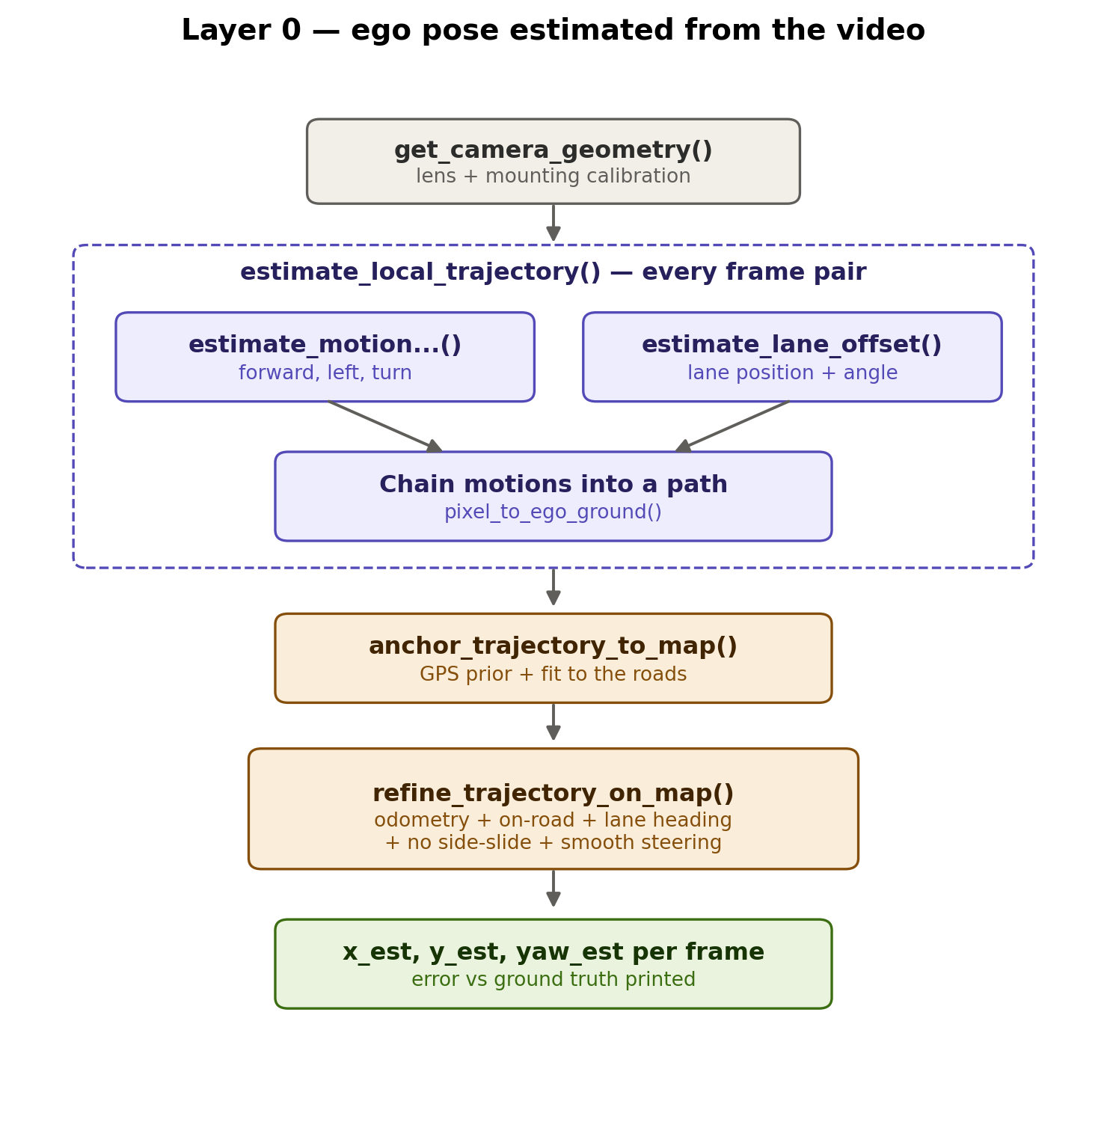
For every frame pair, ground-plane visual odometry measures how far the car moved and turned, while the lane-marking detector measures where the car sits in its lane and its angle to it. The motions are chained into a local path, anchored onto the map near a coarse GPS prior, and finally refined jointly under five constraints: match the odometry, stay on the road, agree with the lane heading, no sideways sliding, and smooth steering. The result is x_est, y_est, yaw_est per frame, with the error against ground truth printed every run.

Function reference

Small helpers
- quaternion_yaw — rotation quaternion to a single heading angle.
- wrap_angle — keeps angles within -180..+180 degrees.
- simplify_category — "vehicle.car" becomes "car".
- rotated_rectangle_corners — corners of a rotated vehicle box, for drawing.
- ego_to_global — converts "3 m ahead, 2 m left" into map coordinates.
- point_on_drivable — is this map point on real pavement (yes/no).
- collect_camera_frames — gathers 5 s of camera frames and their poses.

Layer 0 — ego from video
- get_camera_geometry — reads camera calibration (lens and mounting).
- pixel_to_ego_ground — casts a pixel ray onto the road; returns meters.
- estimate_motion_between_frames — tracks road texture between two frames; returns forward/left/turn (distant features give the cleaner turn).
- estimate_lane_offset — finds lane paint; measures lane position and angle; rejects arrows and symbols.
- estimate_local_trajectory — chains all per-frame motions into one path.
- anchor_trajectory_to_map — slides and rotates the path near the GPS prior until it fits the roads.
- refine_trajectory_on_map — polishes all poses jointly with the five constraints.
- apply_ego_estimation — runs the whole Layer 0 chain; writes x_est/y_est/yaw_est; prints the error.
- get_anchor_road_network — road points, directions, and widths from the optimized OSM map.

Lane model and vehicle states
- generate_lanes_from_roads — splits each road into lanes, clipped to real pavement.
- LaneMap — lane queries: locate a pose, project into a lane, convert lane coordinates back to the map.
- load_lane_map — builds the lane model from the optimized map.
- get_agents_global — annotated boxes at global positions with box_velocity speeds.
- AnnotationLaneTracker — persistent ID per vehicle, its lane, lane-relative position, and staged lane-change status.
- VehicleTracker — full detector-based tracker (dormant; ready for the FCOS3D/YOLO swap).

Maps and OSM
- create_map_background — renders the ground-truth map panel and the drivable mask.
- fetch_osm_geometries / auto_align_osm_geometries — download OSM and snap it onto the nuScenes lane graph.
- crop_optimized_surface / render_osm_background — load the pre-built optimized map and cut out the view window.
- nuscenes_xy_to_latlon / latlon_to_nuscenes_xy — coordinate conversions between map meters and GPS.

Reference layers and outputs
- get_ego_lane_info — Layer 1 reference from the HD map, compared against the video estimate.
- get_agents_in_ego_frame — Layer 2: boxes relative to the ego (feeds the BEV panel).
- get_static_structure — road edges and crossings around the ego.
- build_scene_description — fuses everything into the keyframe JSON.
- write_scenic_file — JSON into a Scenic program for CARLA.
- draw_camera_panel / draw_bev_panel / draw_reconstructed_map_panel — the three drawn panels.
- VideoRecorder — captures each rendered figure into the MP4.
- main — orchestrates everything, per the first flowchart.

