Cutting out Robot arm on 1/8” (inch) acrylic

Load the file

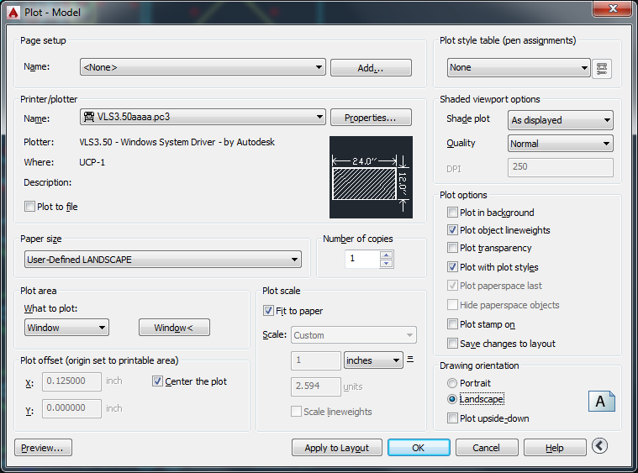

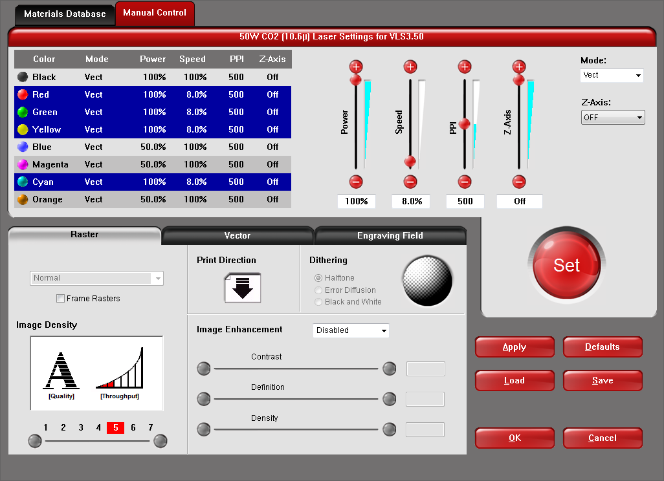

Use the right arrow in the lower righthand to give all the options

3.25mm (1/8 inch) Acrylic:

|  |  |  |  |  |  |
| --- | --- | --- | --- | --- | --- |
| Material | Power | Speed | PPI | z-axis | Result |
| 3.25 mm Acrylic | 100% | 8% | 1000 | off | ?? |

