See C:\LaserCutter\HowToUseLaserCutter.docx for instructions on the Laser Cutter

# Printer Settings

**Please record all settings you try in the tables below. *Thank you*, Aaron Becker**

*There are some reasons to change the ppi. The higher the ppi is set, the hotter the material gets. So if you're working with wood or something else flammable/burnable, you may want to lower the ppi. This is also useful for lessening the charred/burnt look on what you're cutting (like wood).*

*If you're cutting acrylic, and you want sharp corners, a low ppi may be useful for you. But if you want to have nice rounded corners, and a smooth edge, a higher ppi will help achieve that look, by melting the edge of the acrylic where the laser is cutting. (*[*http://www.instructables.com/id/How-to-Use-a-Laser-Cutter/step6/Frequency-Settings/*](http://www.instructables.com/id/How-to-Use-a-Laser-Cutter/step6/Frequency-Settings/)*)*

¼ in Sanded Plywood

|  |  |  |  |  |  |
| --- | --- | --- | --- | --- | --- |
| Activity | Power | Speed | PPI | z-axis | Result |
| Vector light engraving, no cutting through | 50 | 75 | 1000 | 0 | Very fine line |
| Cut through | 100 | 15 | 1000 | 0 | Need a double pass, lots of smoke but no fire. If the cuts are small, the second pass can be at 30% speed. If the cuts are large continuous lines, the double pass should bet at about 20-25%. |

5.2 mm Lauan Plywood:

|  |  |  |  |  |  |  |
| --- | --- | --- | --- | --- | --- | --- |
| Material | Power | Speed | PPI | z-axis | Setting | Result |
| 5.2 mm Lauan Plywood: | 30% | 10% | 500 | 0.25 | Vector | Not cut |
| 5.2 mm Lauan Plywood: | 100 | 8 | 500 | Off | Vector | Cut  (SOMETIMES FOR BIRCH PLYWOOD, THE CUT IS INCOMPLETE – 8% SPEED? |
| 5.2 mm Lauan Plywood: | 100 | 30 | 500 | Off | Vector | Not cut |
| 5.2 mm Lauan Plywood: | 100 | 100 | 500 | Off | Raster | Raster – burns image into wood(Depth = 0.35 mm) |
| 5.2 mm Lauan Plywood: | 100 | 100 | 500 | Off | Vector | (Vector) Etch black lines into wood |

6 mm Acrylic (~1/4” red cast acrylic):

|  |  |  |  |  |  |
| --- | --- | --- | --- | --- | --- |
| Material | Power | Speed | PPI | z-axis | Result |
| 6 mm Acrylic | 100% | 3% | 1000 | off | Nice cutting |
|  | 100 | 100 | 500 |  | Raster: fine line |
|  |  |  |  |  |  |
|  |  |  |  |  |  |

3.25mm (1/8 inch) Acrylic:

|  |  |  |  |  |  |
| --- | --- | --- | --- | --- | --- |
| Material | Power | Speed | PPI | z-axis | Result |
| 3.25 mm Acrylic | 100% | 8% | 1000 | off |  |

3 mm Acrylic:

|  |  |  |  |  |  |
| --- | --- | --- | --- | --- | --- |
| Material | Power | Speed | PPI | z-axis | Result |
| 3 mm Acrylic | 100%  10% | 10%  1.5 | 250  1000 | Off  off | Still slightly melted together – we had to push the pieces apart. Noticeable ridges on edges |
| 3 mm Acrylic | 100 | 3 | 1000 | On, 0.17 | Lots of flame, but beautiful smooth edges. |
| 3 mm Acrylic | 100 | 10 | 1000 | On, 0.17 | Not complete. Kerf: autocad dimensions was 0.75”, we got 0.745” |
| 3 mm Acrylic | 100 | 6 | 1000 | On, 0.17 | Great |

12.7mm Acrylic

|  |  |  |  |  |  |
| --- | --- | --- | --- | --- | --- |
| Material | Power | Speed | PPI | z-axis | Result |
| 12.7 mm Acrylic | 100% | 3% | 1000 | off | Nice cutting (but need to cut 3 times) |

1.5 mm Acrylic:

|  |  |  |  |  |  |
| --- | --- | --- | --- | --- | --- |
| Material | Power | Speed | PPI | z-axis | Result |
| 1.5 mm Acrylic | 100% | 8% | 1000 | off |  |

1.5 mm Acrylic:

|  |  |  |  |  |  |
| --- | --- | --- | --- | --- | --- |
| Material | Power | Speed | PPI | z-axis | Result |
| 1.5 mm Acrylic | 100% | 10% | 500 | off | Cut complete and smooth edges |

0.12mm Kapton:

|  |  |  |  |  |  |
| --- | --- | --- | --- | --- | --- |
| Material | Power | Speed | PPI | z-axis | Result |
| 0.12mm Kapton | 10% | 10% | 500 | off | Cuts |
| 0.12mm Kapton | 10% | 10% | 1000 | off | Power tested from 1% to 20% best was 10%  For small patterns higher PPI is better |

0.02mm Kapton Tape:

|  |  |  |  |  |  |  |  |  |
| --- | --- | --- | --- | --- | --- | --- | --- | --- |
| Material | Power | | Speed | PPI | z-axis | | | Result |
| 0.02mm Kapton | 10% | | 50% | 500 | off | | | Cuts, but we could use less power. Lines that were 50 micron lines could not be distinguishes, 300 micron could |
| 0.02mm Kapton | 6% | 10% | | 1000 | | off | Power tested from 1% to 15% best power is 6%  For small patterns higher PPI is better  The adhesive residue will left on sub | |

0.38 mm Silicone elastomers:

|  |  |  |  |  |  |
| --- | --- | --- | --- | --- | --- |
| Material | Power | Speed | PPI | z-axis | Result |
| 0.38 mm Silicone elastomers | 8% - 14% | 10% | 1000 | off | Best power is 14% |
| 0.38 mm Silicone elastomers | 14% | 10% | 1000 | off |  |

0.5mm Polycarbonate:

|  |  |  |  |  |  |
| --- | --- | --- | --- | --- | --- |
| Material | Power | Speed | PPI | z-axis | Result |
| 0.5mm Polycarbonate | 10% | 10% | 500 | off | Cuts |
| 0.5mm Polycarbonate | 14% | 10% | 1000 | off | Power tested from 1% to 20% best was 14%  For small patterns higher PPI is better |

0.3mm Acrylic:

|  |  |  |  |  |  |
| --- | --- | --- | --- | --- | --- |
| Material | Power | Speed | PPI | z-axis | Result |
| 0.3mm Acrylic with 3M double sided tape | 18% | 10% | 400 | off | Cuts, but not cleanly. (0.5mm slot) |
| 0.3mm Acrylic with 3M double sided tape | 10% | 5% | 1000 | off | Cuts, but not cleanly. (0.4mm slot) |
| 0.3mm Acrylic with 3M double sided tape | 5% | 5% | 1000 | off | Cuts, cleanly |
| 0.3mm Acrylic with 3M double sided tape | 3% | 5% | 1000 | off | Cuts, cleanly (even better!) |
| 0.3mm Acrylic with 3M double sided tape | 2% | 5% | 1000 | off | Cuts, very thin cut |
| 0.3mm Acrylic with 3M double sided tape | 1% | 5% | 1000 | off | Does not cut through |

Optical fiber on top of glass:

|  |  |  |  |  |  |
| --- | --- | --- | --- | --- | --- |
| Material | Power | Speed | PPI | z-axis | Result |
| Optic fibers | 100% | 5% | 1000 | off | Cut through the optics and the glass substrate |
| Optic fibers | 10% | 5% | 1000 | off | The cut is deep enough and clean |
| Optic fibers | 40% | 5% | 1000 | off | Cut through the fiber, not the glass |
| Optic fibers | 30% | 20% | 1000 | off | Clean cut, deep into the optics |
| Optic fibers | 10% | 5% | 1000 | off | Clean cut, deep into the optics |
| Optic fibers | 8% | 5% | 1000 | off |  |

Poster Board (Neon green, 0.011in thck, 0.29mm):

|  |  |  |  |  |  |
| --- | --- | --- | --- | --- | --- |
| Material | Power | Speed | PPI | z-axis | Result |
| 0.29mm Posterboard | 10% | 100% | 1000 | off | Engraves, not cuts 1/25/16 |
| 0.29mm Posterboard | 25% | 100% | 1000 | off | Engraves deeper, not cuts 1/25/16 |
| 0.29mm Posterboard | 75% | 100% | 1000 | off | Cuts cleanly 1/25/16 |

Printer Paper- Fine cuts

|  |  |  |  |  |  |
| --- | --- | --- | --- | --- | --- |
| Material | Power | Speed | PPI | z-axis | Result |
| 0.29mm Posterboard | 100% | 100% | 500 | off | Raster- Engraved the paper but will not cut it. |
| 0.29mm Posterboard | 100% | 50% | 500 | off | Raster- Clean cut, Missed a few spots |
| 0.29mm Posterboard | 100% | 25% | 500 | off | Raster- Sharp cuts, Charring on the edges |

Vector cutting depth and raster engraving depth (or marking intensity if you are surface marking only) are controlled by specifying the speed of processing and the laser power level for raster engraving and by specifying the speed of processing, laser power level and number of pulses per inch (PPI) for vector cutting and marking. These parameters are specified in the printer driver printing preferences interface.

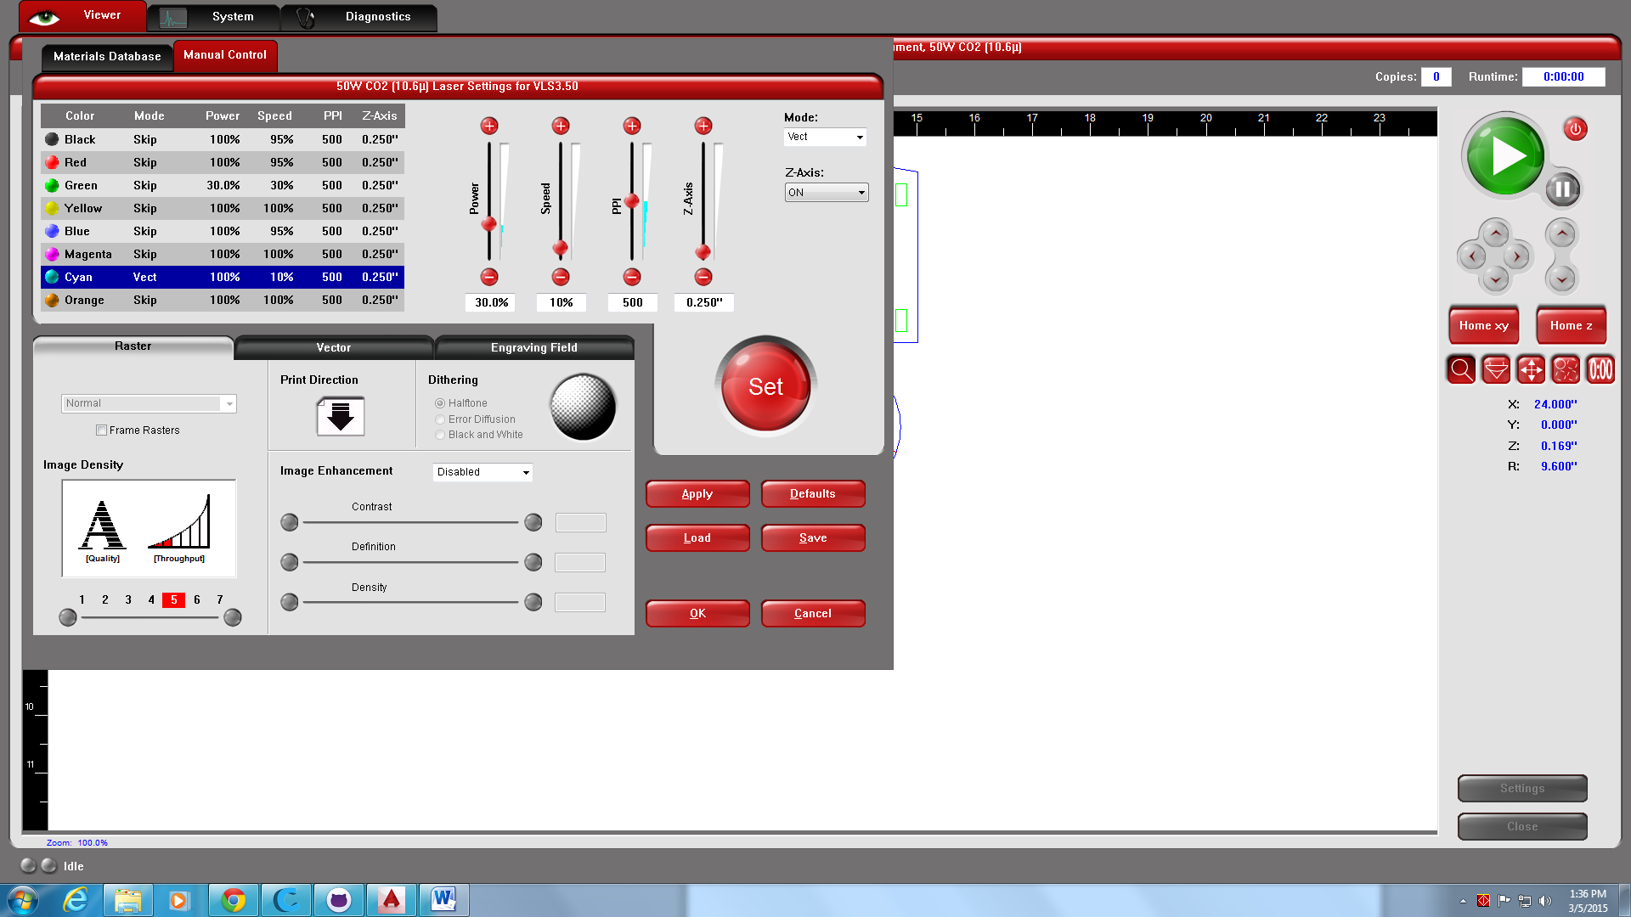

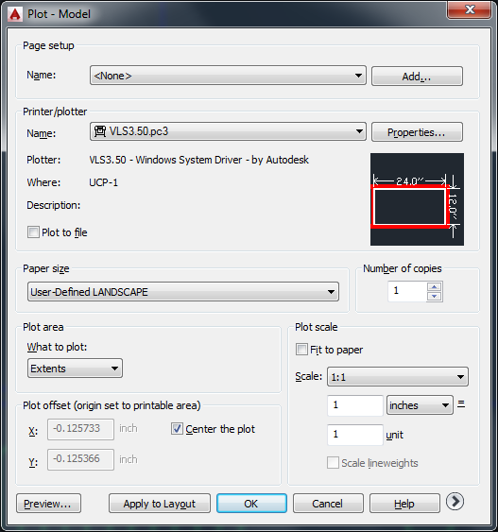 Print Extends