Weekly reports are to be emailed to atbecker@uh.edu by 5:00pm on Tuesdays. The purpose of a weekly report is to: (1) give you text and images for your papers, thesis, and dissertation, (2) document progress, (3) identify if you are stuck or need resources.

Weekly report

1. **My *Goals* from last week**

* Run ‘FindBuildPath’ for binary images of very large 2D parts and check if it returns a path
* Write equations in Mathematica to find the size bounds for the factory
* Make some changes to factory layout and algorithms in the paper.

1. **My *Accomplishments* this week**
   1. The codes and the paper have been updated on github
   2. I’ve installed Mathematica and I’m learning to program in it. I’m working on writing equations in it
   3. I’ve checked the depth first search algorithm for the large maze part:

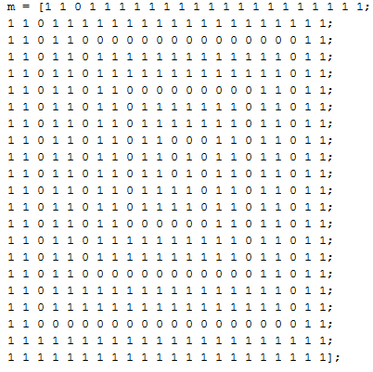

And I get a valid build path:

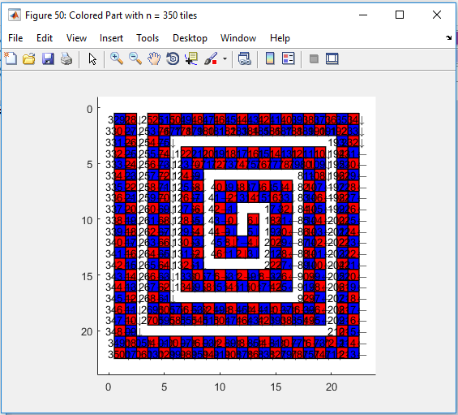

1. **My *Goals* for next week**
   1. Meeting with Dr. Becker on <13th January 2017 at 9:00 am>
   2. Work on the ‘Related Work’ section of the paper
   3. Put simulation results for running time and space required in the paper
2. **What I need Dr. Becker to do:**
   1. ----