Weekly reports are to be emailed to atbecker@uh.edu by 5:00pm on Tuesdays. The purpose of a weekly report is to: (1) give you text and images for your papers, thesis, and dissertation, (2) document progress, (3) identify if you are stuck or need resources.

Weekly report

1. **My *Goals* from last week**

* Complete first draft of contribution to Sheryl’s particle assembly paper.
* Complete several tests to determine the magnetic, gravitational and frictional forces involved in the physical particle assembly demo.
* Begin working on second draft of particle assembly contribution.

1. **My *Accomplishments* this week**
   1. Project 1: Conducted experiments to find weight, magnetic and friction forces of the magnetic sliders.

* In order to find the average weight of the sliders I weighed each of them multiple times to ensure the measurements were precise and then took the average of these measurements. The average force of weight of a slider is 0.0269 Newton. In order to find the magnetic breaking strength I used a clamp to suspend one slider over the edge of the workbench and then tied one end of a piece of string to an alligator clip and the other to a Styrofoam cup. I then clipped this onto another opposite charged slider and connected the sliders. I filled the cup with metal nuts until the sliders separated and then weighed the nuts, cup, alligator clip and bottom slider. I repeated each weight measurement to ensure precision and repeated the test with the same sliders four more times. I repeated this entire process for ten different sets of sliders and then found the average force from these 50 tests. The average magnetic breaking strength of the sliders is 0.1 Newton. To find the friction force acting on the sliders I did several tests in multiple tilt directions with ten sliders on the board at once. I drew a line at the angle that the first slider started moving, a line at the angle when all of the sliders moved and several lines between these at which various numbers of sliders began to move. I found the angles from these lines and calculated the static friction coefficient for each angle. I then plotted a curve for the percent of sliders moving as the angle increases. I then took a weighted average of this data to find that the average friction force acting on the sliders is 0.0074 Newton.

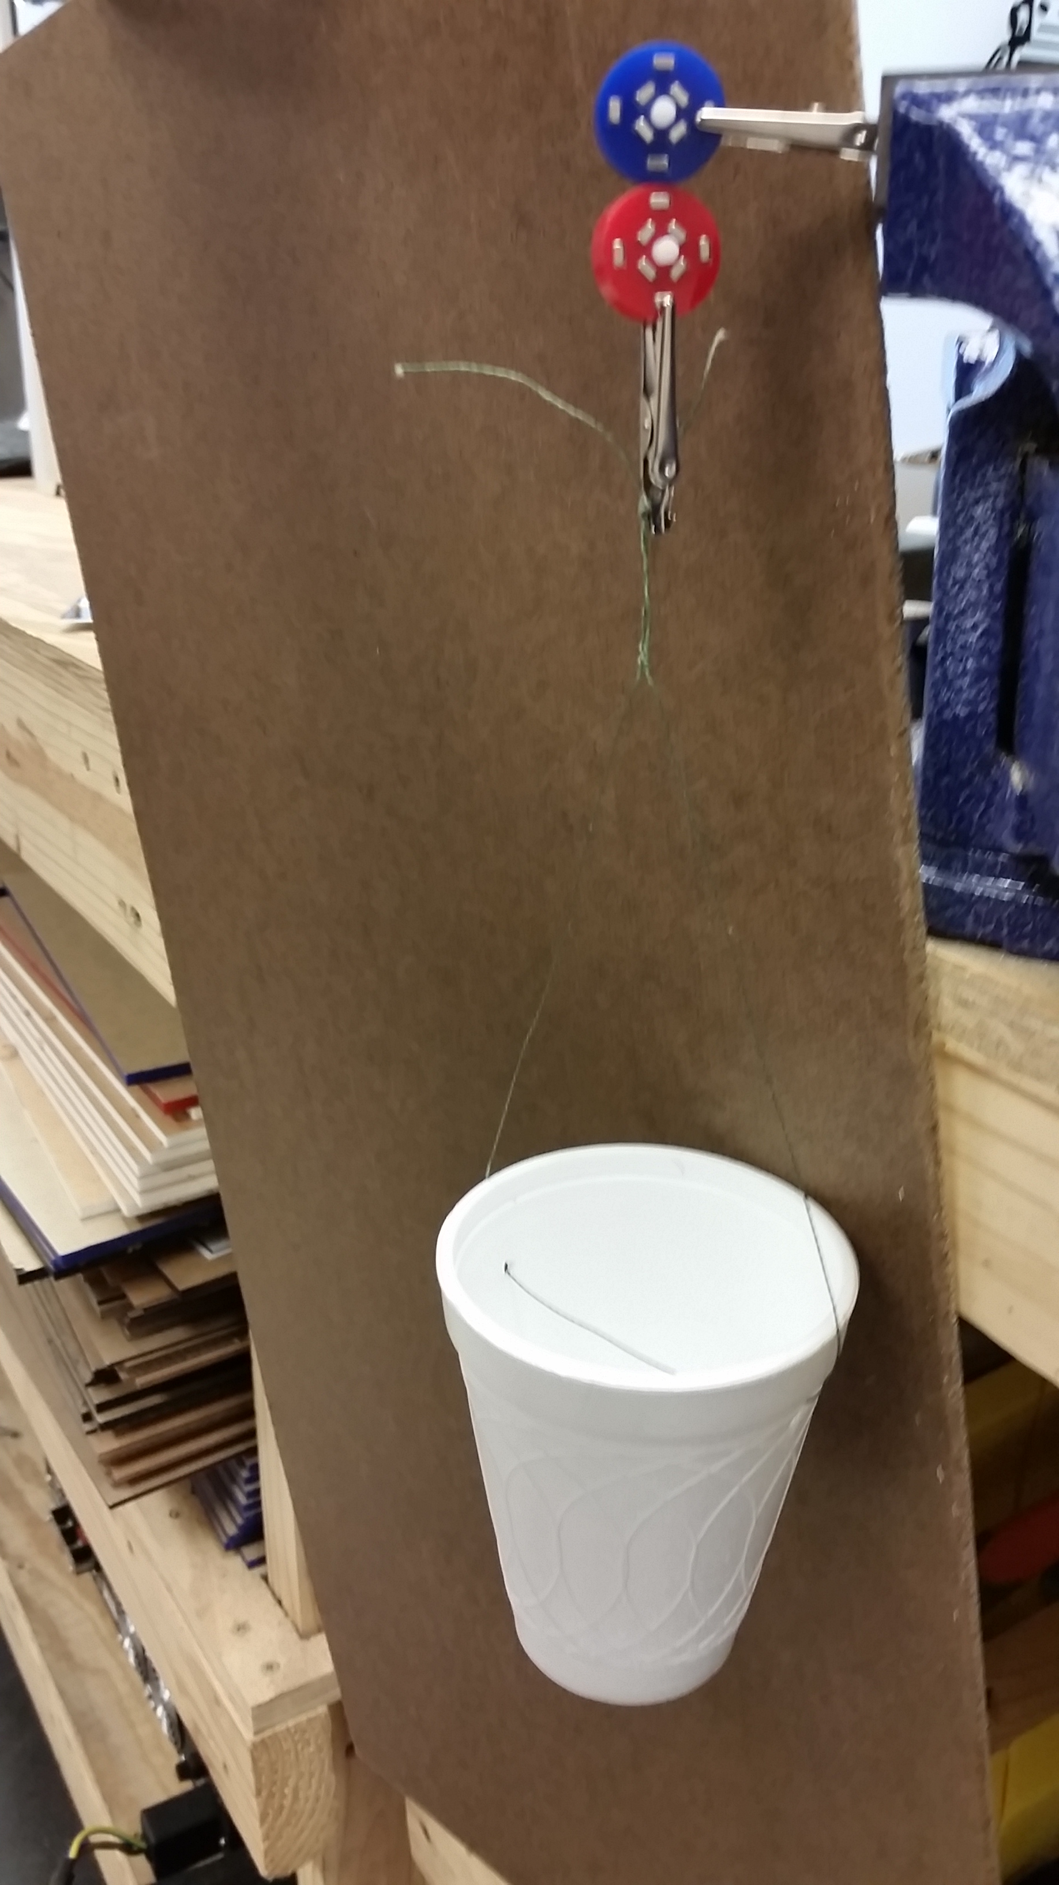

**Figure 1:** Magnetic Breaking Strength Experiment.

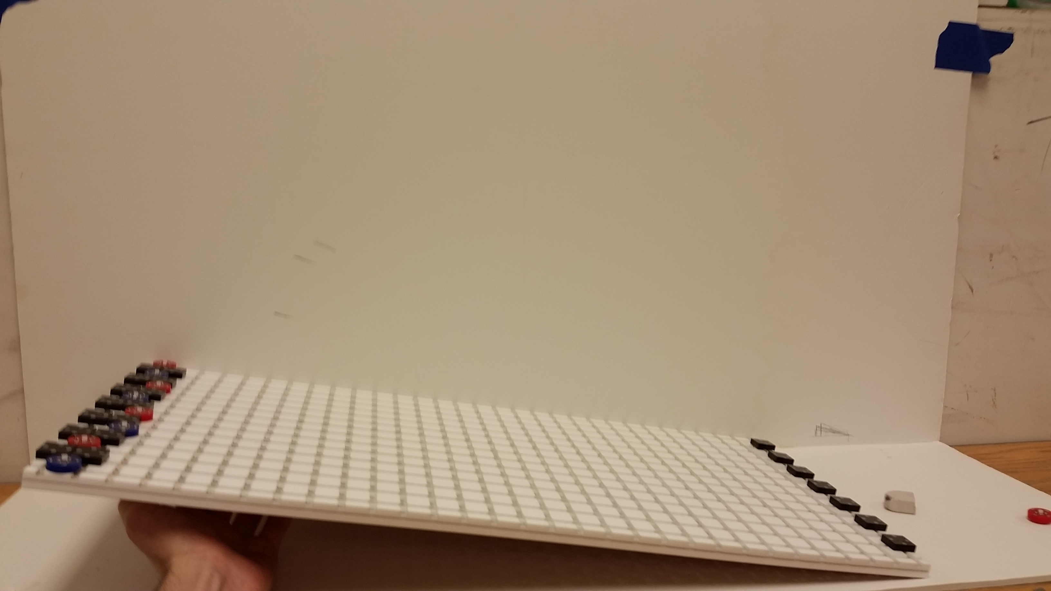

**Figure 2:** Frictional Force Experiment

* 1. Project 2: Write rough draft of parallel assembly contribution
* I directly addressed each of the five points you gave me to cover about the large-scale demo and once revised I will take the good parts of each point and piece them together into a more coherent paragraph or two, elaborating where necessary. I feel like I have a decent starting point but it is not very organized or adequately professional yet.
* Github Link to my Parallel Assembly contribution rough draft.

<https://github.com/aabecker/particleComputation/blob/master/assembly/JLonsford%20Parallel%20Assembly%20Contribution.docx>

1. **My *Goals* for next week**

* Write an organized second draft of parallel assembly contribution.
* Test magnetic breaking strength of Gauss Gun components

1. **What I need Dr. Becker to do:**
   1. Read and revise the very rough draft of the parallel assembly contribution. Let me know what should be expanded on, what should be reworded, what doesn’t need to be included and any other issues.