Weekly report

1. **My *Goals* from last week**
   1. Run mapping and coverage experiment for 100 runs.
   2. Make 1D map.
   3. Do related work study.
   4. Check ci equation which I had proposed earlier.
2. **My *Accomplishments* this week**
   1. 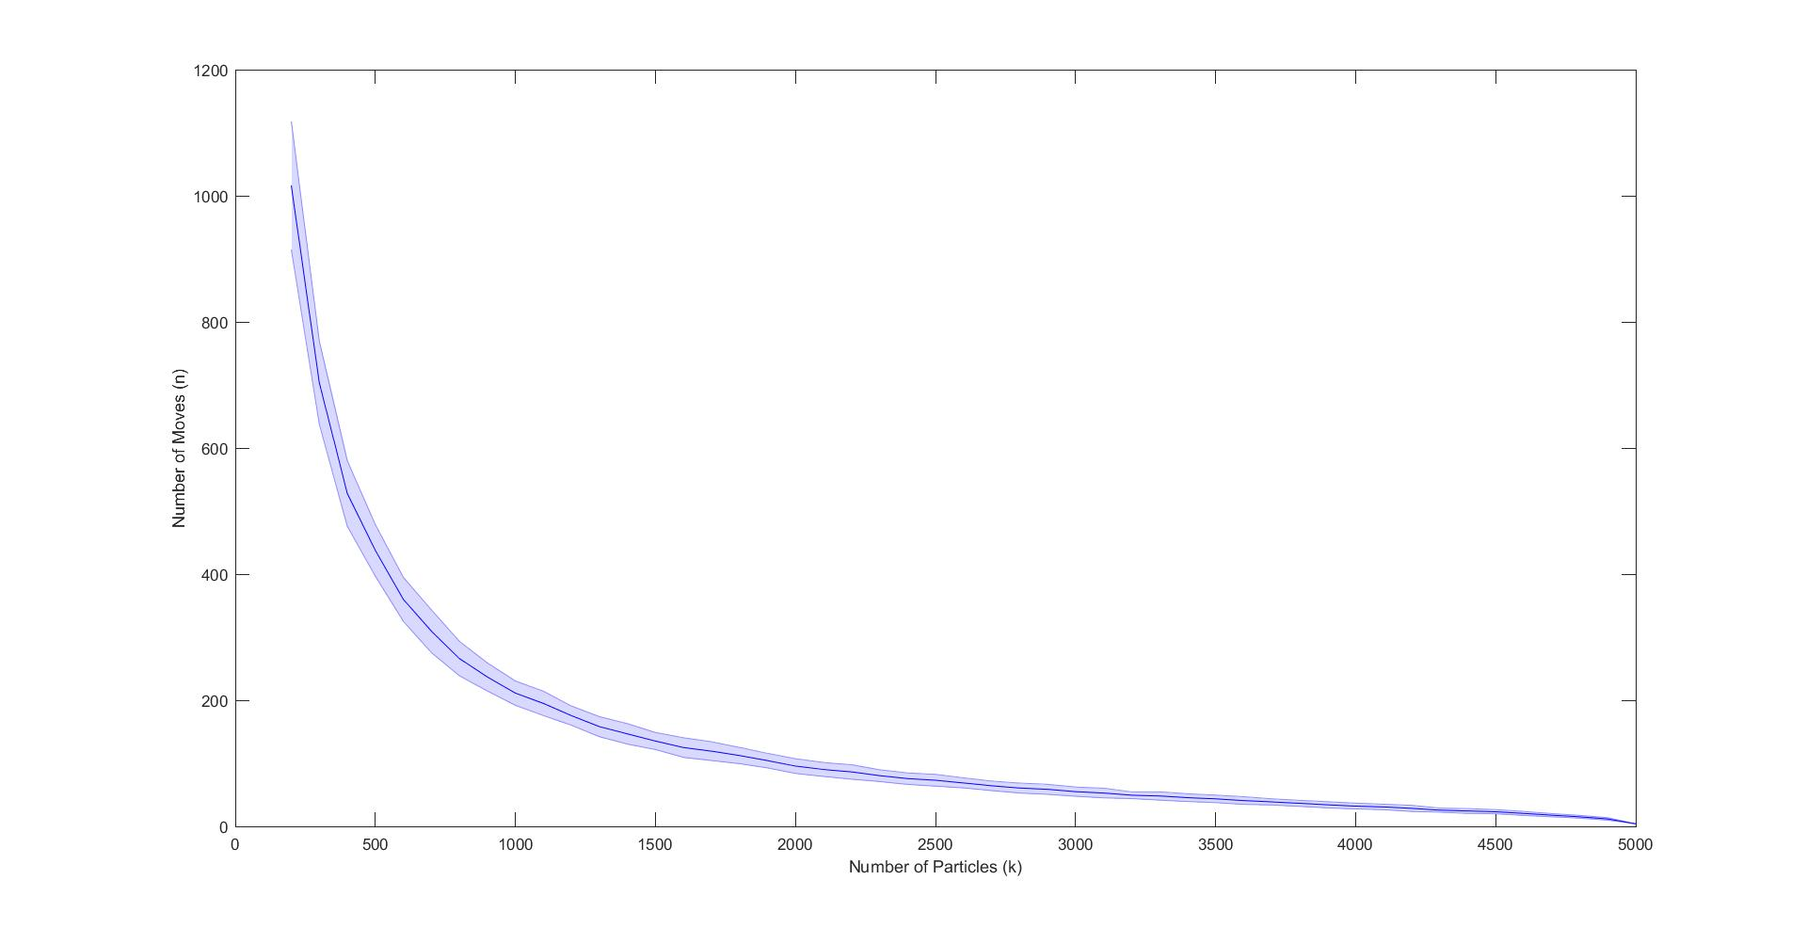The mapping simulation was repeated 100 times for a given number of robots in a map with 5000 free spaces. In each run the robots were placed randomly throughout the workspace. For smaller ratio of robots/workspace we see that the standard deviation is large. As we increase the robots from 100 to 5000 by increments of 100, we see that the deviation decreases. The function of moves vs no. of. robots is an exponentially decreasing curve. The legend will be changed in pdf image to have italics. The maximum number of moves required was for no. particles=100 with an average moves ~ 1816 and standard deviation of 160 moves.

The

This decays down to average moves ~ 4 and standard deviation of 0 moves for no. particles= 5000 ( which is the number of free spaces).

* 1. The Maxwell computer registration is complete. I also installed Mathematica on my system and going through the mathematica tutorial given by Shiva. Once I get the activation key from UH I will start the comparison of mathematica 1D maximum gap to the results from matlab code given by author of the paper.
  2. Bugs in the coverage code have been fixed and the coverage simulation for n=100 to 5000 is currently running for 100 runs each.

1. **My *Goals* for next week**
   1. Go through the related work by Dr.Sándor and work on related work section from paper.
   2. Compare max gap between mathematica and matlab.
   3. Contact Dominik regarding algorithm.
   4. Flood fill setup for particles to start in.
   5. Writhe Algorithm in Latex.
2. **Needed from Dr Becker**
   1. **Meeting on Friday for update on work.**