Weekly report

1. **My *Goals* from last week**
   1. Create Mechanism to utilize force sensor
   2. Test if force sensor we have is able to sense kilobots
2. **My *Accomplishments* this week**
   1. Project 1: <Kilo-bot Force Measurement>
      1. Thought about ideas for utilizing force sensor
         1. 21 mm to top of PCB to table (height of aluminum angle)
         2. Tape does not seem to inhibit reading, as used in tests below
      2. Experimented with the force sensor
         1. Learned that the more force is applied, the smaller the resistance is of the force sensor
            1. I do not know how this correlates to actual newtons
            2. I do not have the actual circuit in datasheet (see below), but measured via kOhms, like suggested

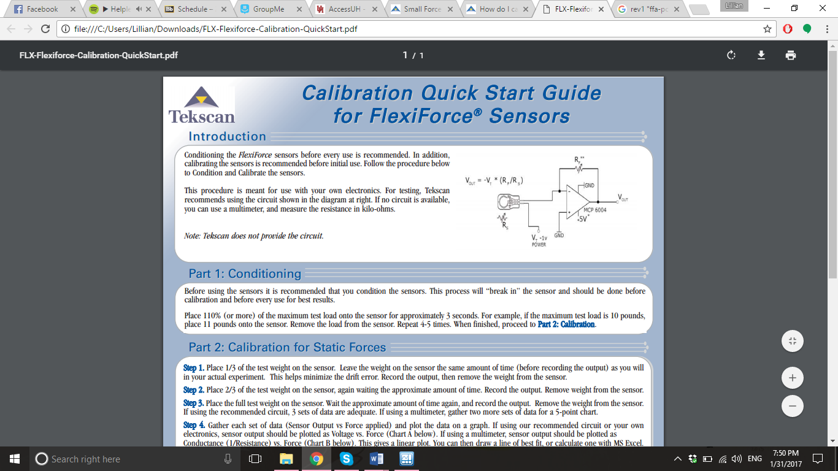

* + - 1. Upon realization that the force sensor cost 67 dollars, create new idea <[source](https://www.tekscan.com/products-solutions/force-sensors/a201)>
         1. Despite being called trim lines, applying force to other areas other than the circle doesn’t appear to change the resistance anyways
      2. The kilobots are hard to aim at the force sensor, they don’t seem to like it very much
      3. When Kilobots do hit sensor, the value is not significant
         1. The force sensor might not precise enough to measure the kilbots
         2. There might be too much noise to notice the kilbots with the way I am measuring the sensor.
    1. I am unsure what the circuit in the force sensor kit is
       1. I’ll try to ask Julien
       2. Googling FFA-PCB-001 Rev 1.0 that is printed on the board doesn’t get anything
       3. The components on the board don’t have the MCP 6004 Op-Amp printed on any of them
  1. Project 2: <Volunteering>
     1. Built NXT robots for Mars Rover Event
     2. Taught 2 groups of elementary schoolers how to program
     3. Taught 3 groups of middle schoolers to debug and calibrate programs
  2. Project 3: <Other>
     1. Learned the only time to work on the table with the kilobots is at night… since during the day everyone uses the table to work on
     2. Helped Javier hold his torque bar.

1. **My *Goals* for next week**
   1. Create Mechanism to utilize force sensor
   2. Win VEX competition in Oklahoma
2. **Needed from Dr Becker**
   1. Nothing at the moment, although I thought you should know on Wednesday, some of the kilobots on the charger aren’t accepting programming. Which is pretty interesting as only some of them are affected and not all.
      1. They were clearly on as their LEDs were blinking and one still had a blue led on
      2. I thought they were just left on so I tried to turn them off, nothing happened
      3. I attempted to check their voltage to see if they were accepting input, the ones next to them lit up appropriately but those did not despite holding programmer over them for 3 minutes