Weekly report

1. **My *Goals* from last week**
   * Objective 1: Change the tilting frame so I can put the particles on the rotating bar easier and without an initial velocity.
2. **My *Accomplishments* this week**
   1. Objective 1: Cut out a new frame piece so the upper half is open. The piece came out fine but the hole there the axle supporting the rotating bar goes was (for some reason) a bit out of place. Fixed it with some good old drilling. The new frame can be seen on Fig 1.

Tested with the lead balls, but no success. Still have to test with salt and other types of particles.

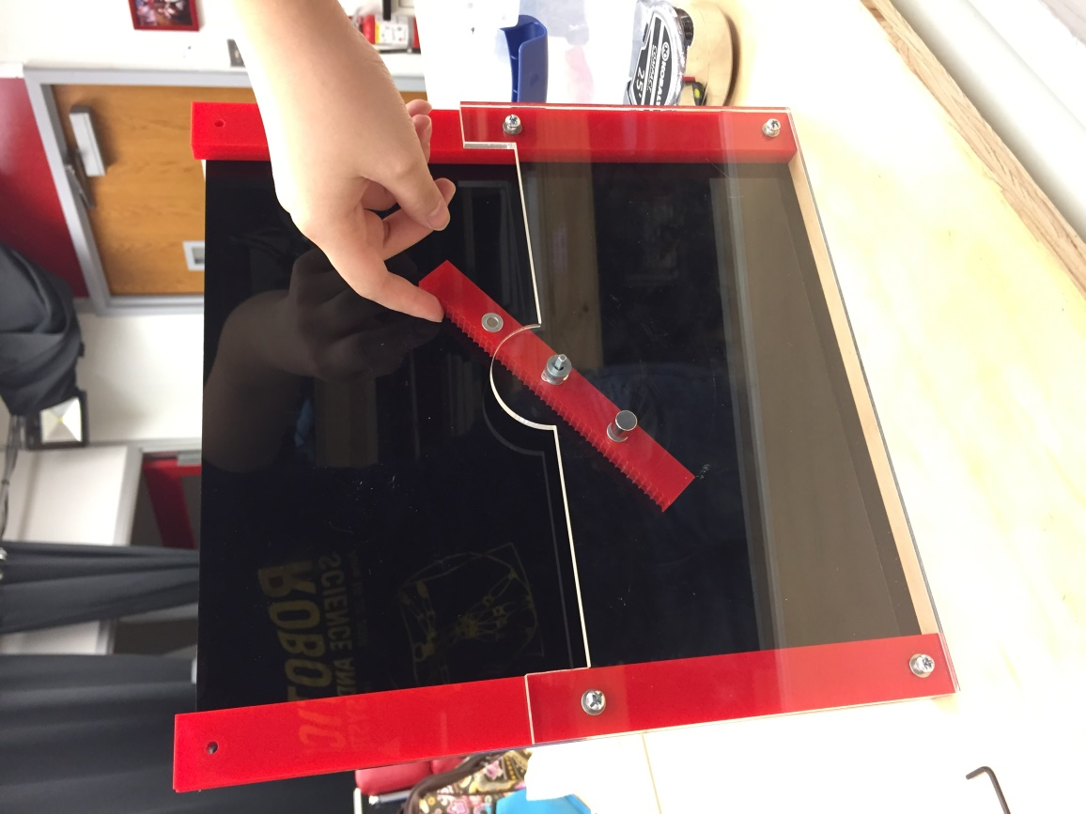

Figure 1. New frame with the upper half cut out.

* 1. (Not really related but it’s cool): The UH Robotics team went to Muskogee, Oklahoma, last weekend to participate in a VEX U competition, and we won!!!

1. **My *Goals* for next week**
   * Tilting frame

* Test with salt and other types of particles (like sand)

1. **What I need Dr. Becker to do:**
   * Can we acquire sand, like that used for the geophones penetration experiments?