Weekly reports are to be emailed to atbecker@uh.edu by 5:00pm on Tuesdays. The purpose of a weekly report is to: (1) give you text and images for your papers, thesis, and dissertation, (2) document progress, (3) identify if you are stuck or need resources.

Weekly report

1. **My *Goals* from last week**

* Write an organized second draft of parallel assembly contribution.
* Test magnetic breaking strength of Gauss Gun components

1. **My *Accomplishments* this week**
   1. Project 1: Conducted experiments to find weight, magnetic and friction forces of the magnetic sliders.

* Github link for stl files. <https://github.com/aabecker/LaserCutter3DPrinter/tree/master/3Dprinter/Jarrett%20Lonsford>
* I 3d printed a holder for the steel ball so that it can be tied to a bucket to hold weight. The part originally had a top and bottom to ensure the ball would stay secured but it turned out that the bottom part was tight enough that the top was unnecessary. For the actual experiment I filled a bucket tied to the steel ball with lead shot until the ball disconnected from a magnet being held in a vice and recorded the weights for various spacer distances. I am still in the process of doing these measurements but I should have enough data to form a decent curve already.

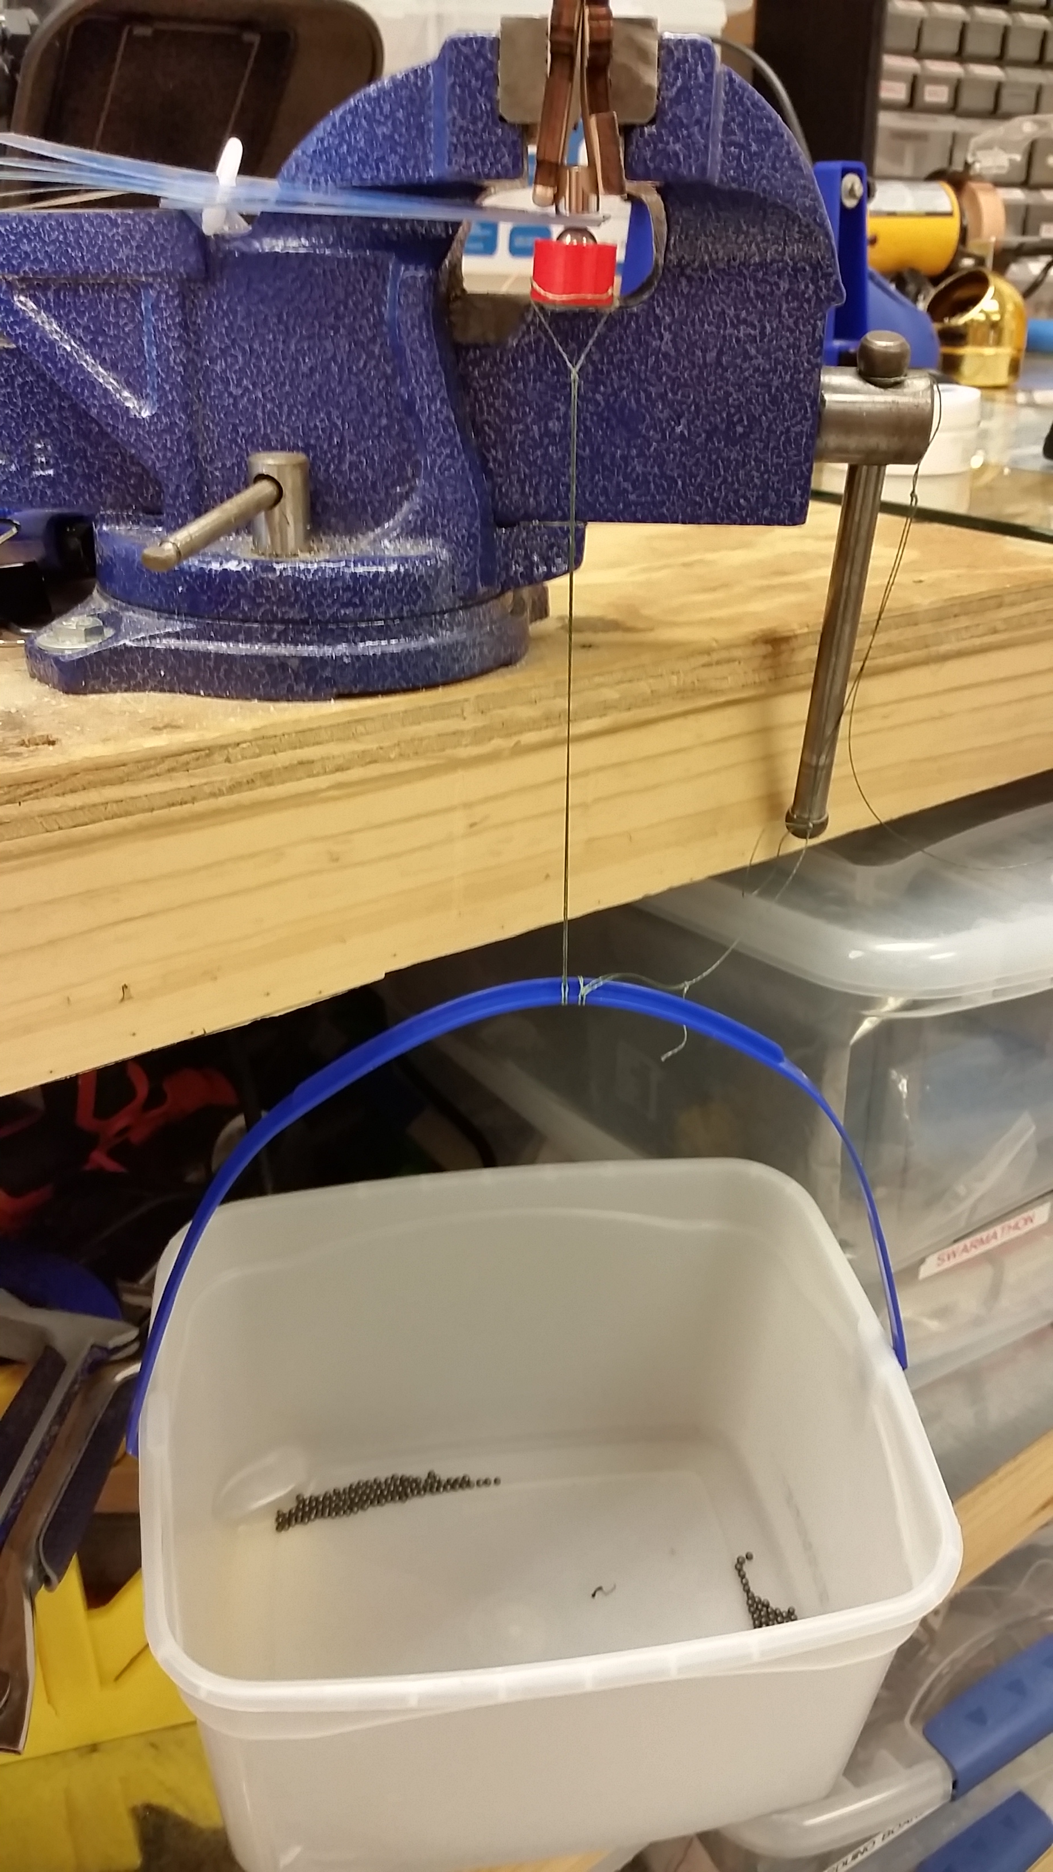

**Figure 1:** Gauss Gun Component Magnetic Breaking Strength Experiment.

1. **My *Goals* for next week**

* Write an organized second draft of parallel assembly contribution.
* Finish testing the magnetic breaking strength of Gauss Gun components and generate a good curve of the magnetic force over distance.

1. **What I need Dr. Becker to do:**