Weekly report

1. **My *Goals* from last week**
   1. Go through the related work by Dr.Sándor and work on related work section from paper.
   2. Compare max gap between mathematica and matlab.
   3. Contact Dominik regarding algorithm.
   4. Flood fill setup for particles to start in.
   5. Writhe Algorithm in Latex.
2. **My *Accomplishments* this week**
   1. The comparison plot between the mapping of the three maps ‘complex’, ‘empty rectangle’ and ‘linear’ shows that the complex map requires the most moves. There is also an observable difference in moves between the linear and the rectangular. This is probably because of the number of useful moves. In the linear case, only left and right are useful moves. Up and down just help eliminate boundaries. Nevertheless, it is important to identify the boundary. Whereas in ‘empty rectangle’ case most of the moves are moves which will surely add to the number of mapped spaces. Only when the number of particles is around 2/3 of the number of free spaces, we have an overlap between the moves taken to map rectangular space and linear space. We should look at bounding the complexity.

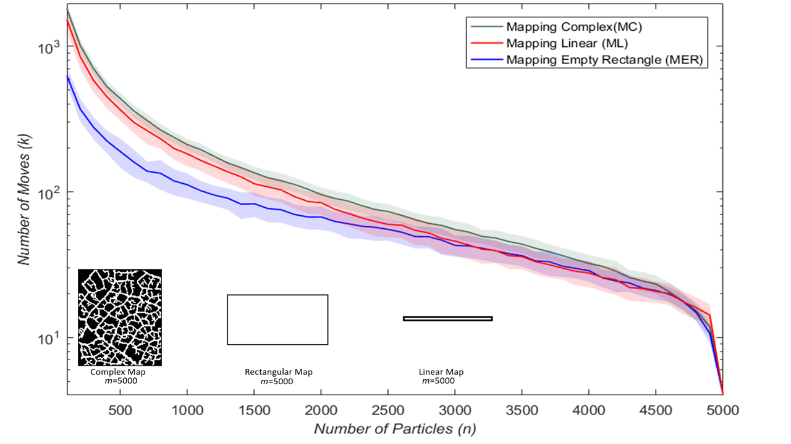

* 1. The flood fill algorithm is completed and running for 100 runs.
  2. Currently working on draft of paper.
  3. Data for foraging, coverage and mapping has been acquired for complex map.

1. **My *Goals* for next week**
   1. **Finish elect particle code, plot for random mapping vs elect vs closest boundaries.**
   2. **Learn to analyze complexity of code and complexity of algorithm.**
2. **Needed from Dr Becker**
   1. **Meeting on Friday for update on work.**