Weekly reports are to be emailed to atbecker@uh.edu by 5:00pm on Tuesdays. The purpose of a weekly report is to: (1) give you text and images for your papers, thesis, and dissertation, (2) document progress, (3) identify if you are stuck or need resources.

Weekly report

1. **My *Goals* from last week**

* Write an organized second draft of parallel assembly contribution.
* Finish testing the magnetic breaking strength of Gauss Gun components and generate a good curve of the magnetic force over distance.

1. **My *Accomplishments* this week**
   1. Project 1: Finished experiments to find magnetic breaking strength of Gauss Gun Components.

* I used 13 different spacing distances from 0.1 mm to 10 mm to find a good curve of the magnetic force between the neodymium cylinder and steel ball as well as a baseline measurement with no spacer. I plotted the curve in excel, which can be found below.

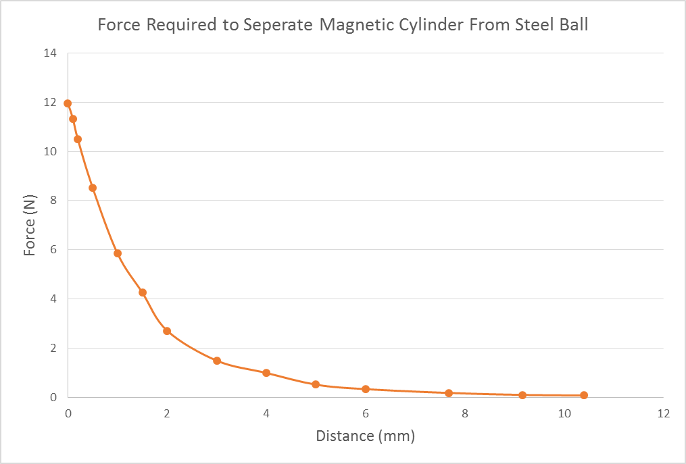

**Figure 1:** Gauss Gun Component Magnetic Breaking Strength Curve.

* 1. Project 2: Second draft of Assembly contribution / Assembly reviewing
     + Github link to second draft

<https://github.com/aabecker/particleComputation/blob/master/assembly/Jarrett%20assembly%20contribution.docx>

* + - I reorganized my original draft into an organized format for the paper, edited it to flow better and removed unnecessary sentences. I also reviewed the rest of the paper and marked errors / things that could be reworded, which was already emailed to you.

1. **My *Goals* for next week**

* Start designing some possible underwater gauss guns based off of the original MRI gauss gun design.

1. **What I need Dr. Becker to do:**
   * + Assign me more goals for the Gauss Gun project.