Weekly reports are to be emailed to atbecker@uh.edu by 5:00pm on Tuesdays. The purpose of a weekly report is to: (1) give you text and images for your papers, thesis, and dissertation, (2) document progress, (3) identify if you are stuck or need resources.

Weekly report

1. **My *Goals* from last week**

* Start designing some possible underwater gauss guns based off of the original MRI gauss gun design.

1. **My *Accomplishments* this week**
   1. Project 1: Created list of Gauss Gun questions that can be answered through experiments.

* Is there a better alternative to steel as the force transmitter?
* How can the Gauss Gun be made airtight/watertight?
* How can the Gauss Gun be made neutrally buoyant?
* When does the efficiency of chaining Gauss Guns together become null.
  1. Project 2: Measuring coefficient of restitution for 15 mm long cylinders of steel, copper, brass, aluminum and titanium
     + Javier and I are in the process of measuring the coefficient of restitution of these metals in three different diameters. We will then generate plots to compare how changing the diameter of the metal affects the coefficient of restitution. We initially had to cut these 15 mm long samples from longer rods and then grind and polish one surface so that the rods are flat and gives accurate results during testing.

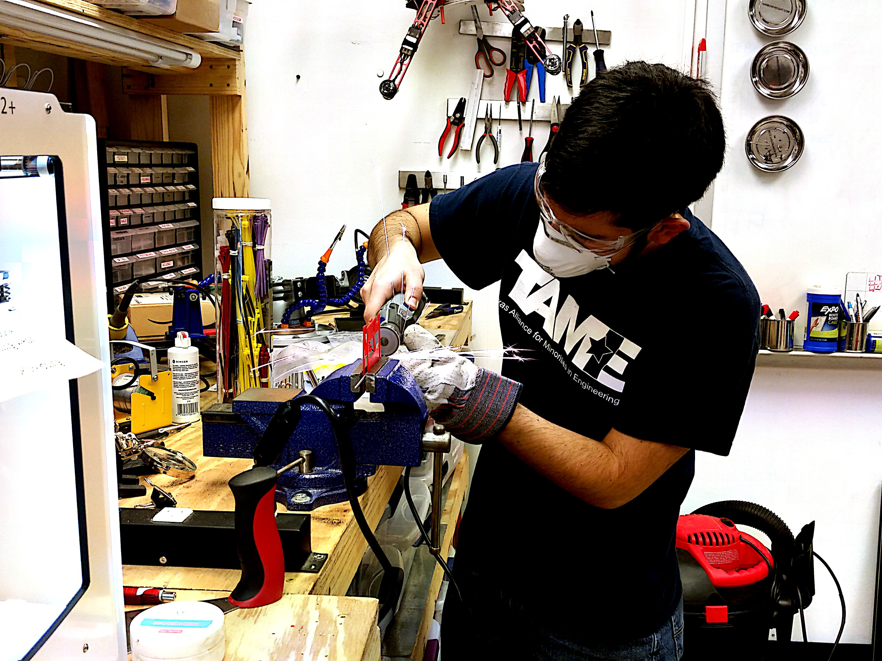

**Figure 1:** Javier cutting sample piece of titanium.

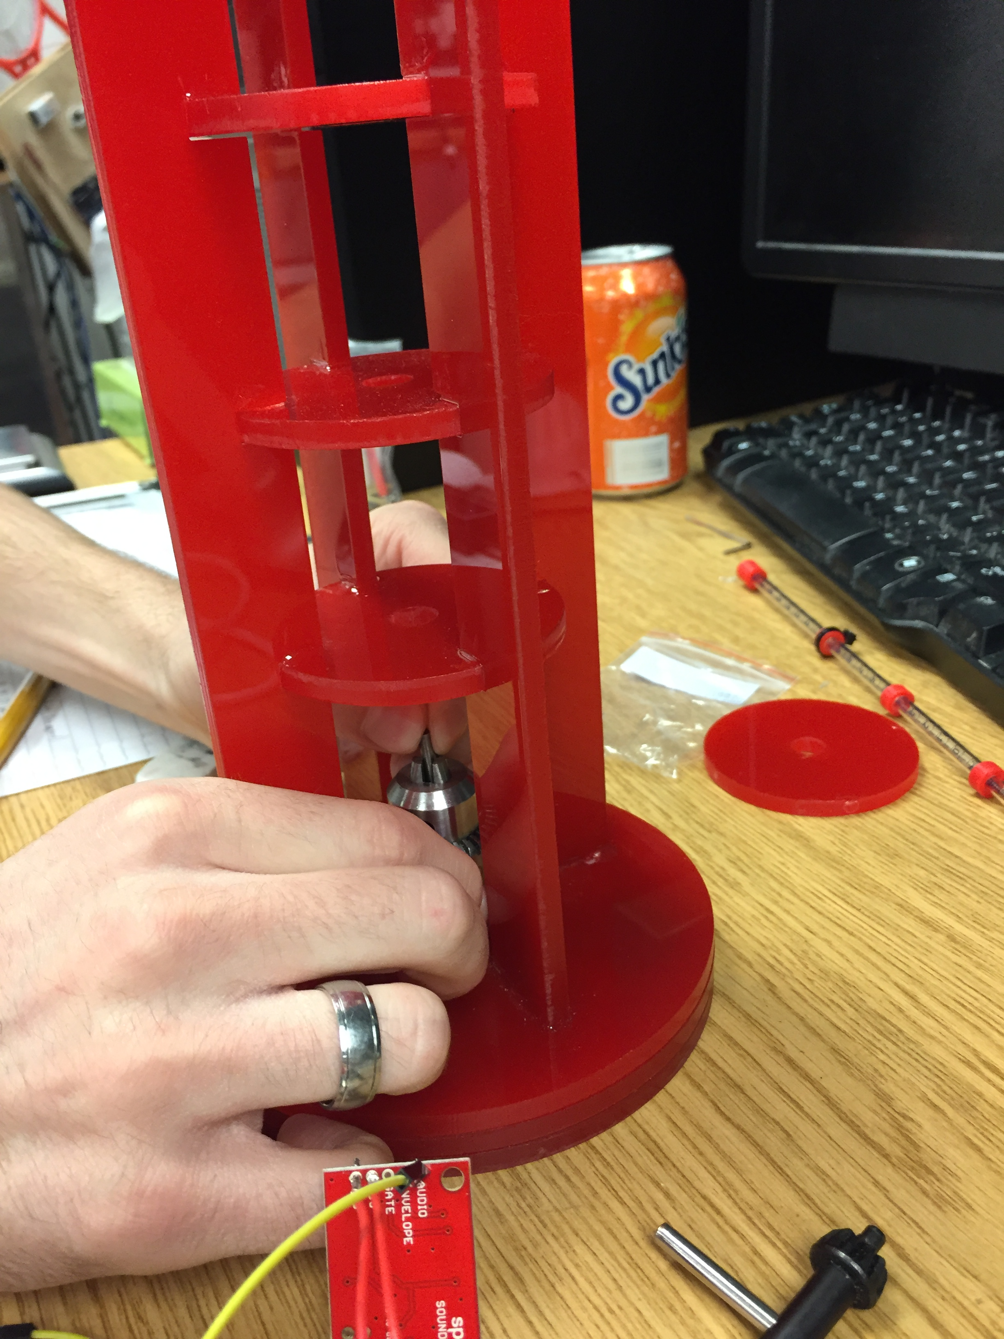

**Figure 2:** Placing sample into coefficient of restitution testing device.

1. **My *Goals* for next week**

* Complete coefficient of restitution data analysis.
* 3D print a replicate of the MRI compatible Gauss Gun to use for initial redesigning.

1. **What I need Dr. Becker to do:**