Weekly report

1. **My *Goals* from last week**
   * Objective 1: Find particles to test the new tilting frame
   * Objective 2: Start designing prototypes for MRI compatible gauss guns
2. **My *Accomplishments* this week**
   1. Objective 1:
      1. Designed a barrel shaped gauss gun with Jarrett. This prototype replaces the intermediate balls with metal rods (not attracted to magnets) and has holes in its ends so we can design something to seal them (water-proof). This prototype can be seen in Figure 1
      2. Tested the prototype. 2 stage gun works well but it’s pretty weak

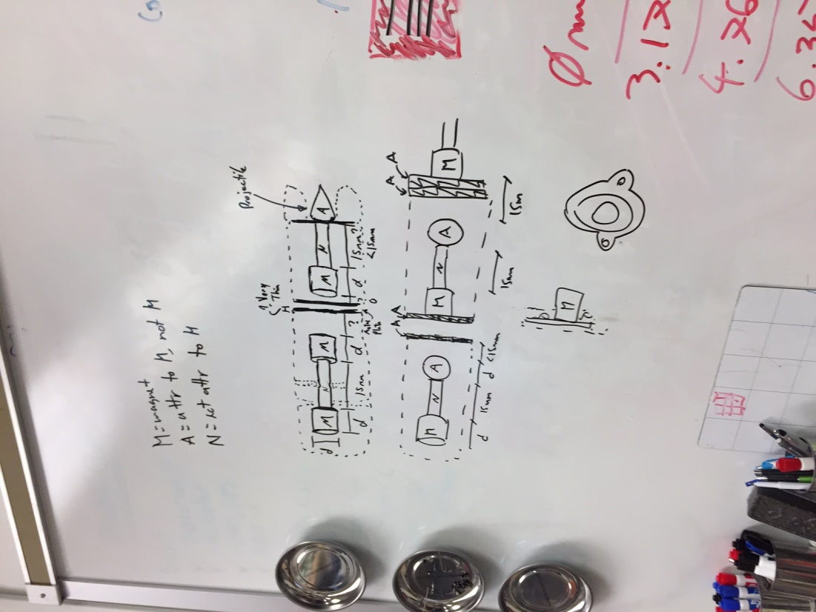 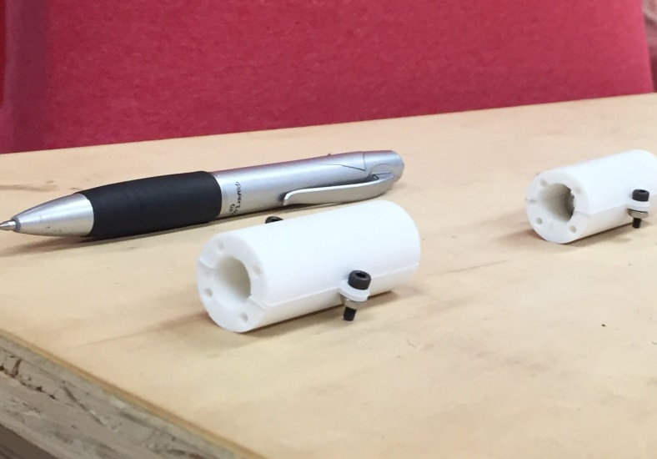

Figure 1. MRI compatible Gauss gun prototype.

1. **My *Goals* for next week**
   * Tilting frame

* Find particles to test it
* MRI compatible Gauss Gun
* Improve the design to make multiple stages be stable when connected and the firing stage isn’t present. Prototype cap to seal them.

1. **What I need Dr. Becker to do:**
   * Nothing for now