The purpose of a weekly report is to: (1) give you text and images for your papers, thesis, and dissertation, (2) document progress, (3) identify if you are stuck or need resources.

Weekly report

1. **My *Goals* from last week**

* Read about ‘Grid Graphs’ and ‘Cut Points of a Graph’ for decomposition
* Prove that for a part of greater than 5 tiles, there exists no arrangement of tiles which can’t be broken down into elements of 2, 3 or 4 tiles.
* Show decomposition of some of the parts we have built, in Power point

1. **My *Accomplishments* this week**
   1. I’ve read about ‘Grid Graphs’ and ‘Cut Points of a Graph’
   2. I’ve tried different arrangements of a 6-tile part and they all can be further broken down into elements:

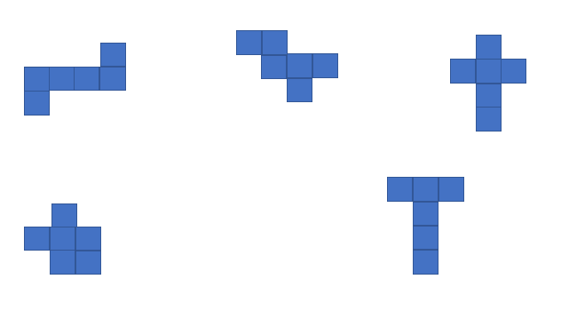

* 1. I’ve shown how some of the parts could be decomposed in the images below. However, I don’t understand why are we interested in breaking the parts into elements of 2 or 3 or 4 tiles. Why can’t we make bigger sub-parts?

Also, how are we going to make sure that cutting the connected graph (part) at some point is going to result in two or more connected sub-parts? They could be disconnected. Please see the third image below.

Furthermore, I’m not quite sure if this approach of decomposition is going to help us make the parts which can’t be built by additive construction. For instance, in case of double spiral how do I know that choosing a cut point in the middle and then making two spirals is the solution? Unless I try multiple cut points.

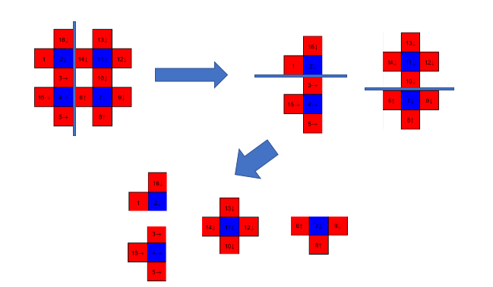

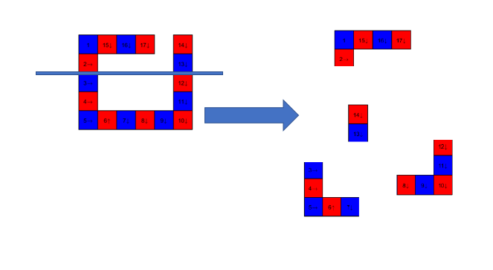

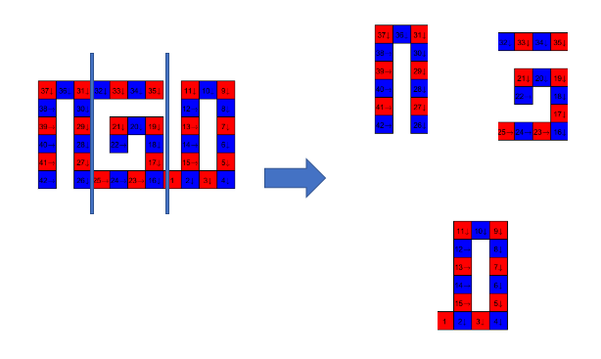

1. **My *Goals* for next week**
   1. Meeting with Dr. Becker on <17th March 2017 at 9:00 am>