Weekly reports are to be emailed to atbecker@uh.edu by 5:00pm on Tuesdays. The purpose of a weekly report is to: (1) give you text and images for your papers, thesis, and dissertation, (2) document progress, (3) identify if you are stuck or need resources.

Weekly report

1. **My *Goals* from last week**

* 3D print a replicate of the MRI compatible Gauss Gun to use for initial redesigning.
* Begin redesigning the Gauss Gun.

1. **My *Accomplishments* this week**
   1. Project 1: 3D printed Gauss Gun prototype

* Javier and I spent some time developing a few designs for Gauss Gun prototypes, he made CAD files for some and we printed out two versions to test. One version works decently well and may be modifiable to become watertight while the other was less promising. I also tested the prototypes in water to determine how we can make them buoyant and I found that if wrapped twice in bubble wrap, the gauss gun sections will float. However the prototype does not shoot when submerged.

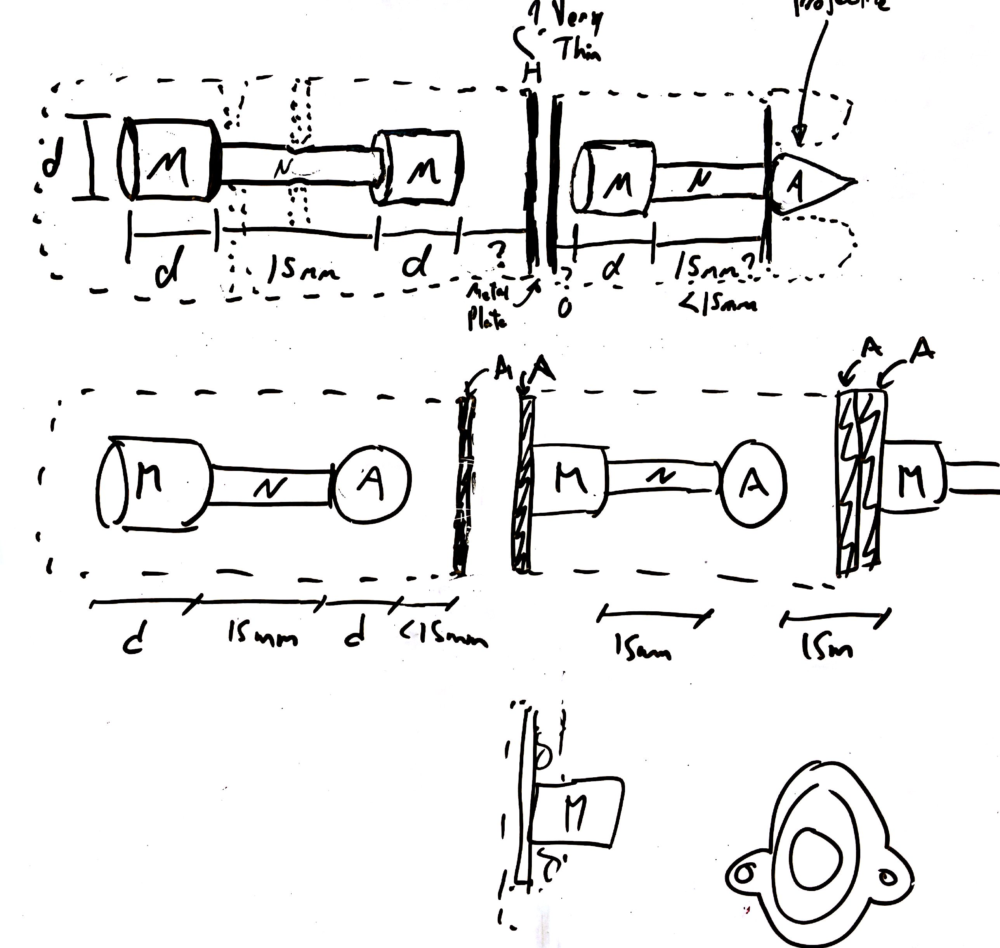

**Figure 1:** Rough initial design sketches for Gauss Gun prototypes.

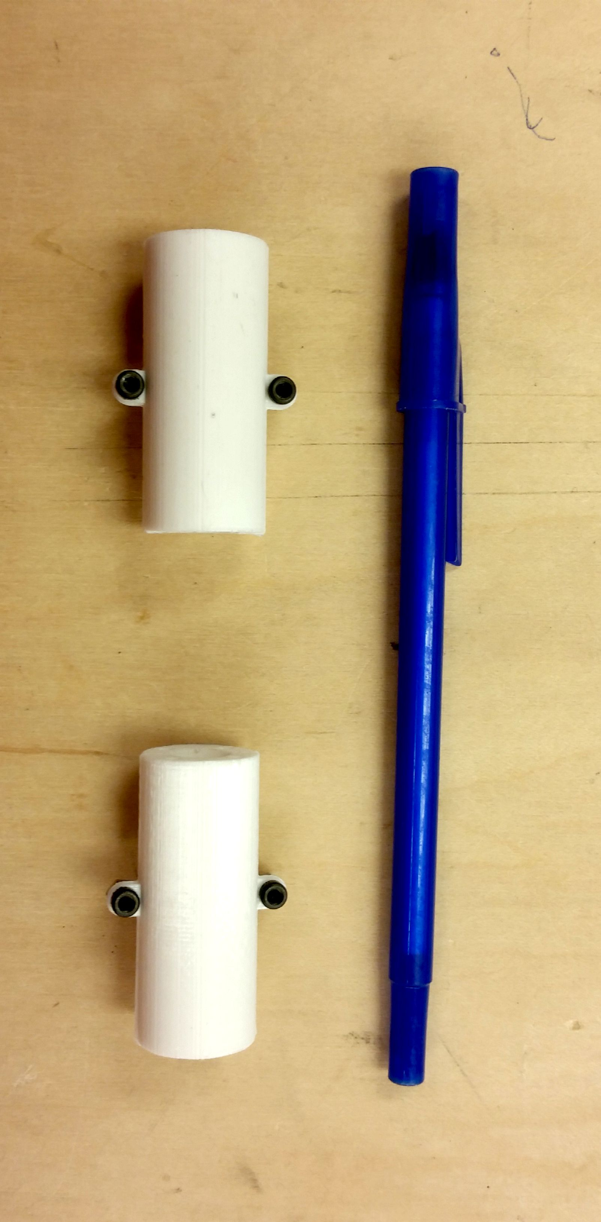

**Figure 2:** First Gauss Gun prototype.

1. **My *Goals* for next week**

* Modify Gauss Gun prototype to be watertight and make new prototypes if necessary.
* Help Ashwin and Julien with experiments if necessary.

1. **What I need Dr. Becker to do:**