Weekly reports are to be emailed to atbecker@uh.edu by 5:00pm on Wednesdays. The purpose of a weekly report is to: (1) give you text and images for your papers, thesis, and dissertation, (2) document progress, (3) identify if you are stuck or need resources.

Weekly report

1. **My *Goals* from last week**

* Modify Gauss Gun prototype to be watertight and make new prototypes if necessary.
* Help Ashwin and Julien with experiments if necessary.

1. **My *Accomplishments* this week**
   1. Project 1: 2nd and 3rd 3D printed Gauss Gun prototype

* Javier and I made two different modifications to the original prototype print, the first of which has a shorter spacing and non-magnetic metal rod between the magnet and steel ball of each stage. We printed three extra second stages for this prototype but only one of them actually fires. The one that does fire does not deliver nearly as much force as the original prototype. We think the issue with this design is due to the magnets of each stage being closer together, as the magnet of the second stage tends to be pulled out of the casing when the stages are brought together. We may be able to resolve this by gluing the magnet into the casing. As for the other prototype, we only modified the flat faces of the gauss gun stages so that they fit into one another, similar to your original design. This prototype has yet to be tested as we have had issues with the quality of the 3d prints.

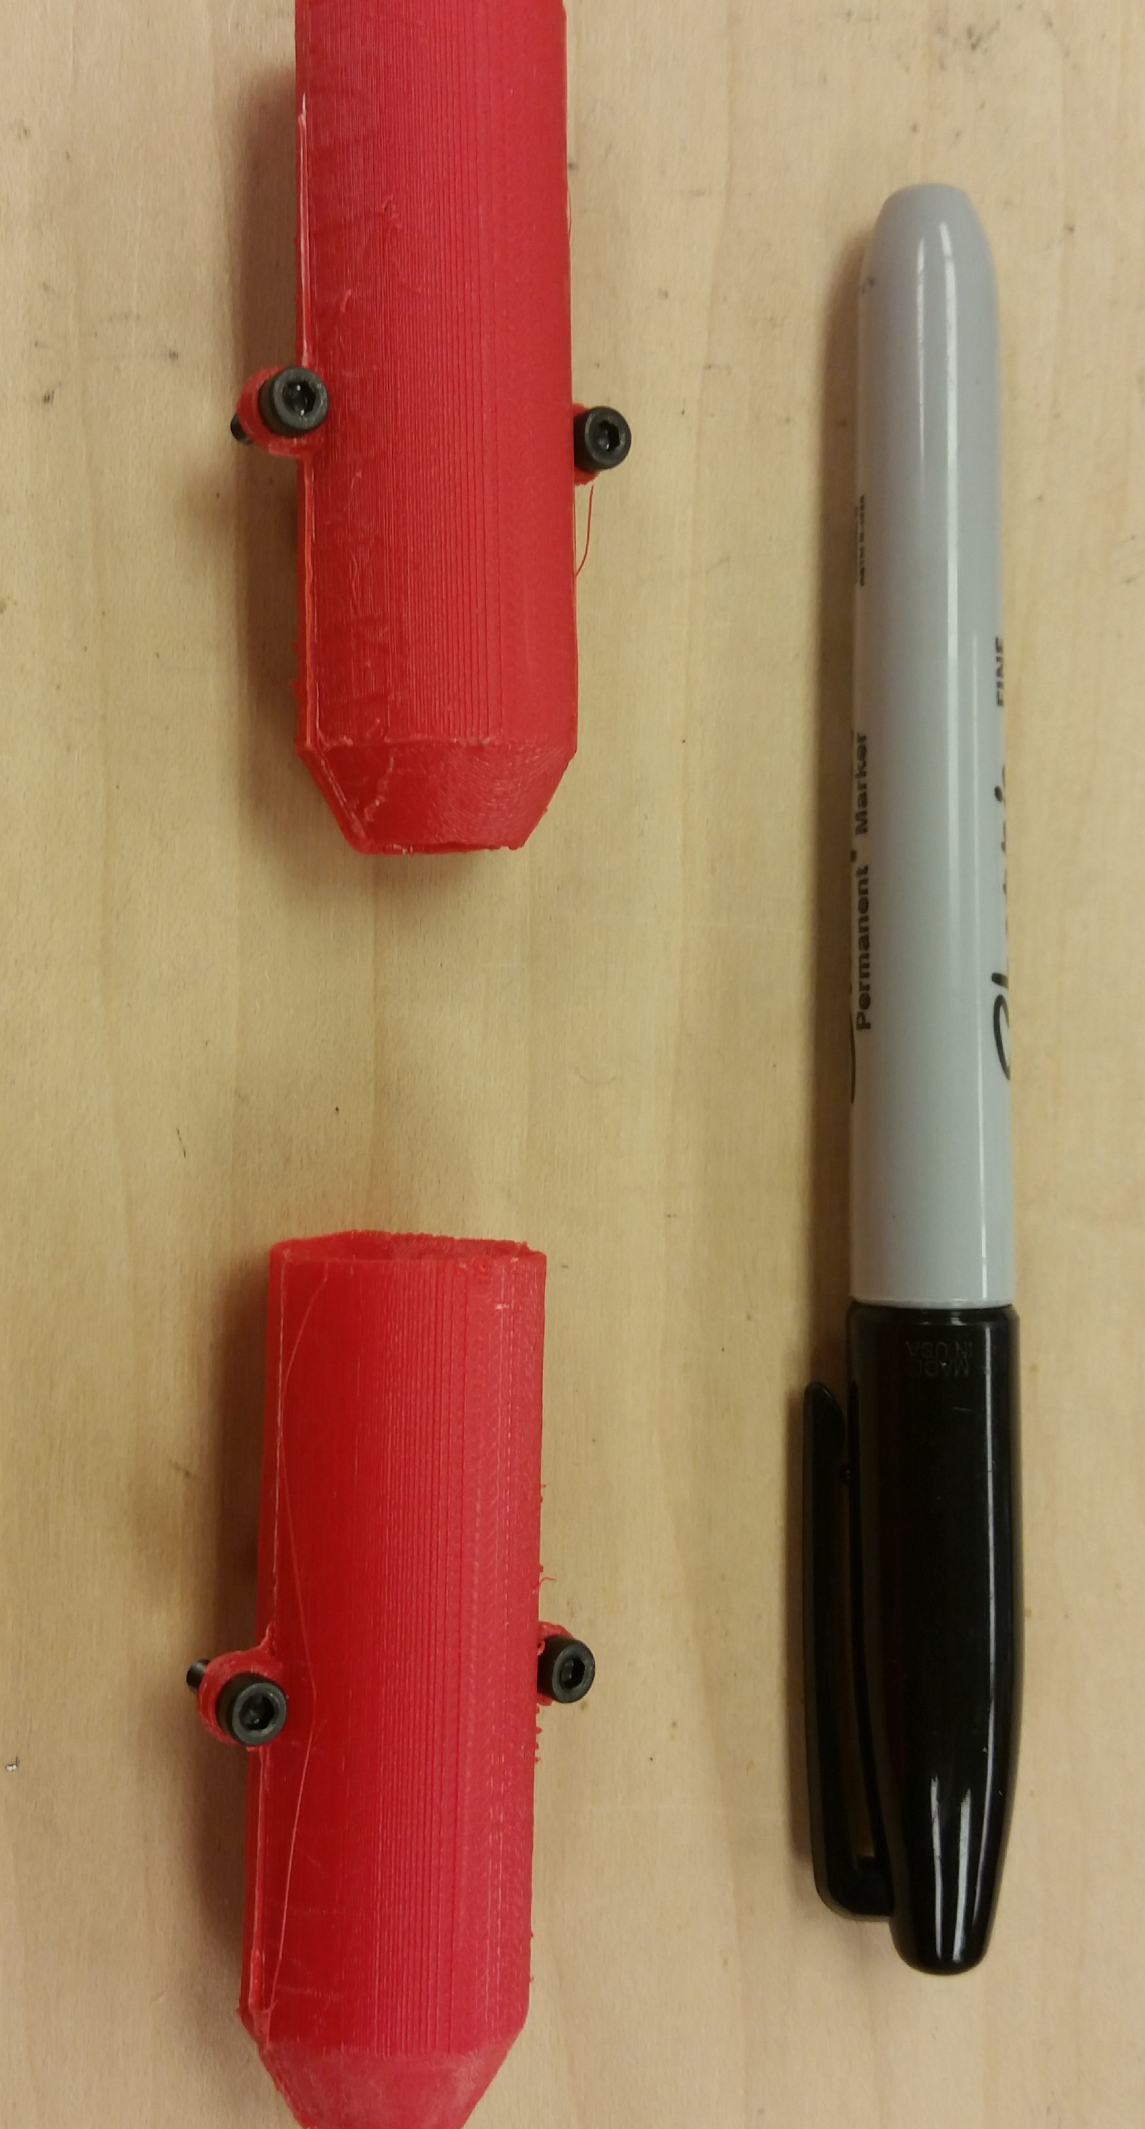

**Figure 1:** 3rd Gauss Gun prototype, note the poor quality of the print.

* 1. Project 2: Watertight modifications
     + In order to make a watertight Gauss Gun prototype, the original prototype was sealed on all edges with two part epoxy. After leaving the epoxied gauss gun stage in water for ten minutes, no water had leaked inside. Epoxy seems like it will be a cheap and sufficient method for sealing the edges of the casing but Javier and I still need to decide how to seal the ends of the stages. We tested the first prototype with a one mm sheet of steel between the two stages and had poor results. We then tested the second prototype with cellophane secured over the openings of each stage and found that it functioned the same as without the cellophane, however the cellophane gets worn down easily and is very susceptible to ripping. Our next test will be to use a thinner sheet of steel and/or aluminum to cap the ends of the gauss gun stages, we have already purchased thin sheets of galvanized steel from home depot for this purpose. Something we would like to determine is if the caps being a magnetic material improves or lowers the performance of the gauss guns.

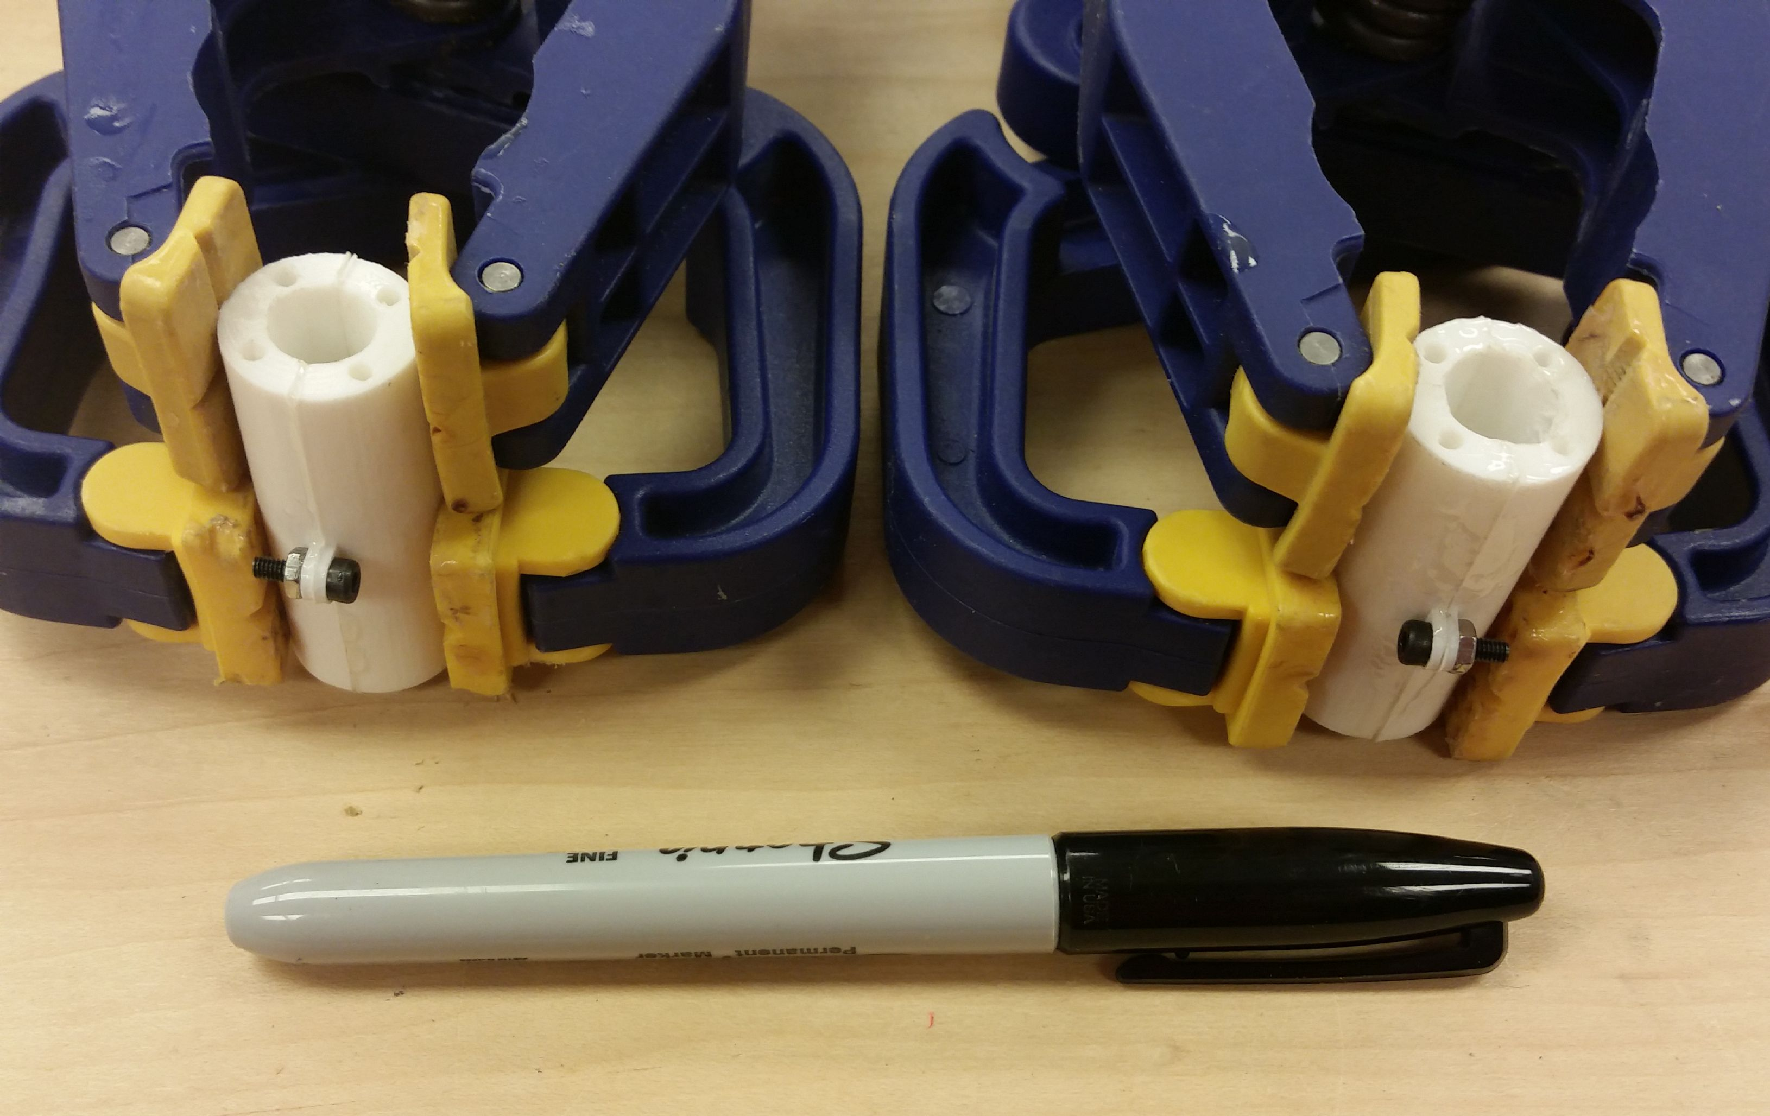

**Figure 2:** 1st Gauss Gun prototype being epoxied.

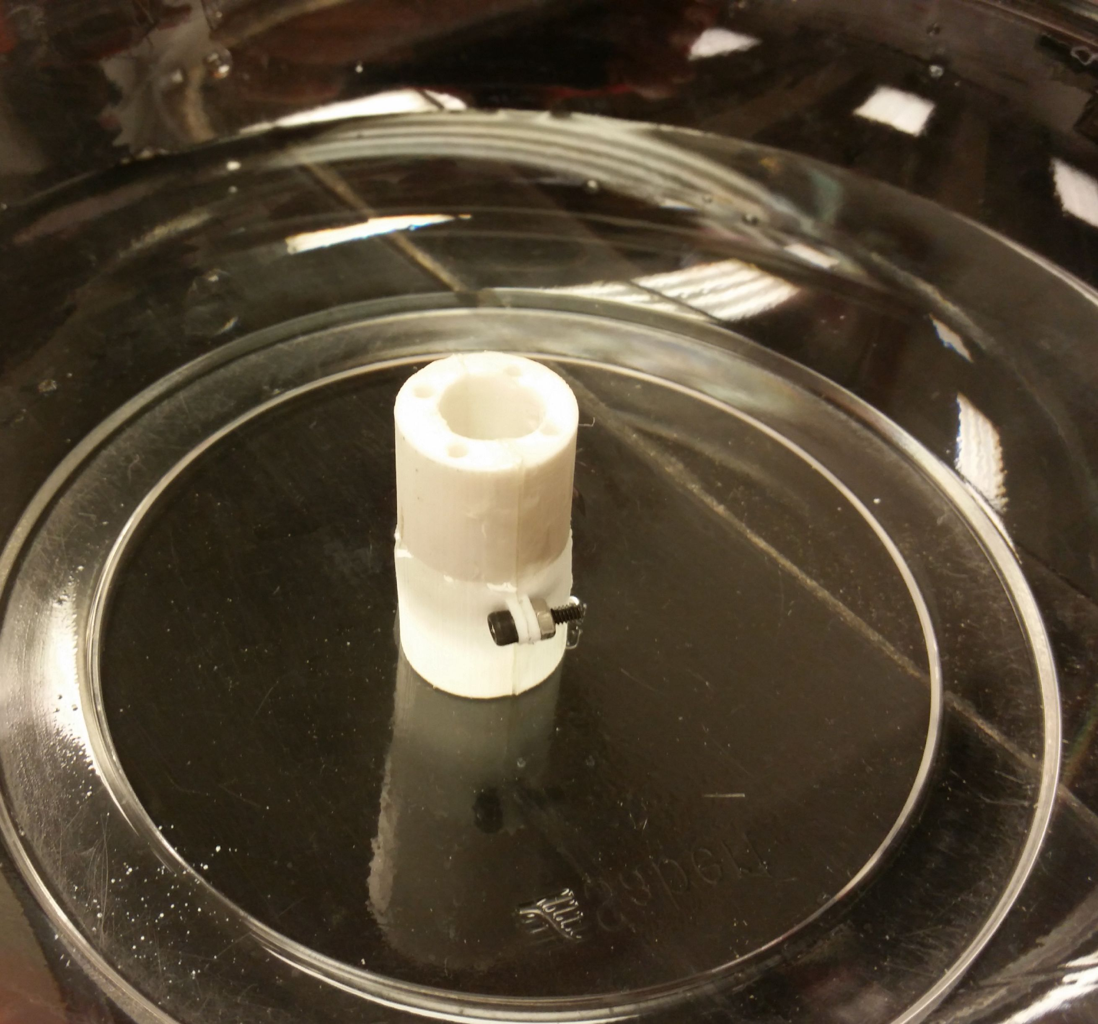

**Figure 3:** Newly sealed Gauss Gun being tested for water resistance.

1. **My *Goals* for next week**

* Test Gauss Gun with metal caps and perform experiment to determine if magnetic caps are better or worse.
* Test a good print of the 3rd prototype and possibly make it watertight.
* Modify the 2nd prototype so that the magnet is not pulled out of the second stage and retest it.
* Help Ashwin and Julien with tip prototypes if necessary.

1. **What I need Dr. Becker to do:**