The purpose of a weekly report is to: (1) give you text and images for your papers, thesis, and dissertation, (2) document progress, (3) identify if you are stuck or need resources.

Weekly report

1. **My *Goals* from last week**

* Hand Design Logarithmic Factory
* Write a program for the Logarithmic Factory
* Read the comments/questions received for the submission to RA-L
* Think about the paper I would present for the lab weekly meeting on 14th June

1. **My *Accomplishments* this week**
   1. I’ve hand designed the logarithmic factory. I’ve also learned to do this in Sublime

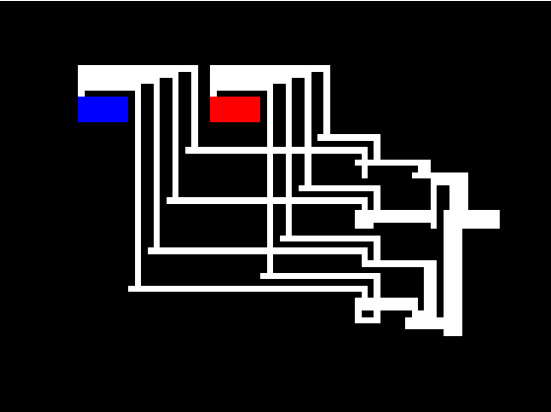

* 1. We discussed about programming the logarithmic factory in my weekly meeting on Friday. I would need a matrix for each stage of the factory; That matrix will contain the coordinates of the tiles to be joined and the direction from which we want to assemble them.

To make the logarithmic factory layout I would need to write programs for:

Each of the four directions

The two hoppers

Concatenation of the sub-assemblies

I’m working on it. So far, I’ve written a program for the hoppers and I’ll update on my progress in my weekly meeting.

* 1. I have read through the comments/questions received for the Assembly paper we submitted. However, I would like to discuss the changes before I implement them in the paper. I have put all the reviews in one document and separated the ones related to micro-scale.
  2. I’ve read two papers which I could present but I’m considering the paper titled: **Automated Micro-Assembly Sequence Planning with Sub-Assemblies.** The paper is primarily concerned with sequence planning of micro-assemblies. It presents an expansion of Breakout Local Search algorithm to generate sub-assemblies which can then be assembled together to achieve an optimized solution.

1. **My *Goals* for next week**
   1. Meeting with Dr. Becker on <2nd June 2017 at 10:00 am>
   2. To continue writing the program for logarithmic factory
   3. To make changes to the Assembly paper and submit the final version