Weekly reports are to be emailed to atbecker@uh.edu by 5:00pm on Wednesdays. The purpose of a weekly report is to: (1) give you text and images for your papers, thesis, and dissertation, (2) document progress, (3) identify if you are stuck or need resources.

Weekly report

1. **My *Goals* from last week**

* Assemble the new Open ROV kit.

1. **My *Accomplishments* this week**
   1. Project 1: Replace the thrusters on old ROV kit.

* Javier and I removed the old thrusters from the old Open ROV kit, tested each of the new Blue Robotics thrusters to ensure they functioned properly, wired them to the ROV, retested them, water proofed the new connections and mounted the thrusters onto the ROV chassis.

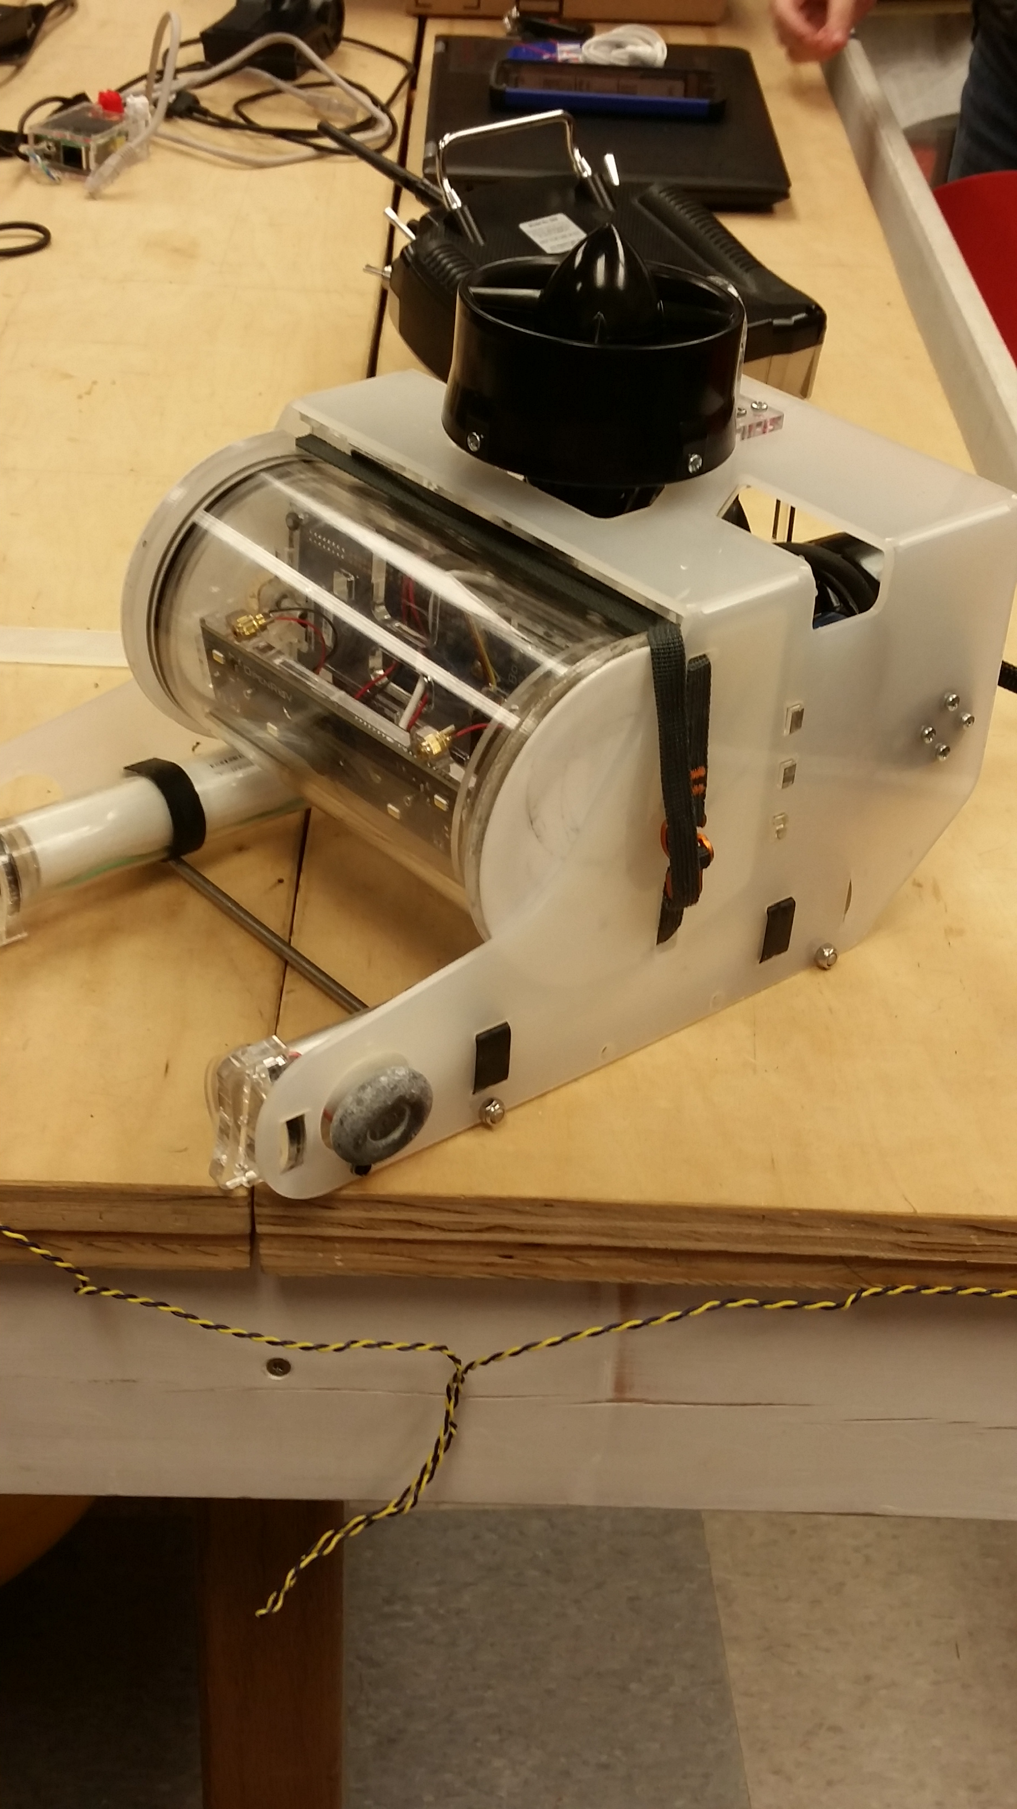

**Figure 1:** Old ROV kit with upgraded thrusters wired and mounted.

* 1. Project 2: Assembled the new Open ROV kit.
     + Austin, Javier and I cracked open the freshly shipped Open ROV kit and followed the instruction manual to assemble over a few days. There were a few small hiccups along the way but we completed the assembly and tested all of the components, now it just need to be tested in water.

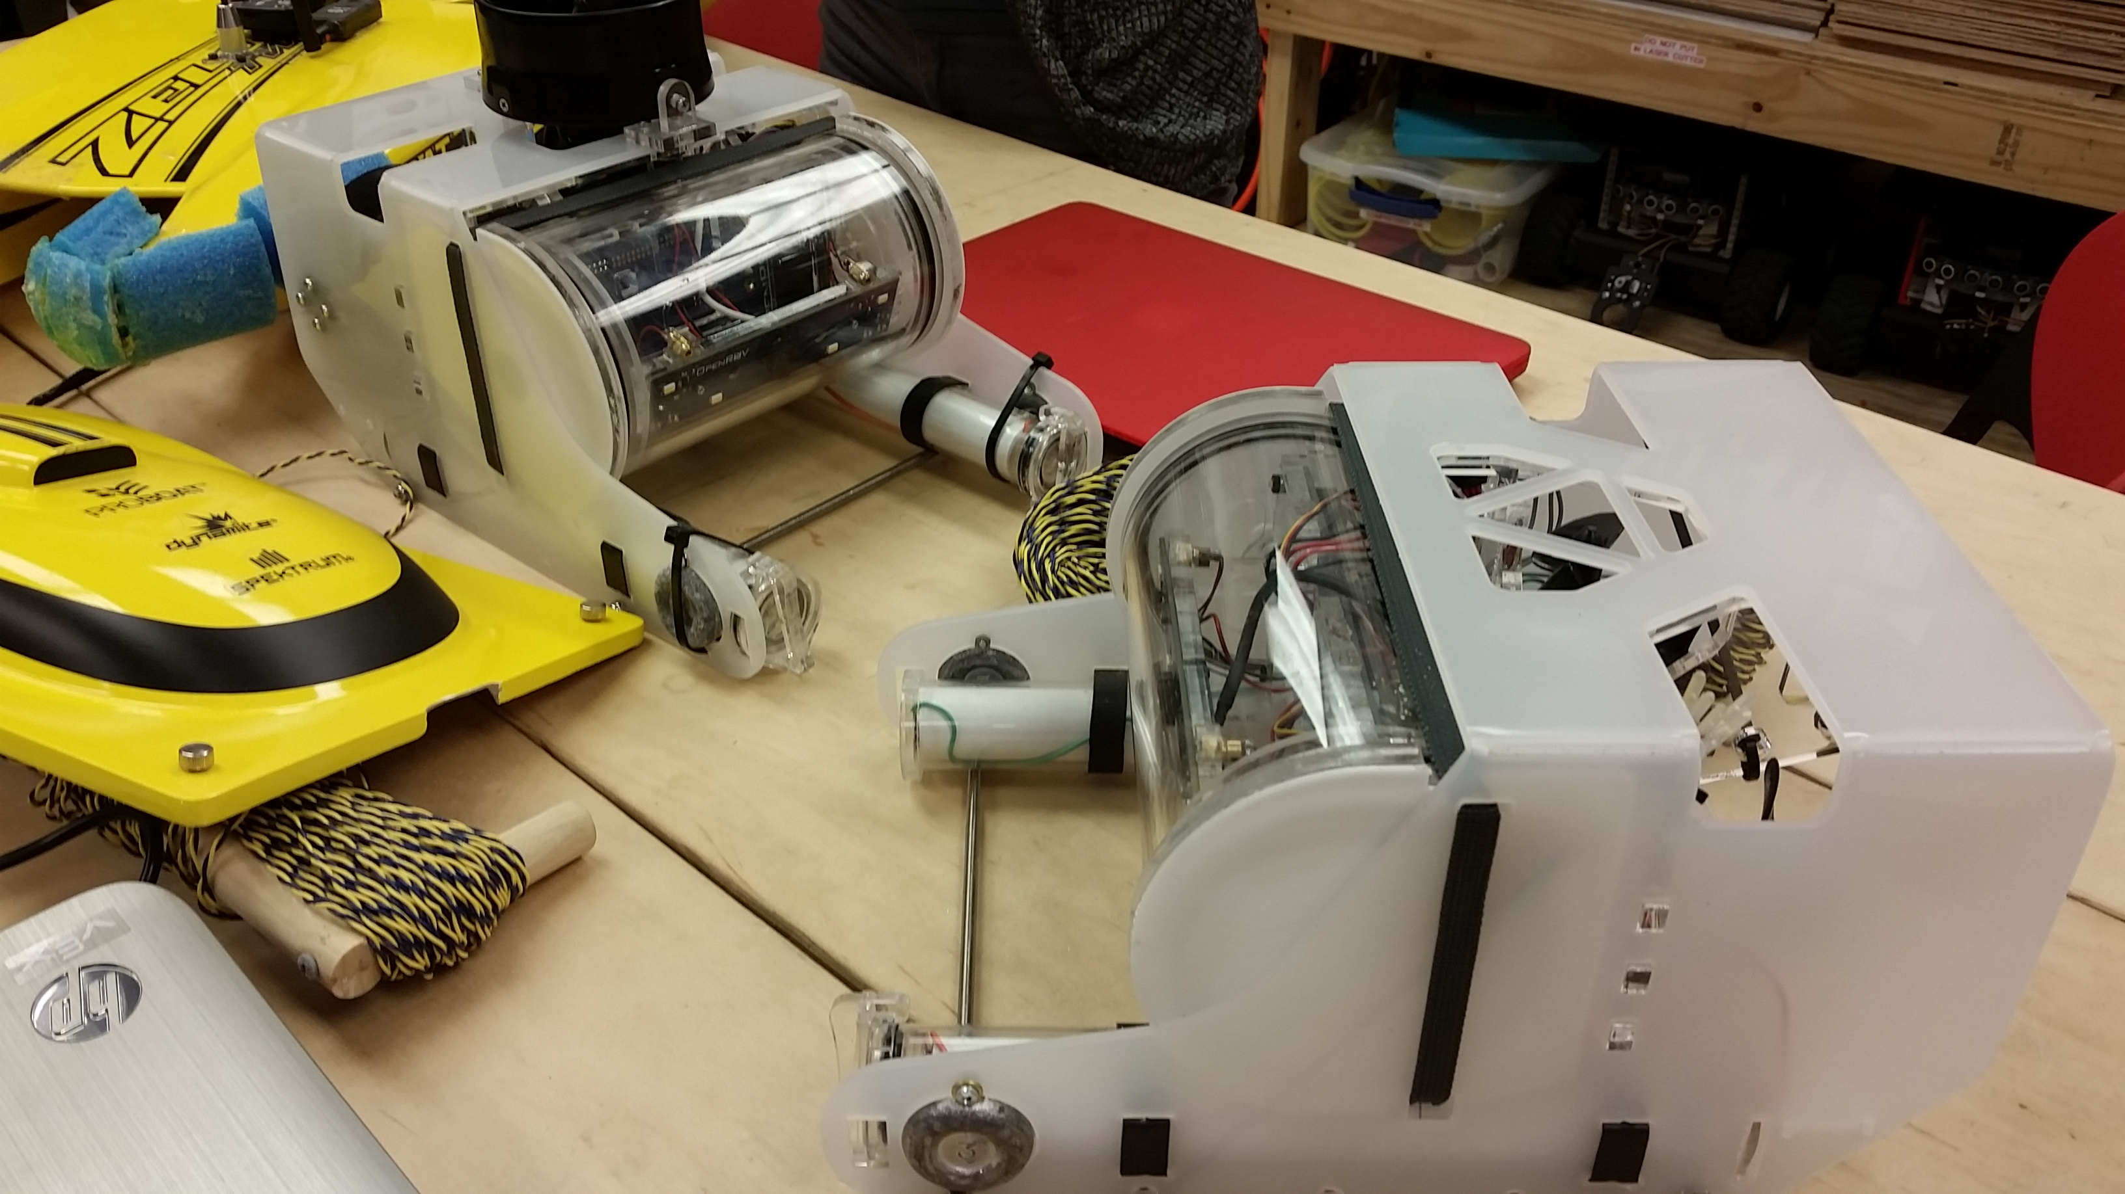

**Figure 2:** Two Open ROV kits, one with thruster upgrades one is stock.

1. **My *Goals* for next week**

* Perform a comparison test between the new ROV thrusters and the old ROV thrusters.
* Prototype deployment mechanisms for the ROV sensor modules.
* Print second prototype of sensor module.

1. **What I need Dr. Becker to do:**

1. **Timesheet:**



Comments:

Week 1: On Monday I was sick, on Tuesday I had a doctor’s appointment and was in a car wreck on the way to said appointment.

Week 2: Monday was a holiday, Tuesday I had a doctor’s appointment and had to pick someone up from the airport at 4.