Weekly reports are to be emailed to atbecker@uh.edu by 5:00pm on Wednesdays. The purpose of a weekly report is to: (1) give you text and images for your papers, thesis, and dissertation, (2) document progress, (3) identify if you are stuck or need resources.

Weekly report

1. **My *Goals* from last week**

* Perform a comparison test between the new ROV thrusters and the old ROV thrusters.
* Prototype deployment mechanisms for the ROV sensor modules.
* Print second prototype of sensor module.

1. **My *Accomplishments* this week**
   1. Project 1: Fleet Video

* After several days of recording snippets of the ROVs and RC boat in action, Austin was able to put together a great video to display the functions of our fleet. The process of taking these videos also showed the difference of performance between the new ROV thrusters and the stock thrusters. In my opinion the upgraded thrusters are necessary to navigate any body of water that has even a slight current so we should order another set of them.

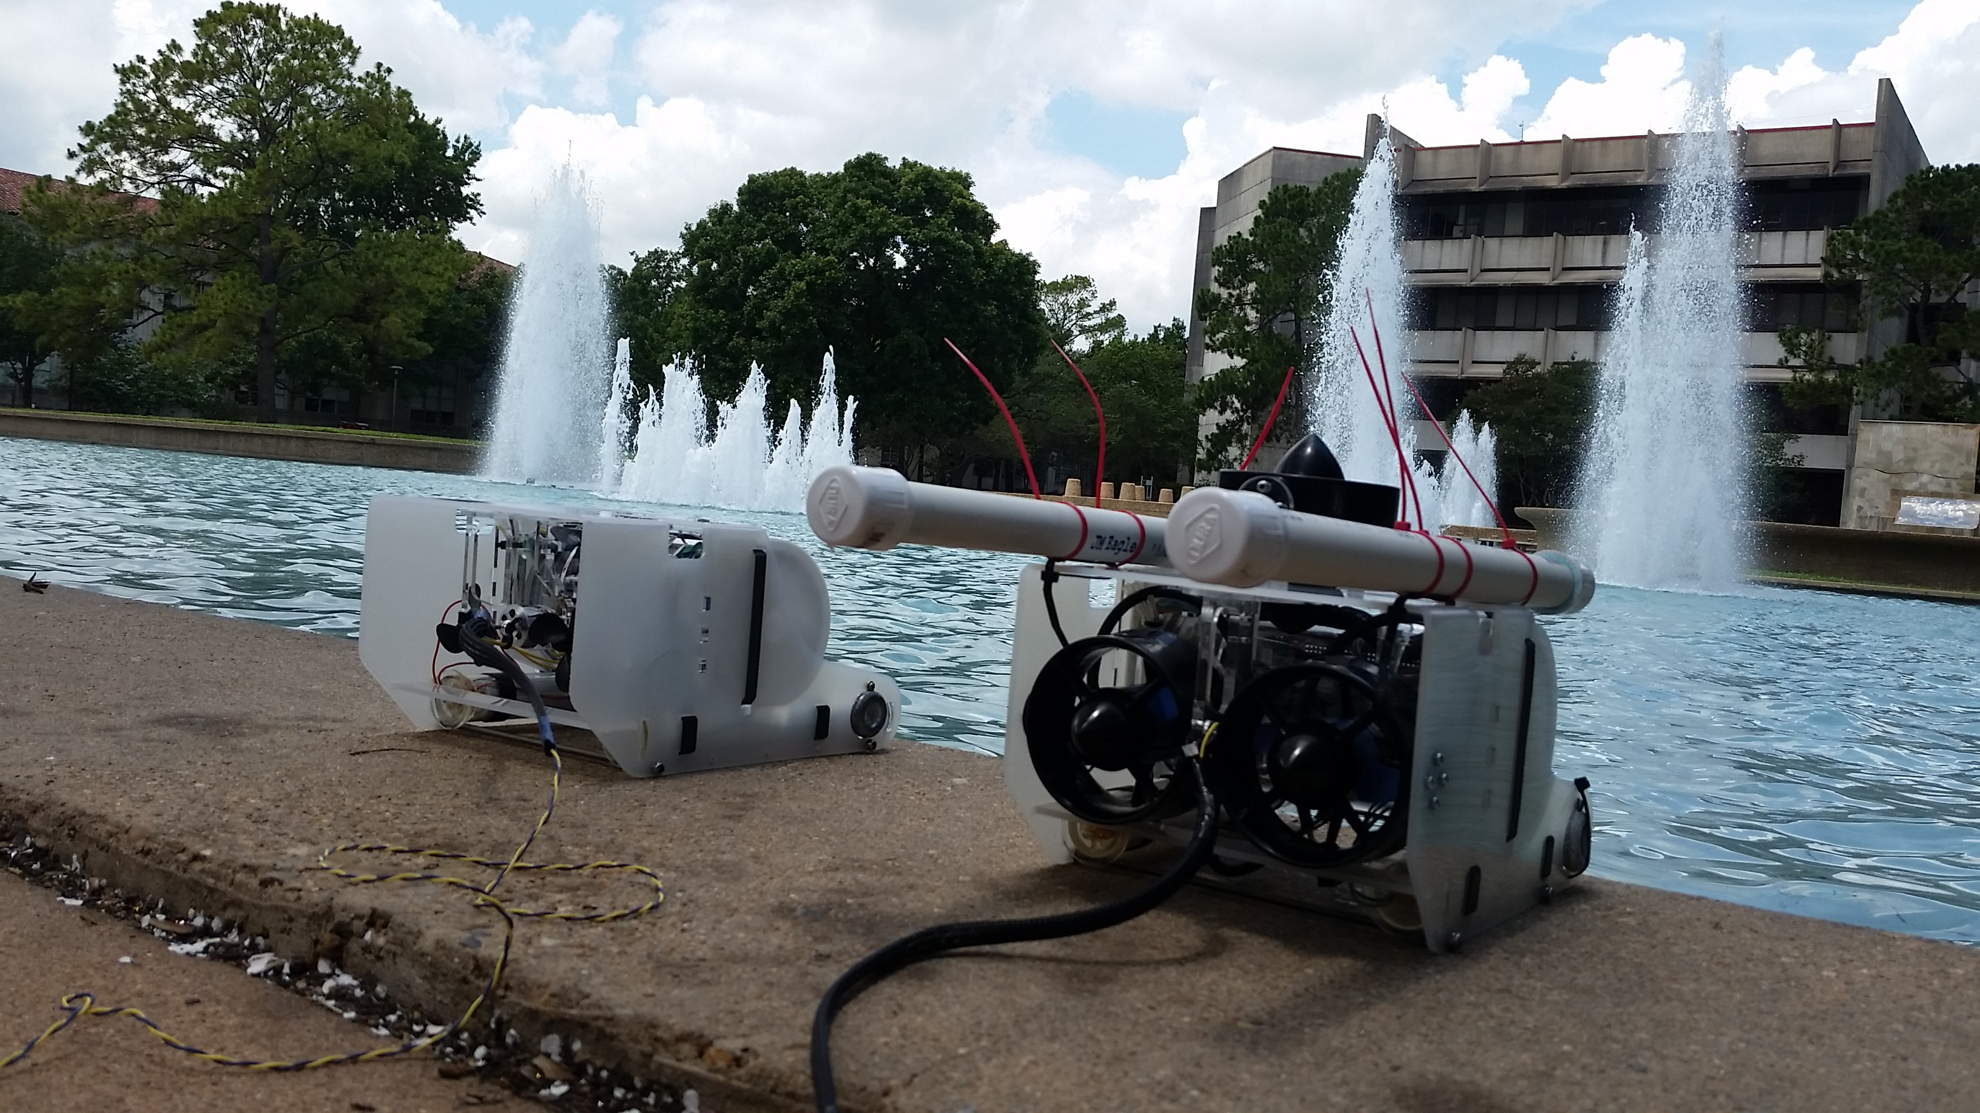

**Figure 1:** ROVs preparing to take a dive in the fountain.

* 1. Project 2: Sensor Module Prototypes
     + The current version of the sensor modules is much smaller than the original design and is a more convenient shape for the ROVs to hold. This sensor module is designed to stay sitting on the bottom of a body of water via its weight and has a small floating ring attached to its top that will be used for easier visual identification and easier retrieval. This design has also allowed us to generate some more efficient designs for the deployment system, of which we will prototype and test at least one in the upcoming week.

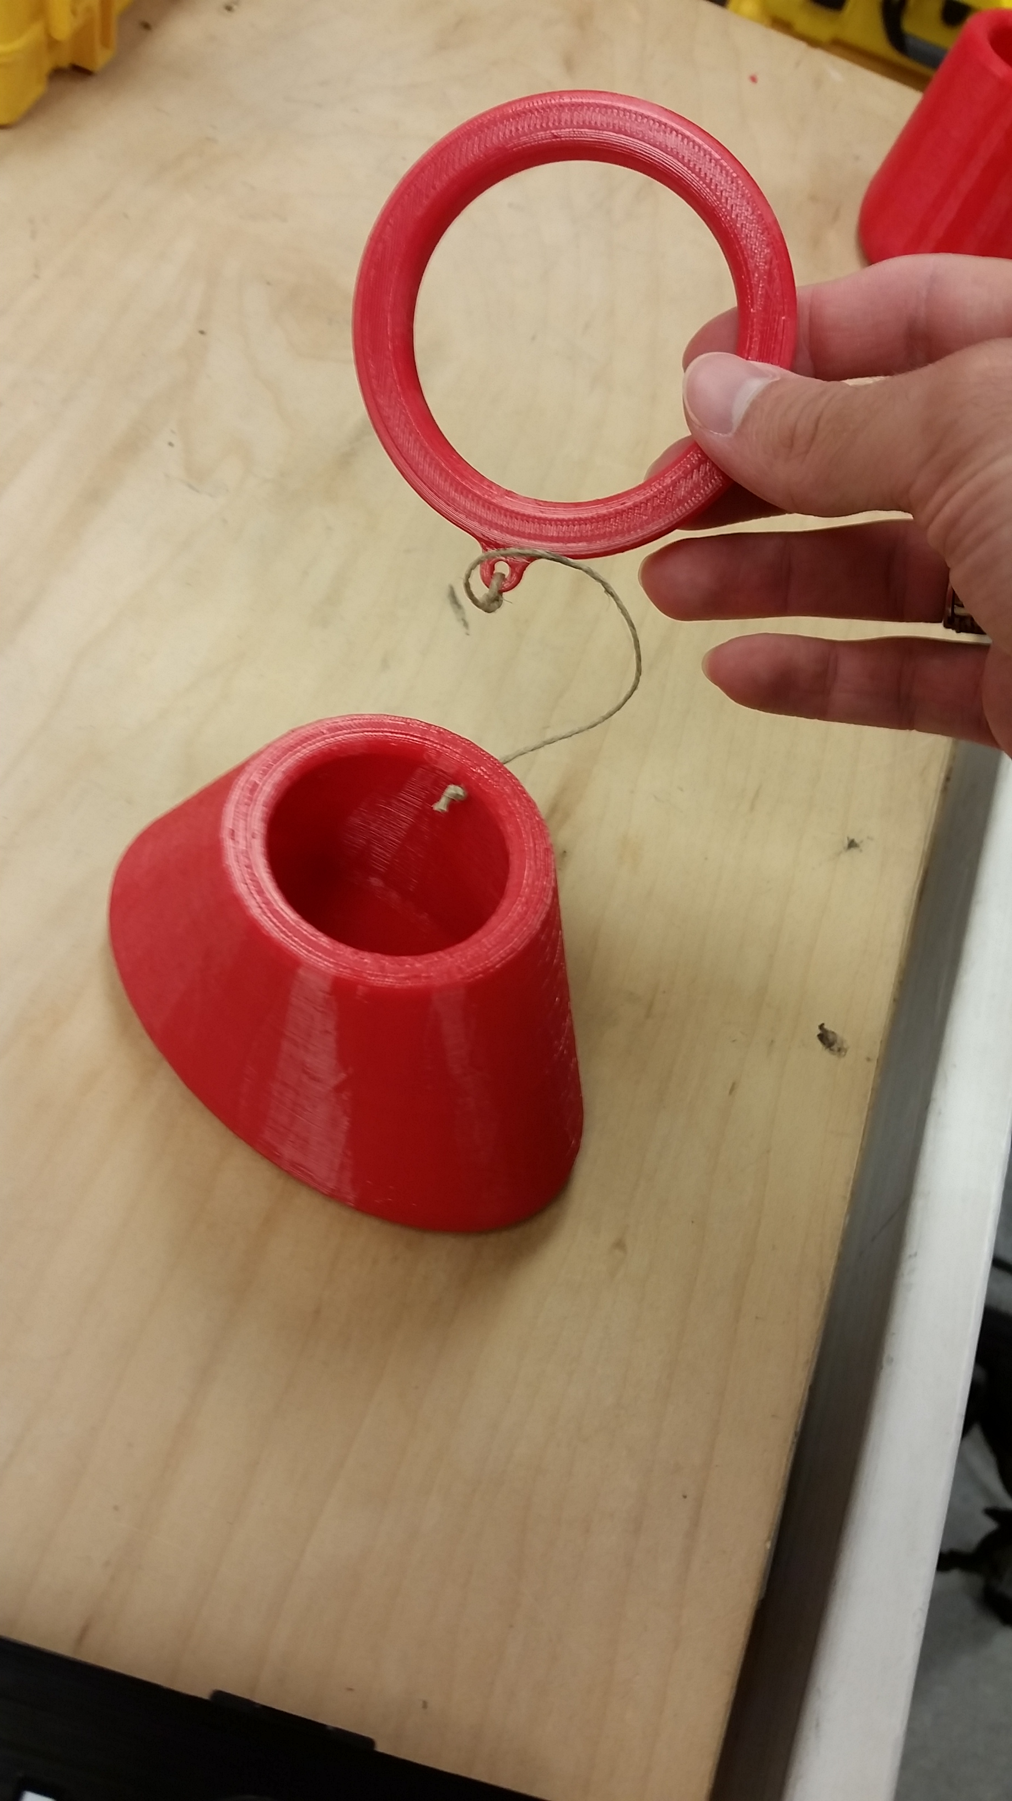

**Figure 2:** Sensor Module Version 2.1

1. **My *Goals* for next week**

* Research implementation of autonomy for the ROVs and surface ship.
* Prototype deployment mechanisms for the ROV sensor modules.

1. **What I need Dr. Becker to do:**

1. **Timesheet:**



Comments: