Weekly reports are to be emailed to atbecker@uh.edu by 5:00pm on Wednesdays. The purpose of a weekly report is to: (1) give you text and images for your papers, thesis, and dissertation, (2) document progress, (3) identify if you are stuck or need resources.

Weekly report

1. **My *Goals* from last week**

* Research implementation of autonomy for the ROVs and surface ship.
* Prototype deployment mechanisms for the ROV sensor modules.

1. **My *Accomplishments* this week**
   1. Project 1: Deployment Mechanism

* This prototype for deploying the sensor modules works similar to a vending machine. The float rings of the sensors will sit on the coil and one end will be controlled by a motor, causing the coil to spin, advancing the sensors down the length of the coil until they fall off the end. While this is not yet attached to the ROV, the proof of concept seems to work quite well and it is a simple design.

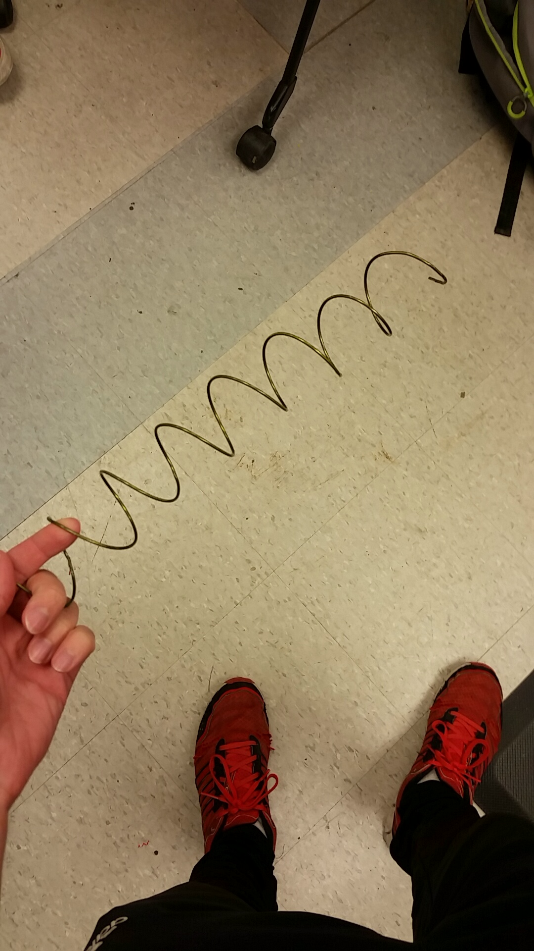

**Figure 1:** Prototype Deployment Mechanism

* 1. Project 2: ROV and Surface Ship Code
     + Javier has taken on the task of digging through the Open ROV code and has been successful in finding how to add and control an extra motor for the deployment mechanism. However, more time will be needed in order to understand how to develop and initialize an autonomous program. Austin has taken on the task of understanding the Pixhawk for the surface ship, but progress has been slow as we don’t have a functional pair of lipo batteries to run the boat with.

1. **My *Goals* for next week**

* Continue researching the code for the ROV and pixhawk
* Attach deployment mechanism to ROV and verify its functionality

1. **What I need Dr. Becker to do:**