Weekly report

1. **My *Goals* from last week**
   * Objective 1: Control an extra servo from the OpenROV cockpit
   * Objective 2: Attach said servo to the deployment mechanism
   * Objective 3: Consider wireless charging of sensor modules
2. **My *Accomplishments* this week**
   1. Objective 1:
      1. After analyzing the OpenROV files I now know how to make plugins and send custom commands from the OpenROV cockpit (I’m making a document with explanations of the process)
      2. Attached an extra servo that is controllable with a different set of keyboard keys than any other plugin. Below is a video demonstrating the success

<https://drive.google.com/open?id=0BxTOLOELsYAPenBnSDdlR0tOdTA>

* 1. Objective 2:
     1. Designed the frame for the deployment mechanism. Jarrett and I just put it together and attached it to the ROV. The sensor modules will hang from the coil, and move forward as the coil rotates. Figure 1 shows the current look of the modified OpenROV, and there’s also a video of the deployment in action.

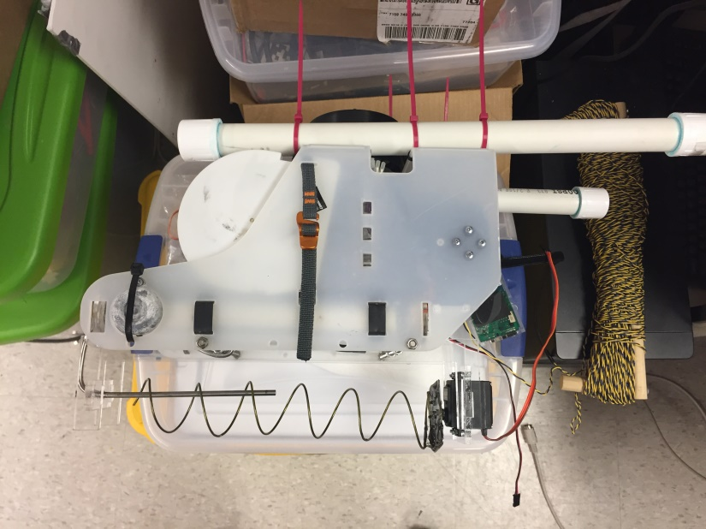

Figure 1. OpenROV with deployment mechanism attached

<https://drive.google.com/open?id=0BxTOLOELsYAPUTlwU04zZi1wTVE>

* + 1. We tested the servo underwater after spraying it with CorrosionX and it seems to work perfectly fine

1. Objective 3: We tested the wireless charging underwater and it worked well

<https://drive.google.com/open?id=0BxTOLOELsYAPU0lrRWhIaGRrUWc>

1. Miscellaneous: Figure 2 shows the fish made out of PVA. Jarrett made a video showing it dissolve in water

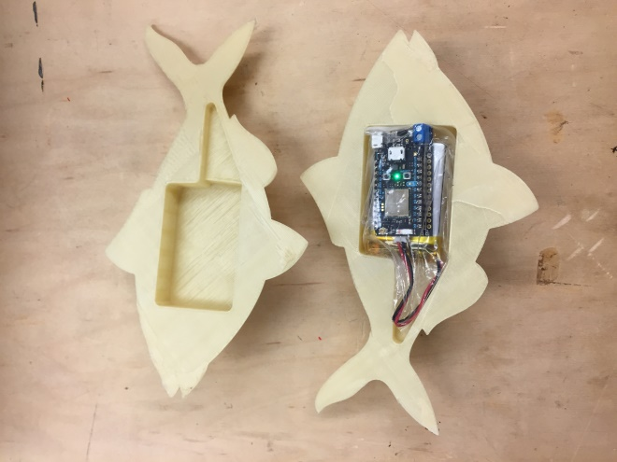

Figure 2. Fish-shaped casing made out of PVA. Inside there’s a Photon board and a battery

1. **My *Goals* for next week**
   * Test deployment mechanism underwater

* Redesign and attach retrieval mechanism
* Design wireless charging mechanism, and modify sensor modules accordingly
* Find a paper to present for next week’s meeting

1. **What I need Dr. Becker to do:**
   * Recommend papers to present