Weekly reports are to be emailed to atbecker@uh.edu by 5:00pm on Wednesdays. The purpose of a weekly report is to: (1) give you text and images for your papers, thesis, and dissertation, (2) document progress, (3) identify if you are stuck or need resources.

Weekly report

1. **My *Goals* from last week**

* Continue researching the code for the ROV and pixhawk.
* Attach deployment mechanism to ROV and verify its functionality.

1. **My *Accomplishments* this week**
   1. Project 1: Water Proofed Deployment Mechanism

* The coil that is to be used as the sensor module deployment mechanism has been attached to a servo motor and this motor has been treated with Corrosion X which prevents rusting and allows electronics to continue functioning in water. We then tested the servo and coil by running it while submerged in water and it worked continuously for several minutes with no issue. The only thing left to cover as far as water proofing this system is to more permanently wire it to the ROV microcontroller and ensure that this is connection is water proofed.

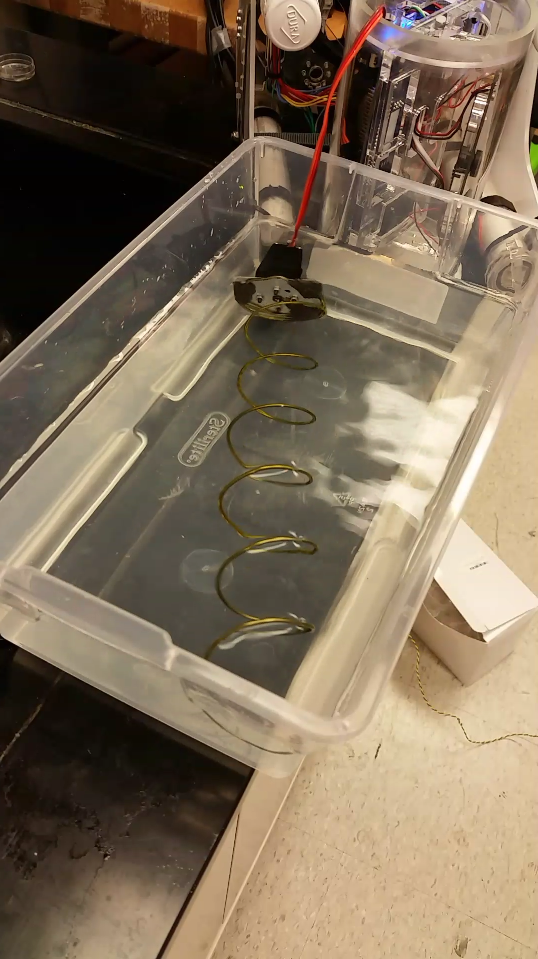

**Figure 1:** Deployment Mechanism Operating in Water

* 1. Project 2: Attached Deployment Mechanism
     + After water proofing the deployment mechanism, Javier and I mounted it to the undercarriage of the ROV with some laser cut pieces and a steel rod for additional support of the coil’s free end. The entire deployment mechanism is attached by nuts to the two screw threads on the bottom of the ROV and can be easily removed for repairs, replacement or if the ROV needs to perform a different task. Some of the mounting assembly is still drying but the mechanism should be ready for a full test by tomorrow afternoon.

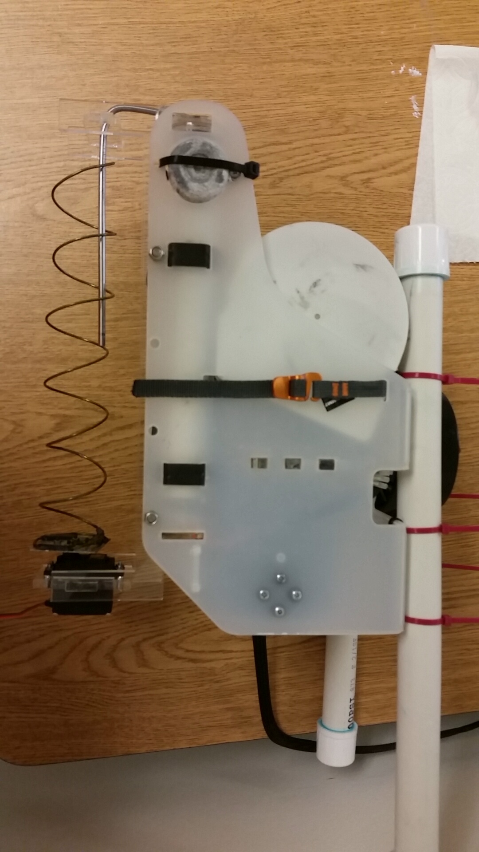

**Figure 2:** ROV with Deployment Mechanism Fully Mounted

1. **My *Goals* for next week**

* Test the deployment mechanism in the fountain.
* Redesign and mount the sensor module retrieval mechanism.
* Begin designing wireless charging system for the ROV.

1. **What I need Dr. Becker to do:**