Weekly Report

My goals from last week:
- Debug example code from https://ramsrigoutham.com/2012/11/22/panorama-image-stitching-in-opencv/ (Not exactly what I want, but still useful.)
- Stitch together a bunch of images iteratively using example code.
- Correspondence problem
- SIFT feature correspondence
- RANSAC

My accomplishments this week:
- Transformed images to give a top down view.
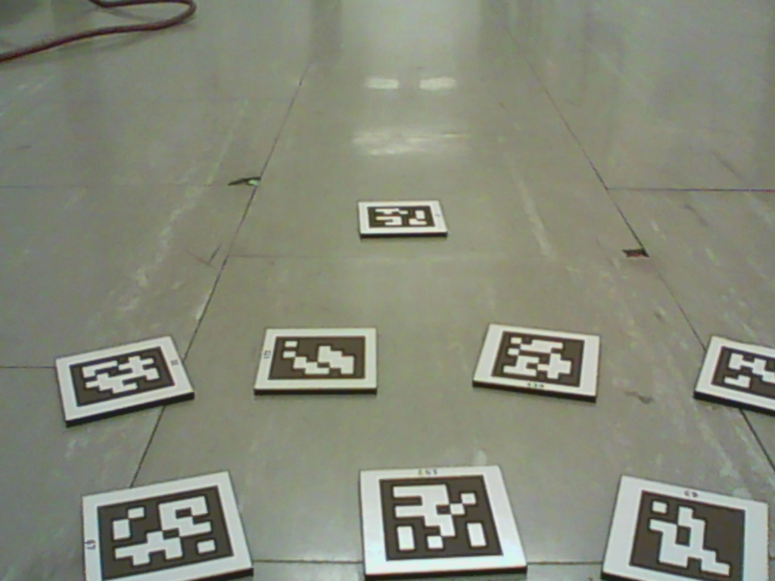
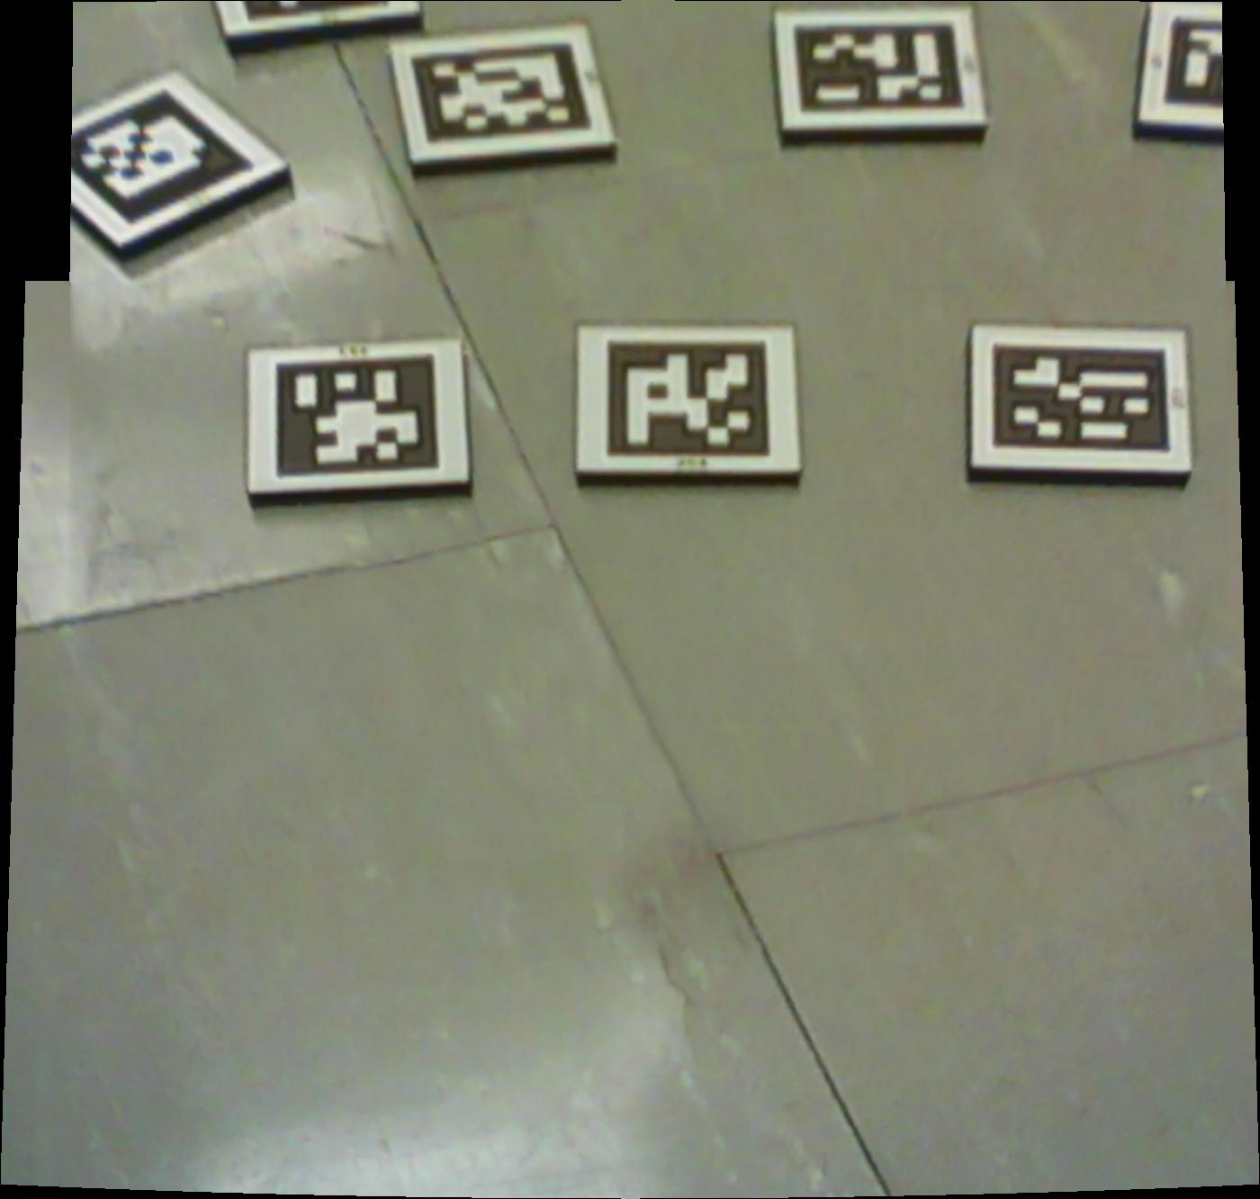
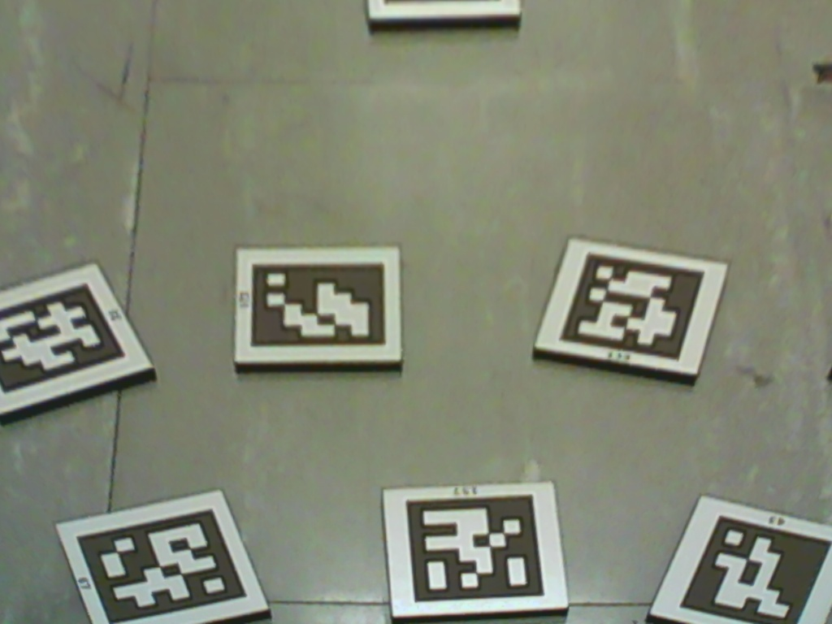

My goals for next week:
- Stitch stitch stitch!
- Sift Features!
- RANSAC!

Dr. Becker needs to:
- Could you delete the repository from GitHub and put it up again. Need to get rid of size limit. https://github.com/RoboticSwarmControl/Swarmathon2016

