Weekly Report

My goals from last week:
- Reverse engineer the Swarmathon code and map out how each file interacts with each other. The documentation isn't detailed enough.
- Fix rover
- Save a bunch of pictures.
- Transform the pictures.

My accomplishments this week:
- Reverse engineered the swarmie code.
- Fixed rover.
- Took a bunch of pictures of rover going straight and rotating (https://github.com/RoboticSwarmControl/Swarmathon2016/tree/master/rawPictures)
- Got source code for image stitching from Dr. Mills
- Got online image stitcher to stitch swarmie photos. (http://matthewalunbrown.com/autostitch/autostitch.html) (http://matthewalunbrown.com/papers/ijcv2007.pdf)
  - Going straight: program failed to stitch. Might need to increase rate of taking pictures.
  - Rotating: program stitched very strangely.

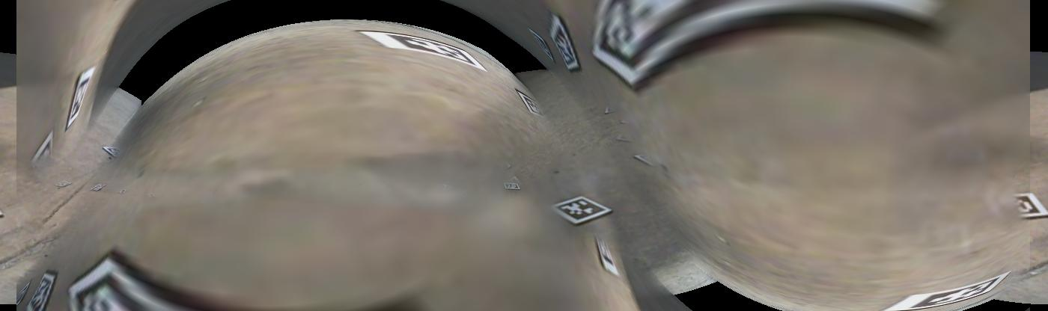
- Manually stitched together images.
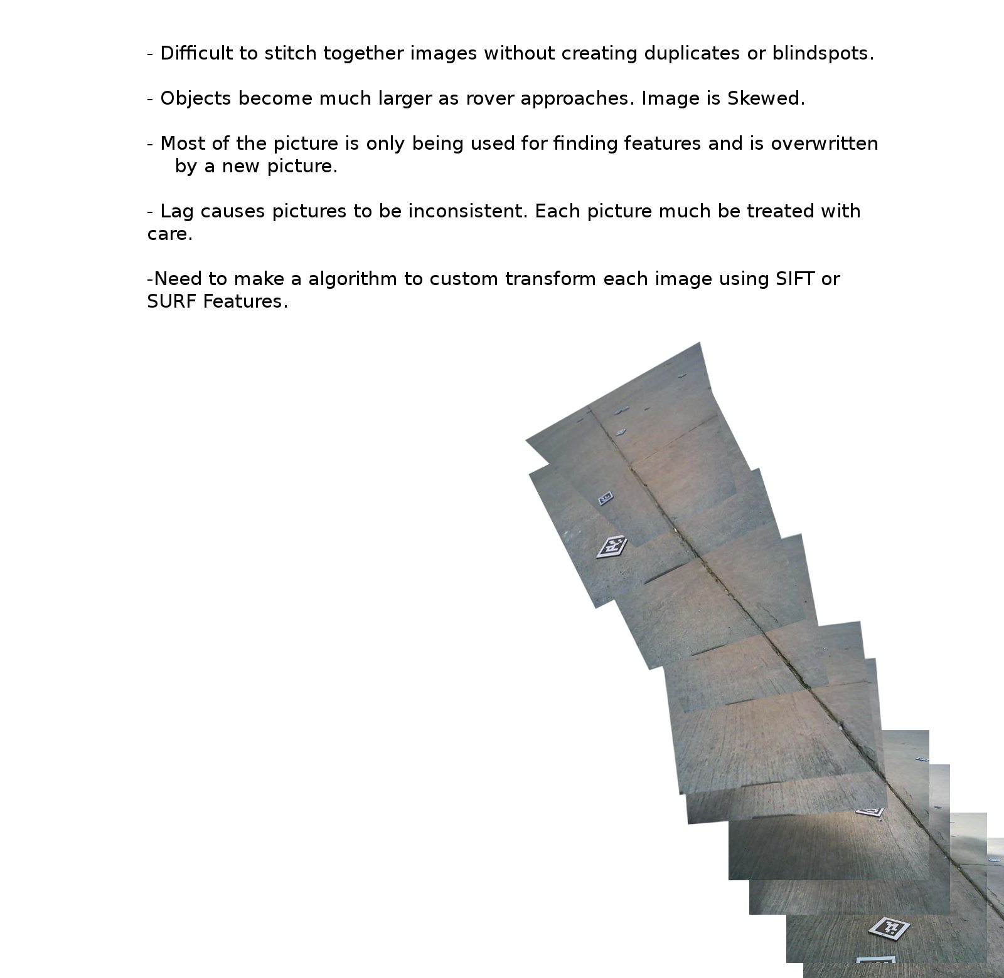
My goals for next week:
- Debug example code from https://ramsrigoutham.com/2012/11/22/panorama-image-stitching-in-opencv/ (Not exactly what I want, but still useful.)
- Stitch together a bunch of images iteratively using example code.
- Correspondence problem
- SIFT feature corrsepondence
- RANSAC

Dr. Becker needs to:
- I'm considering purchasing an image Stitching API/Library from http://www.imagingshop.com/sharpstitch/ I've already contacted them for more info, including pricing, and am awaiting their response.

