Weekly Report

My goals from last week:
- Stitch stitch stitch!
- Sift Features!
- RANSAC!

My accomplishments this week:
- Stitched images (Hit many limitations)

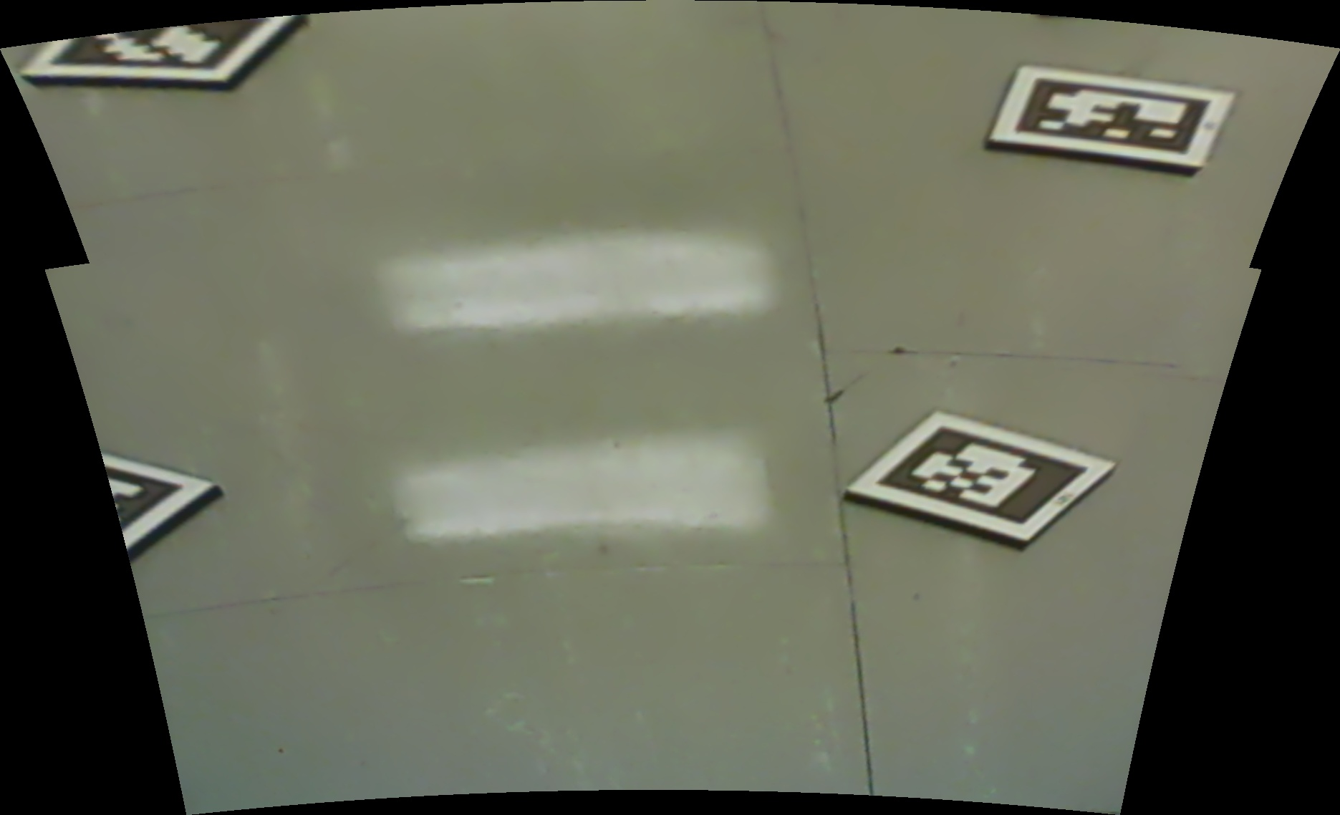

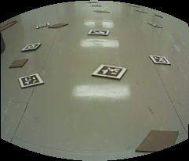

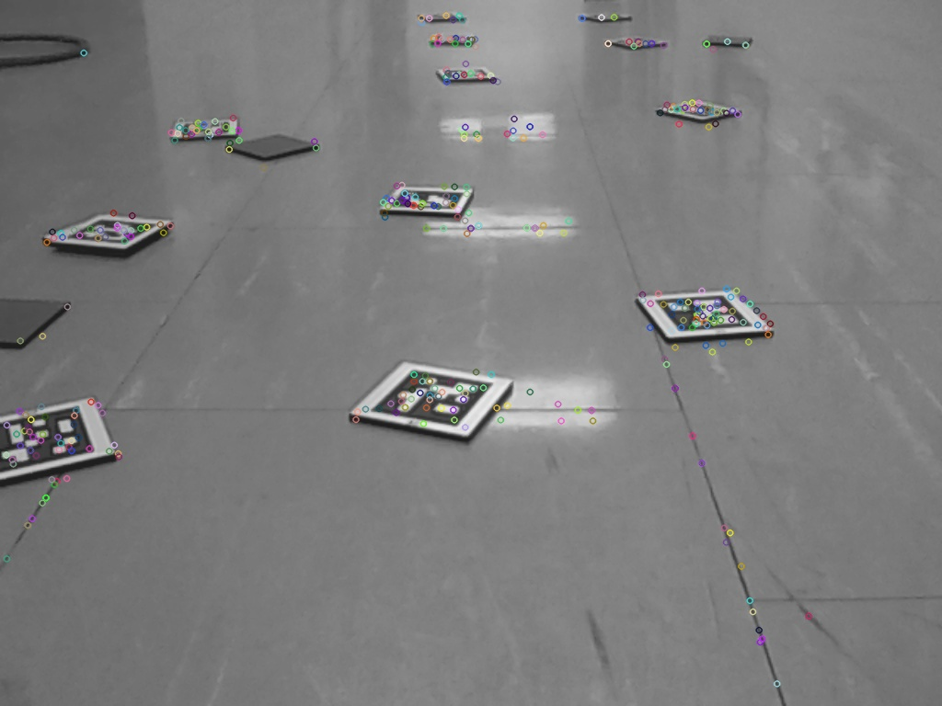

- Finished poster

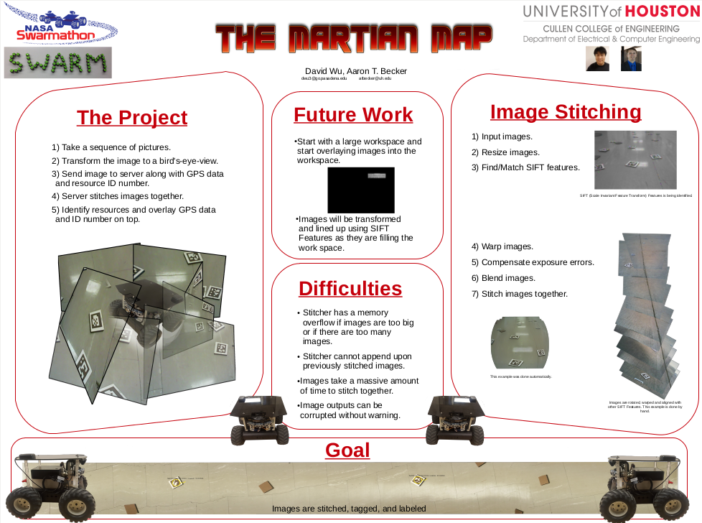

My goals for next week:
- Set up framework for next student.
- Hug everyone goodbye.

Dr. Becker needs to:
- Print out poster
- You can view all my converted previous weekly reports here if you want to look at the pictures.
https://drive.google.com/folderview?id=0B3yB2q_AU3RQUHNleW1Wd2N0bG8&usp=sharing

