A Paper Review about “FicTrac: A visual method for tracking spherical motion and generating fictive animal paths” by Richard J.D. Moore, Gavin J. Taylor, Angelique C. Paulk, Thomas Pearson, Bruno van Swinderen, Mandyam V. Srinivasan

Yu Huang

1. **Goals**

This paper introduces a new approach which is based on the FicTrac (Fictive path Tracking software) to tracking a spherical treadmill motion generated by animals so as to obtain fictive animal paths and then demonstrate the accuracy and robustness of FicTrac outperformers.

1. **Assumptions and Requirements**

Since it is an introduction of assemble the FicTrac system, assumptions are exactly the requirements for the system to work. Firstly, Linux-based operation system is required and the surface map needs to be learned by stitching together frame-by-frame views of the sphere over time. As for the pattern required, the scheme may be composed of any two-color pattern and more importantly, the ball pattern must be non-repetitive which means each view of the ball must be distinct. Besides, there is also an optional assumption for the consideration of simplification, that is to require virtual camera model with a principal axis directly aligned with the apparent center of the track ball in the input ROI as to solve the distance d:

$d=\hat{l_{z}}±\sqrt{{\hat{i_{z}}}^{2}-1+r^{2}}$ [1]

1. **Limitations**



Fig.1. Diagram of the principle of the motion capturing system FicTrac. Rotation of the ball detected on the camera`s coordinates can be transposed to the animal`s coordinates. [1]

This paper exhibited experimental data to show the advantage of the FicTrac have over the standard optical mouse-based approach. In ground truth test, the FicTrac`s average angular error was 0.67°, or 0.02% of the total rotation which cannot be achieved by the optical mouse system. Additionally, the authors also used the measurement of animal behavior to further compare the FicTrac with the optical mouse system. The result generally showed that the FicTrac can capture the movement of animal whereas the measurement from the optical mouse system substantially diverged from the result obtained by FicTrac and then the paper further proved the versatility of the FicTrac by conducting the closed-loop visual fixation experiments on both the honeybee and the fruit fly. The results demonstrated that “that FicTrac was capable of accurately recording the instantaneous motions of a tethered animal under real experimental conditions and that these measurements were accurate enough for the system to faithfully represent the fictive 2D path of the animal” [1].

However, as the paper pointed out, there are still limitations of the FicTrac system. Firstly, the FicTrac requires the track ball to be textured with a high-contrast pattern and “the temporal frequency and latency of FicTrac’s estimates for the orientation of the sphere and the motion of the animal are typically limited by the frame rate of the camera”.

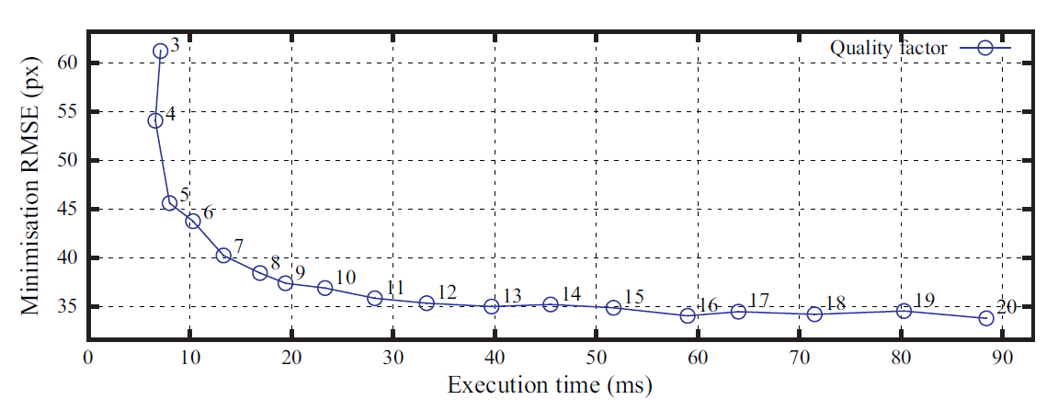

Fig. 2. [1] Exactly, execution time increases exponentially with the tracking ROI resolution.

Reference

[1] Richard J.D. Moore, Gavin J. Taylor, Angelique C. Paulk, Thomas Pearson, Bruno van Swinderen, Mandyam V. Srinivasan, “FicTrac: A visual method for tracking spherical motion and generating fictive animal paths”, Journal of Neuroscience Methods 225 (2014) 106–119