Instructions

- Download and install anaconda3 from given link(ignore step 1,3 if you already done )
- link :https://www.filehorse.com/download-anaconda-64/download/

Make sure that like given in the image below, check first three checkboxes
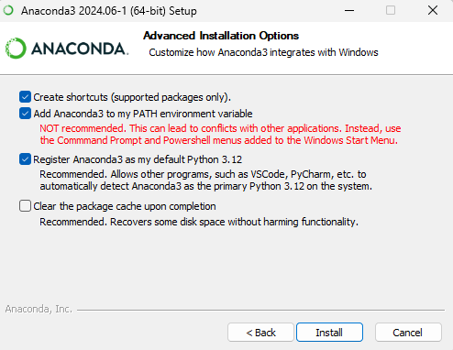
- Extract “Echovox_fullcode.rar” file in a folder
- Extract “lipread_env.rar” file to location C->users->user(it may be vary based on your system)->anaconda3->envs
- Open anaconda prompt and navigate to Echovox_fullcode/echovox folder using ‘cd’
Command
- Run command: activate lipread_env
- Run command: python manage.py runserver

