1. Initial phase --characterize fully the data needs of the prospective database users.

Second phase --choosing a data model•Applying the concepts of the chosen data model•Translating these requirements into a conceptual schema of the database.•A fully developed conceptual schema indicates the functional requirements of the enterprise. ▪Describe the kinds of operations (or transactions) that will be performed on the data.

Final Phase --Moving from an abstract data model to the implementation of the database•Logical Design –Deciding on the database schema. ▪Database design requires that we find a “good” collection of relation schemas.▪Business decision –What attributes should we record in the database?▪Computer Science decision –What relation schemas should we have and how should the attributes be distributed among the various relation schemas?•Physical Design –Deciding on the physical layout of the database

1. A)Student

Age

Name

First_Name

Second_Name

Average_GPA

Hobbies[0..*]

B)University

Name

Address

Country

City

Course

Id

Name

Teacher.id[0..*]

Dormitory

Address

Slots

Price

Singleroom

Doubleroom

Triplerool

Quaripleroom

University_Name

Teacher

Id

Name

First_Name

Second_Name

Age

Birthdate

University_Name

Office of registrar

Number

Worker[0..*]

Average_time_of_accepting_call

University_Name

3)

One to many

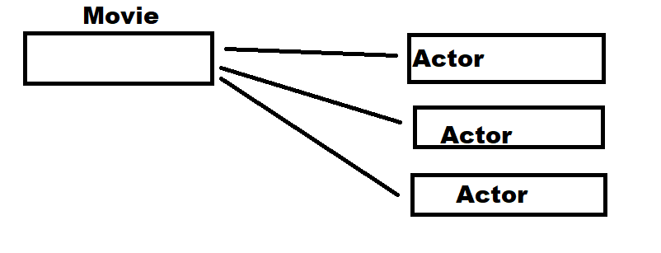

One to one

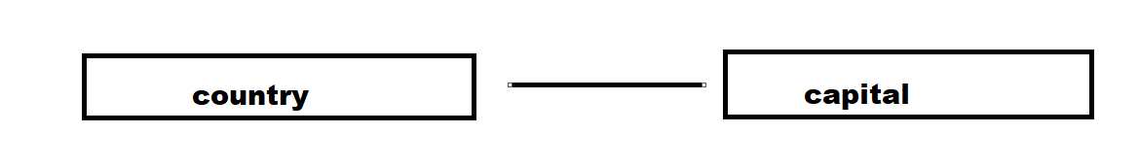

Many to one

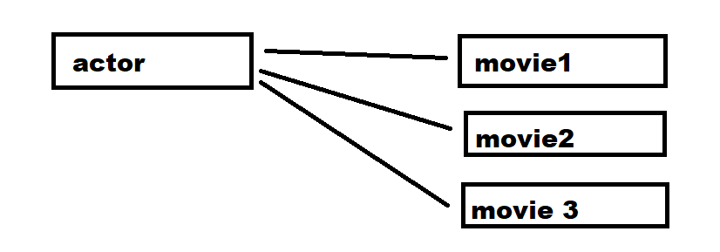

Many to many

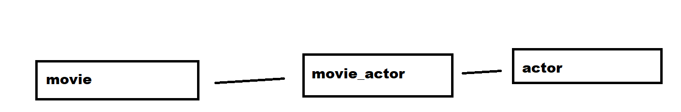

4)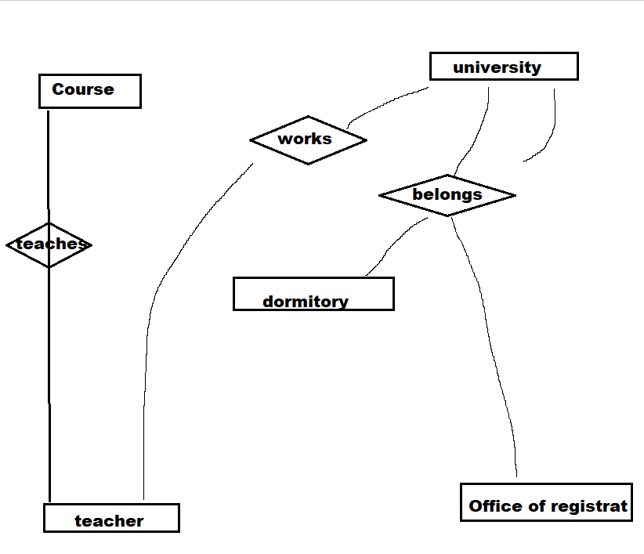

5)

