**Tracking Nope: A Critical Genre Studies Approach for Studying New Media Rhetorics of Resistance**

**Introduction**

Since Shepard Fairey’s *Hope* poster came onto the political scene in 2008, thousands of Obamicons have generated commentary about political leaders all over the world. From [Leopoldo Lopez](https://www.theatlantic.com/international/archive/2017/02/trump-venezuela-maduro-lopez-tintori/517128/) in Venezuela to [David Cameron](https://www.thedrum.com/news/2015/05/15/guerrilla-bus-ad-subverts-obama-s-hope-poster-showing-david-cameron-sucking-gun) in the UK to [Narendra Modi](https://www.thewrap.com/daily-show-jon-stewart-india-narendra-modi-democalypse/) in India, such remixes have surfaced to, among other actions, demonstrate support, incite action, and launch biting, yet often humorous critiques. Donald Trump, as one might suspect, has not been left out of this rhetorical play. In fact, iconographic tracking discloses that of all the politicians besides Obama, Trump has most often been targeted in the style of Obama Hope.

In *Still Life with Rhetoric,* Laurie Gries demonstrates that iconographic tracking can be a useful digital research method for tracking how new media images go viral in a digital age. Here, we demonstrate how iconographic tracking can also help account for how new media genres emerge to play a notable role in the racial politics of the nation-state. If digital visual studies is to have any lasting power, it must ask critical questions about power, ethics, and socio-political affairs. When taken up in concert with a critical genre approach, iconographic tracking can disclose how emergent new media genres, such as Trumpicons, help drive and sustain the racial politics at play in the contemporary United States.

Trumpicons, to be clear, are digital webicons depicting Donald Trump that are produced in the basic style[1] of Shepard Fairey’s iconic *Hope* poster (see Figure 1). During Obama’s first presidential campaign, Obamicons emerged as a popular new media genre as new software platforms made the digital production and distribution of *Hope* poster remixes easily possible and thousands of people took to Obamicons to make their voices heard. An obvious evolution of Obamicons in both design and function, Trumpicons began circulating on blogs, e-purchasing sites, and various social media platforms as early as 2011. It was not until 2015 when Trump announced his presidential campaign, however, that Trumpicons gained momentum and shared widespread recognition. Trumpicons have since circulated widely within the U.S. and across the world in protests, on magazine covers, and in other rhetorical contexts. From “MAGA” to “Bully”to “Unfit,” Trumpicons forward a wide range of commentary about Trump’s politics, character, and ability. In response to Trump’s numerous scandals with women, Trumpicons especially criticize Trump’s misogynist actions—a clear indication that gender plays a significant rhetorical force in this new media genre’s production and circulation. But in this chapter, we are interested in the *racial politics of circulation*, the way that new media genres and race are wrapped up in a reciprocal feedback loop of (re)production and (re)circulation.

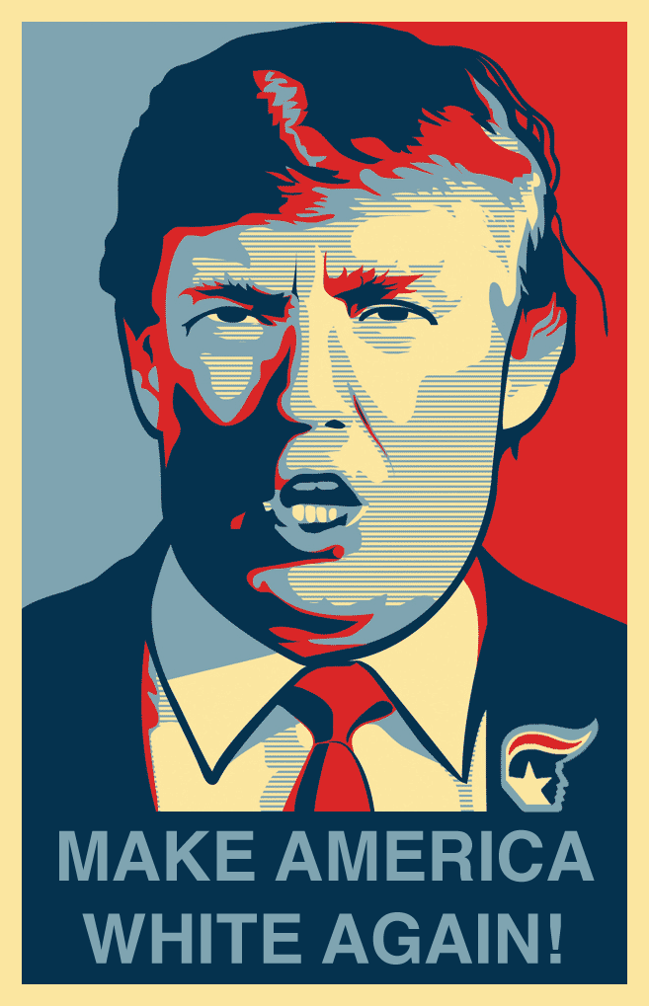

**Figure 1: “Make America White Again” Trumpicon**

The racial politics of circulation is a critical concept that draws attention to how public discourses regurgitate, reinforce, and/or resist racialized logics, such as white supremacy. When it comes to the Obama Hope image’s rhetorical circulation, race has always played a contributing factor. Fairey’s *Hope* poster, for instance, was chosen as an official device for Obama’s campaign over Ray Noland’s designs which presented Obama’s more actual skin color; it was believed that the red, white, and blue palette in Fairey’s design would increase chances for identification and circulation (Gries, *Still*, 249). While such erasure of race is problematic, it helped solidify Obama as a symbol of hope in the mainstream eye, “representing the depths of progressive change necessary to redefine America in a way that is consistent with its fundamental principles of racial equality and equal opportunity” (McIlwain 141). In addition, shortly after Fairey’s *Hope* design emerged, Obamicons with overt racist inflections began surfacing on a pro-white discussion board as did Obamicons with the n-word and one horrific Obamicon depicting Obama with a noose around his neck. Other racist inflections circulated as well, but as evident alone in these Obamicons, the racial politics driving Obamicons’ circulation related to Obama’s Blackness existing within a white supremacy system.

In contrast, with Trumpicons, the racial politics of circulation takes a noteworthy turn toward whiteness in regard to the nation-state. As we show in previous work, many Trumpicons regurgitate and amplify circulating white supremacist *doxai* that have become associated with the Trump’s campaign, rhetoric, and ensuing policies. The [“Build the Wall”](https://twitter.com/ColumbiaBugle/status/1019696188948299776) and [“Fuck your Feelings”](https://alexfontana.wordpress.com/2016/11/12/the-zeitgeist-on-wetback/) Trumpicons, for instance, promulgate white nationalist beliefs, escalate the fear of white majority’s decline, and reassert a white (hyper)masculinity of U.S. identity (see Gries and Bratta). Yet, while Trumpicon’s acceleration and amplification of white supremacist *doxai* is one way to understand their entanglement in the racial politics of circulation, Trumpicons also function to resist white supremacist logics and formations. Rather than continue to study how Trumpicons solidify a dominant racial system in an era of white nationalist postracialism, then, in this chapter we approach the racial politics of circulation with an eye toward resistance.

As evident in our case study of Trumpicons, the relations between race, politics, and the nation-state often get played out in new media genres through competing rhetorics of racial presidentiality that use the president’s image, discourse, and body language to “construct broader meanings about racial politics and the role of race in U.S. national identity” (Cisneros 511). Although white supremacist beliefs and fantasies are finding opportune circulatory paths in new media genres such as Trumpicons, those same new media genres simultaneously push back against such beliefs and fantasies in an intersectional fight against white supremacy. One important inquiry that arises for digital visual studies, then, is how emergent new media genres expand opportunities within and beyond participatory culture to confront racism in our contemporary socio-political climate.

To address this inquiry, we explicate a methodology best identified as *critical genre studies*. As Amy Devitt notes in referencing Aviva Freedman and Peter Medway’s “Towards More Critical Genre Studies,” “genre theory has been largely uncritical in its treatment of genre as a reflector or constructor of norms, values, and epistemologies” (613). As such, Devitt argues that “theorists must find ways of incorporating diversity, conflict, and tension in their sometimes overly placid views of genre” (613). Scholars such as Adam Banks and Cruz Medina have modeled one way we can do this work—by recovering the ways that African American and Latinx rhetors have innovated with new media genres, such as DJ remixes and digital testimonies respectively, to express their unique voices, tell empowering stories, and strengthen community. Such scholarship supplements (but does not forget or neglect) discussions of the digital divide to underscore how persons of color innovate new media practices and draw on traditional, non-Western oral and aural epistemologies to craft digital stories and arguments that generate “decolonial knowledge that breaks from—and often speaks against—dominant colonial narratives” (Medina). As another model, Freedman and Medway suggest to investigate how genres often simultaneously afford creative action for some and dominance for others; interrogate the racial ideologies pinned to specific genres; and examine the ethical and political implications of such genres at work within specific communities of social practice (11-13). We take up this latter call by taking a critical genre approach to digital visual studies in order to investigate how new media genres such as Trumpicons are playing a notable role in the current racial politics of the nation-state.

In this chapter, we begin by discussing numerous theories related to emergent new media genres and critical genre studies that constitute our methodology. We are heavily indebted to the work of Carolyn Miller who has been foundational to studies of new media genres. But, here, we put Miller’s theories into conversation with Lisa Nakamura and Sara Ahmed, among others, to explicate a framework for studying how many new media genres become entangled in an affective economy of hate and a tense friction of competing logics and discourses related to race and white supremacy. We then briefly describe how we adapted iconographic tracking for this study, focusing specifically on our coding/tagging/marking practices for the sake of transparency. We experiment with digital visualization techniques to demonstrate how the racial politics of the nation-state is embroiled in the production, circulation, and rhetorical functions of Trumpicons and vice versa. In our case study section, we draw on these data visualizations to describe and analyze the findings from our research, zooming in on three particular Trumpicons to demonstrate their entanglement with white nationalist postracial logics, rhetorics, and policies through satirical parody, commodity activism, and protest. Finally, we close by acknowledging that while it is clear that Trumpicons participate in diverse kinds of political resistance, future work in digital visual studies might dig more deeply into the actual ability of both satirical new media genres and commodity activism to generate change in an era dominated by patriarchal white capitalism.

**Emergent, Vernacular New Media Genres**

From a rhetorical perspective, we understand genres to be “typified rhetorical actions based in recurrent situations” that provide “the rhetorical means for mediating private intentions and social exigence” (Miller, “Genre,” 159 and 163). While genres often and obviously carry on from generation to generation, genres are always in flux—evolving to meet a particular community’s social needs, adapting to technological innovation, transforming to market demands, and so on. Although many dominant, official genres are enduring and thus make lasting impacts within a community, non-dominant, vernacular genres tend to be ephemeral but nonetheless play notable roles in specific historical-cultural moments within communities that are marginalized, unrecognized, and/or understudied (See also Applegarth 276). In new media environments, vernacular new media genres seem to proliferate constantly through rhetorical play and innovation (Miller, “Where,” 19). Vernacular genres, to be clear, are genres that emerge when users with few administrative or institutional constraints find ways to collectively respond to a shared exigence (Miller, “Where,” 24). Lynn Lewis, for instance, demonstrates how memes have become such a popular means of dissent that we can identify an “emergent participatory economy” that is constituted by a network of “densely imbricated values, exigencies, exchanges, and contexts both embodied and virtual.” As an example of how participatory economies emerge, think about the pepper spray cop meme that surfaced in response to Lieutenant John Pike pepper spraying students at a protest on the UC Davis campus in 2011. As well documented on [Know Your Meme](https://knowyourmeme.com/memes/casually-pepper-spray-everything-cop), once two remixes of a photograph documenting the incident began to circulate, viewers who shared similar values began responding to each other’s remixes, taking advantage of the Web’s speed and digital platforms to participate in a short-lived but intense collective moment of new media resistance.

As Miller notes in “Where do Genres Come From?”, “emergence” in reference to genre innovation is a complicated if not misleading term, especially in that emergence, as a term and phenomenon, has been defined and explained differently across a wide variety of disciplinary contexts. Yet, in terms of new media genres, Miller draws on Timothy O’Connor and Hong Yu Wong to note that emergence might be best understood as a genre that arises out of something pre-existing yet nonetheless is irreducible to it (3). We can best understand emergence, she suggests, if we think about a new media genre in terms of epistemology, not ontology. After all, all cultural innovations derive from patterns of social meaning and thus cannot be entirely novel in their coming into being. But epistemologically, or better yet phenomenologically, we can understand genres as new if they are determined by a community or culture to be something new and meaningfully different. One clear way we can recognize an emergent genre, then, is to look for evidence of shared recognition and shared common practices, for example in the naming, parodying, and metaculture that developed in relation to the pepper spray cop meme (see Miller, “Where,” 5). To better understand how specific genres emerge and come to take on socio-cultural significance, then, Miller argues that we are best off taking empirical, case-based approaches (26), paying close attention to how genres not only emerge onto a community scene but also evolve, circulate, and participate in various collective activities.

Iconographic tracking can be a productive method for doing digital visual studies in that it enables us to empirically account for the emergence and evolution of vernacular genres as well as their circulation and collective activity. In digital visual studies, emergent, vernacular new media genres abound as notable objects of study. In addition to memes, we might think of the ubiquitous selfie, for instance, but we can also think about less prominent genres, such as YouTube Geiger-counter videos (Rea and Riedlinger) and shred videos (Skågeby). Trumpicons and their antecedent Obamicons are also examples of emergent, vernacular new media genres in that they have become wildly popular genres that have developed their own emergent participatory economy with implications for public culture at large.

As apparent in our case study of Trumpicons, vernacular genres do not necessarily stick to one particular domain or serve one narrow function. For instance, vernacular genres can become marketed or commercial genres that offer something that sells to a mass population (Miller, “Where,” 25). Also, as Jason Mittell’s study of television quiz shows demonstrates, many genres are sites of cultural contradiction and tension and have conflicting rhetorical goals (see Miller, “Where,” 15). Such tension surely complicates our understanding of a singular genre’s governing rhetorical action, but this tension and contradiction reveals how new media genres are rhetorically flexible, able to meet the social needs to community members with different ideologies determined to weigh in on contemporary socio-political matters. In this sense, we can position new media genres as socially recognized communicative actions that come to co-constitute our everyday practices and our individual and collective values and identities as they facilitate diverse meaningful interactions, often through engagements of negotiation and struggle.

**Critical Genre Studies**

In this section, we tease out the relations between emergent genres, race, affect, and circulation in order to explicate how a critical genre approach can assist digital visual studies in investigating everyday rhetorics of race and racism. As Raymie McKerrow notes, “The task of unmasking relations of dominance within the context of race relations is not finished” (x). And, as Darrel Enck-Wanzer asserts, because “racism still thrives and circulates in our public culture, . . . active and vibrant anti-racist activism, including scholarship,” is needed (26). It will thus behoove digital visual studies to devote concerted efforts to disclosing how vernacular new media genres are contributing and responding to racial tensions at play in contemporary public life. This is particularly important in that “the mundane, everyday, and routine cultural practices perhaps have the greatest potential to survive, work in in tandem with overt racism, and affect us in their commonplace and taken-for-granted forms” (Lacy and Ono 2). Additionally, as Meta G. Carstarphen and Kathleen Welch note, “while much scholarly inquiry has explored what goes into the construction of racial pathways of identity, little of that inquiry has considered the deliberate ways in which rhetoric has been used to foment racial hate and dissension. These expressions often reveal themselves not in the grand occasions of celebrated oratory, but in the familiar expressions surrounding us” (255). We thus work hard to extend the work of scholars who have provided important inroads into studying how visual artifacts, Internet culture, and race are complexly intertwined in our everyday lives.

Over the past few decades, Lisa Nakamura has examined how the Internet is “a privileged and extremely rich site for the creation and distribution of hegemonic and counter hegemonic visual images of racialized bodies” (*Digitizing Race* 13). Relevant to our research here, Nakamura forwards the idea of cybertypes to “describe the distinctive ways that the Internet propagates, disseminates, and commodifies images of race and racism” (*Cybertypes* 3). Cybertyping, she notes, occurs when circulating images of race emerge as “the fears, anxieties, and desires of privileged Western users . . . are scripted into a textual/graphical environment that is in constant flux and revision” (*Cybertypes* 6). In Nakamura’s work, a number of new media genres such as cyberpunk films, Internet advertisements, and graphic chats contribute to cybertyping. Trumpicons, we argue, ought to be added to such list, as our research makes visible that Trumpicons build on and respond to self-stereotypes that Trump has generated—stereotypes which reinforce fears, anxieties, and desires of whiteness that, in Sara Ahmed’s terms, stick to Trumpicons as they circulate, making impressions upon encountered bodies along the way. We find it useful, then, to supplement Miller’s theories of new media genres and Nakamura’s theories of race and Internet culture with Ahmed’s work on the cultural politics of emotion—a key foundation to our own concept of the racial politics of circulation. As Ahmed’s work in *The Cultural Politics of Emotion* helps to elucidate, emotions and *doxa* (commonplace opinions and beliefs) stick to cultural artifacts that give rise to impressions left on both the individual and collective body (see Gries and Bratta). In one sense, emotions and *doxa* circulate among bodies entangled in close relations. But in an emergent participatory economy, emotions and *doxa* often spread quickly among strangers connected to each other only via the production, remix, and sharing of new media genres, such as Trumpicons. We might think of the connection between Miller, Nakamura, and Ahmed as follows then: the more a new media genre that functions as a cybertype circulates, the more culturally constitutive and reinforcing it becomes of racialized logics and formations as well as economies of deeply affective opinions and beliefs.

As a critical concept, the racial politics of circulation draws attention to the ways in which new media genres such as Trumpicons and race are entangled and constantly feeding off each in the public realm. With the racial politics of circulation, to be clear, we refer to the phenomenon in which race—as a cultural-rhetorical construct that operates in overt and covert dimensions—drives the (re)production and (re)circulation of rhetorical artifacts, which, through various channels, feed back into public discourse and interlocking racialized logics and formations tied to the nation-state (Gries and Bratta). By racial formation, we work from Michael Omi and Howard Winant’s definition: “the sociohistorical process by which racial categories are created, inhabited, transformed, and destroyed . . . a process of historically situated projects in which human bodies and social structures are represented and organized” (124). Michael Lacy and Kent Ono note that racial formation is always shifting within a culture as racialization and racialized logics become reified through emergent rhetorical practice. They remark that “race and racism are cannibalistic and vampiric, feeding off of cultural changes and one another, transforming themselves to fit every situation or context” (6). That is, as old as they are, racialized formations and logics become culturally recemented as different figures, technologies, discourses, affects, and beliefs emerge within and across cultures. The racial politics of circulation helps turn scholarly attention to such phenomena in order to disclose how racism is being both promulgated and resisted in what Jeff Maskovsky calls an era of white nationalist postracialism.

Maskovsky argues that white nationalist postracialism is a “new form of racial politics” that has emerged with Trumpism —a form of racial politics in which “white racial resentment seeks to reclaim the nation for white Americans while also *denying an ideological investment in white supremacy*” (434, our emphasis). Based on our research of how “Build the Wall” and “Fuck your Feelings” Trumpicons promulgate such racial politics, we have suggested that “white nationalist postracialism is a form of circulatory racism that is gaining amplification as it becomes highly distributed across physical and digital contexts and amplified by new media genres” (Gries and Bratta). But, as our case study shows in this chapter, Trumpicons also work to expose and resist white supremacist logics and formations and thus participate in a cultural-rhetorical, affective practice in which tension over white supremacy gets played out.

Resistance, we should note as an end to this section, is perhaps an overused term, one that loses meaning in its ubiquity of rhetorical explanation. By resistance, however, we draw on Brian Ott who defines it as “any discourse, performance, or aesthetic practice, which through its symbolic and/or material enactment, transgresses, subverts, disrupts, and/or rebels against the social codes, customs, and/or conventions that—through their everyday operation—create, sustain, and naturalize the prevailing relations of power in a particular time and place” (335). This notion of resistance is apt for our research in that Trumpicons often work to push back against white supremacist fantasies that are already circulating—amplified in part to Trump and the white supremacist postracial logics that undergird many of his policies and rhetoric. In this sense, many Trumpicons enact visual resistance by taking advantage of the fact that in a culture dominated by the public screen, audiences, as Kevin Michael DeLuca and Jennifer Peeples argue, often are drawn to “[i]mages over words, emotions over rationality, speed over reflection, distraction over deliberation, and slogans over arguments” (133). Determining whether such visual resistance is efficacious in its efforts to challenge/undo white nationalist postracial logics and rhetorics is certainly difficult to determine and beyond the scope of this particular research project. Iconographic tracking, however, demonstrates that Trumpicons, at the very least, attempt to confront such logics and rhetorics head on as they enter into the hypervisible racial politics of circulation at play in our current national and global context.

**Method**

Iconographic tracking is a digital research method designed to follow images as they circulate, enter into diverse collective activities, transform, and become consequential with time and space. While qualitative research strategies are often deployed to do field research and conduct interviews and questionnaires, iconographic tracking largely relies on digital research strategies to follow images on their travels and to trace their rhetorical transformation (see Gries 2017). For this project, we adapted iconographic tracking to learn more about how Trumpicons have been designed, where they have surfaced, and what rhetorical actions they have taken on via circulation since their inception in 2011. We especially tried to take advantage of digital visualization techniques to address these inquiries, deepen our analysis, and develop theoretical insight about this new media genre. (Note: Many of the data visualizations are interactive. We thus invite you to spend time engaging with them to learn more about the new media genre of Trumpicons.)

While iconographic tracking was invented for visual rhetoric research, it is also a viable method for digital visual studies and the humanities writ large. In the humanities (and social sciences), digital tools and research strategies are beginning to play a more prominent role in facilitating research whether text, data, image, sound based, or outcome-based (Gardiner and Musto 72-81). Digital visualization techniques are crucial in helping to generate visual representations of structured data (Gardiner and Musto 77-78) that can aid in facilitating pattern and trend identification as well as catalyzing new questions. As Derek Mueller notes, abstract visual models enhance possibilities for new questions, insights, and knowledge to come to light (4). Rather than think about data visualizations as proofs, closures, and/or conclusions, then, they ought to be understood as provocations, openings, and clearings for rethinking existing and building new theories (4).

While we do not have enough space to explain our exact tracking and data visualization strategies here, we do want to briefly discuss our tagging/coding/marking practices in the spirit of transparency. We began our research by collecting as many different Trumpicons as we could, tagging not only locations and dates, but also, of course, captions. In an effort to code for resistance, we enacted content analysis to determine if the depictions of Trump and captions were supportive of Trump, critical of Trump, or unclear. In terms of rhetorical function, we also created a coding scheme that included the following categories: education, artistic expression, political support, event promotion, protest, commercial sales, and parody, identifying in the latter three cases what kind of protest a Trumpicon took part in and when satirical parody was used for commodity activism.[2] Because of our interest in the racial politics of circulation, we also loosely kept track of which Trumpicons might be associated with racism or white nationalism. For instance, one popular Trumpicon that we discuss in the following section is the “Twitler” design where Trump is depicted as Hitler, who in our mind conjures fascism, racism, and xenophobia. We thus marked this Trumpicon as associated with white nationalism and racism.

In some Trumpicons, the design is clearly and directly related to race. For instance, in one Trumpicon, the caption reads “Whites Only,” while in another the caption simply says “Racist.” In other Trumpicons, however, their association with race surfaces less in the design than in their social action. For example, a “Nope” poster being held up in a protest against Trump’s immigration ban takes on associations with xenophobia and Islamophobia where as in other contexts a “Nope” Trumpicon may simply express one’s desires for the 2016 presidential election results. Therefore, when marking for associations with racism and/or white nationalism, we identified Trumpicons in which such associations could be determined by design and/or social action. This tagging/coding/marking system surely has its limitations and interpretative bias. As Johanna Drucker reminds us, all data sets ought to be considered a rhetorical capturing of data rather than an accurate representation of reality. However, to ensure consistency in light of the fact that we do not know the intentionality behind many Trumpicons, we made these decisions in order to better understand the frequency and creative patterns in which Trumpicons resist Trump’s white nationalist postracial self-stereotype, rhetoric, and policies.

**Case Study**

**[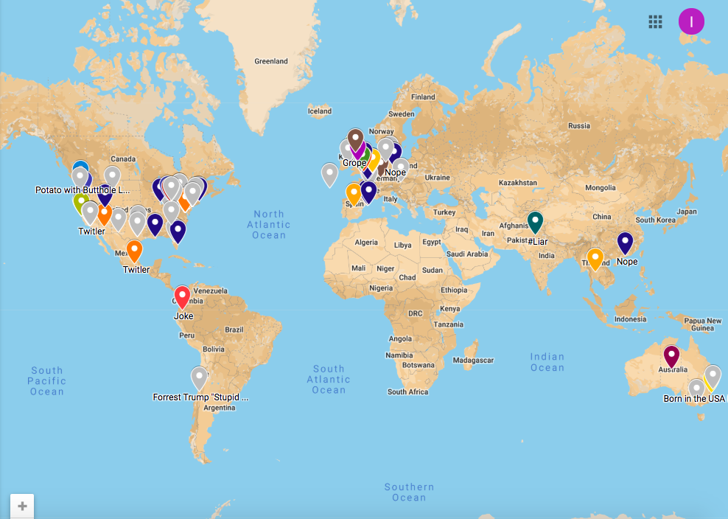](https://drive.google.com/open?id=1P5uY1rOWP4Q7MnLRquddupfMKMsl5N4J&usp=sharing)**

**Figure 2. Map Documenting Geographical Locations in which Trumpicons have Surfaced since 2011. Note: We only could determine location of only 115 Trumpicons; therefore, this map does not reflect our total data set. Also, this map has two interactive layers. If you click on location layer, you can access all mapped Trumpicons. Clicking on Protest layer, you can see all the different locations in which Trumpicon participated in on-the-ground protests. Clicking on all markers will put up metadata.**

As of date, iconographic tracking enabled us to discover over 200 Trumpicons that, as Figure 2 shows, showed up across the world in digital and physical form and participated in a wide range of collective activities. Based on our content analysis of 230 Trumpicon designs, while some Trumpicons include phrases such as “Make America White Again” as evident in Figure 1, most Trumpicons include a one word caption, an affective enthymeme which demonstrates that Trumpicons are reliant on speed, glance, and emotion more than deliberative argument. In terms of resistance, from “Chump” to “Clown” to [“Perv,”](https://twitter.com/PuestoLoco/status/856248636803567616) everyday citizens have taken to Trumpicons to express their suspicions and skepticisms about his character, his behaviors, and his rhetoric and politics. Yet, according to the word cloud in Figure 3, the most prominent captions include “Nope” (42), “Twitler” (9), “Hate” (9), “Grope” (8), and “Dope” (7). In this section, we build our analysis from this and other data visualizations to focus on three of these Trumpicons: the “Hate” Trumpicon, the “Nope” Trumpicon, and the “Twitler” Trumpicon. In order to further elucidate Trumpicons’ role in the racial politics of circulation, we show how each of these Trumpicons—in design and/or social action—function to resist the white nationalist postracial logics of Trump’s rhetoric and policies, which, as Makoskvy helps us understand, contribute to white nationalism while simultaneously rejecting any kind of investment in racism, xenophobia, or white supremacy.

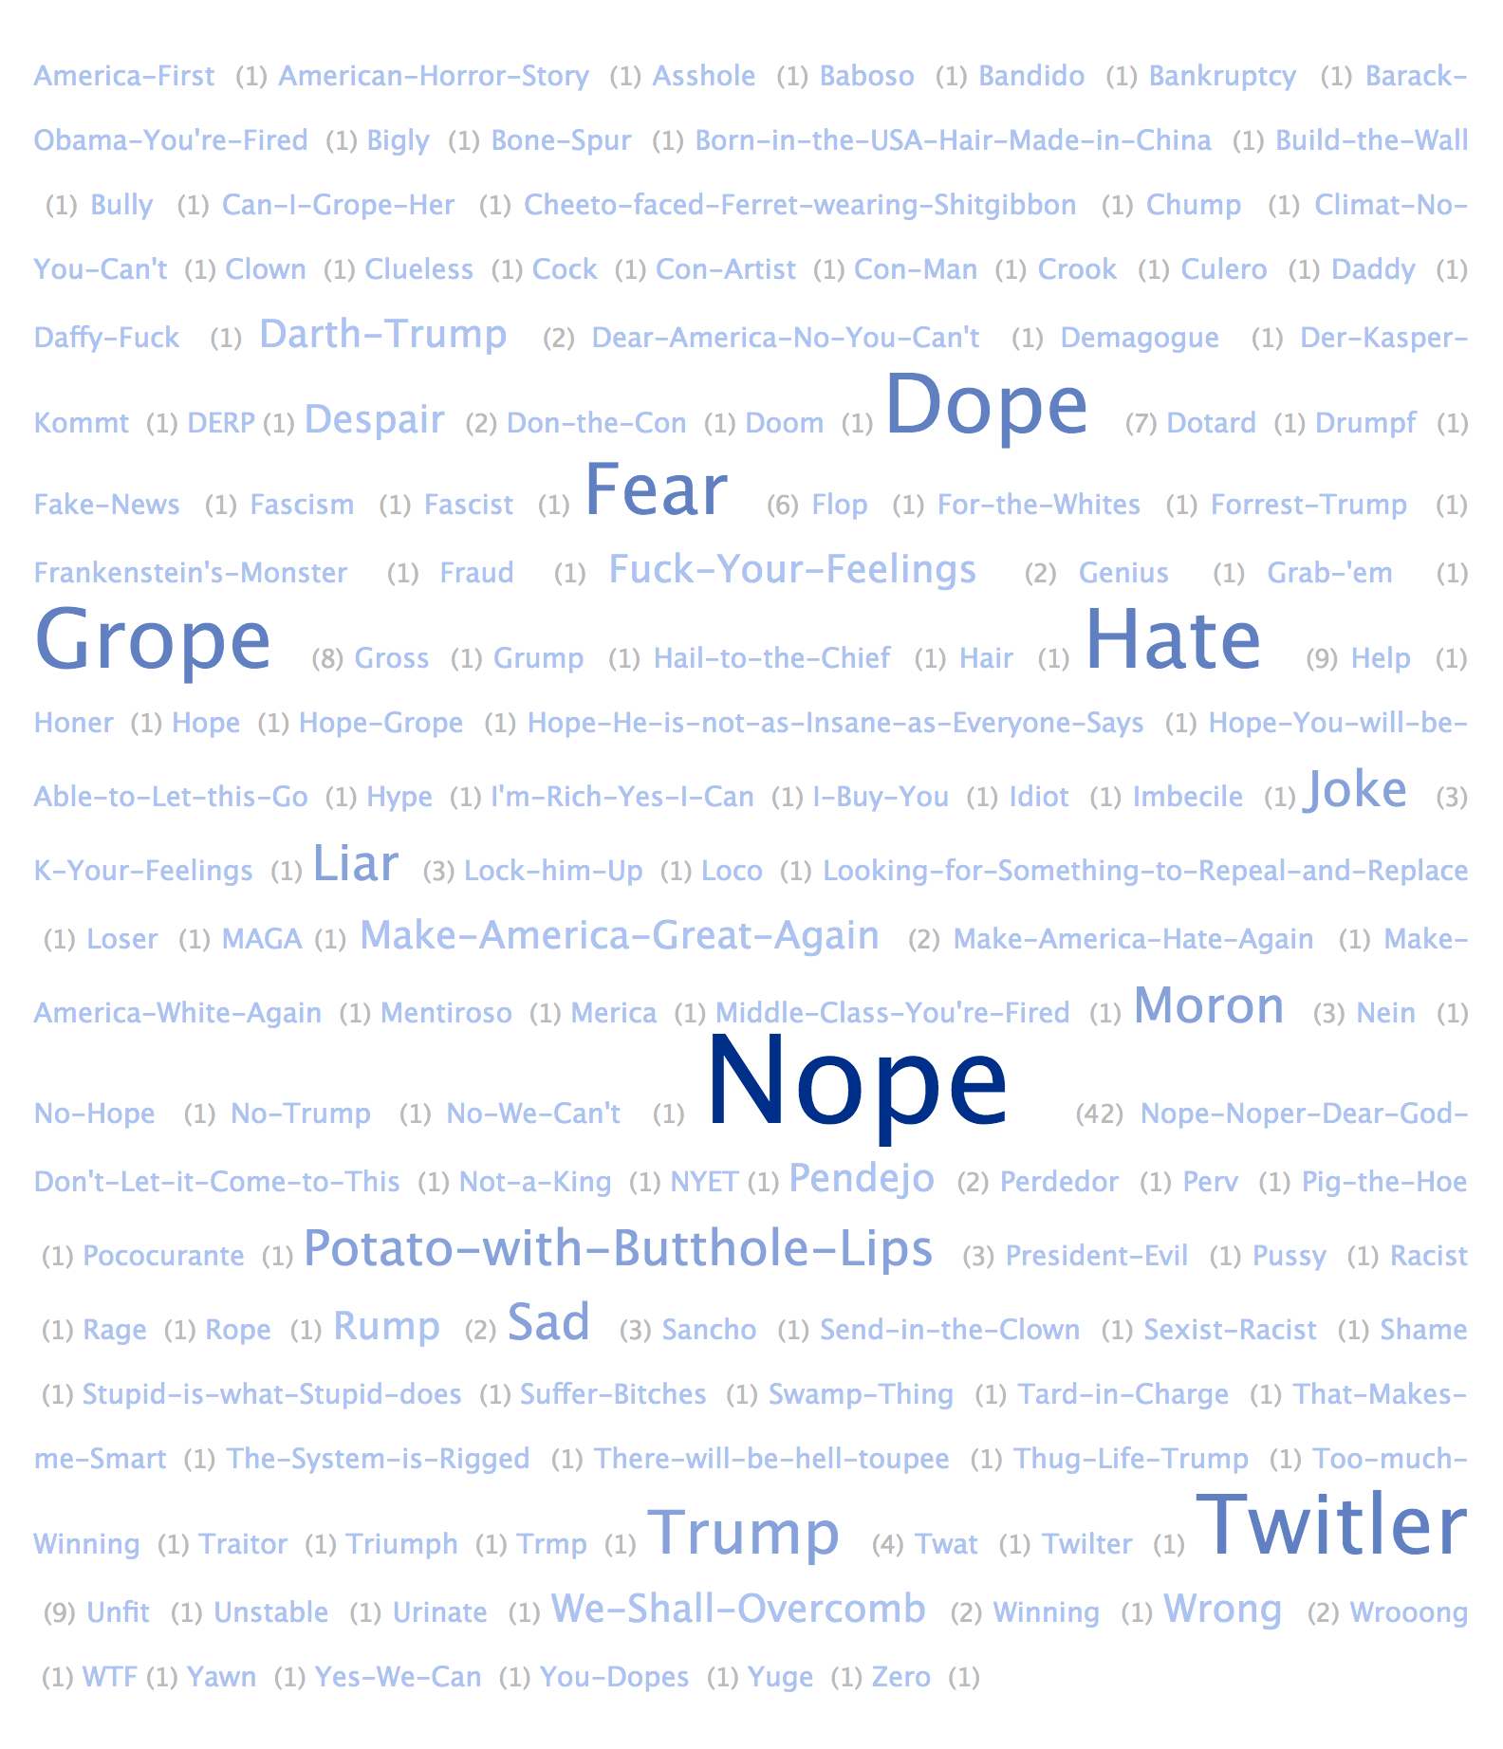

**Figure 3: Word Cloud depicting Captions of Trumpicons from our Data Set. In this word cloud, a darker blue hue and enlarged font communicate the frequency of captions. Additionally, this word cloud provides quantitative data, identifying the specific times a caption shows up in our data set.**

*Hate*

The “Hate” Trumpicon (see Figures 4 and 5) exemplifies how this new media genre often functions as a cybertype to simultaneously expose Trump’s white supremacist rhetoric and resist his racialized logics and policies. Cybertypes, we learn from Nakamura, are digital manifestations of stereotypes that circulate on the Internet to promulgate racist representations that are cemented with essentialized identities. In her work, Nakamura discloses how cybertypes are often shaped by already circulating racial and ethnic stereotypes that map onto racialized Others in the digital sphere. Cybertypes, we argue, are also shaped by self-stereotypes that people generate of themselves. As Stacey Sinclair and Jeffrey R. Huntsinger explain, “self-stereotyping occurs when individuals’ beliefs about their own characteristics correspond to common beliefs about the characteristics of a group they belong” (848). Self-stereotyping, we believe, can also occur through identification with a group that one may not have official affiliation with but does share ideological ties. As many have argued, Trump’s position, rhetoric, and policies—whether intentionally, or even consciously, or not—align with far-right ideologues, even white supremacists such as David Duke who have publicly praised Trump’s work and taken his rhetoric as clear messages to bolster their own white supremacist efforts. As Nicol Turner Lee reported for the Brookings Institution in 2017, “Under Trump, white supremacists have . . . become even more insidious as they find a comfortable ally within an administration whose last nine months has included a steady roll back of civil rights policies and promises” (n.p.). In line with how white nationalist postracial logics work, Trump, of course, has insisted that he or his administration does not condone racism or align with white supremacy. But in light of claims by Duke and others such as Andrew Anglin who calls Trump’s discourse “encouraging and refreshing,” it is hard to deny that Trump’s rhetoric has become a major part of “the engine that fuels white supremacy” in contemporary America (qtd. in Hayden).

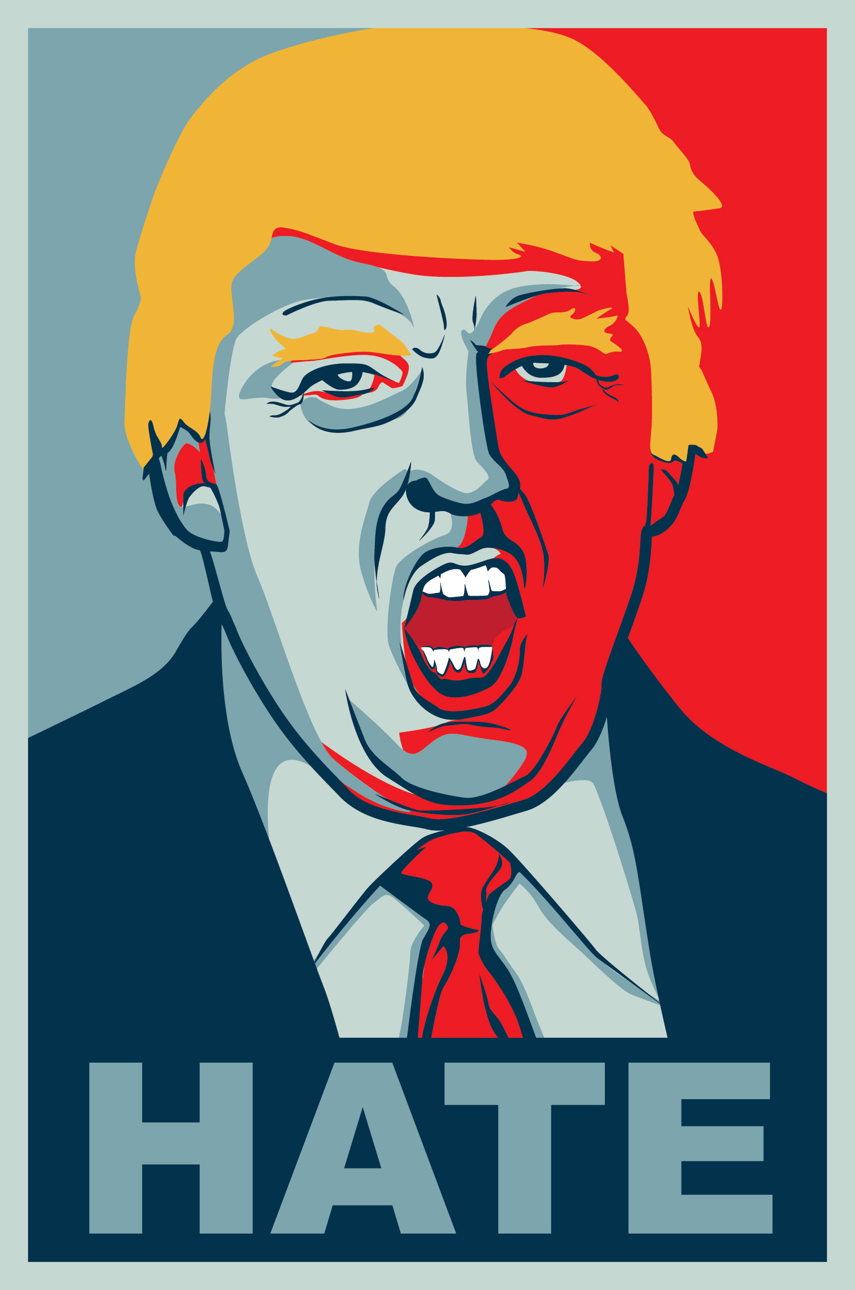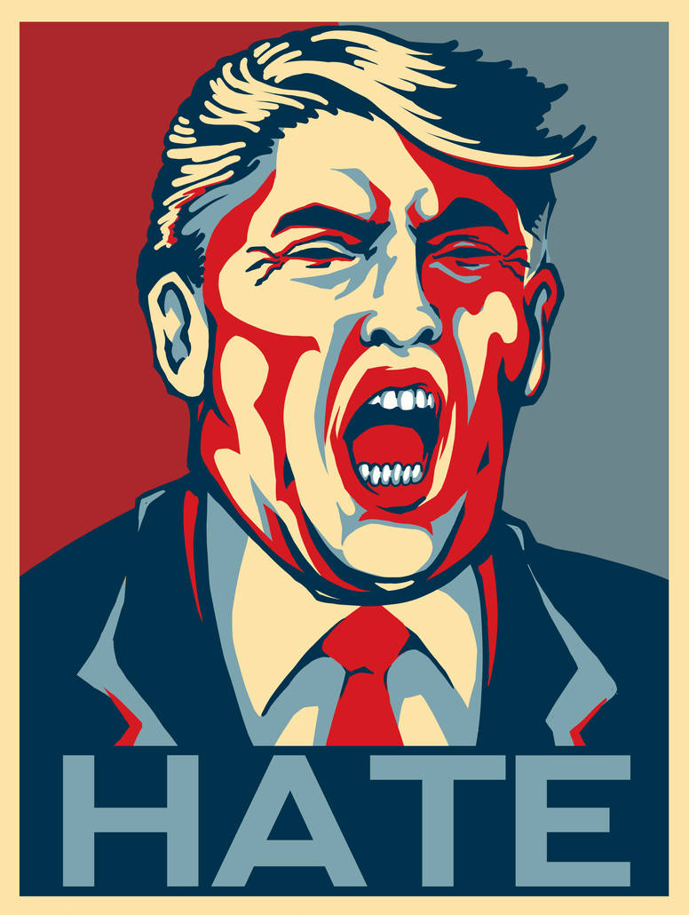

**Figures 4 and 5: “Hate” Trumpicons**

While the “Build the Wall” and “Fuck your Feelings” Trumpicons we previously mentioned are two examples of how Trump has self-stereotyped as a white supremacist and how Trumpicons help fuel white supremacy, the “Hate” Trumpicon simultaneously calls out and resists Trump’s self-stereotyping, going so far as to mock Trump for his obvious and commonplace white supremacist, hateful beliefs. As evident in the Southern Poverty Law Center’s [Hate Watch](https://www.splcenter.org/hatewatch) and [Hate Map](https://www.splcenter.org/hate-map), hate has become a common descriptor to identify far-right radical groups, many of which espouse white supremacist ideologies. According to Ahmed, such deployment of hate is not unwarranted as hate (in conjunction with love) is fundamental to white supremacy. According to their own shared narrative, as Ahmed explains, white aryans share a “love for the nation that makes the white Aryans feel hate towards others who, in ‘taking away’ the nation, are taking away their history, as well as their future” (43). In this sense, hate “works to stick or to bind the imagined subjects and the white nation together” (43). Such hate, of course, can get acted out in various ways, but at its heart, hate is both an intense emotion (49) and an affective economy that functions as a (re)organizing machine that fuels the engines of white supremacist logics, identities, and formations. Hate, like other emotions, sticks to circulating artifacts and organizes bodies with certain relations to and identifications with white supremacy.

As an act of resistance, the “Hate” Trumpicon, admittedly, could be operating in two ways: (1) expressing hate of Trump because of his stereotypical white supremacist discourse, ideologies, and political policies; (2) signifying the hate that Trump shares with other white supremacists that circulates among them and organizes their bodies, even if covertly, in shared, distributed social action. In both “Hate” Trumpicons above, the latter seems more likely, as Trump is depicted as an aggressive figure, mouth agape in the middle of a vehement scream or a fiery bellow, sending not only hate but also a warning, perhaps, to those perceived to be threats to whiteness and white ways of life. By exposing the white national postracial foundation from which Trump operates, these Trumpicons amplify Trump’s vileness—his divisive politics that leak into the public sphere and contribute to an affective economy of hate. In painting Trump as a hateful creature, these Trumpicons also warn and catalyze viewers to be on guard in the face of a president that is so malintent.

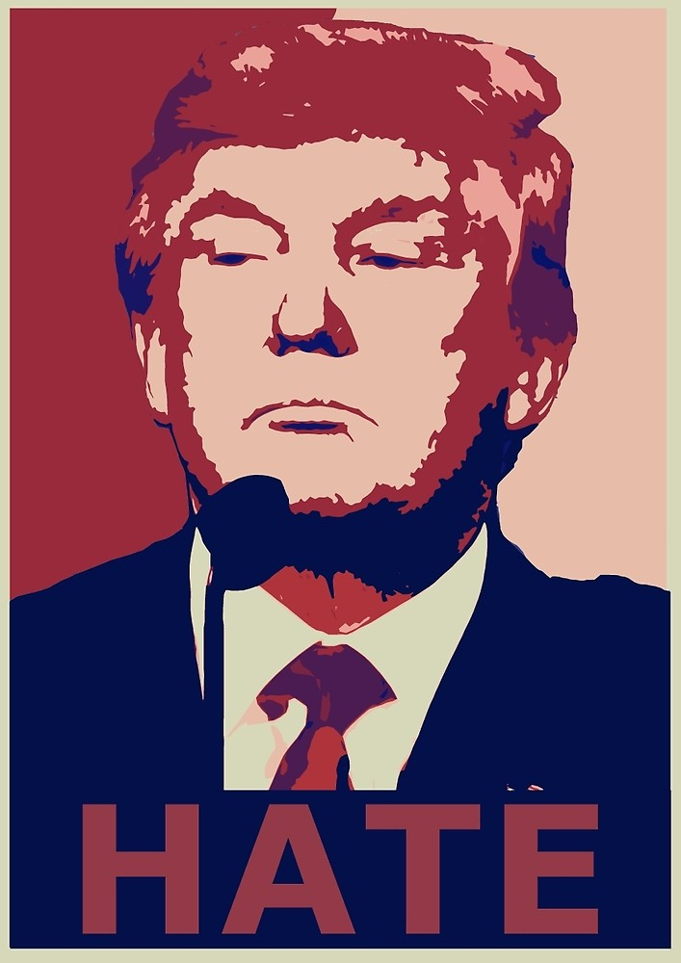

**Figure 6: “Hate” Trumpicon Produced by Responsible History Education Action**

Due to such rhetorical actions, “Hate” Trumpicons appear not only in [protests](https://www.gettyimages.com/detail/news-photo/hundreds-of-north-american-resident-young-persons-in-spain-news-photo/632218698?adppopup=true) against Trump but also efforts by activist organizations to promote human rights causes. Responsible History Education Action, based out of Thailand, as just one example, is an organization committed to not only promote holocaust education but also combat hate speech, teach tolerance, and advocate for the respect and rights for all (About). “Hate,” they pronounce in a homepage visual graphic, “is not a fashion statement.” In order to generate funds for their activist work, this organization sells their own version of a “Hate” Trumpicon. In this version, Trump is not depicted as a ferocious fiend, but rather, with chin raised, a pompous, smug autocrat (see Figure 6). While [some](https://www.wsj.com/articles/trump-is-not-turning-u-s-into-an-autocracy-1515358275) have argued that Trump is not leading the U.S. toward autocracy or aligning with other autocrats around the world, others claim that we have not paid nearly enough attention “to the side of him that relishes autocracy and undercurrents of violence” (Dionne). While certainly different in affect from the “Hate” Trumpicons above, [this “Hate” Trumpicon](https://www.redbubble.com/people/historyaction/works/23838574-trump-hate) draws attention to such autocratic tendencies as it joins a plethora of other Trumpicons in taking action to resist the affective economy of hate that seems to be fueling and organizing figures such as Trump in white supremacist action.

*Nope*

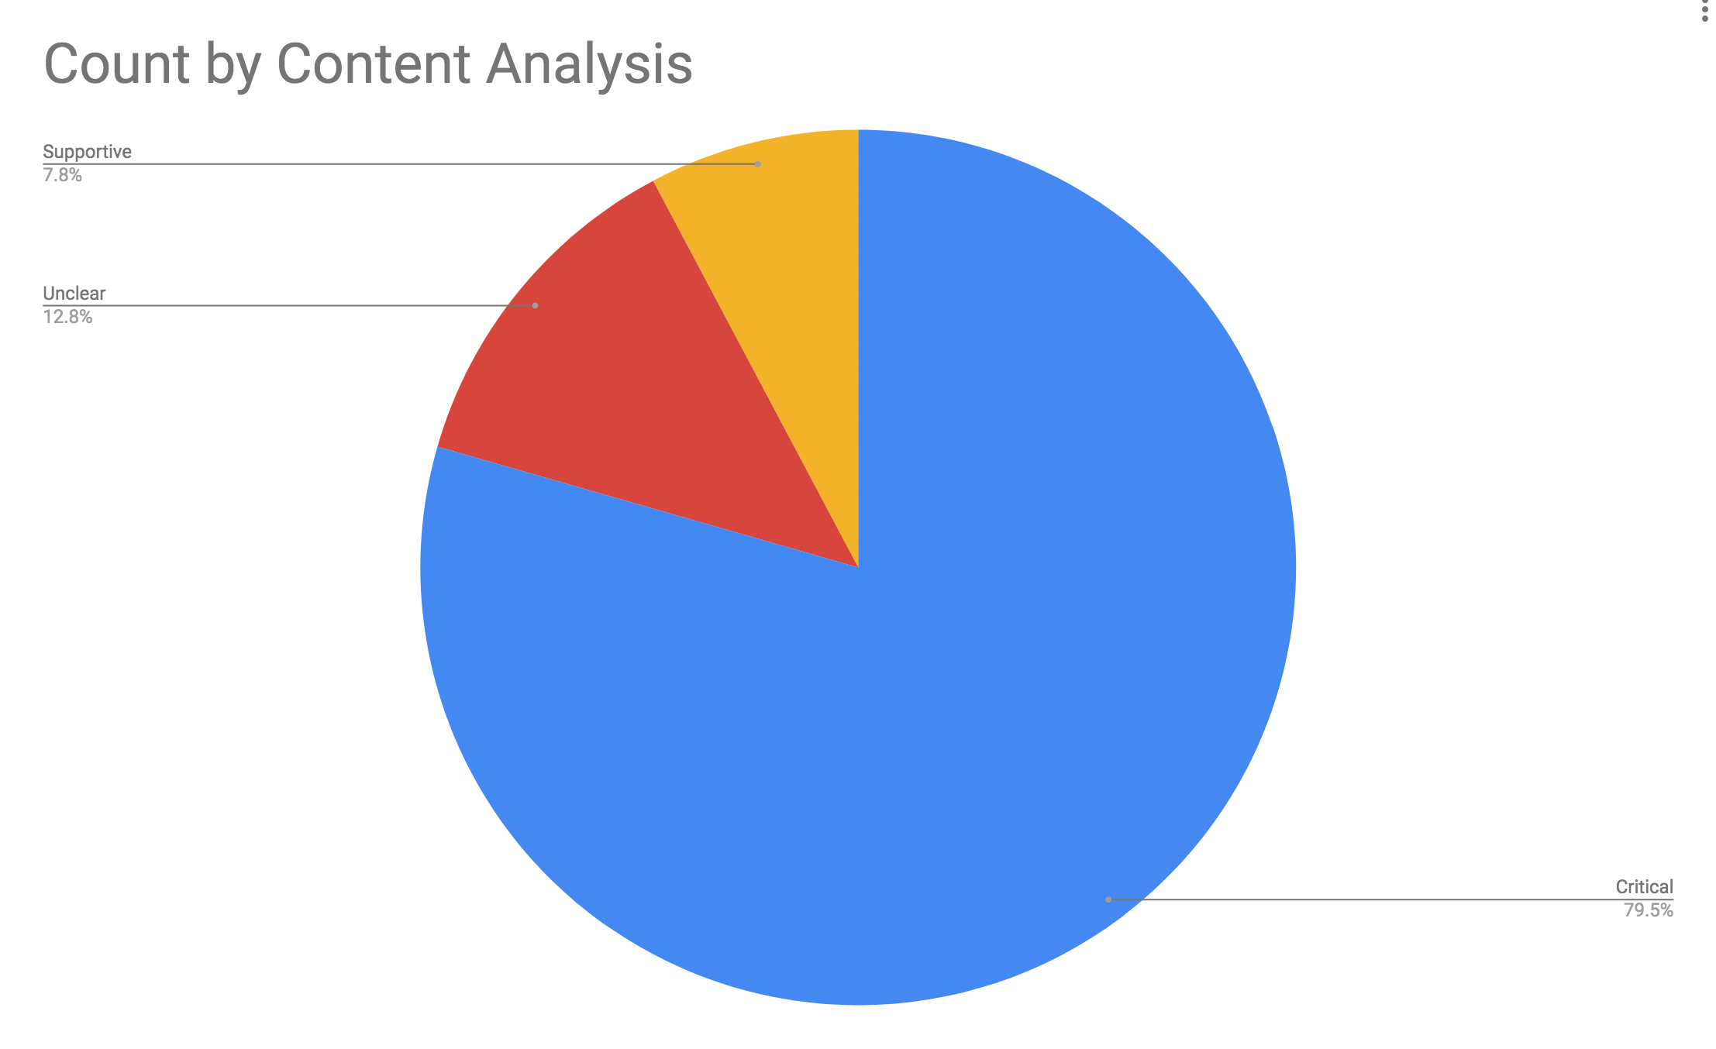**Figure 7: Pie Chart Depicting Results from Content Analysis of Trumpicons**

The “Hate” Trumpicon’s enactment of resistance proves to certainly not be an isolated event. The pie chart in Figure 7 indicates that according to our data set, Trumpicons are overwhelmingly critical of Trump, with only 7.8% of all Trumpicons clearly expressing support for him in design. Resistance to Trump, however, not only happens through critical designs. Our research indicates that resistance also occurs through explicit individual assertions of political opposition that accompany Trumpicons, organized protests in which Trumpicons are deployed, and commonly, according to the data, satirical parody, which often gets taken up for commodity activism. The “Nope” Trumpicon, figure 8 as one example, makes visible such variety of resistance, as it has surfaced in online commercial spaces, blogs, online news sources, and on-the-ground protests to enact and catalyze resistance against Trump.

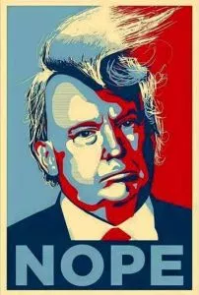

**Figure 8. “Nope” Trumpicon**

In terms of commodity activism, Trumpicons often circulate via online stores such as RedBubble and Zazzle, where people can upload designs—created by themselves or found on their Internet—and sell them as posters, t-shirts, coffee cups, magnets, cell phone covers, and so on. While surely such action can be interpreted as pure commercialism, many designers’ tags for their products, as well as explanations of design or purpose, provide evidence that their Trumpicons’ intended rhetorical action is highly political, often making direct calls to resist Trump and/or raise funds for further political action. Such participation in commodity activism is evident in the Thai activist organization example above, but as another example, two RedBubble members, who go by the name [“Weneedbrain”](https://www.redbubble.com/people/weneedbrain) and identify as “two queer/trans artists outraged and horrified by the Trump administration,” uploaded a “Nope” Trumpicon and posted the following in their artist notes: “Tell the world that Trump is absolutely, unequivocally #notyourpresident. *All money raised will be donated to the ACLU* to power their fight for immigrants, people of color, LGBTQ people and everyone else whose civil rights are in jeopardy.” Such enactment of commodity activism is not rare; while surely Redbubble and Zazzle are used to also express and garner political support for Trump, these commercial sites have become hotbeds for activism, as folks take to their Trumpicons designs to say “Wake up….America is staring into the Abyss!”

Many of the Trumpicons involved in commodity activism, as well as individual acts of resistance on social media and in protests across the world, rely heavily on satirical parody. Satirical parody is a mode of resistance that borrows aesthetic elements from previous work and typically enacts ridicule and mockery to provoke sharp, and often humorous, critiques about contemporary figures and events in public life. As satirical parody, many might argue that Trumpicons go too far, especially in that many generate vernacular, irreverent compositions that “ignore or mock the authority or character of a person, event, or text, with the effect of offering commentary on those entities” (Dietel-McLaughlin, n.p.). The famous [“Cheeto-faced, Ferret Wearing Shitgibbon”](http://www.metalollie.com/2016/07/an-unusual-week.html) Trumpicon that surfaced on Twitter in an individual act of resistance, for instance, launches a brutal, irreverent critique of Trump’s endless attempts to create a physical and intellectual façade through his appearance and rhetoric.[3] But as one Flickr artist suggests, ridicule can be a strategic form of dissent: “Ridicule forces Trump to invent reality to protect his ego. And the more times that happens, the more unhinged and unreal his fantasies will become. So keep marching, keep making funny signs, keep satirizing and joking and posting. It’s not just to make us feel better. It’s a tool, it’s protest, it’s dissent” (The Searcher). Also, we argue that irreverent Trumpicons often go to such extreme satirical measures to simultaneously reject Trump’s egregious rhetorical [offenses](https://slate.com/culture/2017/02/the-origin-of-the-trump-insult-shitgibbon-revealed.html) to global citizens’ morals, ethics, and intellects and call out his façade of posing as a non-racist even as he self-stereotypes as a white supremacist—a move that is indicative of white national postracial logics.

In the perhaps less heated, yet also irreverent “Nope” Trumpicon, for instance, we see Trump depicted with wild, windblown hair (figure 8)—an allusion to an incident in February 2018 that created a spectacle when a gust of wind exposed the [facade](https://hollywoodlife.com/2018/02/09/donald-trump-hair-blowing-in-the-wind-malfunction-video/) that Trump has a full head of hair. The “Nope” caption rejects this physical facade, which we argue also operates as a metonymy for the multiple ways in which Trump attempts to deny his stereotypical white supremacist tendencies to curb the rights of minorities, criminalize people of color, and contribute to the affective economy of hate mentioned above. This non-racist facade is also one that generates much resistance via the Nope Trumpicon. At a protest against Trump’s immigration ban (which we detail below), for instance, a woman holds a sign depicting the statue of liberty with a caption beneath that reads “I’m with her.” On the other side of this sign is the “Nope” Trumpicon. In its enactment alongside the U.S.’s most potent symbol of freedom and other signs at this protest stating “Build a wall against bigotry and racism,” the “Nope” Trumpicon rejects Trump’s discriminatory immigration policy while also calling out his racist and prejudicial tendencies. Such dual approach to confronting Trump’s white nationalist postracial logics and rhetorics is perhaps one reason this Trumpicon has become so broadly relied upon to not only enact but also catalyze protest both in the U.S. and across the [world](https://www.gettyimages.ae/detail/news-photo/protesters-carry-posters-against-trump-in-the-style-of-the-news-photo/633084040).

Another reason, we suspect, is this Trumpicon’s ambiguity, which takes advantage of the “Nope” Trumpicon’s ability to respond to and galvanize action against so many different rhetorical situations worthy of protest. Trump wants to ban Muslims from coming into this country. Nope! Trump wants to treat women inappropriately in public. Nope! Trump wants to perpetuate white supremacist capitalism as my president. Nope! Before Trump’s inauguration, for instance, the “Nope” Trumpicon circulated in fliers generated by different organizations to catalyze resistance to Trump’s inauguration that would take place in over a dozen organized protests in San Diego alone. Take, for instance, the [“San Diego United Against Hate” announcement](https://sandiegofreepress.org/2017/01/a-dozen-plus-opportunities-in-san-diego-to-protest-trumps-inauguration/#.XPBLR4hKg2y) that pairs the “Nope” Trumpicon with the following call to action:

Join Union del Barrio and the greater San Diego community as we unite on Trump’s 1st day in office!! All communities must come together to send a clear message on DAY 1! Only through organized struggle can we win – and win, we will! Actions throughout the nation will send a clear message that we will resist! We will respond! WE ARE WATCHING! People Unite! We have nothing to lose but our chains!

In this announcement, the name of the protest acknowledges the affective economy of hate discussed above, placing Trump square in the middle of it. The “Nope” Trumpicon functions to reject such hate while also protesting the inauguration suggested in the call to action. In this act of resistance, the “Nope” Trumpicon delivers an informal/vernacular rejection of not just an event, however. It aso rejects our current social context at large—arguably, capitalism *and* white supremacy—and through such delivery, “Nope” amplifies the exigency to organize in revolutionary resistance. The call to action concludes with the famous line from Karl Marx and Friedrich Engels’ *The Communist Manifesto*, which was also the closing remark in Assata Shakur’s letter *To My People*: “We have nothing to lose but our chains.” In deploying such allusion alongside “Nope,” the activists are able to take advantage of the ambiguity of “Nope” to identify white supremacist capitalism and evoke organized resistance against systems of domination and oppression.

*Twitler*

Like the “Nope” Trumpicon, the “Twitler” Trumpicon has become a hypervisible force of resistance in protests both in the U.S. and across the world. In this design, the caption “Twitler” sits beneath a portrayal of Trump depicted as Hitler in hues of Twitter blue. As a portmanteau, “Twitler” encompasses a combination of terms: Twitter, twit, and Hitler. Undoubtedly, Twitter is Trump’s favorite communication channel—a means through which Trump can circulate his thoughts, beliefs, and theories, oftentimes with no oversight by his advisors, and provide unprecedented public access to him. Twit means a foolish, silly, and/or annoying person. Twit calls our attention to the content of Trump’s tweets which circulate innumerable outlandish and unfounded remarks that oftentimes exasperate anxieties and fears to reinforce white supremacy. Finally, in conjunction with the toothbrush mustache on Trump’s upper lip, “Twitler” connects Trump to Nazi leader Adolf Hitler, the embodiment of fascism, racism, and xenophobia.

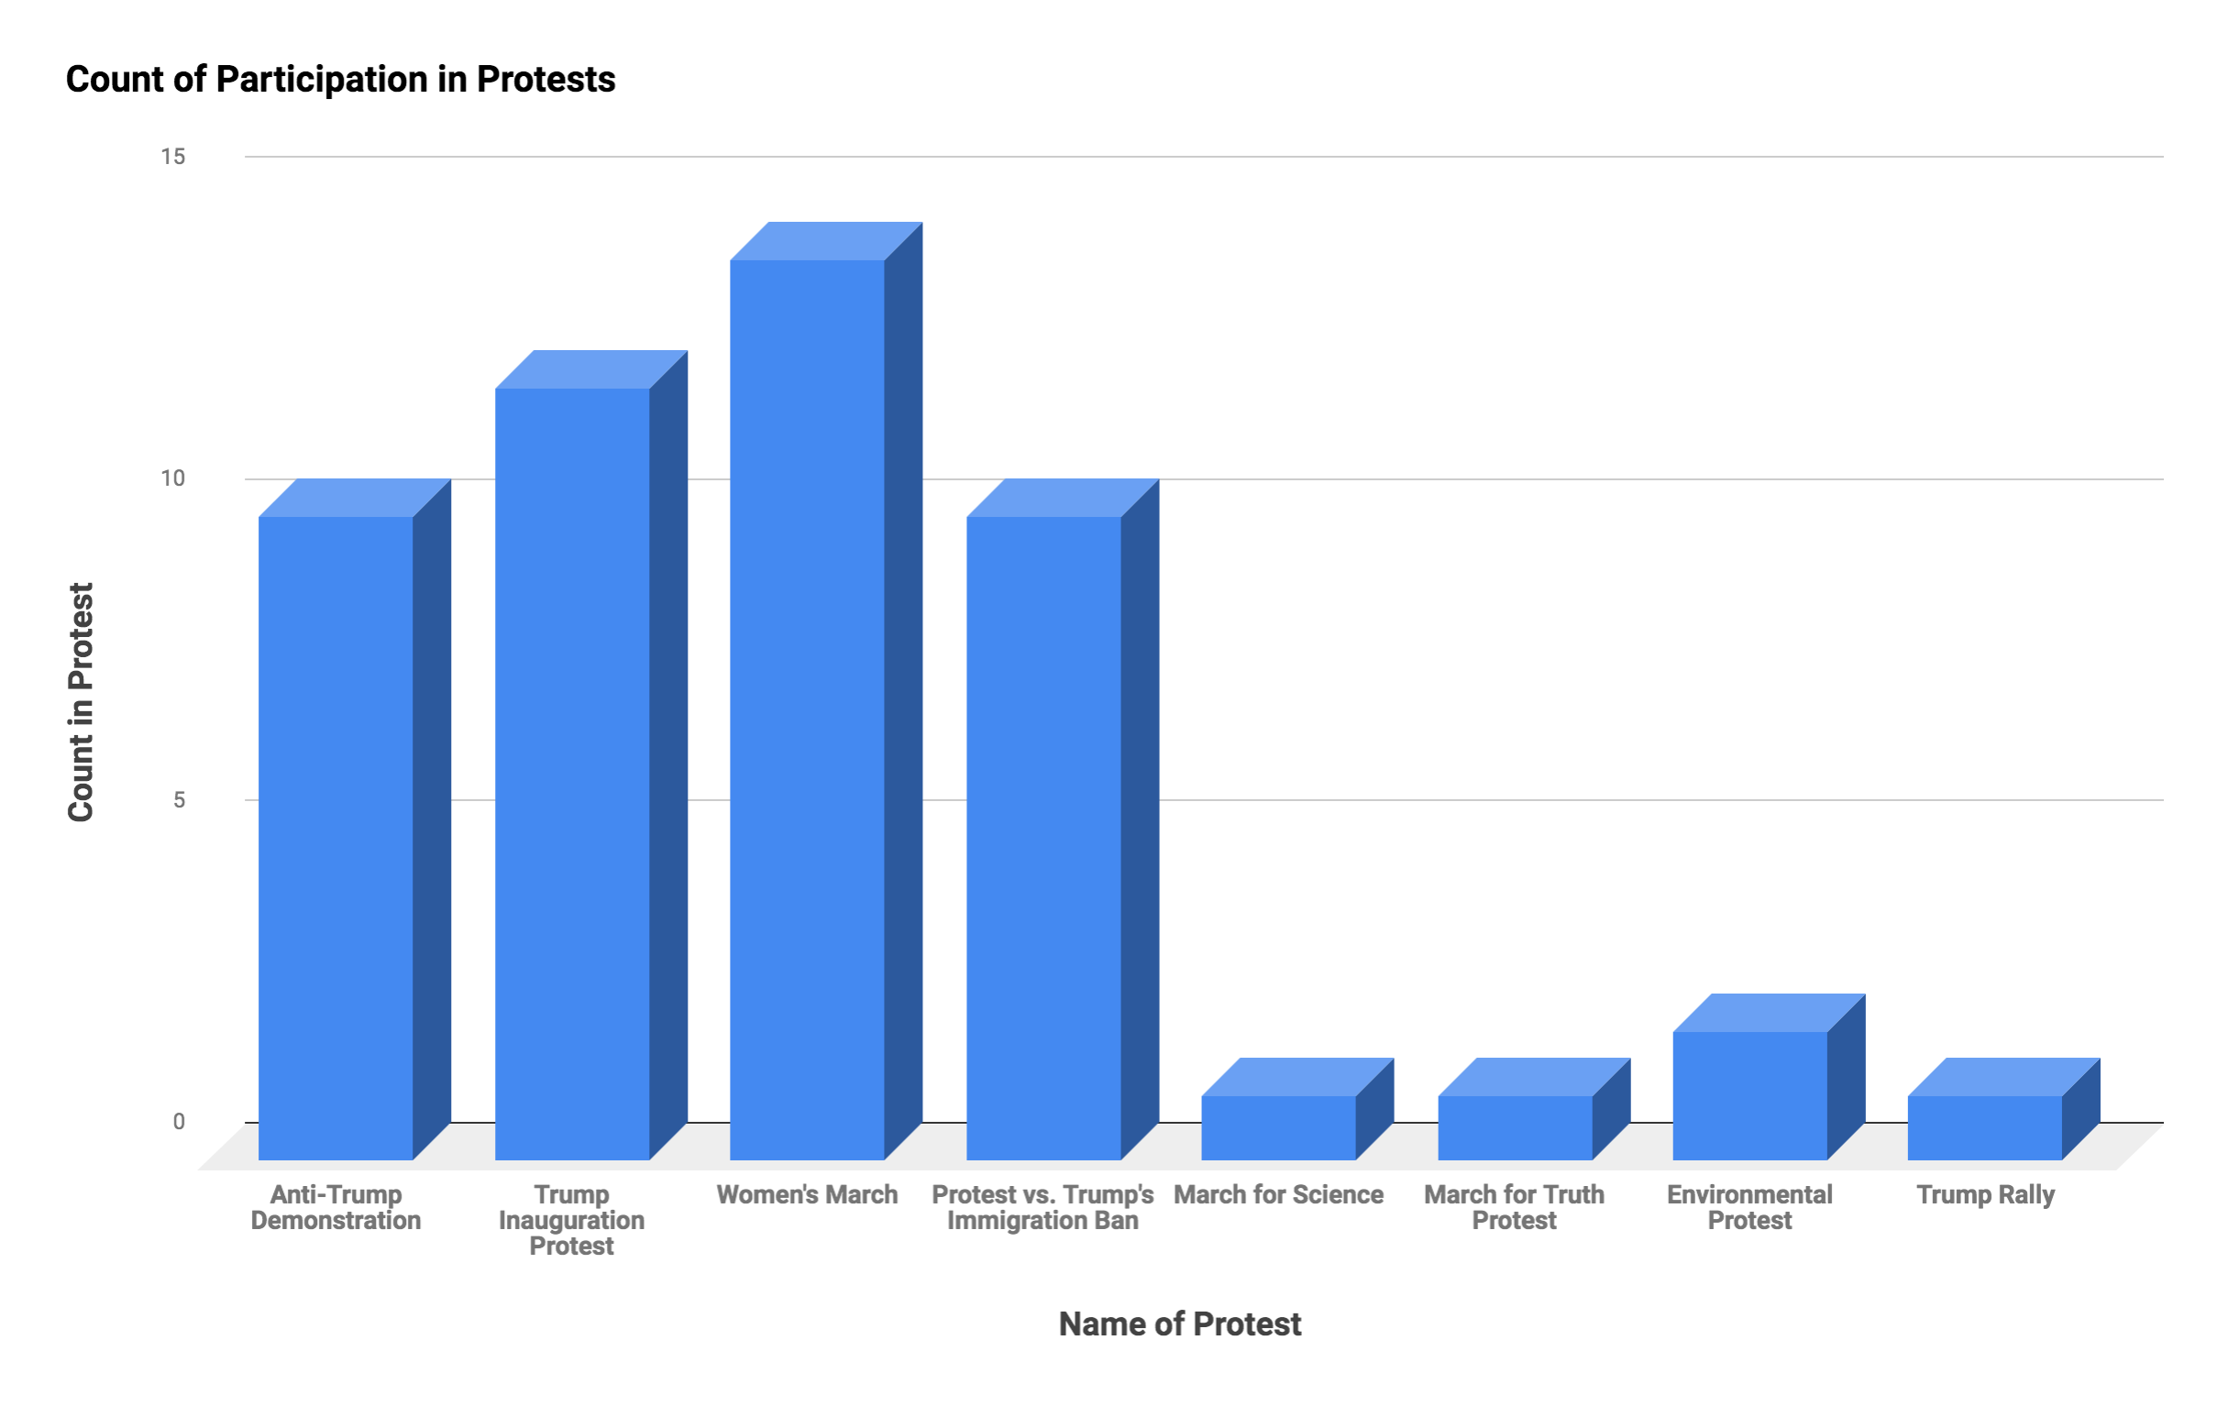

**Figure 9. Bar Graph Identifying Types and Counts of Protests in which Trumpicons Participated in across the Globe**

As Figure 9 makes clear, Trumpicons have enacted protest in over ten different events—from Trump rallies to protests against Trump’s 2017 proposed immigration ban to protests advocating for environmentalism and people’s rights. Based on our research, the “Twitler” Trumpicon appears in nearly all of these protests: from local anti-Trump demonstrations to the 2017 March for Truth protest in the U.S. to the 2017 Women’s March that took place across the world. One protest in which “Twitler” regularly participated was the protest against Trump’s proposed immigration ban in early 2017. The ban—officially titled “Protecting the Nation from Foreign Terrorist Entry into the United States” and often colloquially referred to as the Muslim ban—barred non-U.S. citizens from seven countries (Iran, Iraq, Libya, Somalia, Sudan, Syria, and Yemen) from entering the U.S. Many have argued that such immigration policy and ban is justifiable, having little to do with xenophobia and Islamophobia. But this ban is the hallmark of white nationalist postracial discourse that attempts to reclaim white nationhood while also denying white supremacy. In their remarks about Trump’s discourse on immigration, Jayashri Srikantiah and Shirin Sinnar claim, “Even if certain remarks might be challenged as insufficiently proven or susceptible of non-racist meanings, the record as a whole cannot be read in race-neutral terms.” The “Twitler” Trumpicon goes further, suggesting in this rhetorical moment that, in fact, Trump’s rhetoric and immigration ban cannot only be read in racist terms but fascist ones. Many scholars have noted that likening Trump to Hitler is problematic. Sylvia Taschka, for example, claims that “False equivalencies . . . risk trivializing Hitler and the horrors he unleashed.” Taschka argues, “They also prevent people from engaging with the actual issues at hand – ones that urgently require our attention: immigration reform, rampant xenophobia, social and economic restructuring in a globalized world, and a loss of faith in government’s ability to solve pressing problems.” While we respect Taschka’s first concern, in its interaction with other signs and bodies at the Philadelphia airport (See Figure 10), the “Twitler” Trumpicon demonstrates that analogies between Trump and Hitler can help draw attention to contemporary exigent issues, as it explicitly calls out the xenophobic and racist ideologies undergirding Trump’s ban.

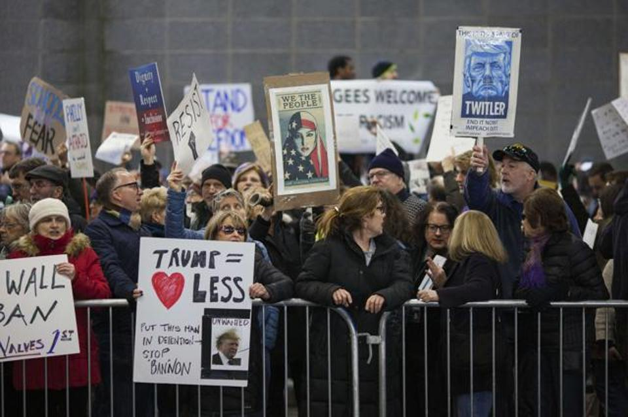

**Figure 10. “Twitler” Trumpicon Participating in Philadelphia International Airport Protest against President Donald Trump's Executive Order Banning Muslim Immigration**

As Trumpicons enter into conversation with other signs at such protests, Trumpicons engage in a phenomenon that Ronald Scollon, Suzanne Scollon and Suzie Scollon refer to as *interdiscursive dialogicality* in which “several discourses are co-existing simultaneously in a particular semiotic aggregate but none of the discourse’s internal meanings are altered by the presence of another” (193). In this situation, the signs are operating independently, but they are also entering into a dialogic relation so that each sign’s meaning is also building off the others (193).

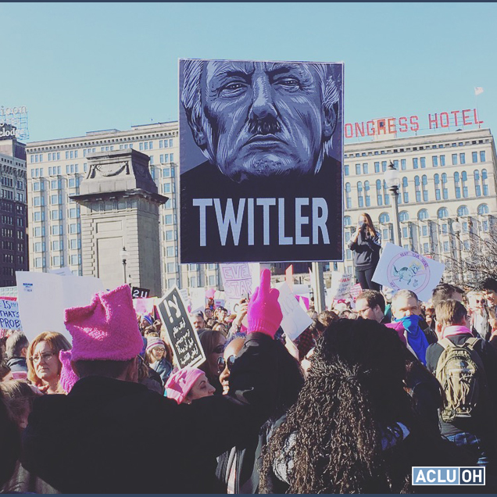

**Figure 11. Depiction of “Twitler” Trumpicon Interacting with other Signs at the Women’s March in January 2017**

So, as in another instance, Figure 11 shows the “Twitler” sign at a Women’s March protest in January 2017 entering into a dialogic relation with a pink hat, a visual statement which became a global sign of solidarity in this widespread global protest. One pink hat knitter, who identifies with the Pussyhat Project, [explains](https://www.pussyhatproject.com/our-story) that the pink hat was “chosen in part as a protest against vulgar comments Donald Trump made about the freedom he felt to grab women’s genitals, to de-stigmatize the word ‘pussy’ and transform it into one of empowerment.” When the “Twitler” Trumpicon comes into dialogic conversation with the pink hat at a Women’s march, it works in overlapping ways to demonstrate how activists are not only protesting Trump’s misogyny but also his racism and xenophobia. Through such interdiscursive dialogicality, affects and *doxa* circulate among signs and bodies involved in protest, co-constituting an affective economy of resistance in which anger, frustration, and disappointment intertwine with anti-white supremacist and anti-sexist beliefs to resist Trump’s discourse and policies. Therefore, if Trumpicons like “Twitler” seem out of place to some at the Women’s March, it all of a sudden becomes crystal clear as to why activists who feel (and are) discriminated against and oppressed would turn to Trumpicons. They remind us something very important about Trump’s rhetoric and policies—that we cannot forget about Trump’s xenophobic and racist policies in a moment of protesting Trump’s misogyny—that we must, as many (queer) women of color have emphasized for decades, fight against multiple systems of oppression at once.

**Conclusion**

In this chapter, we have extended our previous conceptualization of the racial politics of circulation by disclosing how resistance efforts and practices co-constitute the ongoing cultural-rhetorical politics of white supremacy in our contemporary context. We demonstrated how new media genres such as Trumpicons are not simply social actions, aneutral, or apolitical (as politics proper). New media genres are caught up in affective economies and conflicting tensions about Trump’s white nationalist postracial logics, rhetorics, and policies. Trumpicons are both the effects and affects of racio-political tension. They are *both* seeds for the propagation of white national postracial logics and rhetorics *and* the accumulation and force of (some kind of) resistance. Perhaps this should not be so surprising. Politics are systems of power, and in power systems, there is always friction, resistance in which artifacts and bodies rub up against each other. Participatory culture—and the new media genres that emerge within yet circulate beyond it into broader cultural contexts—are not divorced from this process. New media genres are especially important players in the friction that is palpable both in the U.S. and across the world in this crucial racio-political moment.

We have also shown how critical genre studies can be a productive methodology for doing digital visual studies. Vernacular genres such as Trumpicons are ephemeral, emerging and evolving to generate a shared practice of political commentary that, as we saw in our case study, contributes to various acts of resistance—from individual acts of satirical parody to commodity activism to embodied protests. As scholars continue to take a critical genre approach to study how new media genres contribute to public matters, future research might address two important inquiries. First, how effective is satire in era of Trumpism? As Charles Blow recently wrote “The white male racist patriarchy will not be denied. It is having a moment. It has its own president.” Confronted with such a powerful force, does satirical parody have any real power, especially when listening and considering opposite points of view seems so rare (understandably so) these days in the U.S. and divisions between Trump and anti-Trump supporters are so tense? Let’s face it—most of the satirical parodies we identified in this chapter were obviously designed and distributed by anti-Trump citizens. And clearly, as evident in the artist’s Flickr comment above, many believe in the power of ridicule to resist Trump. But what measurable consequence are these new media genres actually having against a white nationalist postracial force that is able to amplify racism and xenophobia and patriarchal white supremacist capitalism under the guise of non-white nationalist aims? It’s an important question we need to keep pressing on.

Second, how might we better understand the participation of new media genres in the commodification of activism, and are such acts of resistance actually consequential in our current neoliberal context? Our research here has been limited in that we shortchanged attention to efficacy and consequentiality in that we mainly focused on how Trumpicons have become embroiled in the racial political of circulation and various efforts of resistance. As Stephen Duncombe pushes us to interrogate, “if resistance doesn’t lead to change, then what is its function, and how do we need to (re)understand it?” While we have made great strides here to show how Trumpicons do in fact become embroiled in activist efforts to resist, we second Duncombe’s question. While new media genres such as Trumpicons are clearly good at enacting satirical parody and selling mass commodities, we still need to be open to the fact that even when coupled with on-the-ground protests, such enactment of resistance might not be (and probably is not) enough to counter the white nationalist postracial logics, rhetorics, and policies that seem to be proliferating not just here in the U.S. but across the world. As we move forward with digital visual studies from a critical genre perspective, then, we might deepen our interrogations of satire and commodity activism, especially so that we can help expose and confront oppressive and dominant justices that have real consequences upon real bodies in the world.

**Works Cited**

Ahmed, Sara. *The Cultural Politics of Emotion*. 2nd ed., Routledge, 2004.

Applegarth, Risa. “Genre Emergence and Disappearance in Feminist Histories of Rhetoric.” *Emerging Genres in New Media Environments*, edited by Carolyn R. Miller and Ashley R. Kelly, Palgrave Macmillian, 2017, pp. 275-290.

Banks, Adam. *Digital Griots: African American Rhetoric in a Multimedia Age*. Southern Illinois UP, 2011.

Blow, Charles M. “White Supremacy Beyond a White Majority.” *The New York Times*, 15 May 2019, <https://nyti.ms/2JiII04>

Carstarphen, Meta G., and Kathleen Welch. “Introduction: Looking into the Mirror.” *Rhetoric, Race, and Resentment: Whiteness and the New Days of Rage*, special issue of *Rhetoric Review*, vol. 36, no. 4, 2017, pp. 255-347.

Cisneros, J. David. “Racial Presidentialities: Narratives of Latinxs in the 2016 Campaign.” *Rhetoric & Public Affairs*, vol. 20, no. 3, 2017, pp. 511-523.

Dietel-McLaughlin, Erin. “Remediating Democracy: Irreverent Composition and the Vernacular Rhetorics of Web 2.0.” *Computers and Composition Online, 7* January 2009, <http://cconlinejournal.org/Dietel/>

DeLuca, Kevin Michael, and Jennifer Peeples. “From Public Sphere to Public Screen: Democracy, Activism, and the ‘Violence’ of Seattle.” *Critical Studies in Media Communication*, vol. 19, no. 2, 2002, pp. 125-151.

Devitt, Amy. “Genre, Genres, and the Teaching of Genre.” *College Composition and Communication*, vol. 47, no. 4, 1996, pp. 605-615.

Dionne Jr., E.J. “Trump relishes autocracy. What are Republicans willing to do about it?” *The Washington Post*, 17 March 2019, <https://www.washingtonpost.com/opinions/trump-relishes-autocracy-what-are-republicans-willing-to-do-about-it/2019/03/17/b4a28242-4775-11e9-8aab-95b8d80a1e4f_story.html?noredirect=on&utm_term=.c6acddc4d23d>

Duncombe, Stephen. Book Review of *Commodity Activism: Cultural Resistance in Neoliberal Times* by Roopali Mukherjee and Sarah Banet-Weiser, *International Journal of Communication*, vol. 6, 2012, pp. 291–294.

Drucker, Johanna. “Humanities Approaches to Graphical Display.” *Digital Humanities Quarterly,* vol. 5, no. 1, 2011, n.p. [www.digitalhumanities.org/dhq/vol/5/1/000091/000091.html](http://www.digitalhumanities.org/dhq/vol/5/1/000091/000091.html)

Enck-Wanzer, Darrel. “Barack Obama, the Tea Party, and the Threat of Race: On Racial Neoliberalism and Born Again Racism.” *Communication, Culture and Critique*, vol. 4, no. 1, 2001, pp. 23–30.

Freedman, Avivia, and Peter Medway. “Locating Genre Studies: Antecedents and Prospects.” *Genre In The New Rhetoric*, edited by Avivia Freedman and Peter Medway, Taylor and Francis, 2013, pp. 1-19.

Gardiner, Eileen, and Ronald G. Musto. *The Digital Humanities: A Primer for Students and Scholars*. Cambridge UP, 2015.

Gries, Laurie. *Still Life with Rhetoric: A New Materialist Approach for Visual Rhetorics*. Utah State UP, 2015.

Gries, Laurie. “Mapping Obama Hope: A Data Visualization Project for Visual Rhetorics.” *Kairos: A Journal of Rhetoric, Technology, and Pedagogy*, vol. 21, no. 2, 2017, http:/​/​kairos.technorhetoric.net/​21.2/​topoi/​gries/​references.html

Gries, Laurie, and Phil Bratta. “The Racial Politics of Circulation: Trumpicons and White Supremacist *Doxai*.” *Rhetoric Review*, forthcoming.

Hayden, Michael Edison. “White Nationalists Praise Trump for ‘Shithole’ Comment: ‘It’s Obviously All About Race.’” *Newsweek*, 12 January 2018, [www.newsweek.com/trump-shithole-comment-white-nationalists-praise-779958](http://www.newsweek.com/trump-shithole-comment-white-nationalists-praise-779958)

Lacy, Michael G., and Kent A. Ono. “Introduction.” *Critical Rhetorics of Race*, edited by Michael G. Lacy and Kent A. Ono, New York UP, 2011, pp. 1-17.

Lewis, Lynn. “Don’t Tase Me, Bro: Emergent Participatory Economies across Web Spaces.” *The Rhetoric of Participation: Interrogating Commonplaces In and Beyond the Classroom*, edited by Paige V. Banaji, Lisa Blankenship, Katherine DeLuca, Lauren Obermark, and Ryan Omizo, Computers and Composition Digital Press/Utah State UP, 2019, <https://ccdigitalpress.org/book/rhetoric-of-participation/lewis/>

Manchester, Julia. “David Duke: Charlottesville protests about ‘fulfilling promises of Donald Trump.’” *The Hill*, 12 August 2017,<http://thehill.com/blogs/blog-briefing-room/news/346326-david-duke-charlottesville-protests-about-fulfilling-promises>

Marx, Karl, and Friedrich Engels. *The Communist Manifesto*. Penguin Books, 1967.

Maskovsky, Jeff. “Toward the Anthropology of White Nationalist Postracialism.” *HAU: Journal of Ethnographic Theory*, vol. 7, no. 1, 2017, pp. 433-440.

McIlwain, Charlton. “From Deracialization to Racial Distinction: Interpreting Obama's Successful Racial Narrative.” *Social Semiotics*, vol. 23, no. 1, 2013, pp. 119-145.

McKerrow, Raymie E. “Foreword.” *Critical Rhetorics of Race*, edited by Michael G. Lacy and Kent A. Ono, New York UP, 2011, pp. ix-x.

Medina, Cruz. “Digital Latinx Storytelling: testimonio as Multimodal Resistance.” *Racial Shorthand: Coded Discrimination Contested in Social Media*, edited by Cruz Medina and Octavio Pimentel, Computers and Composition Digital Press/Utah State UP, 2018, <http://ccdigitalpress.org/book/shorthand>

Miller, Carolyn R. “Genre as Social Action.” *Quarterly Journal of Speech*, vol. 70, 1984, pp. 151-167.

Miller, Carolyn R. “Where do Genres Come From?” *Emerging Genres in New Media Environments*, edited by Carolyn R. Miller and Ashley R. Kelly, Palgrave Macmillan, 2017, pp. 1-34.

Mittell, Jason. *Genre and Television: From Cop Shows to Cartoons in American Culture,* Routledge, 2004.

Mueller, Derek N. *Network Sense: Methods for Visualizing a Discipline*. The WAC Clearinghouse, 2017.

Nakamura, Lisa. *Cybertypes: Race, Ethnicity, and Identity on the Internet*. Routledge, 2002.

Nakamura, Lisa. *Digitizing Race: Visual Cultures of the Internet*. U of Minnesota P, 2008.

Omi, Michael, and Howard Winant. “Racial Formation.” *Race Critical Theories: Text and Context*, edited by Philomena Essed and David Theo Goldberg, Blackwell Publishers, 2002, pp. 123-145.

Ott, Brian L. “Review Essay: Assessing Rhetorics of Social Resistance.” *Quarterly Journal of Speech*, vol. 97, no. 3, 2011, pp. 334-347.

Rea, Jaclyn, and Riedlinger, Michelle. “Exigencies, Ecologies, and Internet Street Science: Genre Emergence in the Context of Fukushima Radiation-Risk Discourse.” *Genre and the Performance of Publics*, edited by Mary Jo Reiff and Anis Bawarshi, Utah State UP, 2016, pp. 219-238.

Responsible History Education Action. “About,” [http://www.historyaction.org/about.html. Accessed 15 April 2019](http://www.historyaction.org/about.html.%20Accessed%2015%20April%202019).

Porter, Doug. “A Dozen-Plus Opportunities in San Diego to Protest Trump’s Inauguration,” *San Diego Free Press*, 13 January 2017, <https://sandiegofreepress.org/2017/01/a-dozen-plus-opportunities-in-san-diego-to-protest-trumps-inauguration/#.XNmaCY5KjIV>

Sanchez, Ray, and Joe Sutton. “Trump ‘says it’s OK,’ says man accused of groping passenger on Southwest flight.” *CNN*, 23 October 2018, [www.cnn.com/2018/10/23/us/southwest-airlines-sexual-assault/index.html](https://www.cnn.com/2018/10/23/us/southwest-airlines-sexual-assault/index.html)

Scollon, Ronald, Suzanne Scollon, and Suzie Scollon. *Discourses in Place: Language in the Material World,* Psychology New Press, 2003.

The Searcher. “Ridicule.” *Flickr*, 25 January 2017, <https://www.flickr.com/photos/bar-art/31710711973/>. Accessed 15 April 2019.

Shakur, Assata. “To My People By Assata Shakur (written while in prison).” *The Talking Drum Collective.* 4 July 1973, <http://s182466708.onlinehome.us/KevinsDir/2018/03/12/to-my-people-by-assata-shakur-written-while-in-prison/>

Sinclair, Stacey, and Jeffrey R. Huntsinger. “Self-Stereotyping.” *Encyclopedia of Social Psychology*, edited byRoy F. Baumeister and Kathleen D. Vohs, SAGE Publications, Inc., 2007, pp. 848-849.

Skågeby, Jörgen. “Dismantling the Guitar Hero? A Case of Prodused Parody and Disarmed Subversion.” *Convergence*, vol. 19, no. 1, Feb. 2013, pp. 63–76.

Srikantiah, Jayashri and Shirin Sinnar. “White Nationalism as Immigration Policy.” *Stanford Law Review*, March 2019, <https://www.stanfordlawreview.org/online/white-nationalism-as-immigration-policy/>

Taschka, Sylvia. “Trump-Hitler Comparisons too Easy and Ignore the Murderous History.” *The Conversation*, 12 March 2018, <https://theconversation.com/trump-hitler-comparisons-too-easy-and-ignore-the-murderous-history-92394>

Turner Lee, Nicol. “Can White Supremacy be Legislated under Trump?” *Brookings*, 4 October 2017, [www.brookings.edu/blog/fixgov/2017/10/04/can-white-supremacy-be-legislated-under-trump/](http://www.brookings.edu/blog/fixgov/2017/10/04/can-white-supremacy-be-legislated-under-trump/)

1. In some cases, as one reviewer so kindly pointed out, the font style differs from Fairey’s *Hope* design. As with many Obamicons, the color palette sometimes changes as does occasionally the illustration style.
2. We coded Trumpicons as Commercial Sales when sales is the only obvious or stated goal. We coded Trumpicons as parody when a designer identified their work as being created purely for fun in commercial or commercial contexts. We coded Trumpicons as satirical parody when critique was obvious either in design or designer’s tags, accompanying text, or labels.
3. The “Cheeto-faced, Ferret Wearing Shitgibbon” caption, for instance, was first deployed in a tweet by a Britishman responding to a tweet Trump had made about Scotland’s vote to take their country back—an intellectual affront to anyone who keeps up with European politics.