Digging Up Obama Hope:

The Infrastructure of Viral Images

1. Introduction

“The domain obamicon.me is for sale. To purchase, call Afternic.com at +1 781-373-6847 or 855-201-2286. Click here for more details.” This quote lays out the generic process of registering a domain name. When you click for more details, you are re-directed to form where you can enter your personal information, prove you are not a robot, and get a price quote for the domain within 24 hours. What you do not find is anything about the history of what used to be available at Obamicon.me, a once active website that Laurie Gries (2015) argues is largely responsible for the mass production *Obama Hope* remixes that began to widely circulate in 2009. The fact that Obamicon.me is no longer active is not surprising—with the average lifespan of a website estimated around 100 days, there is a lot of content going offline (Lepore 2015). Web users encounter this phenomena in the form of broken links (often marked with error messages or solicitations to purchase such as the offer above), being automatically redirected to a different website (which is what would have happened if you had attempted to access the Obamicon.me URL back in 2016), or finding old content overwritten by something new (what would happen if you purchased the domain and created your own website). In the face of such instability, often termed *reference rot* or *link rot*, one must look elsewhere to understand what Obamicon.me was and what happened to it.

*Paste Magazine* conceived of Obamicon.me in late 2008, a few months before the United States election of President Barack Obama (Paste Staff 2012), and launched the site January 7, 2009 with the message “Regardless of your candidate of choice in the 2008 election, here's your chance to sound-off" (Paste Staff 2009). The site allowed visitors to create and share customized Obamicons, webicons designed in Stephen Fairey’s vectorized version of the Obama Hope image. To create on Obamicon, visitors could upload a photo or taking one with a webcam, adjust the color levels, and insert a custom caption at the bottom of their own digital design (see Fig. 1). Once complete, visitors could save their Obamicon to their computer, share it through social networks such as Facebook or Twitter, and/or upload it to the gallery on the Obamicon.me site where other visitors could interact with it (see Fig. 2). As the announcement for the site urged: create, browse, rate or comment (Paste Staff 2009).

[Insert Figure 1 here]

[Insert Figure 2 here]

And people did. Within a week, the site had generated over 1.5 million views and 40,000 Obamicons, drawing in higher traffic than the monthly average for *Paste’s* primary website. *Paste* editor Josh Jackson explains that Obamicon.me “was officially bigger than our magazine site,” and it was later credited as part of the magazine’s successful business strategy of “generating buzz and traffic for a small, 180,000-cicrc[1] [sic] magazine in a tough independent music market” (FOLIO: Magazine Staff 2009). As part of this business strategy, the bottom of the Obamicon.me site featured a banner advertisement with an invitation to learn more about *Paste Magazine* and a trial subscription offer. *Paste* also partnered with online vendor Zazzle in order to offer visitors the ability to get custom Obamicons printed on items ranging from T-shirts to coffee mugs to more (Duffy 2009; Paste Staff 2012). To promote the Obamicon.me service, *Paste* launched a designated Facebook Page on 18 January 2009. Judging from the posts and the number of current Likes and Follows on the page, few initially listened (@ObamiconMe 2017). Similarly, a company Twitter account shared news coverage of the service and relevant announcements, such as upgrades to the site’s server in response to heavy traffic leading up to the presidential inauguration (@ObamiconMe 2017). Such traffic resulted in the eventual creation of millions of Obamicons.

With site traffic peaking around inauguration, it is clear that part of Obamicon.me’s appeal is tied up with politics and current events. However, even that appeal is not so straightforward. Despite the name of Obamicons, *Paste* framed the site around self-expression and creativity rather than a political messaging—a frame that echoed in the coverage of the phenomenon. Online news sites and blogs often featured galleries of Obamicons selected for humor or quality rather than political commentary (for example, Marino 2009; *The Telegraph* 2009; Yoo 2009). These featured Obamicons tended to draw upon figures from popular culture, such as Yoda from Star Wars and David Bowie, or Internet staples, such as Rick Astley and cats.[2] Political themes did appear, with variations of Obama’s image and the message of hope, such as the zombie Obama (L. Gries 2015), and the satirization of popular U.S. political figures, such as John McCain, Sarah Palin, and Bill Clinton. People also used the Obamicon-making tool to modify photos of themselves, their friends, family, and pets (Mackey 2009; L. E. Gries 2015). Whether used as a venue for creativity or a good way to waste some time, as a political tool or a small chuckle, Obamicon.me offered an ambivalent outlet. To the question put forward by someone on the Facebook page—“Can I like Obamicons and dislike Obama?”—the answer seems to have been decidedly yes.

After the inauguration, the site continued to evolve both in form and offerings. Some of the changes involved making the image filters, in Obamicon.Me creator and *Paste* co-founder Tim Regan-Porter’s words, “white-labeled for clients” (Regan-Porter 2017). To white-label a product or service is to rebrand it so as to seem like a creation of a client company. Such white-labeling included the Green for All image filter, designed for the non-profit of the same name, and a sports filter for the Atlanta Hawks NBA team. Others incidents of white-labeling attempted to make Obamicon.me relevant to emerging events, such as the *Iranicon* (see Fig. 3) launched “to show support for democracy in Iran” and the *Luvicon* (see Fig. 4) designed to tap into Valentines Day celebrations (@obamiconme 2009). From the end of January 2009 through September of that same year, *Paste’s* Twitter account featured a webicon of the day to promote the site. Shortly thereafter, *Paste’s* Facebook Page and primary website stopped offering updates until the announcement of the site’s return in August 2012, just in time for the next election cycle (@ObamiconMe 2017; Paste Staff 2012). Despite the initial popularity of the site, as alternative automatic photo editing options, styles, and trends became available on mobile applications like Instagram, Snapchat, and Meitu and integrated into social networks such as Facebook, and the anchoring current events passed, interest in Obamicon.me waned. The declining interest lead *Paste* to take the site offline in 2013—the same year technology journalist Lauren Orsini declared “the year of the image,” citing the growing popularity of image-oriented social media sites such as Pinterest, Instagram and Tumblr (Orsini 2013). From 2013 through 2016, the URL continued to redirect visitors to *Paste Magazine’s* website and by 2017, the domain was listed as available for purchase. As one Facebook user commented, “Sadly its [sic] not working anymore ☹.”

[Insert Figure 3 here]

[Insert Figure 4 here]

I share this story because Obamicon.me raises interesting research dilemmas for digital visual studies scholars interested in studying visual history and preserving visual culture. If sites that are responsible for producing, storing, and circulating digitally born artifacts that make a lasting impact on culture(s) disappear, scholars lose important primary sources that provide important links to an image’s historicity. In the case of Obama Hope, although Obamicon.me has been taken down, traces of the site do remain scattered—from files saved on computer hard drives to photos uploaded to other social media sites, from custom printed Zazzle goods to blog and news coverage, from web forums to digital archives produced on Pinterest and websites. Despite these traces, according to Gries, the loss of access to Obamicon.me has resulted in the loss of what she approximates to be hundreds of Obamicons and related webicons that play an important role in Obama Hope’s rhetorical history (L. E. Gries 2015). For something with so much interest and uptake as Obama Hope, for something that has become so deeply embedded in the cultural psyche of our contemporary era, the immediate and complete takedown of the Obamicon.me domain marks a significant cultural void, especially for scholars of visual rhetoric. Since visual rhetoric aims to account “systematically for the ways in which images become inventional resources in the public sphere,” link rot poses a particularly pernicious problem (Finnegan 2004).

Fortunately, digital research approaches and technologies do exist that can help address this dilemma, which is the focus of this chapter. Underlying this dilemma, it is important to understand, is a concern with the infrastructure that makes possible not only Obamicon.me, but also the entire visual web. To attend to infrastructure is to examine a set of prior conditions or structuring relationships that influence an image’s unfolding and materialization. Media archeology is a particularly useful research approach for foregrounding infrastructure, especially the conditions that make the reproduction and circulation of images possible. Drawing from a German Media Studies tradition, media archeology is an interdisciplinary approach to the study of media that brackets content as an epiphenomenon in order to look backwards at the enabling conditions.[3] Media archeology is especially useful for recovering sites such as Obamicon.me and the cultural practices that took place there in that it encourages us to look for places of decay, failure, or absence and offers strategies for analyzing the social and technical structures that facilitate historical phenomena. The now-defunct Obamaicon.me site is a case perfectly consistent with media archeology’s general preference for sites of failure, error, and stasis; the removal of the site is an instance of infrastructural inversion (Bowker and Star 1999), an accident or breakdown that suddenly makes infrastructure a visible and pressing concern.

Due to its ability to draw out the infrastructure of the visual web and complicate our understanding of the materiality and temporality of visual culture generally, this chapter argues that media archeology can be a valuable methodology for digital visual studies. This chapter will begin by providing an overview of media archeology, identifying its benefits for digital visual studies, and zooming in on the method of infrastructural inversion. Next, the chapter takes up infrastructural inversion to analyze the now-defunct image generator and social network site Obamicon.me, a study made possible by accessing the site through the Wayback Machine, the public-facing portal of the Internet Archive, the largest archive of the Internet. In addition to offering useful research approaches to helping recover an important part of visual history, this research shows continued relevance of older institutions and forms of centralized power on the existence of digital images, the emergence of new institutions such as the Internet Archive, and the relevance of these new institutions for the study of digital visual culture. Finally, the chapter concludes by suggesting other ways of using media archeology to expand digital visual studies.

2. Media Archeology and Infrastructural Inversion

Media archeology offers digital visual studies a kind of media criticism and analysis that decenters the focus on visual media content and representation in order to concentrate attention on the “intersections of design, implementation, and production of media technologies themselves” (Nakamura 2014a). Unlike more institutionalized research methodologies, media archeology lacks a clear disciplinary home within the university, and no academic organizations or journals are exclusively devoted to media archeological research. Instead, a loosely affiliated group of researchers, artists, archivists, and practitioners together create media archeology through presentations, publications, citational practices, special issues of journals,[4] edited collections,[5] labs,[6] gallery installations, conferences,[7] workshops, and related practices. Such material configurations of media archeology exist alongside a set of common thematics and intellectual commitments, which include a challenge to dominant narratives of media culture and history, the use of the past as an inventional resource[8] to produce an alternative understanding of the present or new possibilities for the future, a sustained attention to archives and artifacts, and an openness to experimental methods.

With a focus on the past, media archeology shares similar concerns with media history. However, media *archeology* differentiates itself from media *history* by pushing back against dominant narratives (e.g., technological progress), universal claims (e.g., mass media produces passive subjects), and tidy periodizations (e.g., digital culture versus analog culture) (Huhtamo and Parikka 2011, 3; Parikka 2012, 13; Zielinski 2006, 27; Zielinski 1999; de Vries 2012, 19)[9]. Similarly, Michel Foucault’s study of discourse as outlined in *The Archeology of Knowledge* has been highly influential on the development of this methodology. For Foucault, an archeological approach entails using history as a critical means to engage the present; it involves diagnosing a problem in the contemporary situation, working genealogically, exploring the epistemological underpinnings of the discourses of a period, and attending to the ways that a given discourse has been imprinted on machines and systems (Garland 2014, 369-372). As Jussi Parikka explains, “Foucault’s contribution to the archeology of knowledge and culture was to emphasize it as a methodology for excavating conditions of existence” (2012, 6).

Media archeology offers an alternative perspective for digital visual studies by reframing the object of study, shifting attention away from the image itself towards the manifold conditions that make the creation, circulation, and even disappearance of images possible. In its deprivileging of content and representation, it broadens our understanding of how images are, or become, meaningful. In so doing, it also pushes digital visual studies to consider how seemingly mundane features of the technological environment, such as web protocols and crawlers, and seemingly remote considerations, such as business models and archival organizations, play important roles in the contemporary visual culture. In addition, media archaeology provides multiple ways to engage the idea of materiality, including the materiality of cultural practice, or attention to the situatedness of human activity and affective investments, the materiality of materials, or significance of non-human elements in the construction of social and political worlds, and the materialities of technologies, with practices of tinkering and reverse engineering in order to understand how technologies work (Parikka 2012, 163-164). Taken together, these attributes attest to the promise of media archeology as a materialist methodology for recovering unconventional aspects of visual culture and offering a compliment to existing approaches such as iconographic tracking concerned with the production, reception, and circulation of images.

While media archeologists draw on a diverse set of research methods, including practice or arts-based research, archival research, and object analysis, the method of infrastructural inversion has particularly unique potential for digital visual studies, especially in relation to digitally born images such as Obama Hope. Errors and breakdowns draw attention to aspects of existence that often go unnoticed and are taken for granted. Geoffrey Bowker and Susan Starr describe this phenomenon as *infrastructural inversion*, the ways that “infrastructure comes out of the woodwork” at moments of accident or break down (Peters 35).[10] For example, a picture failing to load on a webpage may indicate a problem with a plugin, or a problem with the browser, or a problem with the access device, or a problem with the network, or a problem with the website or application, among other possible sources. As a method, infrastructural inversion draws attention to such failings as well as to errors, crashes, glitches, and breakdowns that indicate an encounter between different logic systems and structures and, in doing so, makes visible the infrastructural situatedness of media, particularly visual media. As Bowker and Star note, infrastructure “Becomes visible upon breakdown. The normally invisible quality of working infrastructure becomes visible when it breaks: the server is down, the bridge washes out, there is a power blackout. Even when there are backup mechanisms or procedures, their existence further highlights the now visible infrastructure” (Bowker and Star).[11] *Paste’s* takedown of Obamicon.me is an instance of infrastructural inversion, where an image generator tool, an archive, and social network suddenly became no longer available and, as a result, draws attention to the networked infrastructure and commercial imperatives that had significantly facilitated the circulation of the Obama Hope image. As such, infrastructural inversion can help provide a richer account of the various factors that support digital visual culture.

3. Centralization, Infrastructure, and Institutions

What were the enabling conditions for the spread of the Obama Hope image? In an interview, creator Shepard Fairey attributes it to a kind of grassroots movement supported by motivated individuals and the Internet. This account is certainly partially correct in that grassroots dynamics, motivated individuals, and the Internet *did* contribute to the ubiquity of Obama Hope. However, it is worth emphasizing the partiality of such account; while the overall spread of the image could be characterized as a grassroots phenomenon, a number of influential centralizing organizational forces remained at work, such as the official Obama campaign. Commercial entities such as *Paste Magazine* also played a key role in Obama Hope’s broad circulation because, in producing Obamicon.me, *Paste* provided easy-to-use image generation, sharing, and web hosting. As Laurie Gries notes, the website was one among many digital technologies available to create your own Obama Hope style image, but “Obamicon.me differentiated itself from other Obamifying technologies in allowing Obamicons either to be saved onto visitors’ computers via a simple right click and then uploaded to Flickr or Facebook, which many people have done, or archived and shared in the obamicon.me gallery so that comments can be made in response to an image and links can be established” (Gries 2015, 253). Although “the Internet” was certainly involved in the viral success of the image, the creation of streamlined tools to generate images and social platforms to share images introduces significantly more centralization than the phrase itself might suggest.

The instant and immediate removal of millions of user-generated Obamicons shows how, despite the accounts of decentralization that dominate discussions of user-generated content and virality, centralization is in some ways more salient on the web than in other physical spaces. Compare the spreading of the Obama Hope image through the more traditional means of street art: pasting and graffiti. This approach is carried out by individuals or small collectives of individuals and requires more time and materials from the individual, whether prints and paste or paints. It also often entails a degree of personal risk for the individual, as many places have regulations against the spread of street art. Once placed, the image is subject to a variable life span depending on the content and the area and the interests of property owners, police officers, street artists, and others. While it is likely that images created and collected at Obamicon.me outlived a majority of their street counterparts with the site remaining online through 2013, there are very different dynamics of control at work with images on the Internet. An Obama Hope image pasted on a wall is subject to local jurisdiction and distributed factors such as regulations, traffic, neighborhood dynamics, interest and means of enforcement, the weather, and so on. An image created and hosted on Obamicon.me is subject to more centralized control, living and dying according to the corporation that holds the servers.[12]

Many aspects of digital visual culture are networked, and it is important to pay attention to the characteristics of this network. If images are hosted on a single platform, that platform is subject to the actions of a corporation and will be available only as long as the interests of the corporation are served keeping it online. As Jill Lepore cautions, “a lot of people do believe that if it’s on the Web it will stay on the Web. Chances are, though, that it actually won’t” (Lepore 2015). Consider the takedown or substantial transformation of other web platforms such as GeoCities and MySpace, where entire online communities now only exist in fragments, saved to individual computers, as cached pages, or in archived but unorganized collections. Likewise, consider the controversial policy changes that image hosting service Photobucket implemented in June of 2017, when the company disabled the free hosting of images on third party sites and required users to pay an annual fee of $399 (US). The service, which has been around since 2003, removed hosted images and replaced them with an image of a speedometer and the message that “Your account has been restricted for 3rd party hosting” and an urge to upgrade membership. These error message images now litter websites and online marketplaces like Etsy and eBay, as most users have refused to upgrade their accounts (Garun 2017). While the spread of viral images may be partially attributed to grass roots phenomena, especially with the distribution of people involved, the case of Obamicon.me shows an important way in which centralizing forces are at work in digital visual culture, with political implications.

Although the web has signaled a move away from the primacy of media institutions like broadcast television and the press, circulation (and its failure) continues to depend on institutions—just not those we might expect. Consider the institutions guiding the web, the sets of standards that make pages load consistently and globally, the commercial institutions that get in on trends, finding ways to try and monetize them. The huge spike in web traffic on Obamicon.me was one that generated advertising revenue, that could lead users to other *Paste Magazine* content, that could help contribute to the relevance of the brand (FOLIO: Magazine Staff 2009). When those goals are no longer being met, the company can (and did) pull the content and features offline. While the collection of Obamicons are an important part of the cultural heritage of Obama’s election and presidency (L. E. Gries 2015), did fuel partisan divides and support dog-whistle politics (L. Gries 2015), did represent a facet of the democratization of online activism (Bayerl and Stoynov 2016) and did serve as an exemplary of remix culture on the web (Edwards 2011), these circumstances were not salient to the institutions and infrastructure that enabled such diverse functions. As a commercial entity, *Paste* was mainly, if not solely, concerned with Obamicon.me for the ways it did (and later did not) contribute to the profitability of the magazine. This is not to say that Obamicons did not perform import cultural and political functions, but rather that these functions were dependent, at least in part, on technological infrastructures built and supported by underlying economic imperatives.

4. Digging Up Infrastructure with the Wayback Machine

While infrastructural inversion helps us account for the mechanisms and related factors that deepen our understanding of how sites such as Obamicon.me come into development and then fade from activity, the issue still remains as to how we might access the content lost when such link rot occurs. The Wayback Machine was developed to address such infrastructural issues and, as such, offers a valuable resource for the study of digital visual culture. The Wayback Machine began saving copies of web pages in 1996 and the growth of its archive is now propelled by automated web crawlers, a curated selection service used by librarians and subject experts called Archive IT, and individual users saving pages (Lepore 2015). As Brewster Kahle, founder of Internet Archive and the Wayback Machine explained, the goal is to make cultural materials safe and perpetually accessible because “the history of libraries is one of loss” (Robertson 2016).

As a project of the Internet Archive, an organization devoted to the free and open spread of knowledge, the Wayback Machine represents a novel institution of the web that provides both a way of studying images that have been otherwise removed from the web but also a force that significantly affects the lifecycle of images online, in part by using images (the cached webpages) as a method of preserving web content. The Wayback Machine allows users to access snapshots of select webpages that extend back to the mid-1990s. Users can search by web address and then see a calendar and time distribution graph of when the web page has been saved. By selecting a particular time, the user pulls up the images of the webpage captured at the particular date and time. The Wayback Machine is the result of the efforts of Internet Archive director Brewster Kahle to make some resources of the Internet Archive more publicly accessible, although how accessible the archive actually is remains a point of contention; as Lepore explains, “You can’t search it the way you can search the Web, because it’s too big and what’s in there isn’t sorted, or indexed, or catalogued in any of the many ways in which a paper archive is organized; it’s not ordered in any way at all, except by URL and by date” (Lepore 2015). Although Kahle proposed the Wayback Machine as “a browsing interface, a wow-isn’t this-cool interface” even he notes that it’s only “a first step” (Kahle, quoted in Koman 2002). To date, there have been few applications of the archive in academic research.[13]

The removal of Obamicon.me is just one small instance of the loss that is endemic to the web, but also one that did not go unnoticed. On a discussion on the Obamicon.me Facebook Page following the takedown of the website, one person offered a workaround to create Obamicons, directing others to the saved version of the site on the Wayback Machine but noting that one would have to take a screenshot of the image because the save feature no longer worked (see Fig. 5 for an example). The archive contains cached versions of the website captured at different points in time and preserves many aspects of the original site, including an extensive collection of Obamicons, ratings, and comments. However, because the archive preserves cached versions of the website, any functionality that requires contact with the original server no longer works. Social functionality like saving, sharing, and commenting are no longer available and an array of error messages (see Fig. 6 for an example) and glitches in the archive signal their absence.

[Insert Figure 5 here]

[Insert Figure 6 here]

Still, presence and absence alike in the Wayback Machine’s archive of Obamicon.me helps contribute to a more complex understanding of the site, the ways in which a visual phenomenon is simultaneously and irreducibly technical, and what the Wayback Machine can help recover for visual rhetoric. The discursive accounts of Obamicon.me, referenced in the introduction, give a general sense of what the site was but tend to focus on exemplar Obamicons rather than infrastructure. The Wayback Machine, on the other hand, includes many images of the site captured over time—over 403 times between January 20, 2009 and February 22, 2013 for the main page—and these images contain additional information that helps one understand the infrastructure of the site, including changes in orientation and functionality, advertisements, and general site design. Additionally, the errors in the archive, what is missing and what does not load, also get at aspects of the site’s infrastructure. As cached web pages, many of the advertisements do not load and the ones that do are no longer monetized. The individual pages and images are not networked in the same way, with any link or content dependent upon accessing *Paste’s* servers rendered inoperable. While evidence of the sites concern with engagement remains (see Fig. 7 for the site registration page, encouraging users to log in or sign up despite the fact that neither feature is functional anymore), the different governing logic and technical capacities of the Internet Archive have altered the functionality.

[Insert Figure 7 here]

Examining the appearance of the website over time shows that the Obamicon.me site was dynamic, changing in its design and mode of address, and expansive in its account of what an Obamicon entails. The first chronological capture includes more explanatory, introductory information, explaining the timeliness of the launch (“The longest election season in memory is now over, and we wanted to help you unwind and express yourself as we head into the new era”), an explanation of what the site offers, and instructions for getting started. Additionally, the slogan at the top of the page characterizes it as “a bit of presidential fun created by *Paste Magazine*.” For the next few months, research on the Wayback Machine reveals a number of site updates that include a variety of generated Obamicons, the launch of a Twitter profile, and Facebook app. For example, on February 6th 2009, Luvicon launched to allow visitors to create Valentine’s-themed red and white images. Merchandise became available in April of 2009 and new features appeared on the front page, including Obamicon of the day. Also, in April, the creation tool added a cutout feature to remove background material from user images and create an image that more closely approximates Shepard Fairey’s style. In June, a third photo generator became available: the Iranicon, a green and white take on the Obama-hope style image designed to allow users to demonstrate their solidarity for free elections in Iran. As *Paste* president Tim Regan-Porter explains on the homepage: “These symbolic gestures may not have a huge impact, but millions around the world want to show their solidarity with those fighting for such fundamental rights and I think it's important to offer whatever encouragement we can."[14] Gone is the focus on presidential fun and instead a more generalized or generic take on “webicons,” explained as a generic name for color manipulated images.

In addition to the homepage captures displaying such features and information, the Wayback Machine allows researchers to access eighty-six captures of the Gallery page, with user-uploaded images, ratings, and interactive features. The Gallery archives are partial—some cached pages do not load the images, others lack the ratings or comment features. Saved images from the first page of the Gallery note that it contains thousands of pages of webicons, but after clicking through the first few pages, error messages like “The page you were looking for is not available” become increasingly common (Fig. 6). Still, the Gallery contains a far greater number of Obamicon images than available from news articles or blog posts about the site. In the pages on the Wayback Machine, many Obamicons are more mundane takes on the image style, featuring anonymous figures, captions that do not seem to make any sense, low quality photographs, etc. While there were certainly many humorous remixes of popular culture and pointed political messages created with Obamicon generators, the viral phenomenon was also constituted by a much larger number of mundane, confusing, boring, and/or personal images. Most of these images, with few views and even fewer comments, do not feature in Gries’ accounts of the Obamicon phenomenon, but they represent the unique views and metrics of engagement that, in turn, helped make the platform economically viable and facilitate the creation of all Obamicons, clever, insightful, humorous, meaningful—or not. As such, the captures of the Gallery pages highlight the often-overlooked importance of forms of attention and engagement that sustain online advertising-supported platforms. Although this is not the kind of material that gets pulled off the platform and reported on as exemplary (for its message, for its quality, etc.), it remains significant because it is the very stuff that made Obamicon.me valuable to *Paste Magazine* and was thus also an enabling condition for the exemplary works.

From the broader range of content recovered from the archived pages of Obamicon.me on the Wayback Machine, one can also create an account of Obama Hope phenomenon that diverges from prominent discursive accounts. This includes many instances of blurry photos and poor composition, of personal messages rather than a more general address through politics or popular culture. While the overall Obamicon phenomenon was certainly a viral success, its success depended in part upon the creation of many individual Obamicons that generated little to no attention. This finding cautions against an understanding of virality that takes any set of formal or technical features as guarantees of success. Instead, the numerous mundane, ignored, overlooked images, ones with few ratings and no comments, perform failures of the spreadability so championed by Henry Jenkins (Jenkins, Ford, and Green 2013). Any viral trend leaves a much more numerous group of ignored content in its wake and the Wayback Machine provides a better glimpse of the mundane, even boring, aspects of the social production of visual culture.

Despite the errors and limitations of the archive, the record preserved on the Wayback Machine is not completely static, creating opportunities to explore traces of dynamism and the ways interactivity was structured on a given website. Some of the hyperlinks on Obamicon.me pages still work and the filter mechanism has been preserved. Although it is not possible to upload an image to the site, the webcam feature is also still functional and you can modify the balance between the colors of the site to create a better balance or achieve other desired aesthetic ends. When engaging in this process, one can almost pretend that the site is still active, giving researchers a sense of how the site originally functioned. Unfortunately, this illusion is quickly shattered if one goes to save the image, as that function is not available. Instead, the uploading webicon screen runs indefinitely, confronting the expectations for sociality, interactivity, and instantaneousness that are typical to contemporary social image sharing sites. All of the built-in features to share on the site suggest that it is not about the process of image creation in and of itself, but the ability to create a sharable image. At the same time, there is an expectation that the process of creating a sharable image should be seamless: even the uploading page gives a bar to show progress, indicating one way that the site was designed to manage the expectations of visitors and give meaning to any delay. Technically created and modified images constitute the raw material for establishing connections between people, and providing content for social networks.

In sum, the Wayback Machine makes it clear that sharing is not just something that automatically happens on the web; it is engineered at the technical level of site design. Using their archives, one can also recover the different kinds of technical features that contribute to a viral visual phenomenon: ratings, comments, and export features establish the technical functionality for sharing and the image ranking setup of the gallery display provides incentives for user engagement. Despite the dominance of the visual in contemporary culture, visuality cannot be made sense of in isolation. Instead, there is value to considering the ways that the visual is modified and transformed within historical and material contexts. The analysis of the Obamicon.me as an example of the visual web suggests that the phrase itself is shorthand for particular understandings of sociality, interactivity, and instantaneousness. These are not natural occurrences; these are accomplishments structured by protocols of the web, the design of platforms, and the underlying imperatives that support such institutions. One of the key insights taken from looking at infrastructure is that possible relations are complex, certainly, but they are not infinite or random. Instead, relations are multiply determined, partially structured. This is particularly evident in digital environments, where hyperlinks, flows, feeds, tags, and code all contribute to structure the circulation of digital content.

4. Conclusion

From a grassroots poster, to the iconic image of the 2008 U.S. presidential election, to a meme with conflicting and controversial politics, Shepard Fairey’s image “Obama Hope” has lived, in Laurie Gries’ words, “an extraordinary rhetorical life” (2). Over ten years have passed since Fairey first created the Obama Hope poster, although one could just as easily trace the origins of the image back further to Mannie Garcia’s photograph of then-senator Barack Obama in 2006. In this time, Obama Hope posters on the streets of America have been placed, defaced, reworked, and removed while digital reproductions and remixes of Obama Hope have been created, shared, corrupted, and forgotten. Given all of this, does the Obama Hope image still live? Insofar as physical versions of the image continue to persist on streets, walls, magazine covers, and various other material artifacts; insofar as digital versions of the image continue to occupy URLs; and insofar as the memory of the image continues to manifest in instances of recognition, interest, and inspiration, the answer must be affirmative: yes, the Obama Hope image still lives. At the same time, however, it would be a mistake to characterize the image as eternal and unaffected in light of all the changes and signs of decreased vitality discussed above. Although these changes are supported by complex and multiple determinants, this chapter has worked to show the role of infrastructure in enabling—and disabling—image culture online.

This chapter has also worked to demonstrate how media archeology offers visual studies a methodological orientation for reframing an object of study in ways that foreground the conditions of possibility for the creation and maintenance of visual culture. It offers a cautionary tale about the impermanence of images online, showing the infrastructural precarity in the face of competing economic imperatives and the challenge posed by link rot as a general phenomenon. Additionally, this chapter has proposed a particular approach to media archeology: infrastructural inversion. This approach was applied to the case study of Obamicon.me in order to show the possibilities for application, the research value of the Wayback Machine, and the socio-technical nature of the *visual* in the Visual Web. Given the range of goals and interventions, this chapter is intended to be generative rather than exhaustive in its argumentation, to show the possibilities for future work even as they are not argued for extensively or demonstrated fully. Within this spirit of generativity, I would like to conclude by offering some more explicit suggestions for future research:

* Take up the Internet Archive and Wayback Machine: so far, these resources have received very little academic attention, outside of research librarians assessing their value as online resources and legal scholars documenting the strengths and limitations of the Wayback Machine as a form of legal evidence and relevant case law. For media archeologists interested in the web, these resources are accessible, understudied, and offer a challenge to the dominant presentist orientation of the Internet that privileges the now and the new. For visual studies scholars, the archive offers a rich account of changing web aesthetics, show the importance of visuality in current efforts at web preservation, and provide access to images that may otherwise be no longer available online. This is particular importance for anyone interested in the history of visual culture. As Cara Finnegan has compellingly argued, to understand the role of images in history requires attention to the production, reproduction, and circulation of those images (2004). However, as many of these processes have moved online, it is important to rethink these categories in the context of digital technologies. The Wayback Machine provides a particularly compelling resource for this work.
* Use the theoretical concept of infrastructure to study socio-technical materiality of images on the web: errors and breakdowns offer a method for connecting particular cases with contexts, for drawing attention to the otherwise invisible or unacknowledged infrastructures. This approach comes from bringing the insights of Science and Technology Studies to bear on the study of media and shows another possibility for interdisciplinary work. Additionally, this point emphasizes the importance of taking context seriously and considering the ways that the Visual Web is enabled through an assemblage of technologies, standards, and practices. No infrastructure, no #selfie.
* Attend to the technicity of the visual: digital images are often networked images and it is important to approach these networks agnostically—as a question to be answered through research. This is particularly important given the connotations of the Internet as open and decentralized. The case of Obamicon.me shows how centralization is built back into the web through platforms, often with much greater potential for control than in analog environments. Scholars interested in the politics and culture of images online should consider the ways the affordances of technology work with—and against—the lifecycle of images. This suggests a more complicated account of interactivity as an accomplishment of social and technical design that can be simultaneously empowering and exploitative for users, creating affordances for interaction that can also be leveraged by online corporations towards competing commercial and political ends.

While Lauren Orsini designated 2013 as the year of the image, available evidence indicates that the image continues to grow in quantity and as a site of significant cultural engagement. In response to these developments, the framework for media archeology pushes scholars to be skeptical towards tidy periodizations, to be curious about the discursive and material conditions underpinning the Visual Web, and to consider the ways that the Visual Web manifests outside of the most popular sites and accounts, at the margins. Errors or not, these seem worthwhile dispositions for visual scholars to take up.

Fig. 1

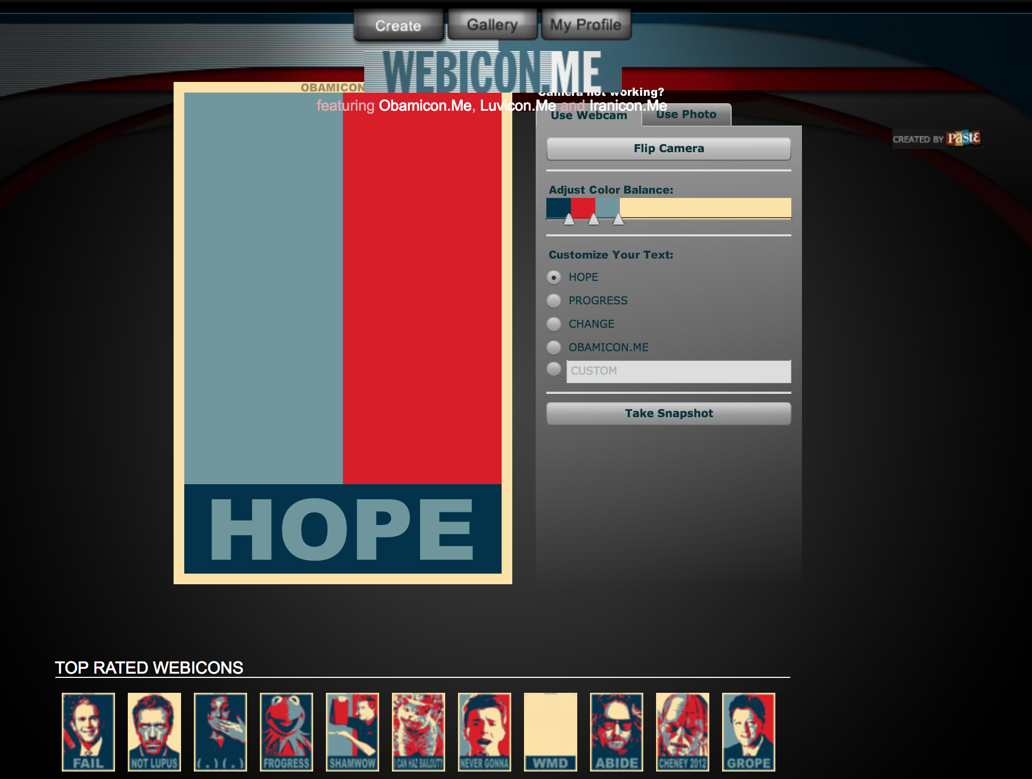

Fig. 2

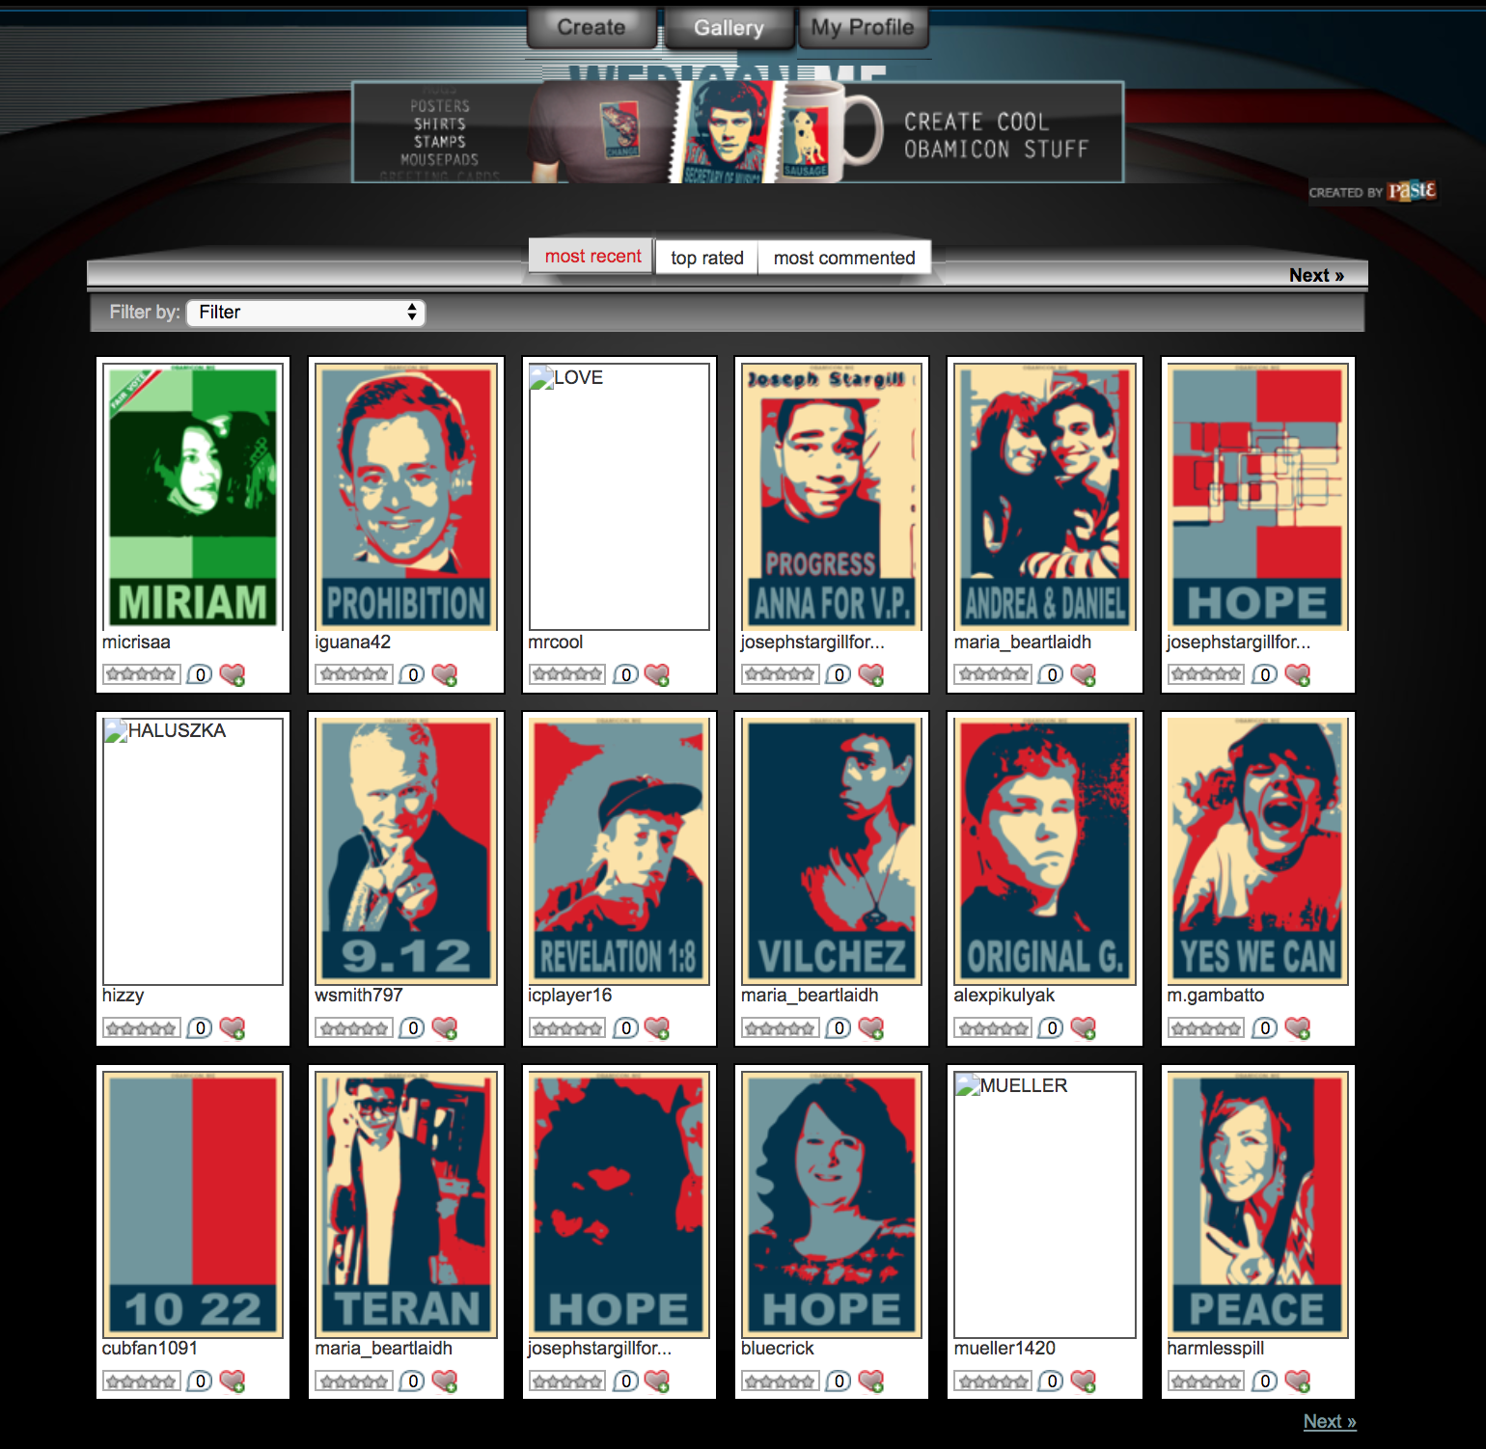

Fig. 3

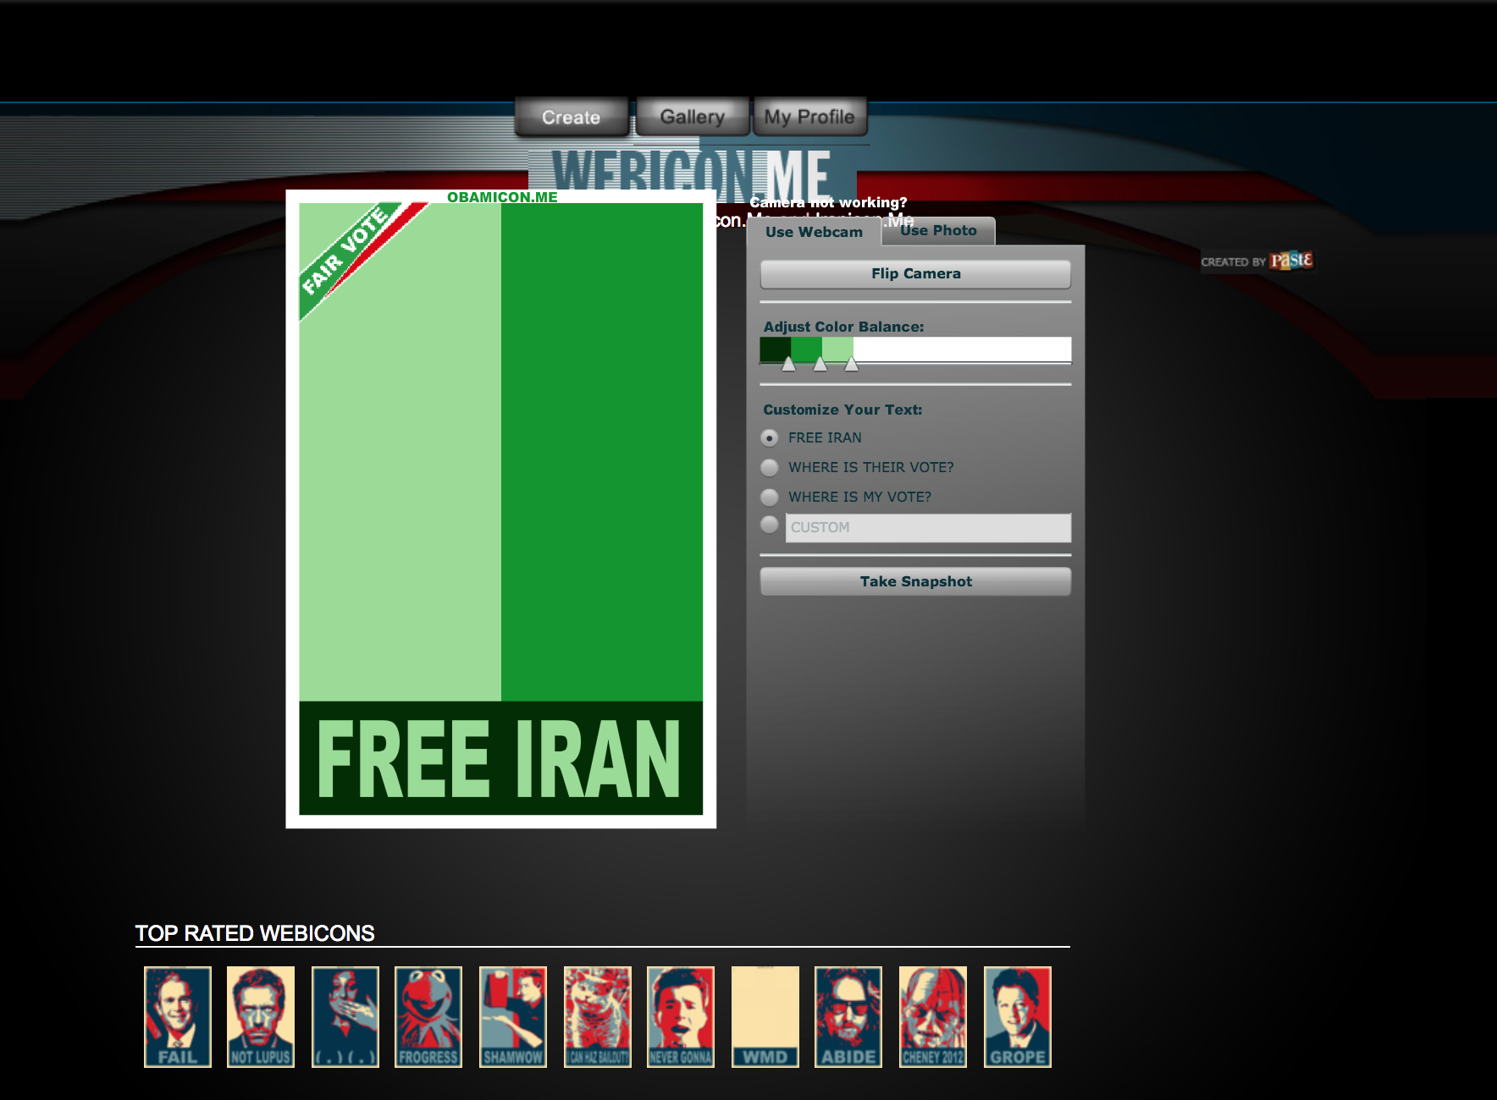

Fig. 4

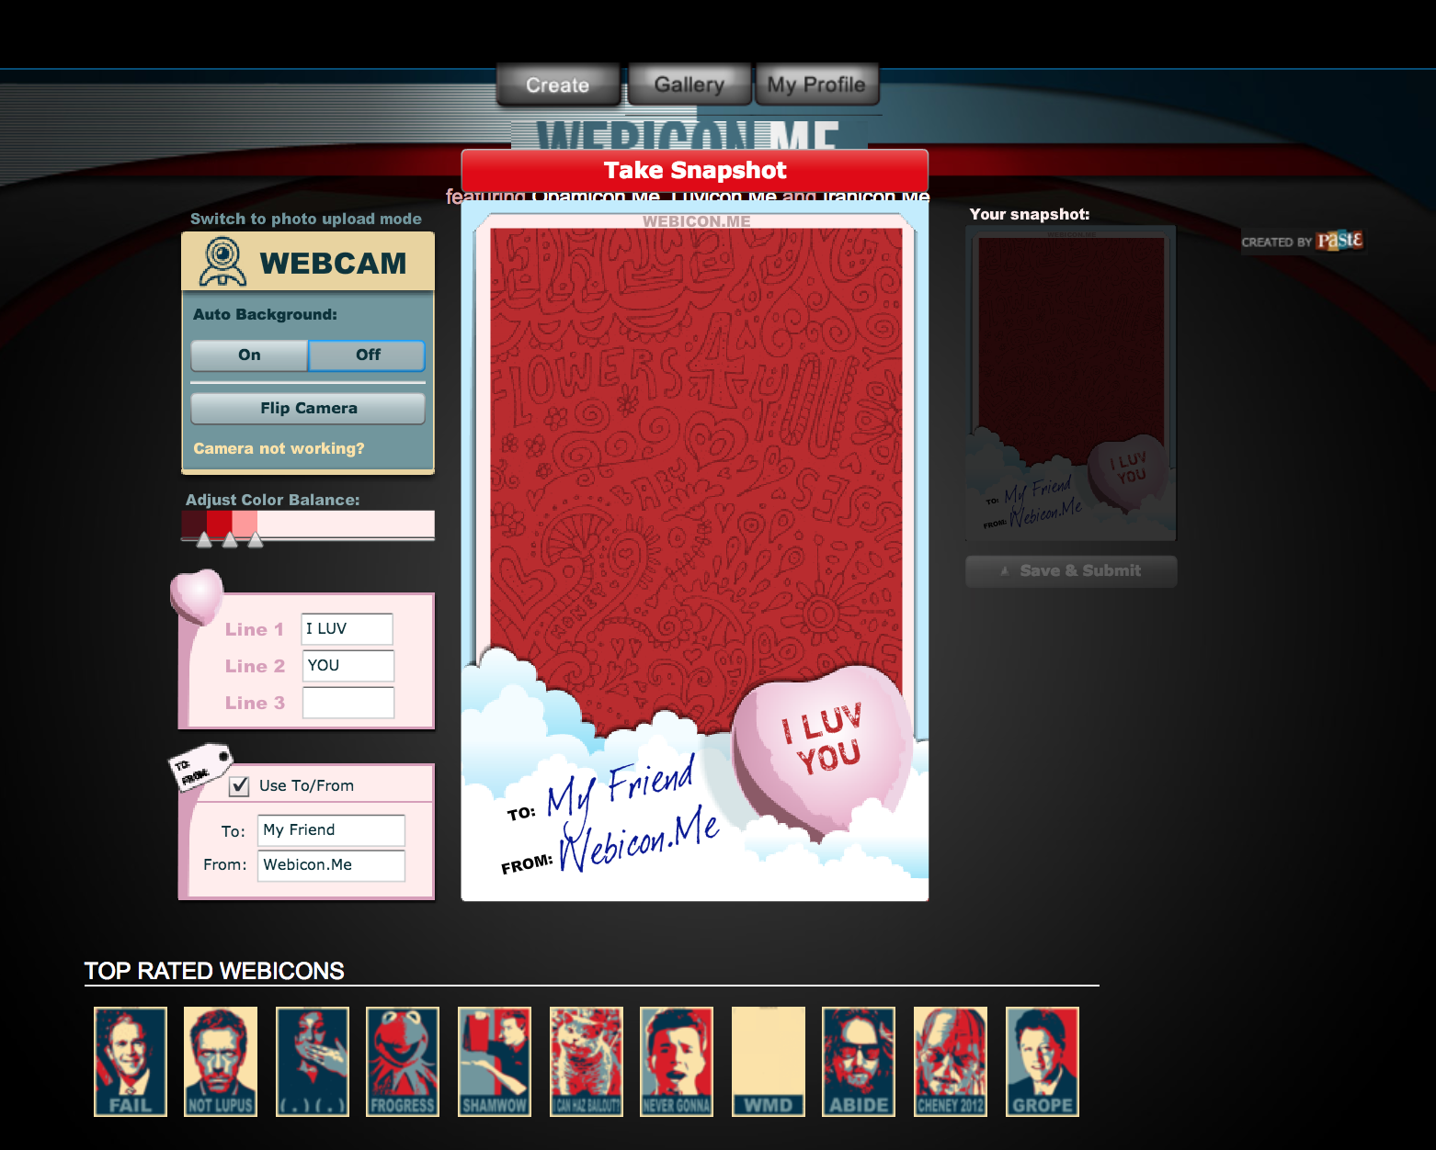

Fig. 5

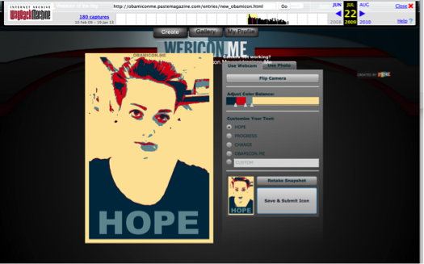

Fig. 6



Fig. 7

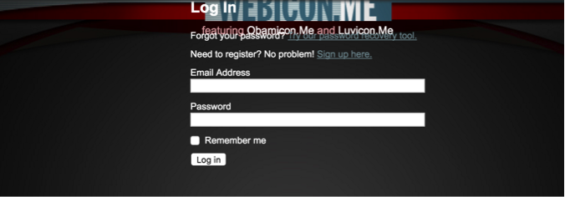

Works Cited

@obamiconme. 2009. “Obamicon.Me.” *Twitter*. https://twitter.com/obamiconme.

@ObamiconMe. 2017. “Obamicon.me.” *Facebook*. Accessed November 26. https://www.facebook.com/pg/ObamiconMe/.

Barad, Karen. 2007. *Meeting the Universe Halfway: Quantum Physics and the Entanglement of Matter and Meaning*. Durham, North Carolina: Duke University Press.

Boczkowski, Pablo and Leah A. Lievrouw. 2008. “Bridging STS and Communication Studies: Scholarship on Media and Information Technologies.” In *The Handbook of Science and Technology Studies*. Cambridge, Massachusetts: MIT Press. 947-967. Third edition.

Bowker, Geoffrey C and Susan Leigh Star. 1999. *Sorting Things Out: Classification and It’s Consequences*. Cambridge, Massachusetts: MIT Press.

De Vries, Imar O. 2012. *Tantalisingly Close: An Archaeology of Communication Desires in Discourses of Wireless Media*. Amsterdam: Amsterdam University Press.

Druckrey, Timothy. 2006. “Foreward.” In: *Deep Time of the Media: Toward an Archaeology of Hearing and Seeing by Technical Means*, Siegfried Zielinksi, translated by Gloria Custance. Cambrdige, Massachusetts: The MIT Press.

Duffy, Sean. 2009. “Obamicon Yourself!” *Social Media Today*, January 22. <https://www.socialmediatoday.com/content/obamicon-yourself>.

Edwards, Richard L. 2011. “Flip The Script: Political Mashups as Transgressive Texts.” In *Transgression 2.0: Media, Culture, and the Politics of a Digital Age*, edited by Ted Gournelos and David J. Gunkel, 26–41. New York: Continuum.

Elsaesser, Thomas. 2016. “Media archaeology as symptom.” *New Review of Film and Television Studies* 14(2): 181-215.

Ernst, Wolfgang. 2013. *Digital Memory and the Archive* edited by Jussi Parikka. Minneapolis: University of Minnesota Press.

“Explore #obamicon.” n.d. *Deviant Art*.

Fairey, Shepard. 2009. “Spreading the Hope: Street Artist Shepard Fairey.” *Fresh Air* on *National Public Radio*. Available at: <http://www.npr.org/templates/story/story.php?storyId=99466584>.

Fickers, Andreas and Anne-Katrin Weber. 2015. “Towards and Archaeology of Television.” *View: Journal of European Television History & Culture* 4(7): 1-6.

FOLIO: Magazine Staff. 2009. “Tim Regan-Porter.” *FOLIO*, March.

Fuller, Steve and James H. Collier. 2004. *Philosophy, Rhetoric, and the End of Knowledge: A New Beginning for Science and Technology Studies*. Mahwah, New Jersey: Lawrence Erlbaum Associations. Second Edition.

Garland, David. 2014. “What is a ‘history of the present’? On Foucault’s genealogies and their critical preconditions.” *Punishment & Society* 16(4): 365-384.

Garun, Natt. 2017. “Photobucket Accues of Blackmail after Quietly Requiring Users to Pay $400 a Year to Hotlink.” *The Verge*, July 4. https://www.theverge.com/2017/7/4/15919224/photobucket-broken-images-amazon-ebay-etsy-paid-update

Gries, Laurie E. 2015. *Still Life with Rhetoric: A New Materialist Approach for Visual Rhetorics.* Logan: Utah State University Press.

Gries, Laurie. 2015. “Obama Zombies and Rhetorical (Dis)Identifications in an Era of Dog Whistle Politics and Political Polarizaion.” *ImageTexT: Interdisciplinary Comics Studies* 8 (1). <http://www.english.ufl.edu/imagetext/archives/v8_1/gries/?print>.

Helmond, Anne, David B Nieborg, and Fernando N Van Der Vlist. 2017. “The Political Economy of Social Data: A Historical Analysis of Platform – Industry Partnerships.” In *Proceedings of the 8th International Conference on Social Media & Society*. New York: ACM Press. doi:10.1145/3097286.3097324.

Huhtamo, Erkki and Jussi Parikka. 2011. “Introduction: An Archaeology of Media Archaeology.” In *Media Archeology: Approaches, Applications, and Implications*, edited by Erkki Huhtamo & Jussi Parikka, 1-17. Berkeley: University of California Press.

Jain, Ramesh. “Let’s Weave the Visual Web.” *IEEE MultiMedia* 22(3): 66-72.

"media, n.2." *OED Online*. Oxford University Press, March 2016. Web. 17 April 2016.

Koman, Richard. 2002. “How the wayback machine works.” *O’Reilly XML.com*. Available at: <http://webservices.xml.com/pub/a/ws/2002/01/18/brewster.html>.

Lepore, Jill. 2015. “The Cobweb: Can the Internet Be Archived?” *The New Yorker*, January. https://www.newyorker.com/magazine/2015/01/26/cobweb.

Mackey, Robert. “Web users make their own ‘Obamicons.’ The Lede blog on *The New York Times*. 17 Feburary 2009. Available at: <http://thelede.blogs.nytimes.com/2009/02/17/so-sue-us-web-users-make-their-own-obamicons/>.

Magee, Joan R. “Obamicon Me!.” In *Upstart Business Journal*. 28 January 2009. Available at: <http://upstart.bizjournals.com/news/wire/2009/01/28/obamicon-me.html?page=all>.

Marino, Nick. 2009. “Ten Awesome Obamicon Posters.” *Paste Magazine*, January 7.

Nakamura, Lisa. 2014a. “Media.” In *Keywords for American Cultural Studies*, edited by Bruce Burgett and Glenn Hendler. New York: NYU Press. Available at: http://keywords.nyupress.org/american-cultural-studies/essay/media/

Nakamura, Lisa. 2014b. “Indigenous circuits: Navajo women and the racialization of early electronic manufacture.” American Quarterly 66, no. 4 (2014): 919-941.

Orsini, Lauren. “The Triumph of the Visual Web.” *ReadWrite*. 18 December 2013. Available at: <http://readwrite.com/2013/12/18/visual-web-2013-trends/>.

Parikka, Jussi. 2011. “Mapping Noise: Techniques and Tactics of Irregularities, Interception, and Disturbance.” In: *Media Archaeology: Approaches, Applications, and Implications*, edited by Erkki Huhtamo & Jussi Parikka, 256-277. Berkeley: University of California Press.

Parikka, Jussi. 2012. *What is Media Archaeology?* Malden: Polity Press.

Parikka, Jussi. 2013. “Archival Media Theory: An Introduction to Wolfgang Ernst’s Media Archeology.” In: *Digital Memory and the Archive*. Minneapolis: University of Minnesota Press. Pp. 1-56.

Paste Staff. 2009. “Paste Launches Obamicon.Me.” *Paste Magazine*, January 7.

———. 2012. “The Return of Obaicon: Create Your Own Image.” *Paste Magazine*, September 27.

Polonyi, Eszter. 2016. “Media archaeology in cinema studies and art history: a response to Thomas Elsaesser’s ‘Media Archaeology Symptom.’” *New Review of Film and Television Studies* 14(2): 216-221.

Regan-Porter, Tim. 2017. “Tim Regan-Porter.” *Linkedin*. Accessed November 26. https://www.linkedin.com/in/timreganporter.

Robertson, Adi. 2016. “The Internet Archive Is Building a Canadian Copy to Protect Itself from Trump.” *The Verge*, November 29. https://www.theverge.com/2016/11/29/13778188/internet-archive-of-canada-backup-trump-surveillance-censorship.

Sismondo, Sergio. 2010. *An Introduction to Science and Technology Studies*. Malden, Massachusetts: Blackwell Publishing. Second edition.

*The Telegraph*. 2009. “Obamicon: Alternative Presidents,” January 15. http://www.telegraph.co.uk/news/picturegalleries/howaboutthat/4243021/Obamicon-Alternative-presidents.html.

Van Hoven, Matt. “The growth of the visual Web in 5 charts.” *Digiday*. 7 May 2014. Avaialbe at: <http://digiday.com/platforms/5-charts-growth-visual-web/>.

Yoo, Alice. 2009. “Obamicon.Me - Post-Election Fun By Paste Magazine.” *My Modern Met*, January 15.

Zielinski, Siegfried. 2006. *Deep Time of the Media: Toward an Archaeology of Hearing and Seeing by Technical Means*, Siegfried Zielinksi, translated by Gloria Custance. Cambrdige, Massachusetts: The MIT Press.

Zielinski, Siegfried. 1996. “Media Archaeology.” *C Theory* 7 November 1996. Available at: http://www.ctheory.net/printer.aspx?id=42.

@obamiconme. 2009. “Obamicon.Me.” *Twitter*. https://twitter.com/obamiconme.

@ObamiconMe. 2017. “Obamicon.me.” *Facebook*. Accessed November 26. https://www.facebook.com/pg/ObamiconMe/.

Bayerl, Petra Saskia, and Lachezar Stoynov. 2016. “Revenge by Photoshop: Memefying Police Acts in the Public Dialogue about Injustice.” *New Media & Society* 18 (6): 1006–26. doi:10.1177/1461444814554747.

Bowker, Geoffrey C., and Susan Leigh Star. 1999. *Sorting Things Out: Classification and Its Conseqeunces*. Cambridge: MIT Press.

Duffy, Sean. 2009. “Obamicon Yourself!” *Social Media Today*, January 22. https://www.socialmediatoday.com/content/obamicon-yourself.

Easterbrook, Steve. 2010. “On the Uses and Abuses of Infrastructural Inversion.” *Serendipity: Applying Systems Thinking to Computing, Climate and Sustainabilitly*. http://www.easterbrook.ca/steve/2010/08/on-the-uses-and-abuses-of-infrastructural-inversion/.

Edwards, Richard L. 2011. “Flip The Script: Political Mashups as Transgressive Texts.” In *Transgression 2.0: Media, Culture, and the Politics of a Digital Age*, edited by Ted Gournelos and David J. Gunkel, 26–41. New York: Continuum.

“Explore #obamicon.” n.d. *Deviant Art*.

Finnegan, Cara A. 2004. “Doing Rhetorical History of the Visual: The Photograph and the Archive.” In *Defining Visual Rhetorics*, 195–213. Mahwah, NJ: Erlbaum.

FOLIO: Magazine Staff. 2009. “Tim Regan-Porter.” *FOLIO*, March.

Garun, Natt. 2017. “Photobucket Accues of Blackmail after Quietly Requiring Users to Pay $400 a Year to Hotlink.” *The Verge*, July 4. https://www.theverge.com/2017/7/4/15919224/photobucket-broken-images-amazon-ebay-etsy-paid-update.

Gries, Laurie. 2015. “Obama Zombies and Rhetorical (Dis)Identifications in an Era of Dog Whistle Politics and Political Polarizaion.” *ImageTexT: Interdisciplinary Comics Studies* 8 (1). http://www.english.ufl.edu/imagetext/archives/v8_1/gries/?print.

Gries, Laurie E. 2015. *Still Life With Rhetoric: A New Materialist Approach for Visual Rhetorics*. Boulder: Utah State University Press.

Helmond, Anne, David B Nieborg, and Fernando N Van Der Vlist. 2017. “The Political Economy of Social Data: A Historical Analysis of Platform – Industry Partnerships.” In *Proceedings of the 8th International Conference on Social Media & Society*. New York: ACM Press. doi:10.1145/3097286.3097324.

Jenkins, Henry, Sam Ford, and Joshua Green. 2013. *Spreadable Media: Creating Value and Meaning in a Networked Culture*. New York: New York Univeristy Press.

Lepore, Jill. 2015. “The Cobweb: Can the Internet Be Archived?” *The New Yorker*, January. https://www.newyorker.com/magazine/2015/01/26/cobweb.

Mackey, Robert. 2009. “Web Users Make Their Own ‘Obamicons.’” *The New York Times*.

Marino, Nick. 2009. “Ten Awesome Obamicon Posters.” *Paste Magazine*, January 7.

Paste Staff. 2009. “Paste Launches Obamicon.Me.” *Paste Magazine*, January 7.

———. 2012. “The Return of Obaicon: Create Your Own Image.” *Paste Magazine*, September 27.

Regan-Porter, Tim. 2017. “Tim Regan-Porter.” *Linkedin*. Accessed November 26. https://www.linkedin.com/in/timreganporter.

Robertson, Adi. 2016. “The Internet Archive Is Building a Canadian Copy to Protect Itself from Trump.” *The Verge*, November 29. https://www.theverge.com/2016/11/29/13778188/internet-archive-of-canada-backup-trump-surveillance-censorship.

*The Telegraph*. 2009. “Obamicon: Alternative Presidents,” January 15. http://www.telegraph.co.uk/news/picturegalleries/howaboutthat/4243021/Obamicon-Alternative-presidents.html.

Yoo, Alice. 2009. “Obamicon.Me - Post-Election Fun By Paste Magazine.” *My Modern Met*, January 15.

1. Industry abbreviation for circulation.
2. The turn to popular culture is also evident in other archives of Obama Hope images, such as the #obamicon collection on art community site DeviantArt, although there, the references tend towards video games and anime (“Explore #obamicon,” n.d.).
3. In this, media archeology has similarities with Bruno Latour’s Actor-Network Theory and other new materialist approaches to thinking about the role of things. However, media archeology need not share the ontological commitments of those approaches in full. As John Durham Peters explains,

   Bruno Latour, to whom I owe a lot, has polemically called for a “flat ontology,” but in the works of some of his acolytes that can sound like a refusal to make critical judgments about the great inequality of things. Anyone interested in infrastructure, lookouts, and turning points needs old-fashioned sociology about how recalcitrant, not just how cool, “things” are. Ontology is not flat; it is wrinkly, cloudy, and bunched. (30)
4. For example: *Grey Room* No. 43 special issue “Audio/Visual,” *Amodern* No. 2 special issue “Network Archeology,” *View: Journal of European Television History & Culture* Vol. 4 No. 7 special issue “Archaeologies of Tele-Visions and –Realities,” and *MCD: Magazine des Cultures Digitales* No. 75 special issue “Archéologie Des Média,”
5. For example: *The Book of Imaginary Media: Excavating the Dream of the Ultimate Communication Medium* (2007), *Media Archaeology: Approaches, Applications, Implications* (2011), and Siegfried Zielinski’s *Variantology* series.
6. Labs and institutes include the Media Archeological Fundus at Humboldt University, Berlin, the IMA Institute of Media Archeology at Hainburg, the Media Archeology Lab at the University of Colorado Boulder, and the Preservation, Archaeology, Media Art Lab at the Art School of Avignon. For more on the role of labs in research, see the forthcoming *THE* *LAB BOOK: Situated Practices in Media Studies* from Lori Emerson, Jussi Parikka, and Darren Werschler from the University of Minnesota Press <http://whatisamedialab.com/>.
7. For example: the *Network Archeology* conference at the University of Miami in 2012 and the *Media Archealogy Institute Lecture Series* at the School of Art Institute in Chicago in 2013. For a list of more events and publications related to media archeology, see the excellent collection put together at *Monoskop*, a wiki for the study of art, media, and the humanities: <https://monoskop.org/Media_archaeology>.
8. I borrow the language of the past as inventional resource from Alessandra Von Burg’s essay “Stochastic Citizenship: Toward a Rhetoric of Mobility” (2012). Maybe say more about invention in rhetoric and draw from Pete Simonson’s “Reinventing Invention, Again” (2014). This is not language being used by folks in media archeology but captures the spirit of Foucault’s methodological orientation in *The Archeology of Knowledge* that is a significant theoretical connection for this work.
9. Although scholars who identify with a media archeology approach often use this framing to distinguish it from media history, the distinction is a bit misleading and is more applicable to some of the foundational works in media history research such as Lewis Mumford’s *Technics of Civilization*. More recent forays in media history often share media archeology’s rejection of dominant narratives, tidy periodizations, and universal claims. See John Durham Peters’ *The Marvelous Clouds* as an example.
10. The idea of infrastructural inversion can be productively thought of alongside Martin Heidegger’s distinction between ready-at-hand and present-at-hand. For Heidegger, these phrases refer to particular ways of apprehending tools. The ready-at-hand mode approaches a tool as an object to be used for a particular and pre-established purpose; in so doing, it takes the existence of the object for granted. The present-at-hand mode approaches a tool as a thing in its own right, a fuller experience of encounter. When a tool breaks down or malfunctions, it may prompt one to change from a ready-at-hand orientation to a present-at-hand orientation. The idea of infrastructural inversion gets at a similar change in orientation to the world, but the object of the orientation differs. Where Heidegger is concerned with the relationship between a person and a particular object, infrastructure refers to a larger system that extends beyond any individual object and by its nature affects many people. See (Easterbrook 2010) for a more detailed account of the relationship between infrastructural inversion and Heidegger’s work.
11. In bringing the attention to infrastructure from Science and Technology Studies to Media Archeology, I support claims of compatibility between media and information technologies, communication, and science and technology studies (Boczkowski and Lievrouw 2008).
12. Ownership of servers is a crucial mechanism of control for online content. If one owns the servers responsible for hosting a site as *Paste Magazine* did, then one has the authority to determine whether the site is available online. A similar dynamic of control was at work in the closure of early personal webpage community *Geocities*, which was taken offline by *Yahoo* in 2009. Although individual users can save copies of their content to their personal machines or make it available through other locations online, such as posting their Obamicon on a blog or social network site, without access to the original files and control of a server, there is no way to preserve the full context and functionality of a site online.
13. See (Helmond, Nieborg, and Vlist 2017) for an interesting exception. Here, the researchers were interested in tracing a history of Facebook’s commercial partnerships and used cached images of Facebook’s news and advertising pages, along with industry blogs, to create a timeline.
14. This trend of commemorating notable political events and natural disasters continues today with the availability and popularity of Facebook profile picture filters.