Information Visualization  
Homework 3

By Sourabh Shetty

Among the many visualizations displayed at the Places and Spaces exhibit in Newman Library, the ones that caught my eye were:

1. **A Global Projection of Subjective Well-Being, by Adrian White and the National Geographic *EarthPulse* team.**

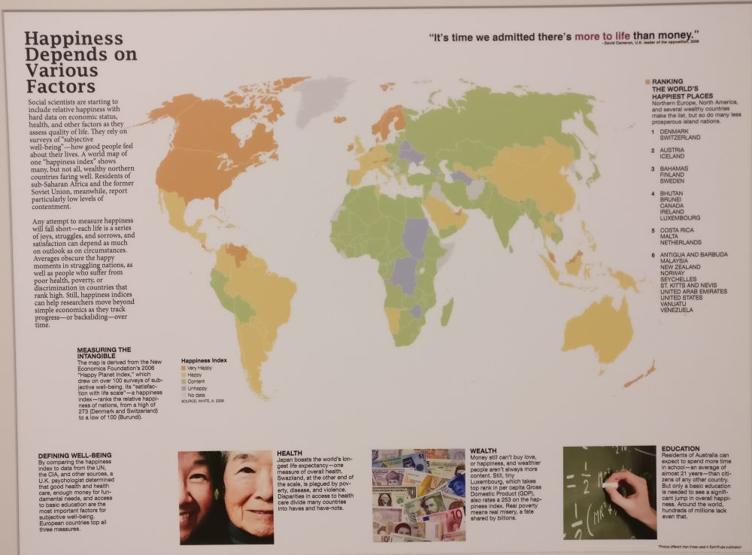

The theme of the visualization is to measure an abstract, not easily quantifiable emotion onto known countries.

There is a assumption people as a whole tend to make, that money is the key to happiness. It’s a natural assumption to make, of course, since having money does give a populace the power to alleviate most of their most pressing problems.

But what this map shows us is that money is not the *only* key to happiness.

It is not just the Western, wealthy nations that make the upper half of happy nations, but also less-wealthy nations like Bhutan and Seychelles.

We can see that apart from money, there are other factors that influence how content a nation’s people can be. Health and education are two other important factors that can sustain a people and help them be happy. When the cost of living isn’t very high, not earning a lot in comparison to people in more advanced countries does not significantly affect quality of life. But access to healthcare, education fresh food can drastically improve it.

For me, the most creative aspect of the map is its simplicity. It could be tempting to go fancier with the data, perhaps size countries according to their happiness ranking or display it in a different format, but the creators of this visualization chose to go with a map that all of us know and recognize, and use the data to essentially update a known entity with additional information.

1. **Death and Taxes 2009, by Jess Bachman**

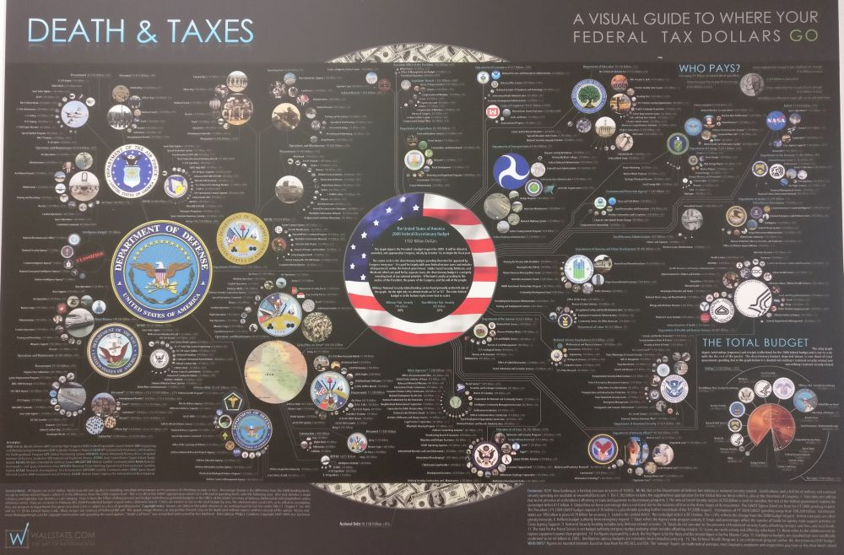

The theme of this visualization is to show how something quantifiable is distributed across various speheres utility.

People of every country are always concerned as to where their tax dollars are being spent. It is always the subject of rival political parties mudslinging efforts to portray the other side as wasteful or inefficient or downright malicious, both accurately or inaccurately.

But since federal spending is public record, and the data is pure numbers, it can be very well depicted and is very well suited for visualization.

What doesn’t come as a huge shock, but is still daunting to look at visually, is just how much the country spends on Defense. The biggest chunk of the budget goes to the Department of Defense, and we can see how large its sphere of influence, encompassing the Air Force, the Army and the Navy, among other departments.

Scientific, medical, and artistic pursuits seemingly receive relatively less money in comparison.

Data like this leads to even greater debate as to what a nation should spend its money on, and what compromises need to be made to ensure all aspects of a nation’s infrastructure should run smoothly.

What I find creative about this map is that it is essentially a much more visually rich pie chart. A large number is dividided into chunks, and each of them is further divided into more chunks. The bottom of the chart even has an actual pie chart depicting how the entire budget is distributed. So even though the data could have been staggeringly hard to comprehend, the usage of existing visualizations simply updated to be visually richer makes it easier to follow.