Information Visualization

Homework 6 Sourabh Shetty

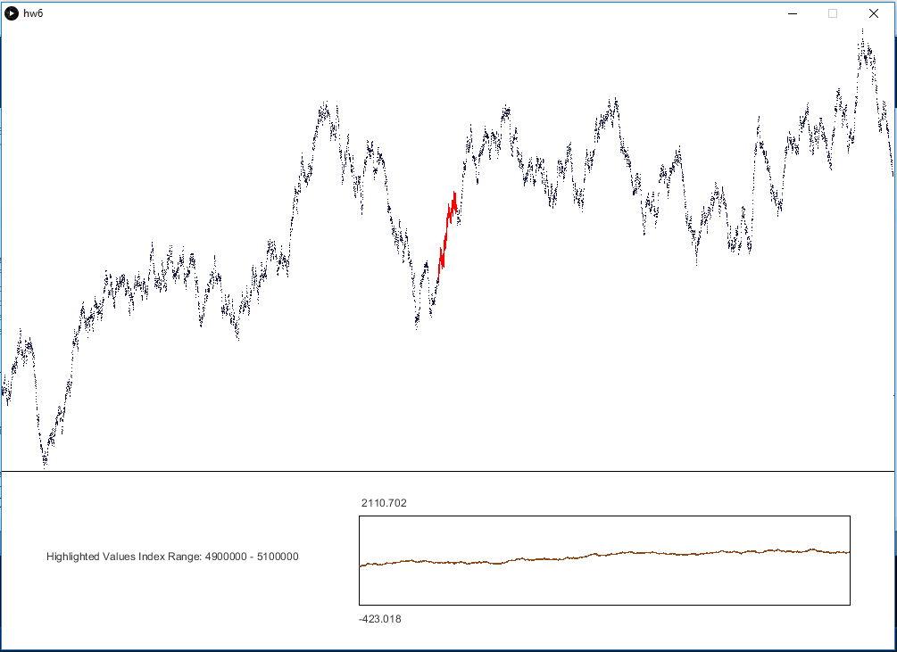

1. In this assignment, I have used concepts from overview + detail as well as from focus + context design methods for providing an overview of the data.
2. The data initially represented on the main graph is a summarized view of the entire data set. Since 1 million+ values of data is inefficient to display in the limited space we have, we show a reduced set of points, where every few points of the original data set is averaged and this mean is represented as a single point. This effectively reduces our entire data set by the divisor we choose.

Having too few points on screen makes the graph hard to see, so we need to choose our data set size and divisor in such a way that the point density makes the graph visible, but without slowing down the code too much.

Now for the detail:

When we hover over any point in the summarized view, we generate points and plot the data from the main raw data set for a certain range before as well as after the current point being hovered over. These points are drawn in red to differentiate them from the summarized points that are in dark blue.

There is also a separate graph drawn below the main graph which shows more detail about the range currently hovered over, and uses the original raw unsummarized data.

1. My impementation currently allows a user to see raw data for a certain range before and after the currently hovered over point in real-time. The x-coordinate of the current position of the mouse is our main and only interaction control.
2. Most of my testing was done by testing for datasets of 1,000,000 – 10,000,000, and the code slows down as we reach higher levels. My laptop also has only about 4GB of RAM, and starts heating up once we reach data sets of 10,000,000 and above, so I was not able to test the code beyond this range.