Information Visualization

Homework 7

Sourabh Shetty

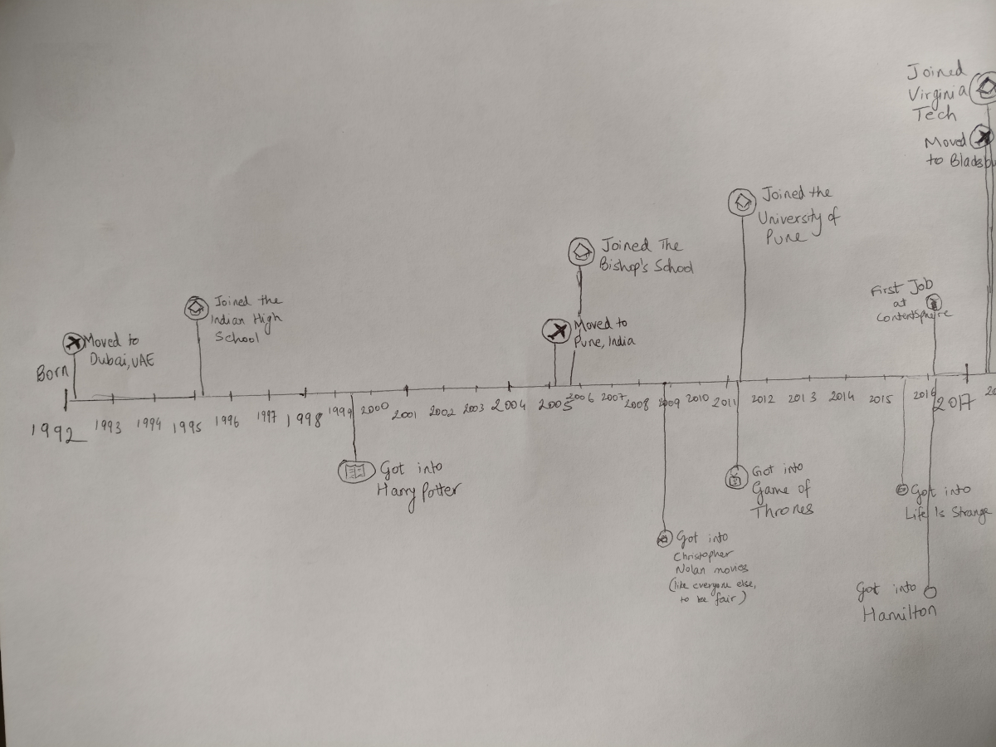

The intent of my visualization is to show a timeline of both my education/career interests, as well as my entertainment interests. Both these aspects have been very important to me in my life so far, and so I wanted to give them equal importance in this.

The way I chose to do it was to keep the time axis in the middle, and separate the two sections by having the “more serious” one on top and the fun one on the bottom.

The serious one maps every major life event, like birth, moving to a new city, joining an educational institution or company, etc.

The fun one maps every time I got into something that defined a form of entertainment for me at that time, like Harry Potter for books and Hamilton for musicals.

The task achieved here is an analysis one. A person looking through it can discover, present and enjoy the findings.

Another visualization I hoped to include into the design is one I generated using Tableau using my own carefully maintained dataset of the number of movies and TV show seasons I watch each year:

