v0.6.0

Code Assignment

Overview

The assignment is to build a small, full stack javascript application. The application is a simple game which can display a random outcome generated on the server.

Requirements

General

* The application must work in major desktop and mobile devices (please state which devices/ browsers the application has been tested on)
* The general principles by which the application will be evaluated are maintainability, testability and reusability.
* Unit Tests are not mandatory but encouraged; the key is that the code is testable.

Client

* Not external libraries or framework can be used
* ES6 is not mandatory but encouraged
* The user must be able to trigger a request for outcome to the server
* The outcome must be displayed to the user using the provided graphical resources (Symbol_0.png, Symbol_1.png,…)
* The type of win must be displayed to the user (No Win, Small Win, Big Win)
* A bonus feature must be implemented. If the server returns bonus, the client must first display any win to the user, then trigger an additional request without any user input (this must also be indicated to the user in some form)

Server

* Server must be a Node.js application
* Server must be written in ES6
* Server must be able to serve needed resources to client.
* Server must be able to receive requests from client and return an outcome (three random integers between 0-5).
* There must be three types of outcomes: No Win, Small Win, Big Win. Two equal integers constitutes a Small Win. Three equal integers constitutes a Big Win.
* Server must randomly (in addition to the outcome) return if bonus feature should be triggered or not.

v0.6.0

Application overview

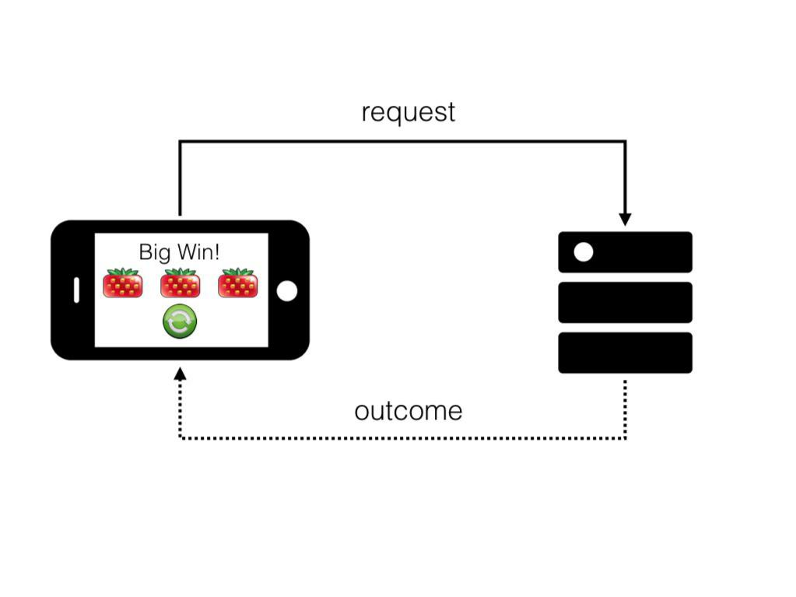

Submission

* Link to private Github or Bitbucket repo
* Zip file per email (change file ending to get through firewall)
* USB-stick on homing pigeon