SELECT – review but using Oracle

These are the commands used on the course

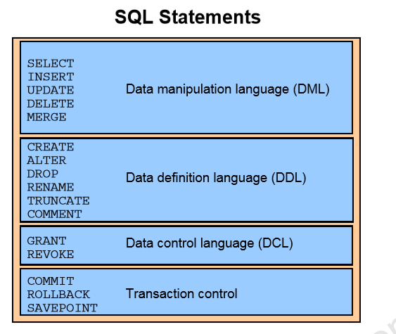

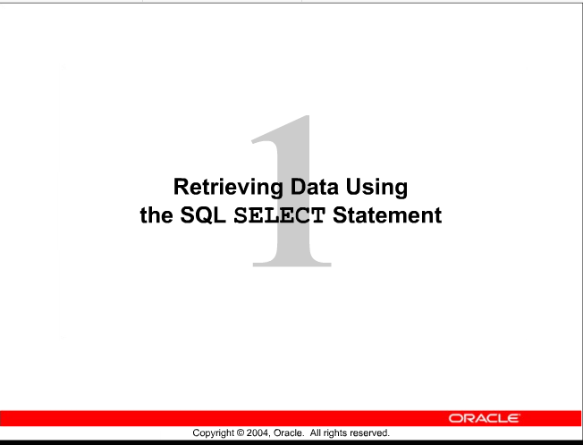

2

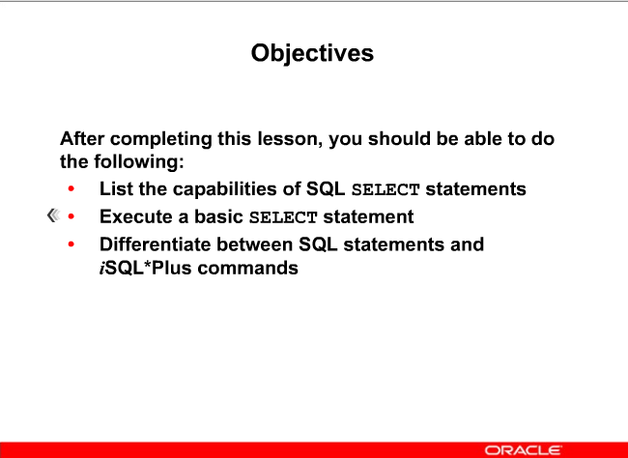

SCHEMA – working with this semester

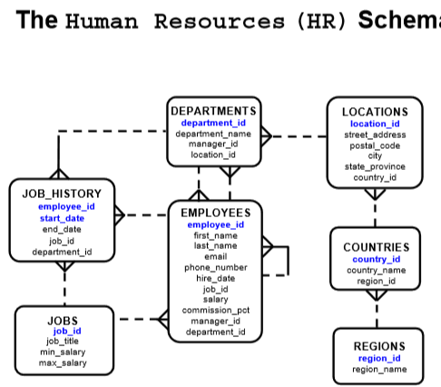

REWRITE this is a better layout for readability

3 (1-4)

# 3 ACTIONS ON TABLES

* + **1 PROJECTION**
  + **2 SELECTION**
  + **3 JOIN**
  + **Done through SELECT statement**

SELECT – Retrieving data from a table

**1 PROJECTION** -- Retrieving specific columns of data such as ALL student names and phone numbers



**2 SELECTION** – Returns only rows ta meet the specific restriction such as all male students from a table of students



**3 JOIN** – Returning data from 2 different tables such as course name and the student name

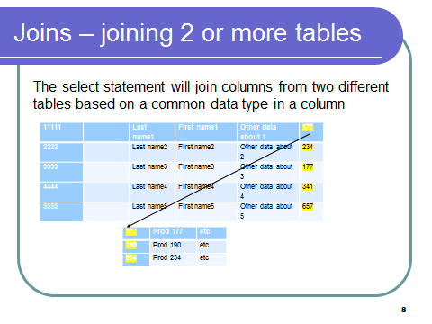

More on this in a later week’s lesson

FORMAT of the SELECT statement

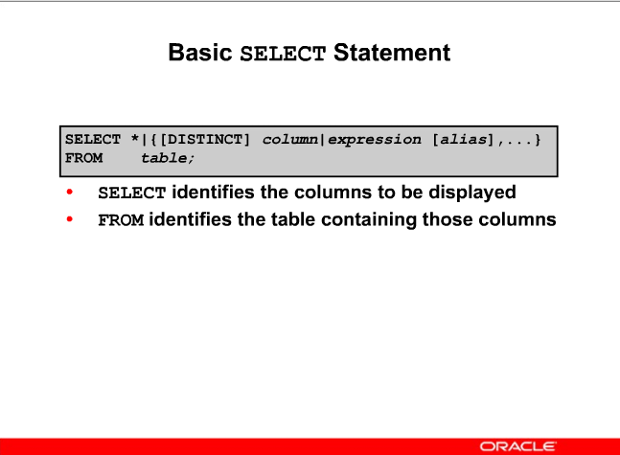

PROJECTION –

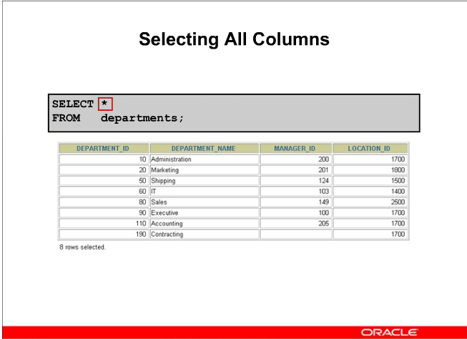

SELECTION --

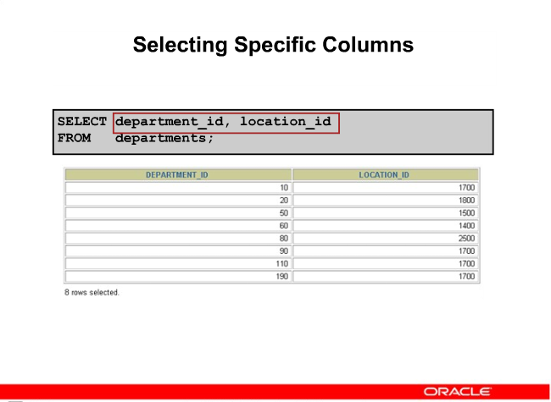

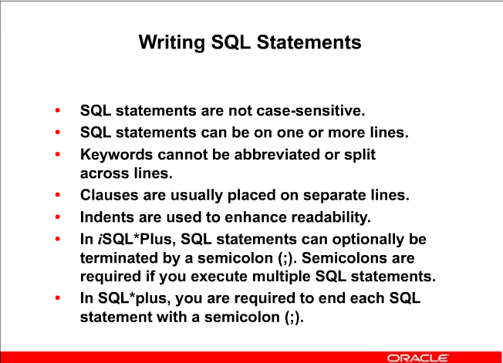

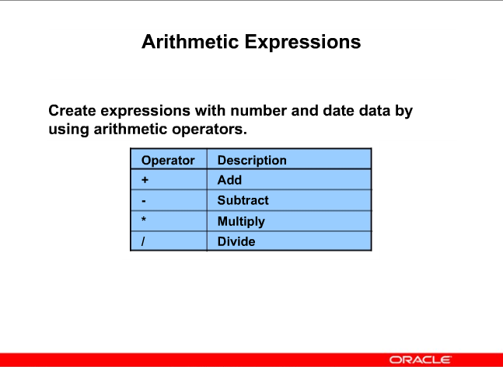

10

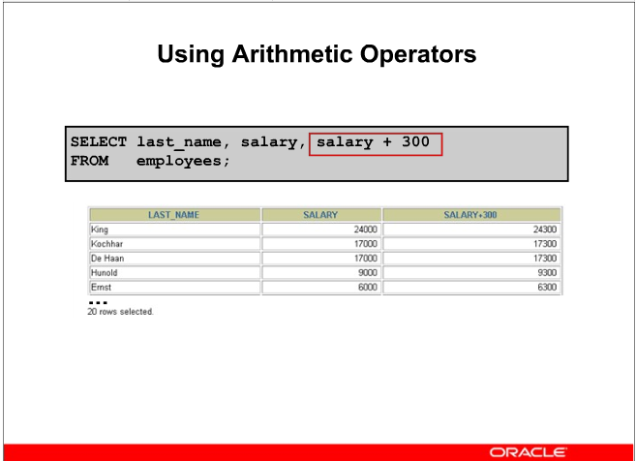

Note how it adds to the salary an additional 300

As in ALL languages it is important to know the order of operation when there are multiple operators

11

Raise everyone’s salary(which is monthly) by 100 dollars then multiply it out by 12 to see yearly salary

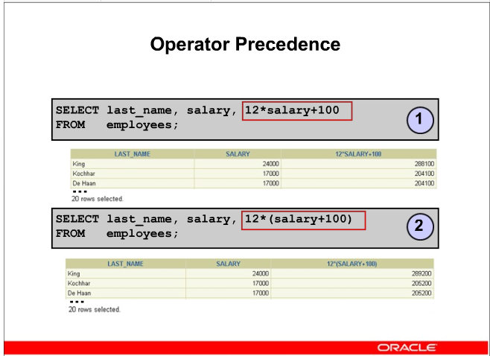

289,200

288,100 is the result

Not a large difference, and might not go noticed, but do this to 12,000 employees and the result is significant.

12

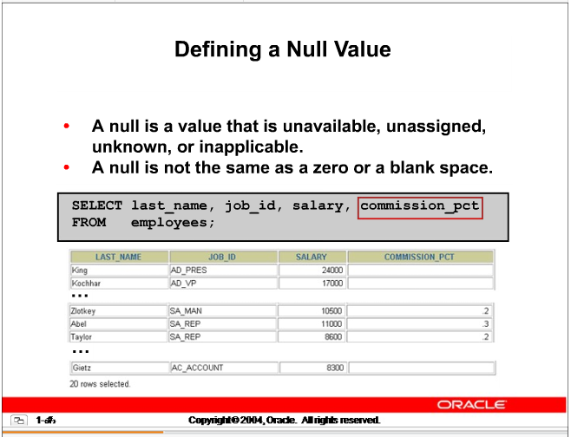

13

**PROBLEM**

Multiply the monthly salary by 12 to get yearly salary.

Then multiply it by the percent to get the commission earned

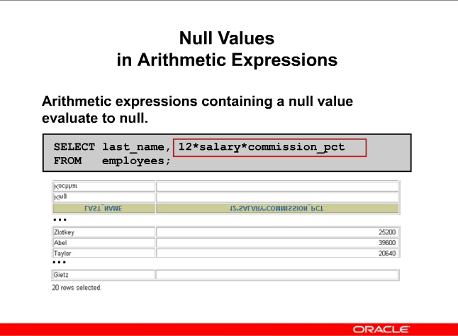

# NOTE: Column Names are not nice – need to fix it with an alias

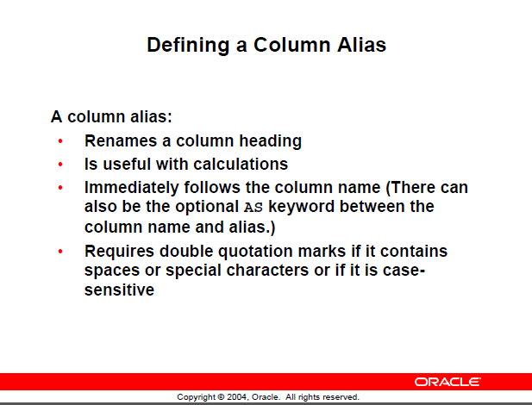

SELECT last_name AS name, commission_pct as comm

FROM employees;

SELECT last_name AS Last Name, commission_pct as comm

FROM employees;

🡺 This one won’t work as there is a space in the alias name

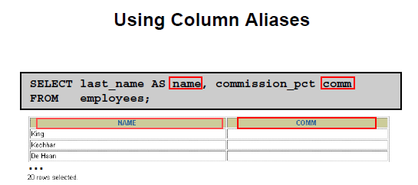

Note that used lowercase, but the default display is UPPERCASE

Using double quotes --

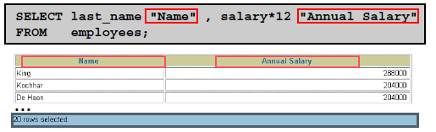

PROBLEM

Display last name and job id from the employees table and look at the result

Spread out ……

Now concatenate it with a **CONCATENATE OPERATOR**

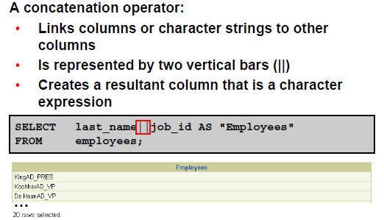

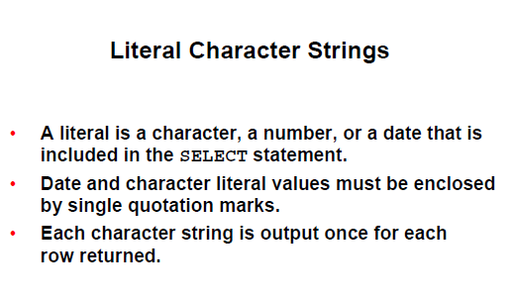

**NOTE:**

**Single quotes for literals**

**Double quotes for alias names**

PROBLEM:

Revise previous SQL 🡪 require Last name and job id with the ‘is a’ between it but nicely displayed

Give it a good title

Example:

Ron is a Dean



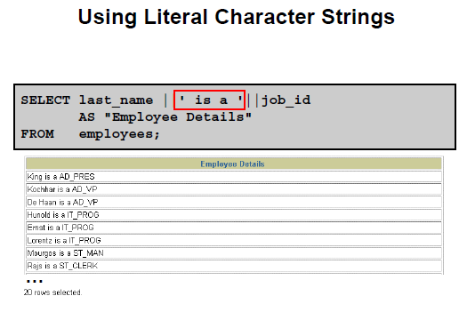

PROBLEM:

Using the employees table, display all the departments in HR

**SELECT department_id**

**FROM employees;**

See the duplicates as there are 20 rows displayed

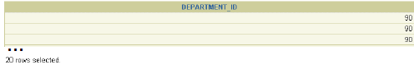

**SELECT DISTINCT department_id**

**FROM employees;**

