**RESTAURANT**

MID TERM REPORT

*by*

**RAHUL SHAW (05)**

**ABHISHEK ANAND (07)**

**ANANT SRIVASTAVA (08)**

**RIYA GARG (09)**



**Department of Intelligent Systems**

**School of Computer Science Engineering**

**Lovely Professional University , Jalandhar**

February 2018

**Student Declaration**

**This is to declare that this report has been written by us. No part of the report is copied from other sources. All information included from other sources have been duly acknowledged. We aver that if any part of the report is found to be copied, we are shall take full responsibility for it.**

**-- RAHUL SHAW (05)**

**-- ABHISHEK ANAND (07)**

**-- ANANT SRIVASTAVA (08)**

**-- RIYA GARG (09)**

**Place: Lovely Professional University**

**Date:**

**TABLE OF CONTENTS**

**TITLE PAGE NO. 1.Background and objectives of project assigned 04**

* 1. **Introduction**
  2. **Motivation**
  3. **Objectives**

**2. Description of Project 05**

**2.1 Restaurant System**

**2.2 Modules**

**3. Pictorial Representation 06**

**3.1 Admin Side**

**3.2 User Side**

**4. Work Schedule of Project---using Gantt Chart 07**

**5. Work Division in terms of Roles among Students 08**

**6. Technologies and Framework to be used 09**

**6.1 Notepad++**

**6.2 Google Chrome**

**7. SWOT Analysis of project 10-11**

**7.1 Strength**

**7.2 Weakness**

**7.3 Oppurtunities**

**7.4 Threats**

**Background and objectives of the project assigned**.

* **Introduction**

A restaurant or an eatery, is a business which prepares and serves food and drinks to customers in exchange for money.

It has long been accepted that the first establishments that we would consider “Restaurants” originated in Paris in the mid-eighteenth century.

The history of the restaurant’s development in the eighteenth century and into the nineteenth century , when it became the institution that we would recognize today , is a complex one.

* **Motivation from the Existing System**

The existing system is manual processing for taking orders, advance booking of table and order, arrange Family Events like Birthday Party, Marriage Anniversary etc.

Lot of paper work so that the data processing is very slow and we know after one month

how many profit get the restaurant which got by manual notes.

The businesses in restaurants are now growing constantly. At the same time, the need for managing its operations and tasks arises. The best way to optimize these activities is growing the business online as well.

* **Objectives of New System**

The goal of this project is to create a system for Restaurant. The system will allow performance of the actions needed in order to manage the restaurants in a simple and comfortable way. The objective is to provide user :

* Information about the number of restaurant available in the city, the famous ones.
* Menu List of different categories without moving around physically.
* Facility to give order in advance for any occasion of his required Menu items on restaurant specified time.

**Description of Project**

We propose to build a website that can efficiently handle and manage various activities of a restaurant and all these activities will be happening under the supervision of the administrator. Today's generation encourages high-tech services especially over the Internet. Hence the project is developed proficiently to help restaurant owners automate their business operations. This project serves the best way of maintaining customer's information and caters their needs.

*It covers the following modules :-*

* Information about the restaurants available in the city.
* Locations of particular restaurants and variety of food they are offering .
* Registered user can easily list out Menu List of different categories without moving
* around physically.
* User can view the remarks on the particular restaurant given by others
* User can give the remark to a particular restaurant
* Discussion forum
* Availability of offers on a particular restaurant.
* Pictures of interiors of restaurants.
* Directions to a particular restaurant.

**Pictorial Representation**

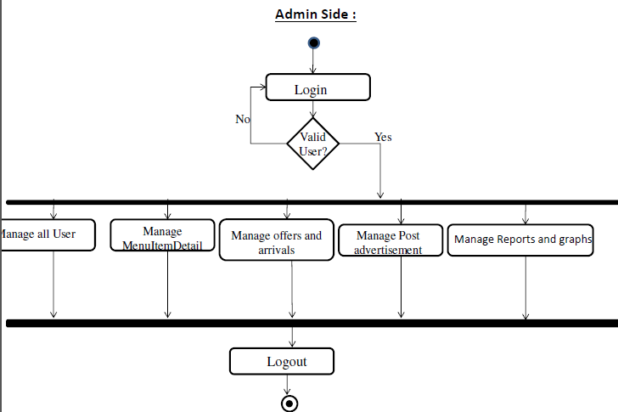

**User Side :**

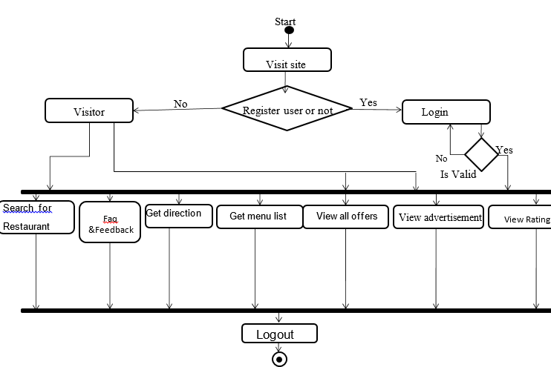

**Work Schedule of Project**

**Gantt Chart**

|  |  |  |  |  |  |  |  |  |  |  |  |  |  |  |  |  |  |
| --- | --- | --- | --- | --- | --- | --- | --- | --- | --- | --- | --- | --- | --- | --- | --- | --- | --- |
| **Development**  **Phase** |  | |  | | **30 Days** | | | | |  | | |  | | | | |
| 00 -03 Days | |  | 04-07  Days | |  | 08-11 Days | 12-20  Days | | | 21-25  Days | | | 26-30  Days | | | |
| **Requirement**  **Gathering** |  |  |  |  | |  |  |  | | |  |  | |  | | | |
|  |
| **Analysis** |  |  |  |  | |  |  |  | | |  |  | |  | | | |
|  |  |
| **Design** |  | |  |  | |  |  |  | | |  |  | |  | | | |
|  |  | |  |  |  | | |
| **Coding** |  | |  |  | |  |  |  | | |  |  | |  |  | | |
| **Testing** |  | |  |  | |  |  |  |  | |  |  | |  | | |  |
| **Implementation**  **Deployment** |  | |  |  | |  |  |  | | |  |  | |  | |  | |
|  | |
| **Documentation** |  | |  |  | |  |  |  | | |  |  | |  | | | |
|  |  |  |  | |  |  |  | | |  |  | |  | | | |
|  |  |  | |  |  |  | | |  |  | |  | | | |

**Work Division in terms of Roles among Students.**

* **Rahul Shaw-**  I will work on the usage of html, css, javascript to make the webpage and the idea of how the webpage will look like.
* **Abhishek Anand-** I will also work on the proper implementation of the codes I will work on login page in which user will enter his ID/password by which user can access their respective accounts.
* **Anant Srivastava-**.I will work on design, template of the website. I will collect all the contents of the project like source code, testing etc. I will work on the report of restaurants.
* **Riya Garg-** I will basically work on creating and collecting data about the project. I will work on overall presentation of the website.

**Technologies and Framework to be used**

Here we have use the Notepad++ to create our topic “library management system ” and we have used the Google Chrome also for the execution of our program.

[1]. Notepad++:-It is a texteditor and source code editor for use with Microsoft windows. It supports tab editing, which allows working with multiple open files in a single window. It features syntax highlighting, codefolding and limited auto compilation for programming, scripting, and markup language but not intelligent code completion or syntax checking.

Notepad++ also has features that improve plain text edit in experience in general, such as:

• Autosave.

• Finding and replacing strings of text with regular expression.

• Guided Indentation.

• Line bookmarking.

Can choose any specified language like HTML init.

[2]. Google Chrome:-If a user types keywords into the previously visited websites and presses enter, Chrome will conduct the search using the default search engine. One of Chrome's differentiating features is the New Tab Page, which can replace the browser home page and is displayed when a new tab is created. In Google Chrome we use to compile/ execute or we can say we use to see the output of the program which is written in Notepad++.

Google Chrome supports the feature like:-

Audio (mp3)

Video (mp4, wav)

Images. (.jpg, .png)

In Google chrome we can also perform autoplay feature in playing the video in chrome.

It supports many of the for mate as compare to other browser(s) present in the market. It is the most convenient browser as compare to other browsers.

**SWOT Analysis of project**

A SWOT analysis (alternatively SWOT matrix) is a structured planning

method used to evaluate the strengths, weaknesses, opportunities, and threats involved in a project.

**STRENGTH :**

* User can easily share his view about the restaurant.
* People can easily decide whether the restaurant is good or bad by using this application.
* This website is more useful for the users who love food.
* Since system ranks the feedback based on the weight age of the keywords in database, so the result is appropriate.
* **Developing multiple fast food restaurant**  
  **When our popularity rising, the crowd will be more, the income will certainly rise. Income is rise; we will open a few more stores. This will lay a solid foundation for the future.**
* Cost effective
* Efficiency in speed and operation
* Time saving

**WEAKNESS :**

* System will match the opinion with those keywords which are in database rest of the words are ignored by the system.
* The computer viruses, lack of standardization for digitized information, quick degrading properties of digitized material, different display standard of digital product and its associated problem, health hazard nature of the radiation from monitor etc.
* As more and more computer are connected to the Internet its speed of access reasonably decreasing. If new technology will not evolve to solve the problem then in near future Internet will be full of error messages.

**OPPURTUNITIES :**

* Information can be saved digitally and therefore renders immediate

access to high demand and frequently used items.

* There is enhanced intellectual control along with new finding tools and support searching capabilities.
* Links are provided to access offers.
* Manipulation of text and images is improved by enabling the enhancement of digital

images in terms of size, sharpness, colour, contrast noise reduction and so on.

**THREATS :**

* **More competition  
  Now, our biggest threat is by some large chain of fast-food restaurants such as, McDonald’s, KFC, Hungry Jack and Red Rooster etc. Above the restaurant has a very high profile and has a substantial amount of money.**
* **Similar concept or service  
  The most of fast-food restaurant has a similar concept or service. In this regard, it is very hard problem. Because it is easier to make customer confusion between us and other companies, and we do not have a deep impression for customers.**
* **Rising operating costs and Price war  
  Sometime the environment will makes the rising operating costs, therefore Price war will comes out , which is mean the famous company they reduce the price, we still need to follow it, then will lose a lot of money.**