The George Washington Universityshort line



**Advanced Software Paradigms (CSCI 6221.10)**

Homework Assignment #4

Date: 20 February 2024

**Submitted By:**

Abhiyan Sainju (G22510509)

**Submitted to:**

Professor Yih-Feng Hwang

Steps for execution:

1. The provided program is written in **Python**. To run it, use any online Python compiler, for example, <https://www.programiz.com/python-programming/online-compiler/>
2. Copy the code from the attached source code .txt file and paste it into the code area in the online compiler.
3. Click the “Run” button in the compiler.
4. Review the output/result displayed by the compiler, as illustrated in Figure 1.

Screenshots:

1. The program displays two data type options and the user selects one.

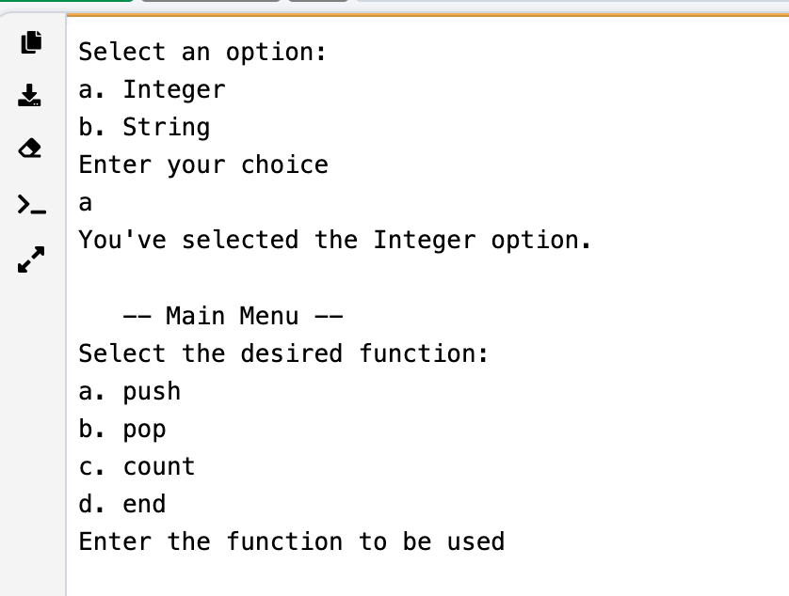

Figure : Result when datatype input is correct

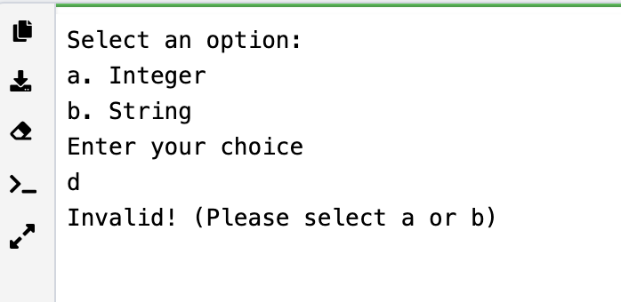

Figure 2: Result when datatype input is incorrect

1. When the push function is used

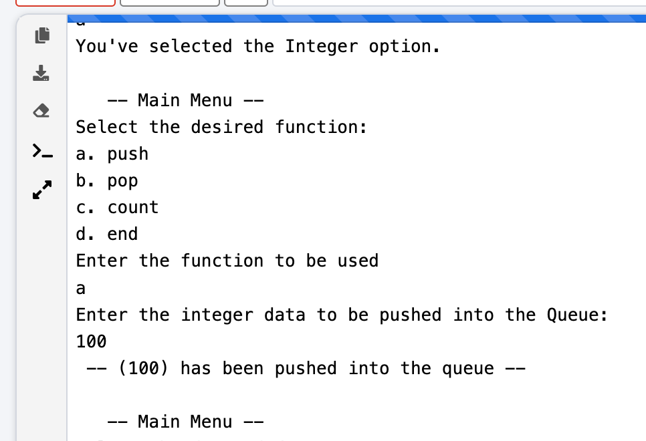

Figure 3: Result when the push function is used

1. When the push function is used with incorrect datatype

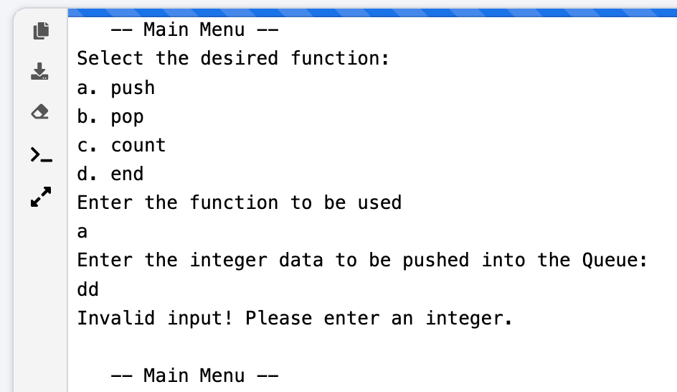

Figure 4: Result when incorrect datatype is used in push function

1. When the pop function is used

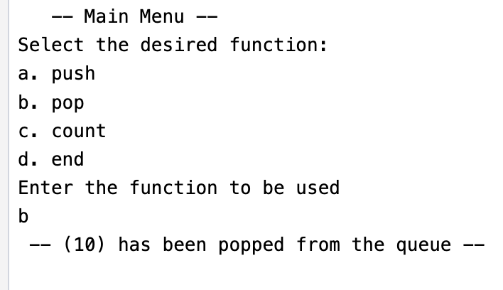

Figure 5: Result when the pop function is used

1. When the pop function is used when there is no data in the queue

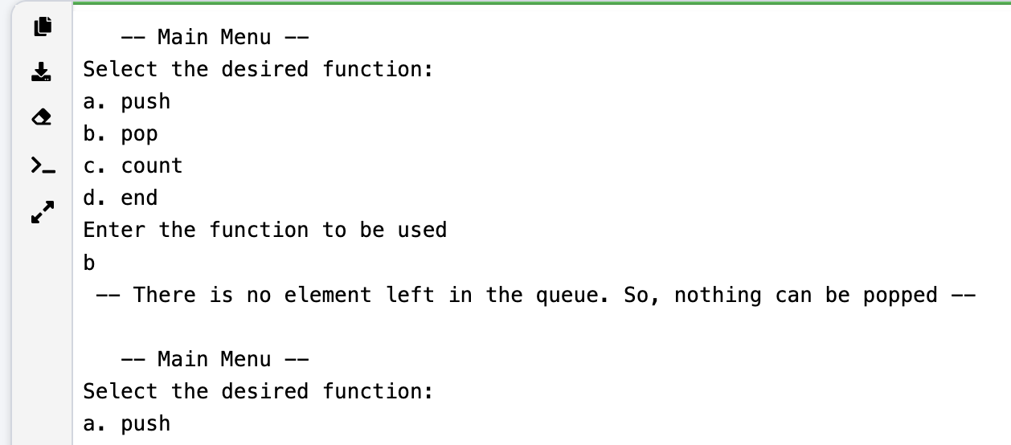

Figure 6: Result when the pop function is used when no data in the queue

1. When the count function is used

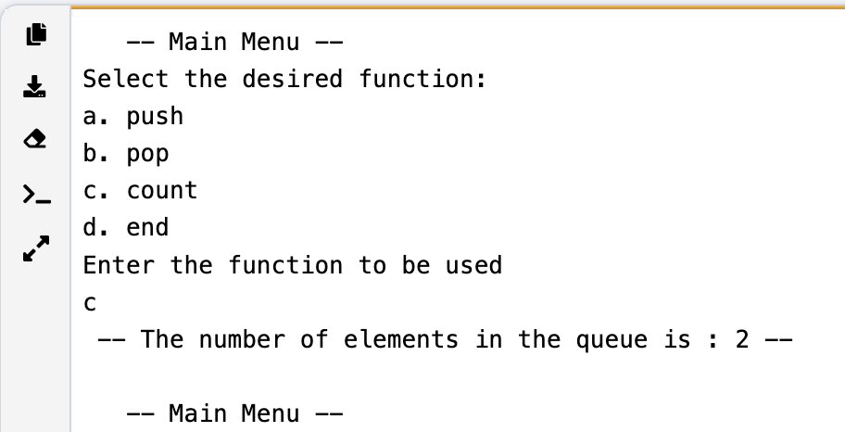

Figure 7: Result when the count function is used

1. When the end function is used

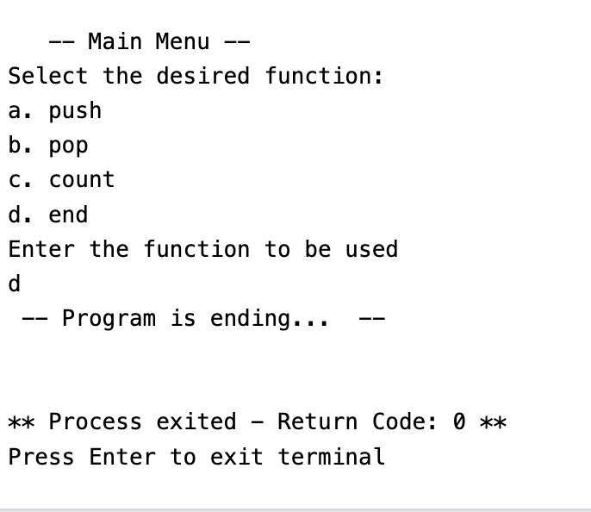

Figure 8: Result when the end function is used