The George Washington Universityshort line



**Advanced Software Paradigms (CSCI 6221.10)**

Homework Assignment #5

Date: 26 February 2024

**Submitted By:**

Abhiyan Sainju (G22510509)

**Submitted to:**

Professor Yih-Feng Hwang

Steps for execution:

1. The provided program is written in **Python**. To run it, use any online Python compiler, for example, <https://www.programiz.com/python-programming/online-compiler/>
2. Copy the code from the attached source code .txt file and paste it into the code area in the online compiler.
3. Click the “Run” button in the compiler.
4. Review the output/result displayed by the compiler, as illustrated in Figure 1.

Screenshots:

1. The Main Menu of the program.

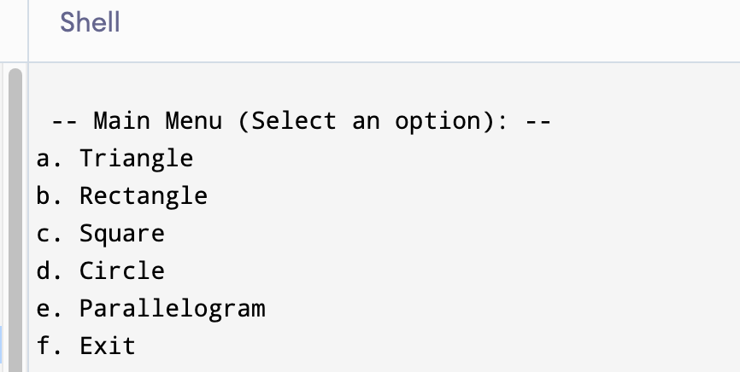

Figure : Main Menu

1. When a correct shape is selected

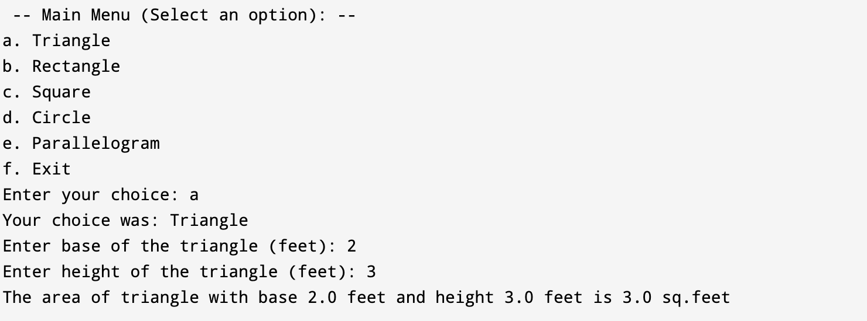

Figure 2: Result when a correct shape is selected

1. When an incorrect shape option is selected

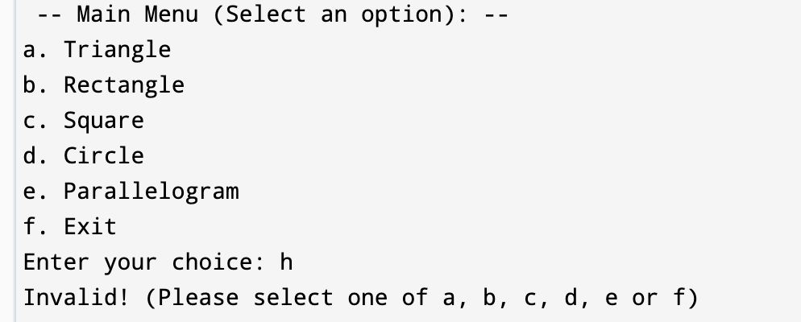

Figure 3: Result when incorrect shape option is selected

1. When the Triangle shape is selected

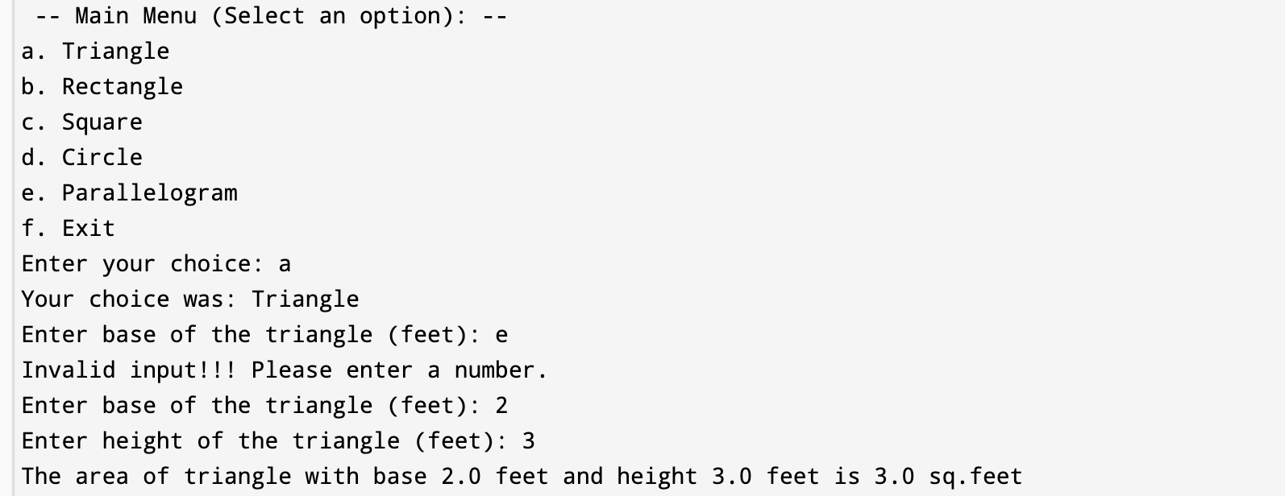

Figure 4: Result when the Triangle shape is selected

1. When the Rectangle shape is selected

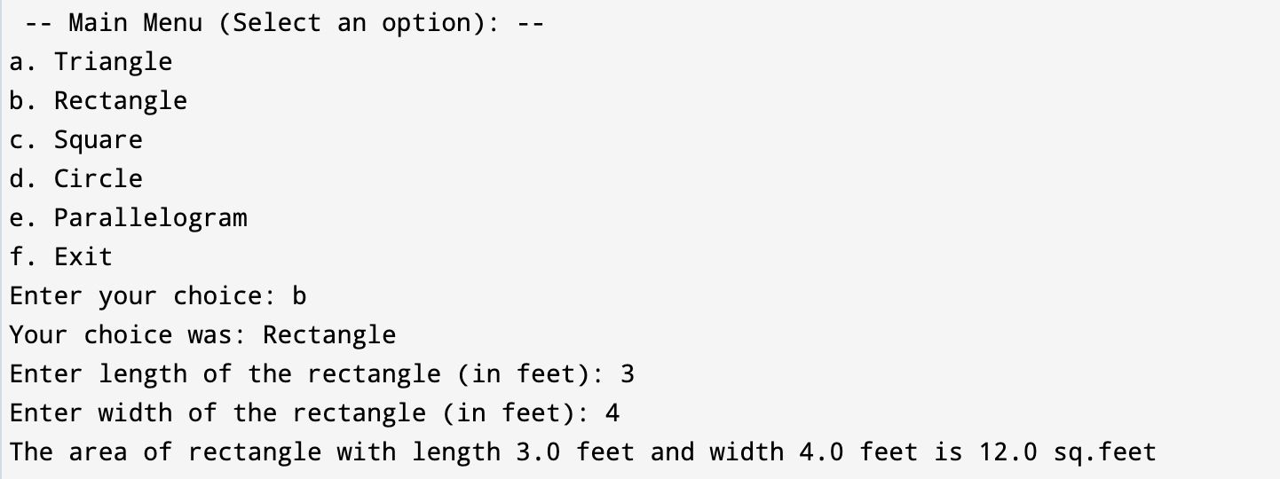

Figure 5: Result when the Rectangle shape is selected

1. When the Square shape is selected

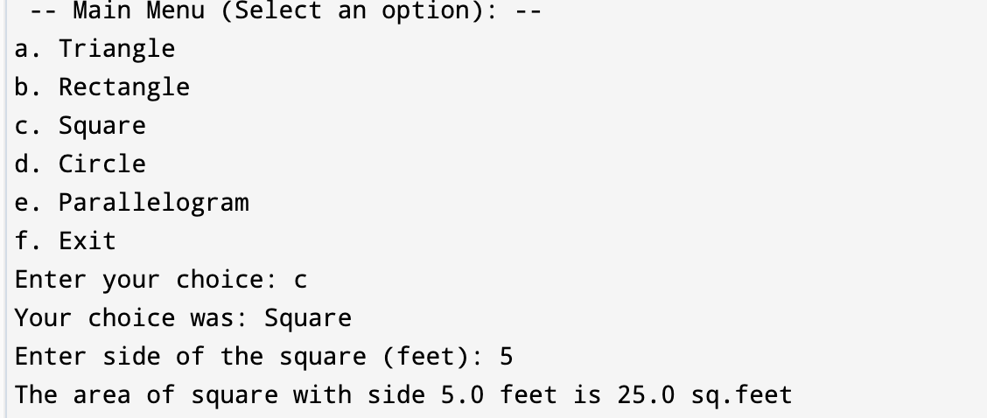

Figure 6: Result when the Square shape is selected

1. When the Circle shape is selected

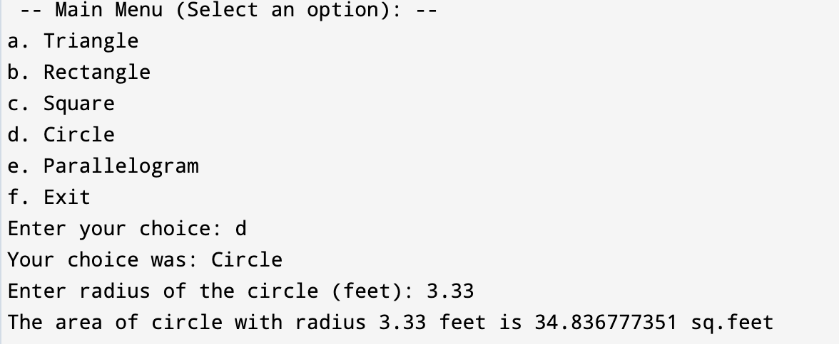

Figure 7: Result when the Circle shape is selected

1. When the parallelogram shape is selected

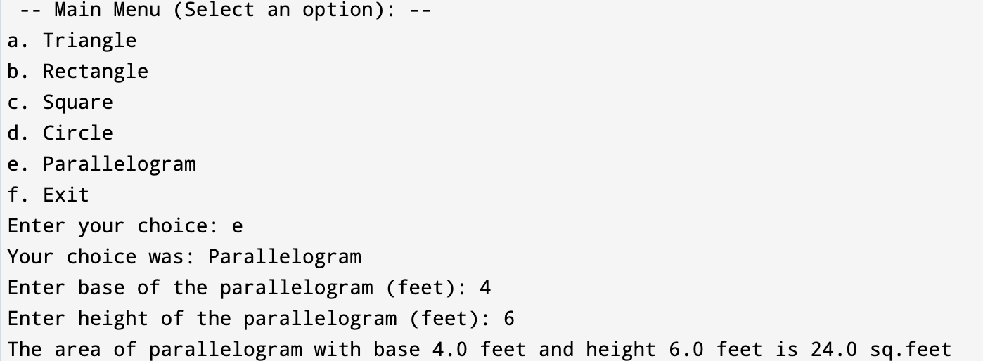

Figure 8: Result when the Parallelogram shape is selected

1. When the exit option is selected

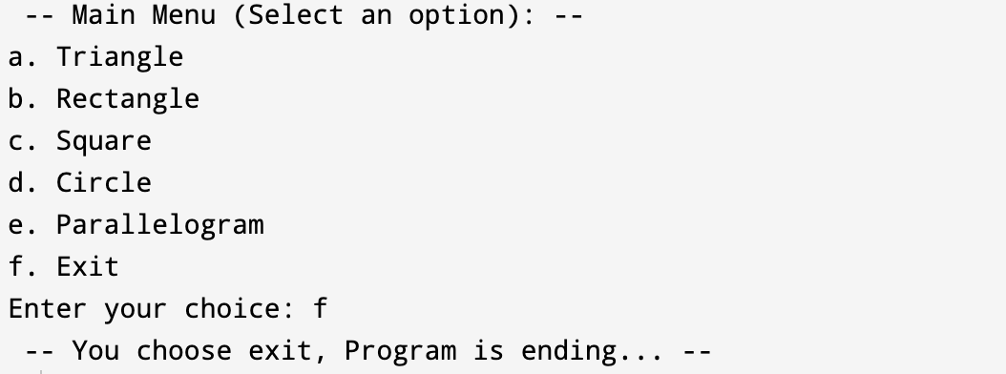

Figure 9: Result when Exit option is selected