The George Washington Universityshort line



**Advanced Software Paradigms (CSCI 6221.10)**

Homework Assignment #6

Date: 4 March 2024

**Submitted By:**

Abhiyan Sainju (G22510509)

**Submitted to:**

Professor Yih-Feng Hwang

Steps for execution:

1. The provided program is written in **Scheme**. To run it, use any online Python compiler, for example, <https://www.tutorialspoint.com/execute_scheme_online.php>
2. Copy the code from the attached source code .txt file and paste it into the code area in the online compiler.
3. Click the “Execute” button in the top left part of the compiler website.
4. Review the output/result displayed by the compiler, as illustrated in Figure 1.

Screenshots:

1. The Main Menu of the program.

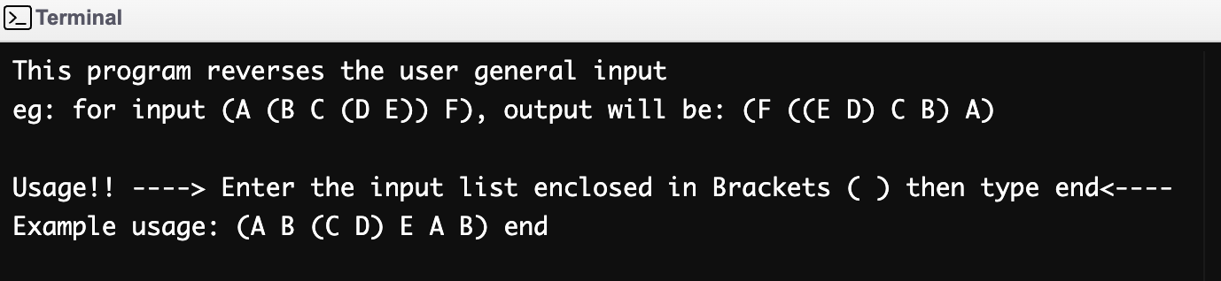

Figure : Main Menu

1. Result of the program

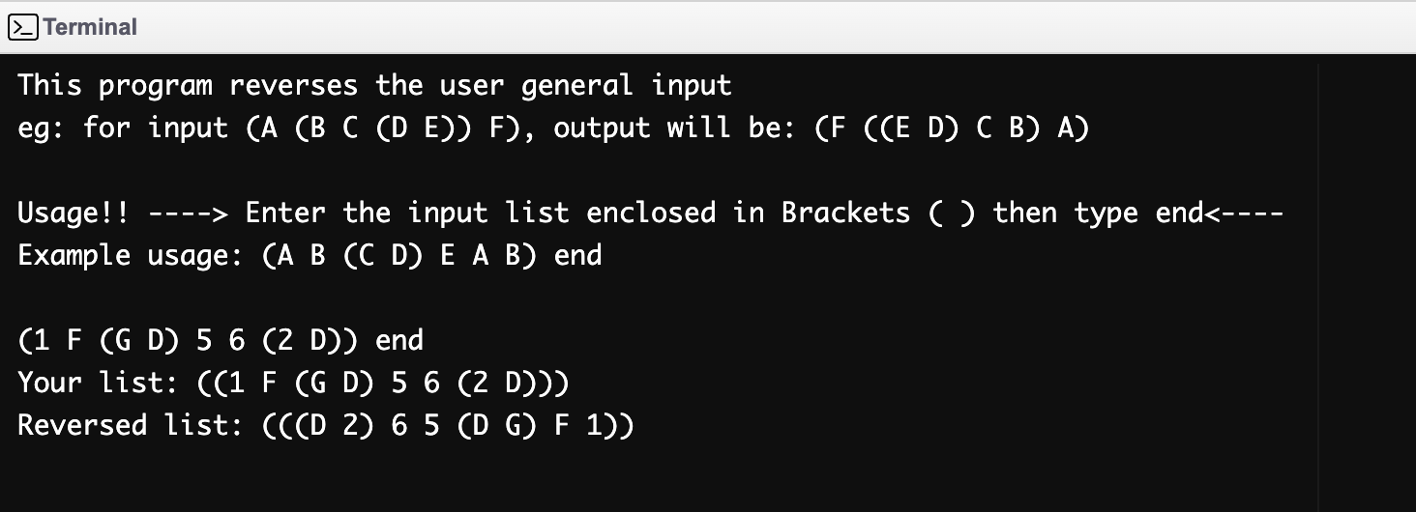

Figure 2: Result of the program