The George Washington Universityshort line



**Advanced Software Paradigms (CSCI 6221.10)**

Homework Assignment #7

Date: 14 March 2024

**Submitted By:**

Abhiyan Sainju (G22510509)

**Submitted to:**

Professor Yih-Feng Hwang

Steps for execution:

1. The provided program is written in **Prolog**. To run it, use any online Prolog compiler, for example, <https://www.tutorialspoint.com/execute_prolog_online.php>. This is the compiler used for testing the program.
2. Copy the code from the attached source code .txt file and paste it into the code area in the online compiler.
3. Click the “Execute” button in the top left part of the compiler website.
4. Review the output/result displayed by the compiler, as illustrated in Figure 1.

Screenshots:

1. Loading student scores

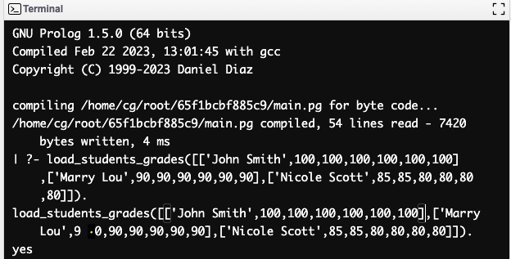

Figure 1: Result of the program when asked to load student scores

1. Displaying all students with a specific letter grade

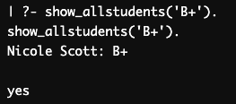

Figure 2: Result of the program when asked for students with a specific letter grade

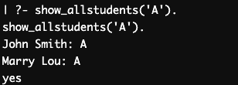

Figure 3: Result of the program when asked for students with a specific letter grade

1. Displaying the letter grade of a specific student using their name.

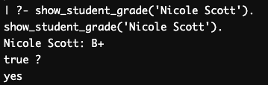

Figure 4: Result of the program when asked for the letter grade of a specific student using their name

1. Displaying the letter grade of a specific student using their name (when the student’s name is not present in the records)

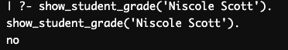

Figure 5: Result of the program when asked for the letter grade of a specific student using their name (when there is no student present in records)