The George Washington Universityshort line



**Advanced Software Paradigms (CSCI 6221.10)**

Homework Assignment #9

Date: 2 April 2024

**Submitted By:**

Abhiyan Sainju (G22510509)

**Submitted to:**

Professor Yih-Feng Hwang

Steps for execution:

* Copy the code from the attached source code.txt file and paste it into the edit area of LTSA jar program.
* Click the “Build” button in the menu bar and select “Compose”.
* To view the FSP Diagram, click the “Draw” Section.

Screenshots:

1. Even function

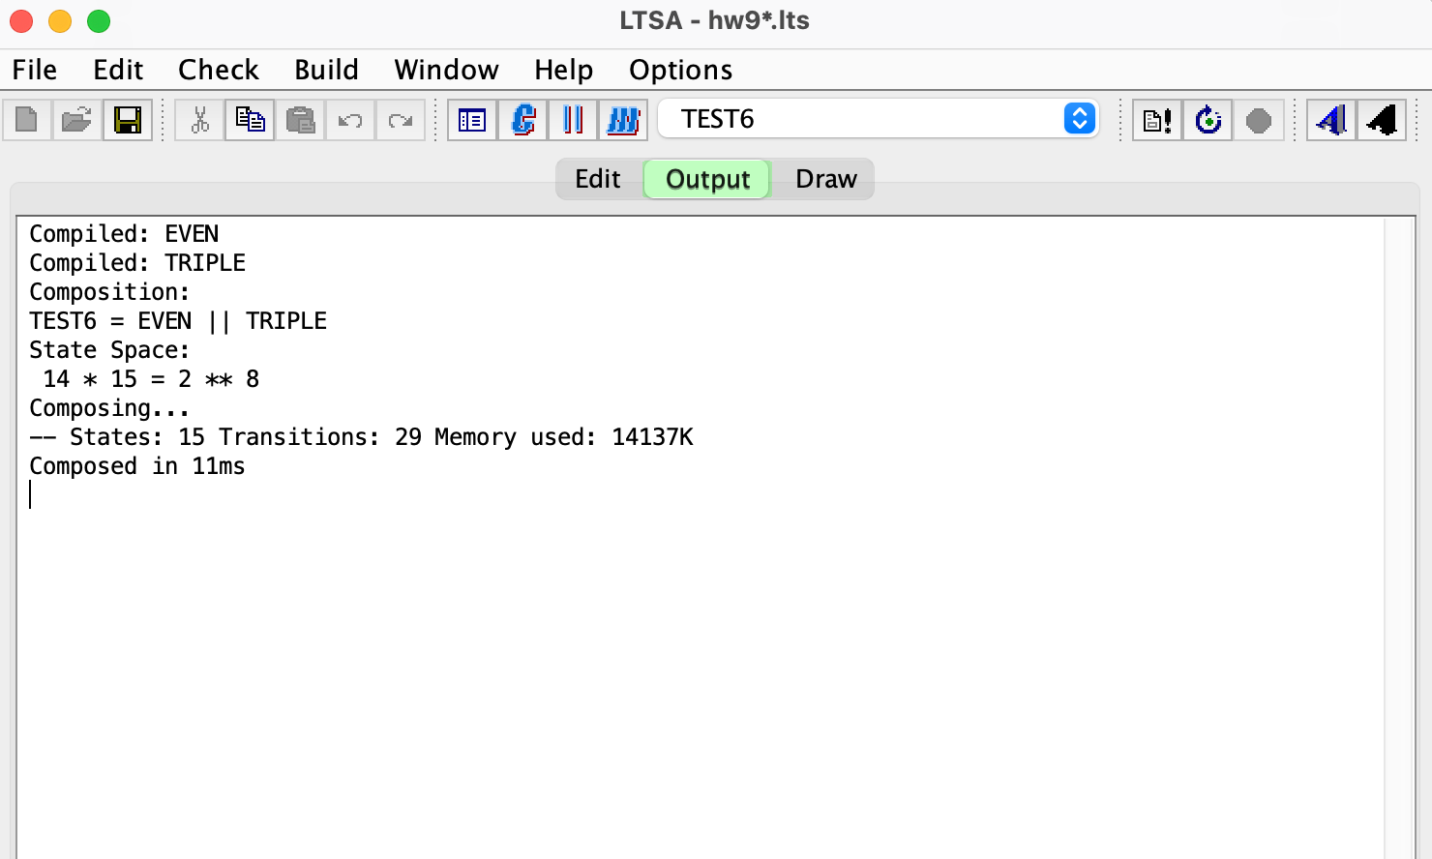

Figure : Composition of program

1. Even Function FSP Diagram

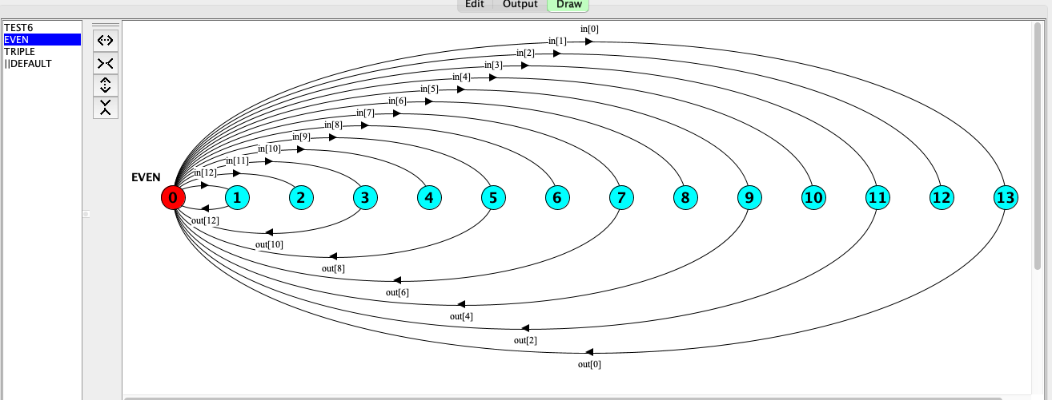

Figure : Even Function FSP Diagram

1. Triple Function FSP Diagram

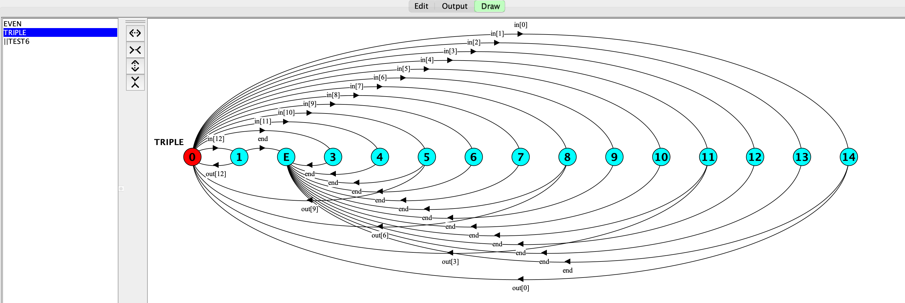

Figure 3: Triple Function FSP Diagram

1. Test6 Function FSP Diagram

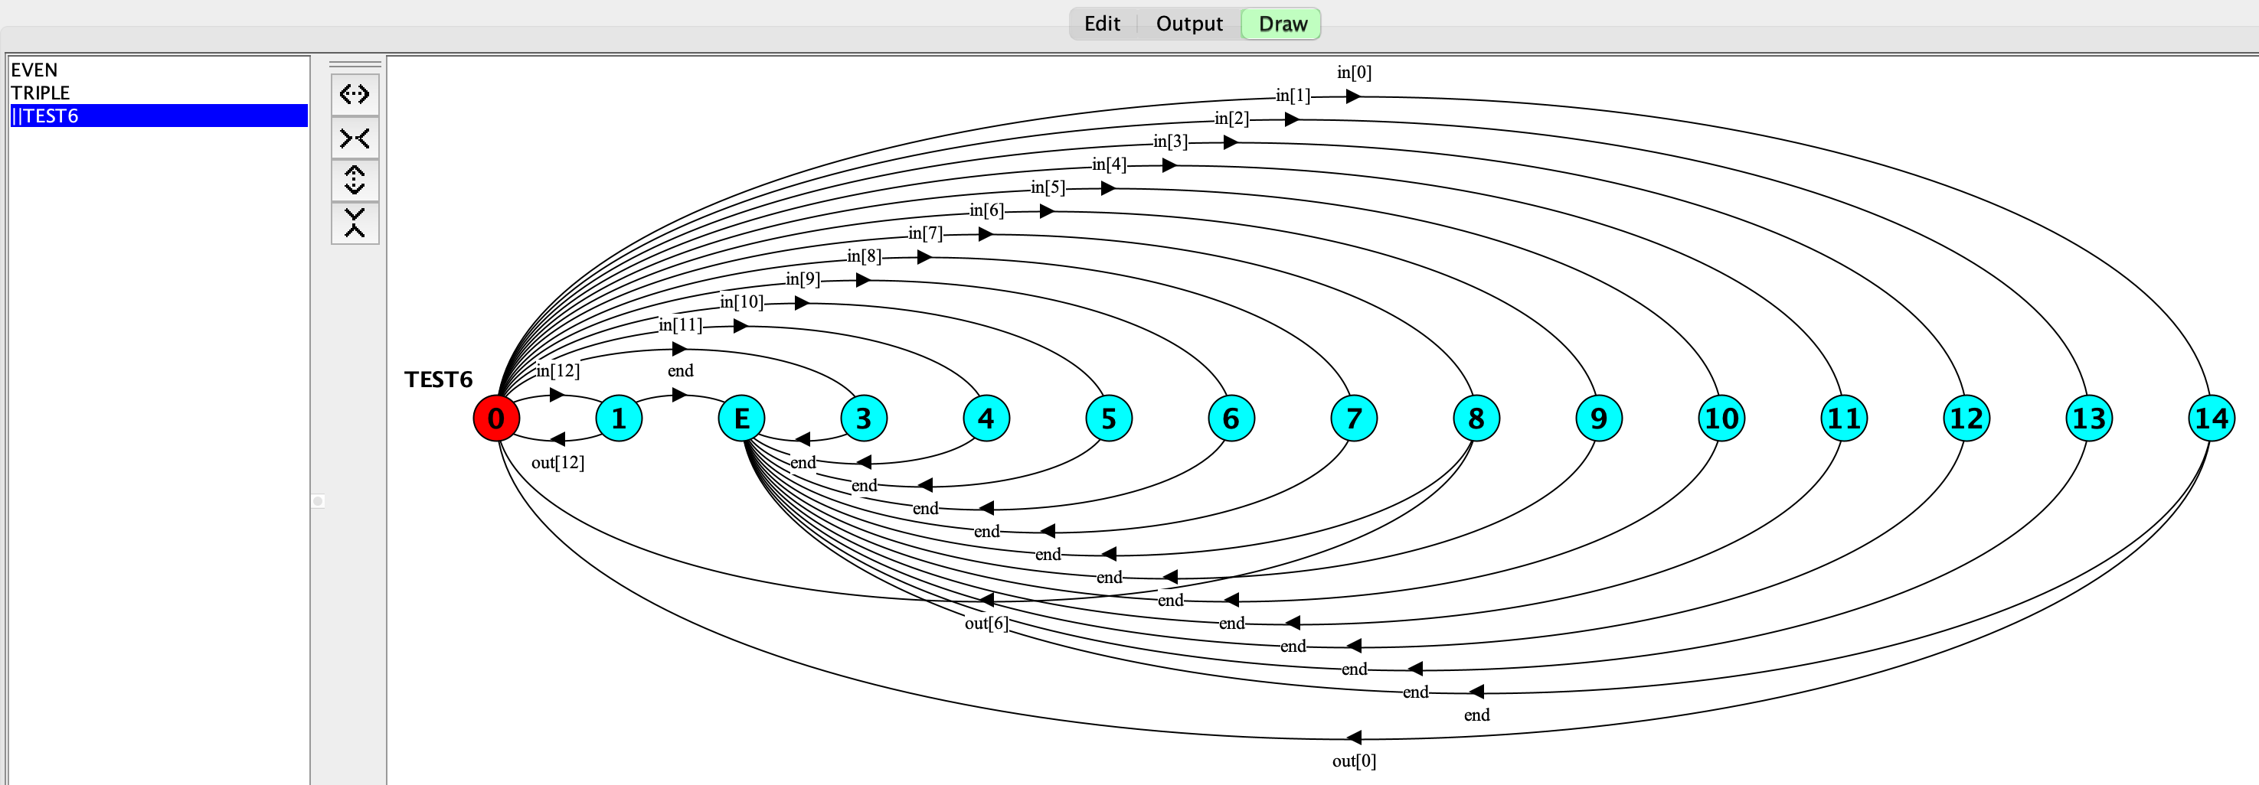

Figure 4: Test6 Function FSP Diagram