WEEK 3 – DATA ANALYSIS AND VISUALIZATION NARRATIVE
Agricultural Production, Yield and Market Intelligence for India
Hypothetical analytical framework with mock visual representations
Prepared for: Junior Data Science Analyst – Agriculture & Agribusiness
Project focus: India | Estimated effort: 33 hours

1. Executive Summary
This report develops a practical analytical framework for studying agricultural production, productivity, climate exposure and market intelligence in India. It converts the objectives established in Week 1 and the data-preparation workflow from Week 2 into a structured analysis plan. The framework combines descriptive statistics, growth analysis, correlation analysis, regression, clustering and time-series methods. Each technique is connected to a specific business question and visualization.
The report includes concrete numerical examples and mock visual representations. Figures 1 and 2 use the project's established DES crop-production reference figures. Figures 3 and 4 are explicitly illustrative mock-ups showing how a possible climate relationship and productivity trend could be communicated. They are not claimed to be measured climate observations.

2. Introduction and Analysis Scope
Central business question: Which crops and regions in India show the strongest production and productivity trends, what factors are associated with those differences, and where could agribusiness opportunities or risks be prioritized?
- Production growth and contribution
- Area versus yield as drivers of production
- Regional productivity differences and yield gaps
- Association between rainfall conditions and yield
- Market prices and arrivals as indicators of commercialization risk and opportunity

3. Alignment with Week 1 Objectives
Objective | Week 3 method | Decision use
Understand production growth | Growth and contribution analysis | Identify expanding crops
Explain productivity differences | Yield-gap analysis and ranking | Prioritize productivity improvement
Assess climate association | Correlation and regression | Identify climate-sensitive areas
Compare regions | Clustering and benchmarking | Segment regions by performance
Study market opportunity | Price/arrival analysis | Support procurement and market decisions

4. Analytical Framework

4.1 Descriptive Statistics
Calculate count, mean, median, standard deviation, minimum, maximum and quartiles for production, area, yield, prices and arrivals. This establishes a baseline and helps detect skewness, unusual values and scale differences before modelling.
Example: if district yield has a mean of 2.8 t/ha and a median of 2.2 t/ha, the difference would indicate that a smaller group of high-performing districts may be pulling the average upward.

4.2 Growth and Contribution Analysis
Production growth will be separated into area and yield effects. Growth % = ((Current value − Previous value) / Previous value) × 100. CAGR can be used for longer periods. Contribution analysis will identify which crops account for the largest share of total production change.
Concrete reference example: total foodgrain production increased from 285.71 million tonnes in the 2022 reference table to 329.22 million tonnes in the 2024-25 reference table, approximately +15.2%. In the same comparison, maize increased from 27.78 to 36.91 million tonnes (+32.9%), while rapeseed & mustard increased from 8.68 to 12.15 million tonnes (+39.9%).

4.3 Correlation Analysis
Pearson correlation will be used for approximately linear relationships between continuous variables. Spearman correlation will be considered for skewed or monotonic relationships. Correlation will be interpreted as association, not proof of causation.

4.4 Regression Analysis
Multiple linear regression can estimate how yield is associated with rainfall, temperature indicators, cultivated area and other available explanatory variables. A simplified model is Yield = β0 + β1(Rainfall) + β2(Temperature) + β3(Area) + ε. Diagnostics will include residual checks, multicollinearity checks and R². Tree-based models may be evaluated if relationships are strongly non-linear.

4.5 Clustering
K-means clustering can segment districts or states into groups such as high-production/high-yield, high-production/lower-yield and lower-production/emerging regions. Variables will be standardized first. Cluster count will be selected using measures such as silhouette score and business interpretability.

4.6 Time-Series Analysis
Annual or monthly series will be examined for trend, seasonality and structural changes. Rolling averages and year-on-year growth provide simple baselines. If enough observations are available, exponential smoothing or ARIMA can be evaluated and tested on holdout periods using MAE or RMSE.

5. Data Preparation Before Analysis
- Start from the controlled Week 2 processed dataset
- Standardize crop, state, district and season labels
- Validate units such as hectares, tonnes and kg/ha
- Check production-area-yield consistency
- Investigate duplicates and extreme values
- Document missing-value treatment
- Keep raw, processed and analytical datasets separate

6. Visualization Strategy
Chart | Purpose | Question | Reason
Bar chart | Compare crops/regions | Which has the highest production? | Clear magnitude ranking
Line chart | Show time trends | Is productivity improving? | Shows direction and turning points
Scatter plot | Show relationships | Is rainfall associated with yield? | Reveals association and outliers
Heatmap | Region × crop/year | Where are gaps concentrated? | Highlights two-dimensional patterns
Box plot | Compare distributions | How variable is yield? | Shows median, spread and outliers
Cluster plot | Show segments | Which regions behave similarly? | Communicates groups

7. Mock Visualizations and Interpretation
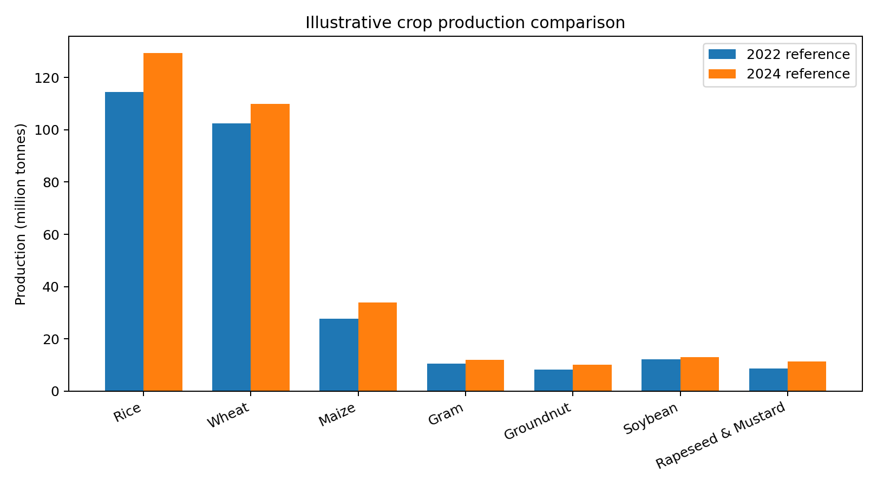
Figure 1. Reference-data illustration: major crop production comparison.
Interpretation: Rice and wheat dominate the selected crop set by absolute production. Maize is smaller in scale but shows strong growth in the reference comparison. A real district/state analysis would combine production with area and yield so that volume is not mistaken for productivity.
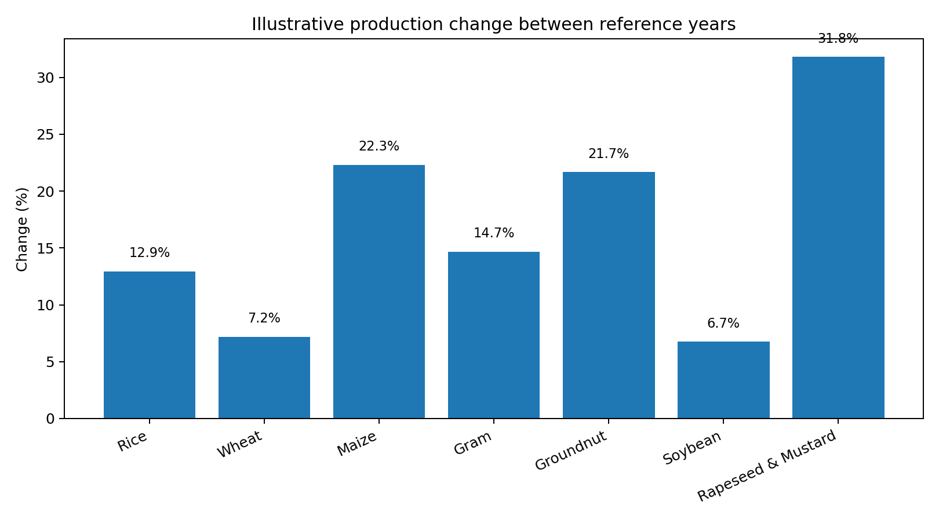
Figure 2. Reference-data illustration: production change between selected reference years.
Interpretation: Rapeseed & mustard and maize stand out as strong growers in this reference comparison. The next analytical question is whether the increase came from additional cultivated area, improved yield, or both.
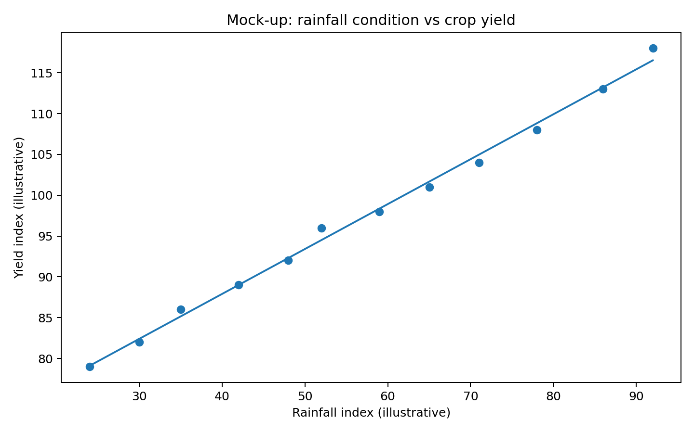
Figure 3. Mock-up: rainfall condition versus yield. Values are illustrative.
Interpretation: If real data showed a similar positive pattern, rainfall conditions could be associated with higher yields. Before making a stronger claim, the analysis would control for irrigation, soil, crop choice, technology and other confounders. Outliers would also be investigated.
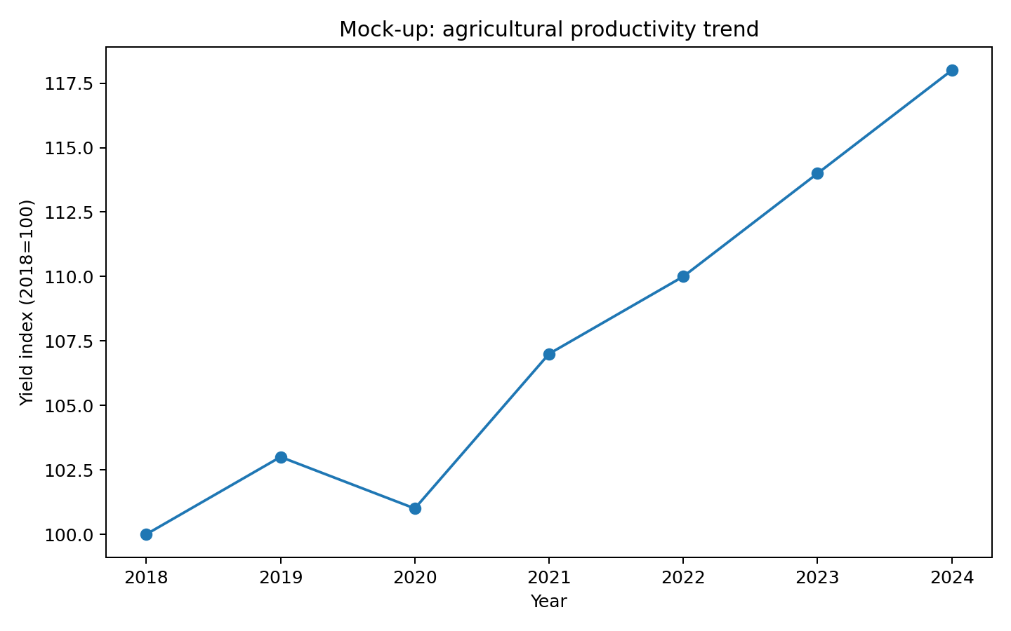
Figure 4. Mock-up: agricultural productivity index over time. Values are illustrative.
Interpretation: A sustained upward trend could indicate productivity improvement relative to the base year. Sudden declines would trigger investigation of weather shocks, pests, policy changes, input availability or reporting changes.

8. Hypothetical Findings and Agribusiness Implications
Scenario | Potential finding | Implication
Yield-led growth | Production rises while area stays broadly stable | Prioritize improved seed, irrigation, mechanization and advisory services
Area-led growth | Production rises mainly through cultivated-area expansion | Assess resource pressure and procurement capacity
Climate-sensitive yield | Rainfall deviation is associated with yield changes | Consider irrigation, insurance and climate-resilient inputs
High-production/low-yield cluster | Large regions perform below peers on yield | Potential high-impact productivity-improvement market
High price + low arrivals | Prices rise as arrivals fall | Possible supply tightness; strengthen market monitoring

9. Pseudo-code for the Analytical Pipeline
LOAD Week 2 cleaned agricultural data
VALIDATE units, dates, crop names and geography
CALCULATE descriptive statistics
CALCULATE area, production and yield growth
RANK crops and regions
MERGE climate and market data using validated keys
CALCULATE correlations
FIT regression when sample size and quality are adequate
CHECK residuals, R² and multicollinearity
STANDARDIZE clustering variables
SELECT cluster count using silhouette score
FIT K-means and profile clusters
BUILD time-series summaries and forecasts where appropriate
CREATE charts and dashboard-ready tables
INTERPRET results against agribusiness questions
EXPORT figures, tables and quality notes

10. Quality Checks and Statistical Cautions
- Correlation will not be interpreted as causation
- Small samples and missing years can weaken regression or forecasting
- Extreme values will be investigated rather than automatically deleted
- Cluster results will be checked for stability and business meaning
- Charts will use consistent units and labelled axes
- Mock figures will remain clearly labelled
- Future climate and market joins will be validated for geography, time period and units

11. Tools and Software
Python is the primary analytical environment. Pandas and NumPy will handle data preparation; SciPy and statsmodels can support statistical analysis; scikit-learn will support regression and clustering; Matplotlib and Plotly can support visualizations; Jupyter Notebook will document reproducible analysis; Excel may be used for quick inspection; Git and GitHub will provide version control.

12. Proposed 33-Hour Work Plan
Activity | Hours | Output
Data validation and EDA | 5 | EDA tables and quality checks
Descriptive and growth analysis | 5 | Production/yield metrics
Correlation and regression | 6 | Association/model framework
Clustering | 5 | Regional segments
Time-series analysis | 4 | Trend/forecast framework
Visualization and narrative | 5 | Charts and interpretations
Documentation and review | 3 | Final report

13. Expected Outcomes
The analysis should identify major production and productivity trends, compare regions, quantify selected relationships, segment agricultural regions and communicate potential opportunities and risks through clear visual narratives. The framework can expand as district-level, climate and market datasets become available.

14. Conclusion
Week 3 converts the project's strategy and cleaning work into a decision-oriented analytical framework. Descriptive statistics establish the baseline, growth analysis explains change, regression tests associations, clustering identifies regional segments, and time-series methods reveal temporal behaviour. The visualization strategy ensures that technical findings can be communicated to non-technical agribusiness stakeholders. The mock scenarios demonstrate how analytical results could translate into practical decisions while keeping hypothetical values separate from observed data.

15. Source and Data Note
Agricultural reference figures are based on the project's established Directorate of Economics & Statistics work and previously compiled Agricultural Statistics at a Glance tables. Future regional, climate and market analysis is intended to use official DES, data.gov.in, Agmarknet/e-NAM and FAOSTAT sources. The climate and time-series mock-ups in this report use illustrative values solely to demonstrate analytical storytelling.

