ECLIPSE EMBEDDED SETUP FOR FREERTOS DEVELOPMENT
- Download Eclipse for Embedded Systems and extract it to your preferred directory. Once extracted, don’t click on eclipse.exe yet.

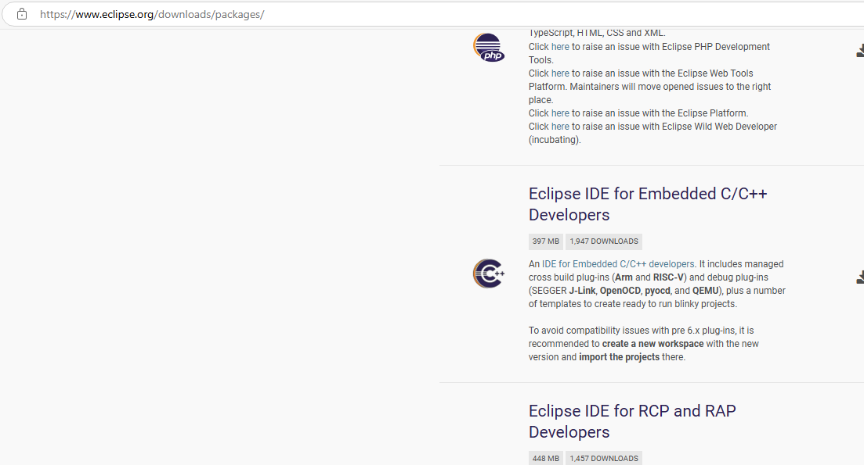

- Download the ARM toolchain and install it. Make sure to add its path to the environment variables PATH. The programs under the toolchain (gcc, gdb, ld, etc.) will be called by the Makefile to build, debug, and do other things to our project.
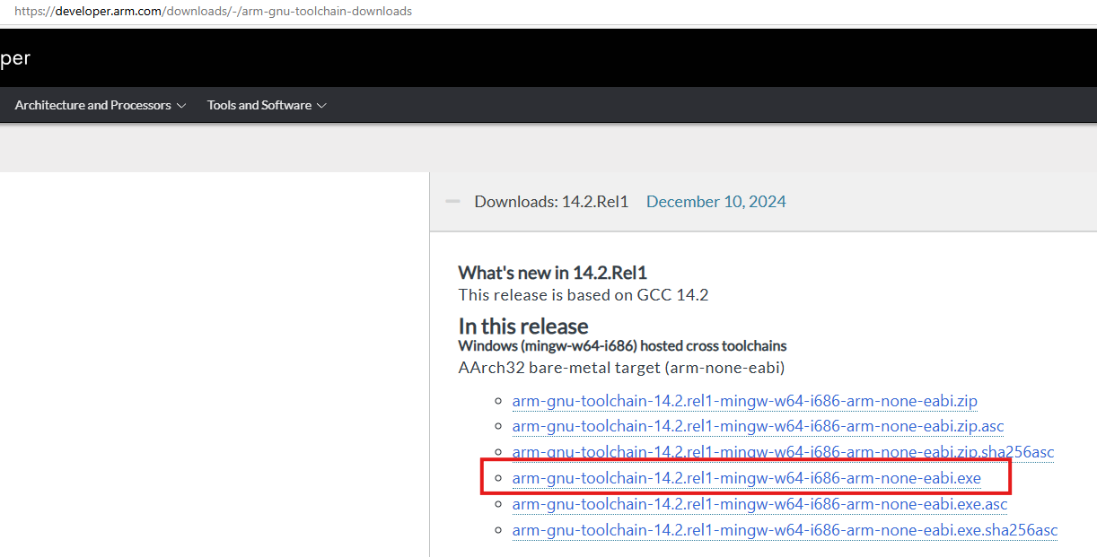

- Download MSYS2. This is a stepping stone for getting the “make” command for Windows. Extract and install.
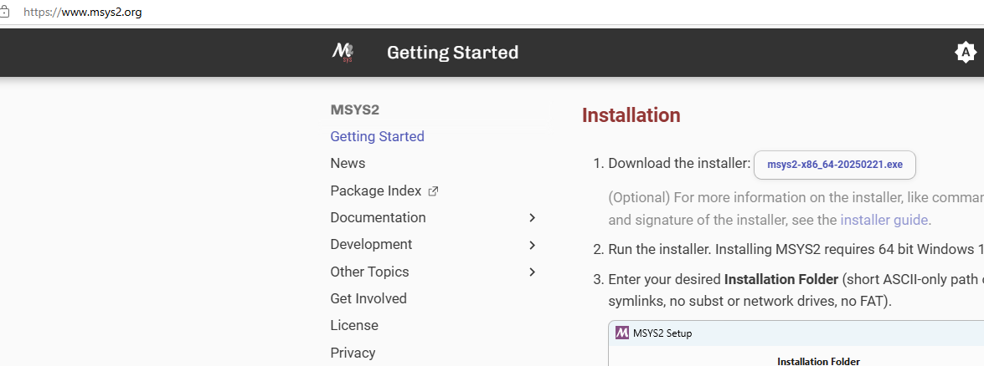

- Open msys2.exe in its directory (e.g. C:/msys64)

- This will open up a terminal-like command prompt. Follow the commands illustrated to install the illustrated packages. One of this is “make.exe” which is needed in Eclipse.
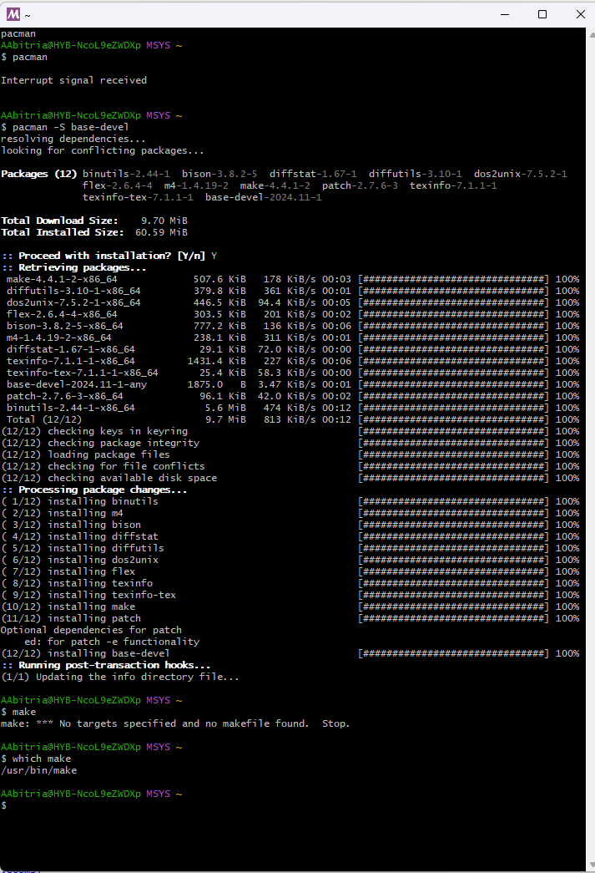

- After installing, add the location of make into PATH under environmental variables.
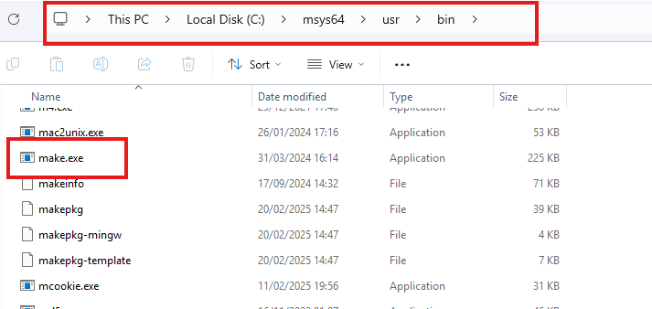

- Download openocd for windows. Just extract and no need to install it. Just take note of its .exe file (openocd.exe). This will be our GDB server.

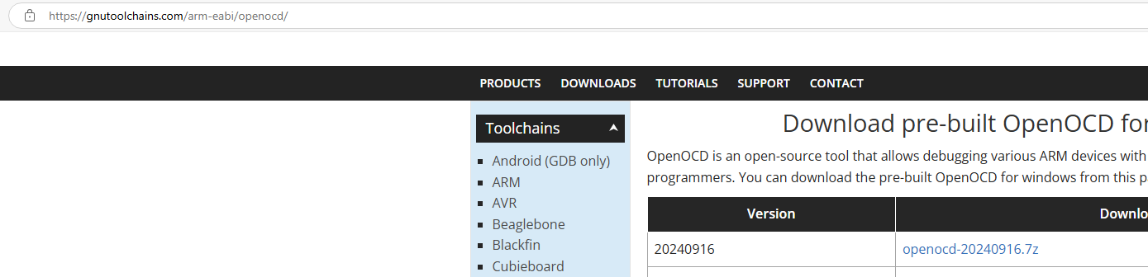

- Clone the repository for FreeRTOS hands-on activity from the following link:
aabitria-adi/FREERTOS_Handson. After doing so, you should be in master branch.
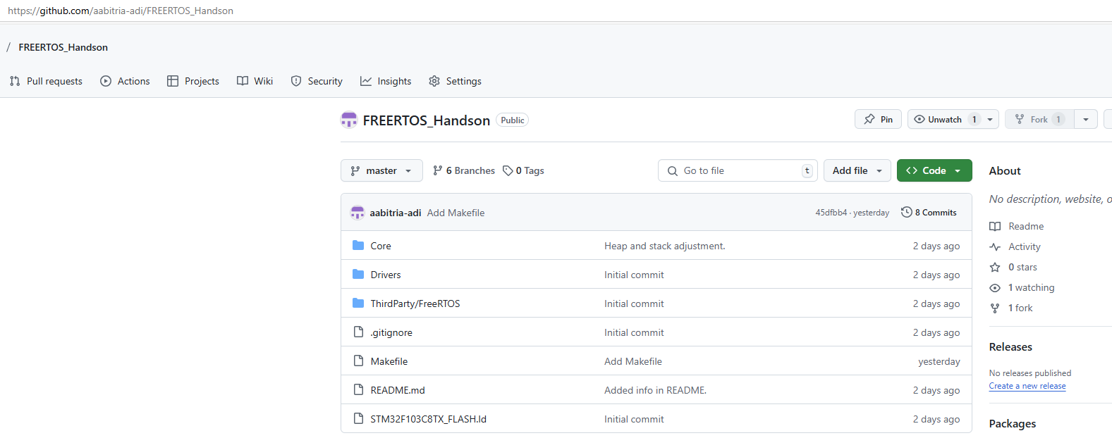

- Open up eclipse.exe, the one you installed earlier. Once opened, to open the repo project you just cloned you have to import it as a Makefile project.
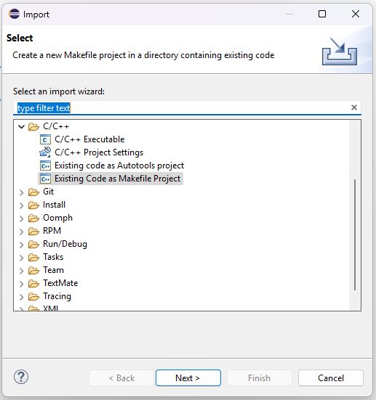

- Point to the repo project and make sure toolchain is selected as <none>, as we are providing our own toolchain (which you recently downloaded).
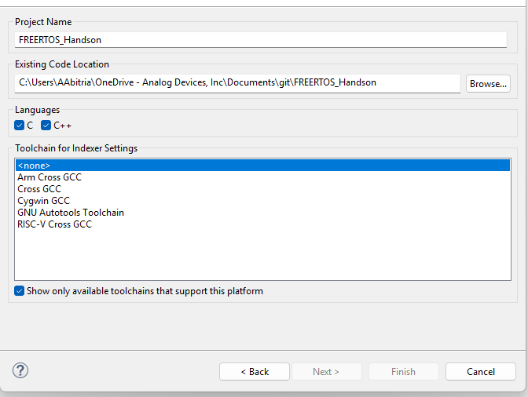

- In the Makefile, a small change has to be done. Change the GNU_TOOLS_DIR variable value to the location of your downloaded ARM Toolchain. See example below.
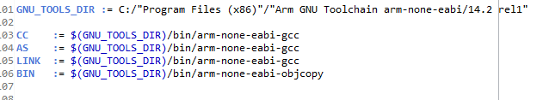

- Build the project from Project Explorer. It should finish the build successfully.

- To debug, make sure STLink USB drivers are installed already.

- To debug this, we have to make a debug configuration. Select it as follows.

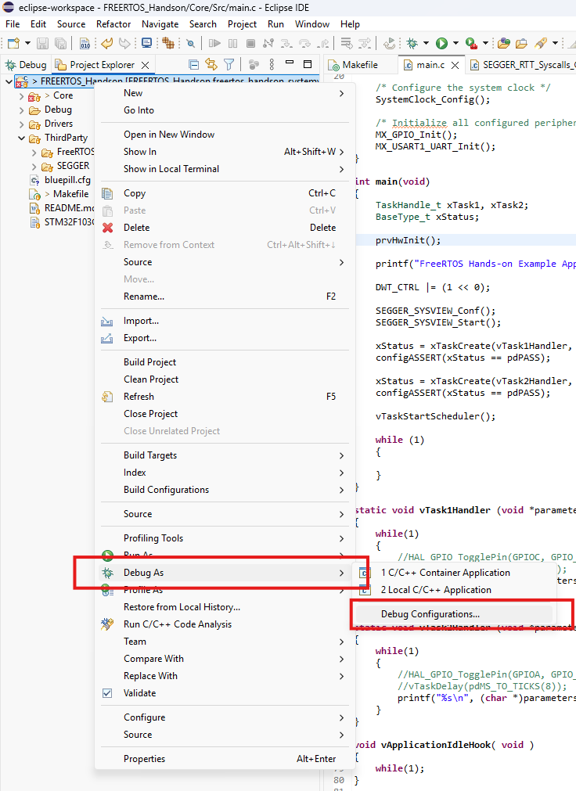

- Create a debug configuration under “GDB OpenOCD Debugging” and follow the settings below for the following tabs: Main and Debugger.
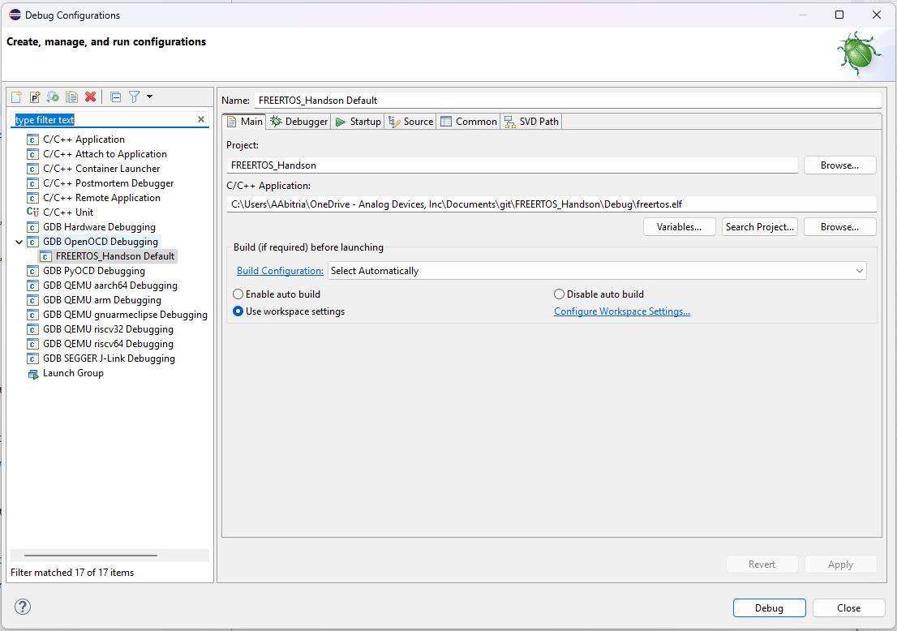

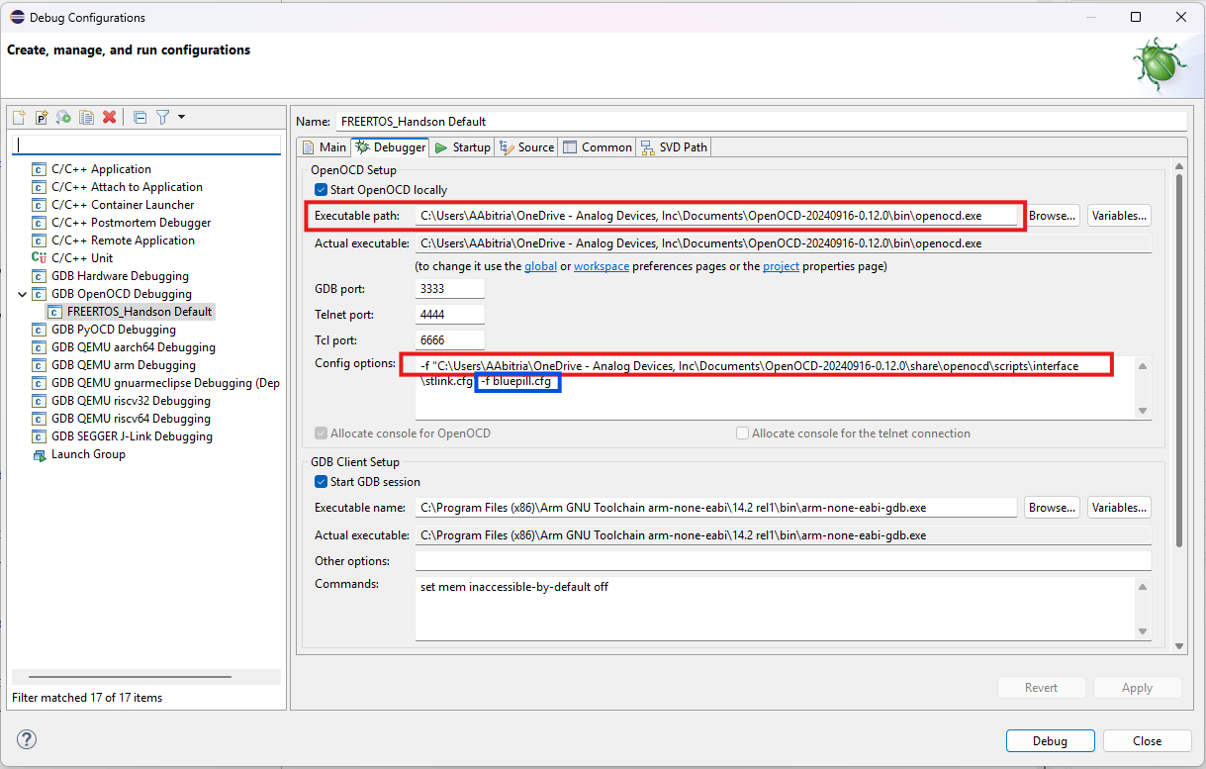
The ones boxed in red are those files found in the extracted openocd folder. We are pointing the openocd.exe location under “Ëxecutable path” and in “Config options”, the location of the stlink.cfg file.

Note: If GDB OpenOCD Debugging is not available, you have to install “Embedded CDT plugin” from Eclipse Marketplace.

For bluepill.cfg which the board config, just create a .cfg file anywhere with the following contents:
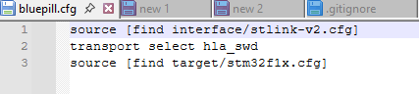
UPDATE (as of 28/03/25): bluepill.cfg is already included in the repository, in all branches. No need to create a new file as specified above.

And include this file and its location on the config options with -f option in the Debugger tab of your debug configurations.

- Debug it by the Debug button. GDB and openocd will be starting as indicated by the messages in the console tab underneath.
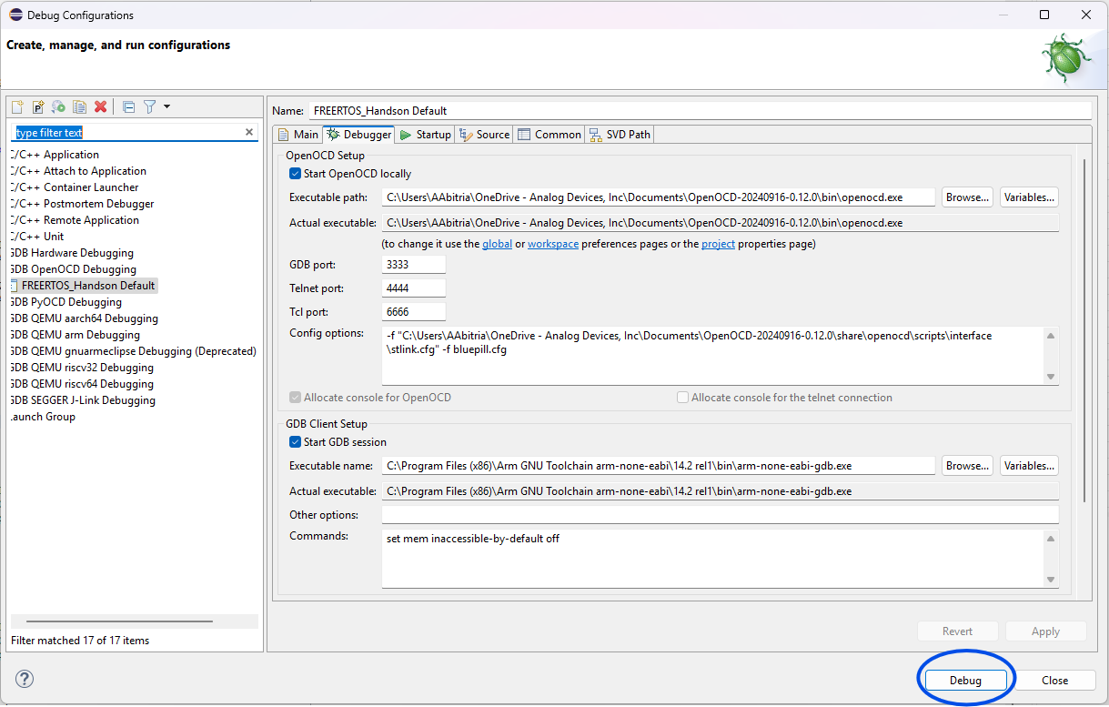

After creating this debug configuration, succeeding debugging can be triggered by the bug button in the menu.

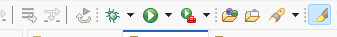
ONESHOT TRACE CAPTURE FOR SYSTEMVIEW
On this part, we will do a oneshot capture of FreeRTOS trace to be analyzed in SEGGER Systemview. Oneshot because we can only do 1 capture for this.

- Checkout the freertos_handson_systemview branch of the repo.

- For this branch, apply the same GNU_TOOLS_DIR change you did earlier. Also, we have to get rid of a certain syscall .c file as it prevents the project from building.
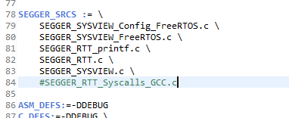

- Take note that this branch includes more files, under the ”SEGGER” folder as we are going to use their tool to capture trace in order to visualize FreeRTOS operation.

- Install SEGGER SystemView from this link: https://www.segger.com/products/development-tools/systemview/. We have to install a particular version as this is the one tested for this course. That version is as follows.

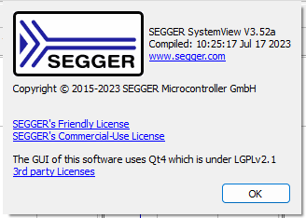

- Build the project, start the debug and have it run for a few seconds just to get the systemview buffer filled up, which is around 4096 bytes. Take note of the changes from master branch such as the use of SEGGER Systemview APIs in main.c

- Pause the debug, and inspect a certain global variable in Expressions tab. This variable is named _SEGGER_RTT. Expand it.

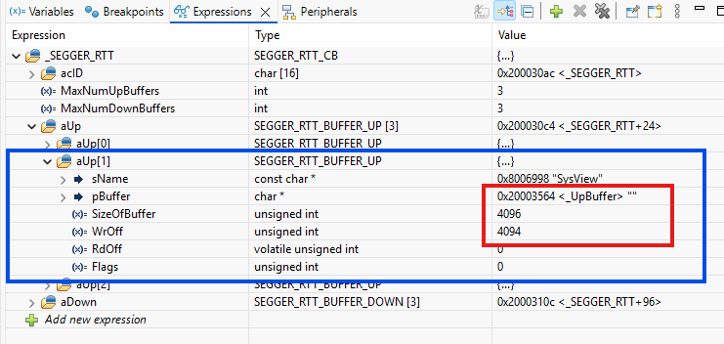
Take note of the address of _UpBuffer and the value of “WrOff”. We will use it to capture the trace.

- Open up memory view using the address of _UpBuffer above, in order for us to see the data captured by the Systemview code. If this region is zero, something went wrong.
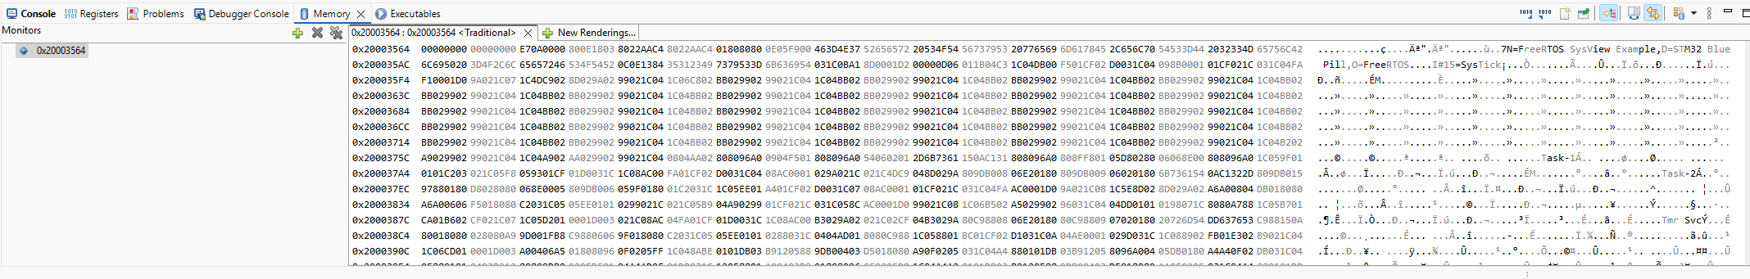

- Click the export button in Memory View.
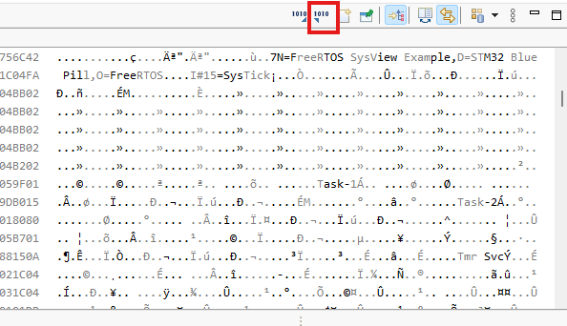

- On the Export Memory window, indicate the Start address and Length of the memory data being exported. It should correspond to the _UpBuffer address and WrOff value, respectively. Don’t bother with end address; it will automatically adjust according to the values of start address and length.
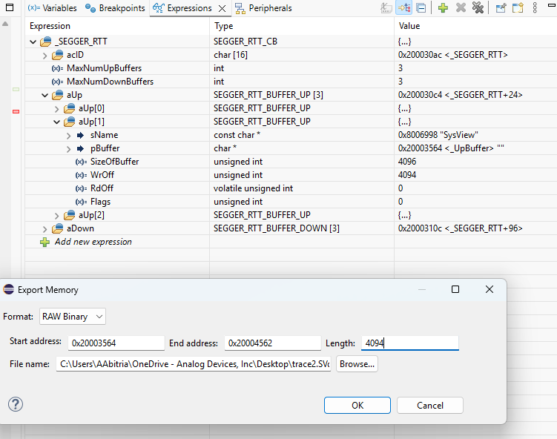

Make sure the Format is RAW Binary (not plain text or others). For the file name, any will do as long as the extension is .SVdat.

- After saving, the file size should be around 4.00kB, which is the size of the buffer. You can now open it with Systemview.
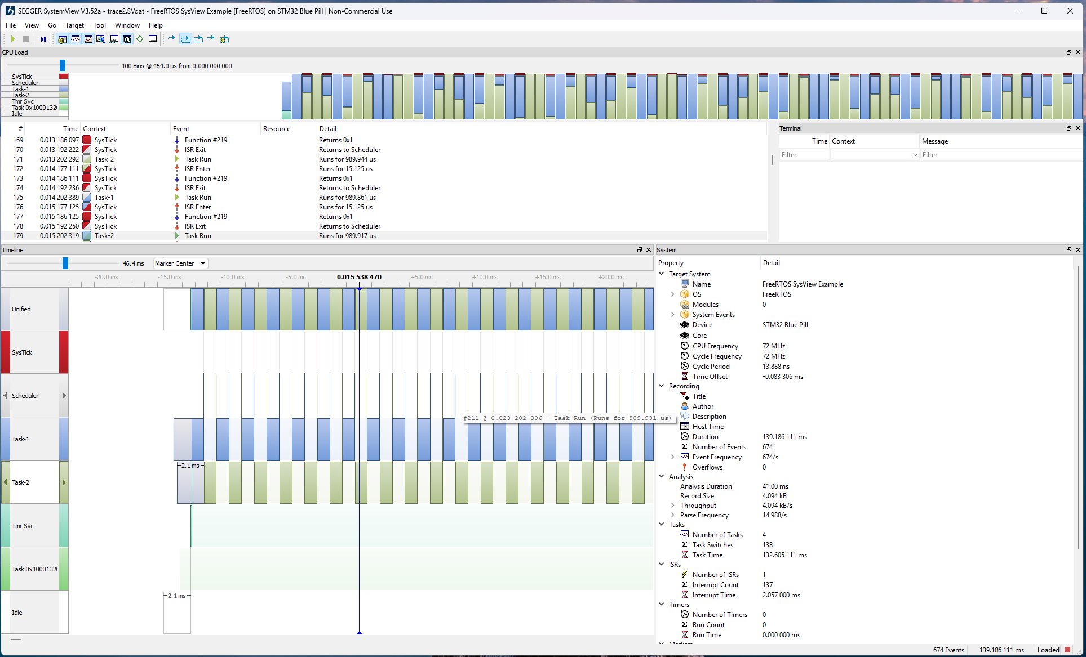

CONTINUOUS TRACE CAPTURE FOR SYSTEMVIEW
With SEGGER Systemview's continuous trace, we don't have to do the cumbersome copying of some MCU memory space into a binary blob. Just connect the MCU device to the host PC via UART, click a start button in Systemview app window, and the traces will be streamed real-time to the host PC.
This uses UART for connection between the Blue pill board and host PC. Of course, other alternative and more optimal connection exist like via SEGGER's J-Link probe, but we don't have it. UART is the most convenient to use for us. And we will have to set UART up for this job.
These steps assume we are continuing from the last step of the previous section about one-shot tracing.
- From the repo git, checkout the freertos_handson_systemview_continuous_tracing branch.

- If you diff this branch with the freertos_handson_systemview branch, the only directory change is the inclusion of Rec/segger_uart.c. This file sets up USART1 for continuous tracing, including the pins to use which are the same as what we use for printf (PA9/PA10), and the interrupt handler. This file change is reflected in the Makefile.
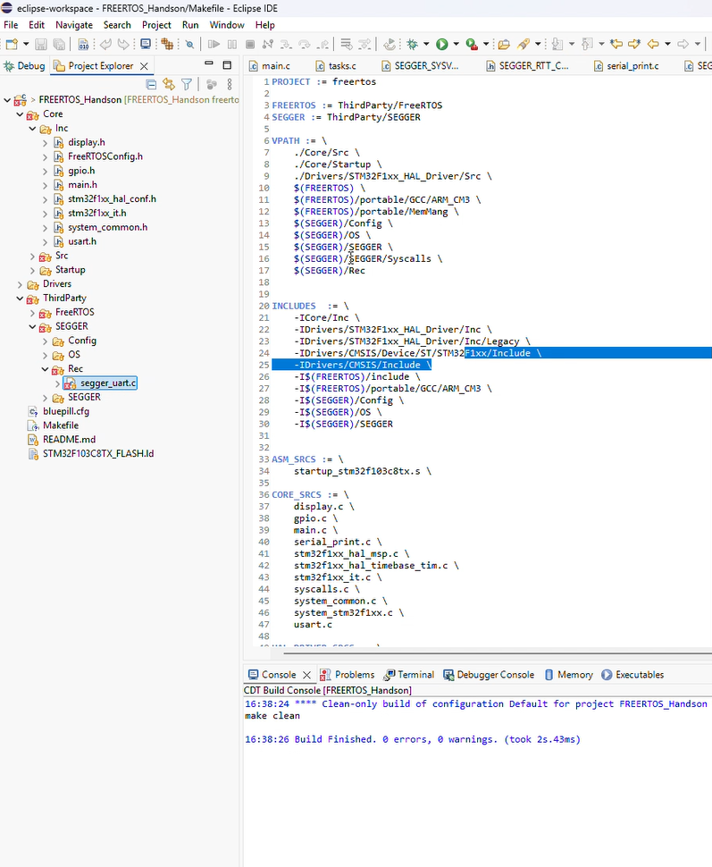

- In SEGGER/Conf/SEGGER_SYSVIEW_Conf.h, note the addition of the following code segment. If it’s absent make sure to add it. Make sure the macro SEGGER_UART_REC is defined to be 1. 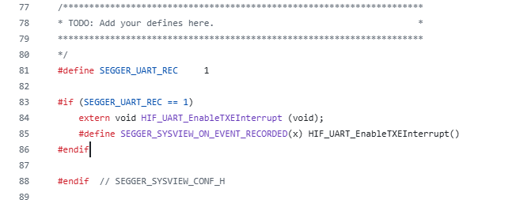

- In the main.c, add the SEGGER_UART_init API and pass the preferred baud rate as a parameter as follows. The baud rate should be high as possible but should still be within the capability of the device UART. Take note of this baud rate. Comment out SEGGER_SYSVIEW_Start() call as it is already done inside SEGGER_UART_init().

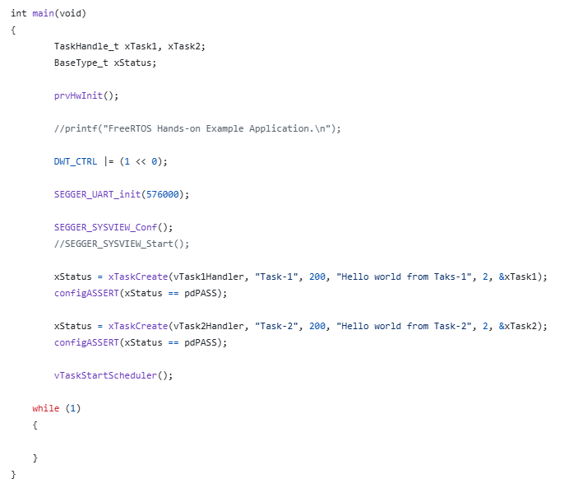

- Build and Debug/Run.
- Connect the MCU target device to the host PC using a UART-to-USB cable. Connect PA9/PA10 pins to the UART side of the cable. Make sure that in the host side, the cable is detected under “Ports” in the Windows Device Manager.

- In Systemview, go to Target->Recorder Configuration then in the window that appears, indicate UART as systemview recorder. Select the correct port then the baud rate. The baud rate should be the same as the SEGGER_UART_init parameter above.
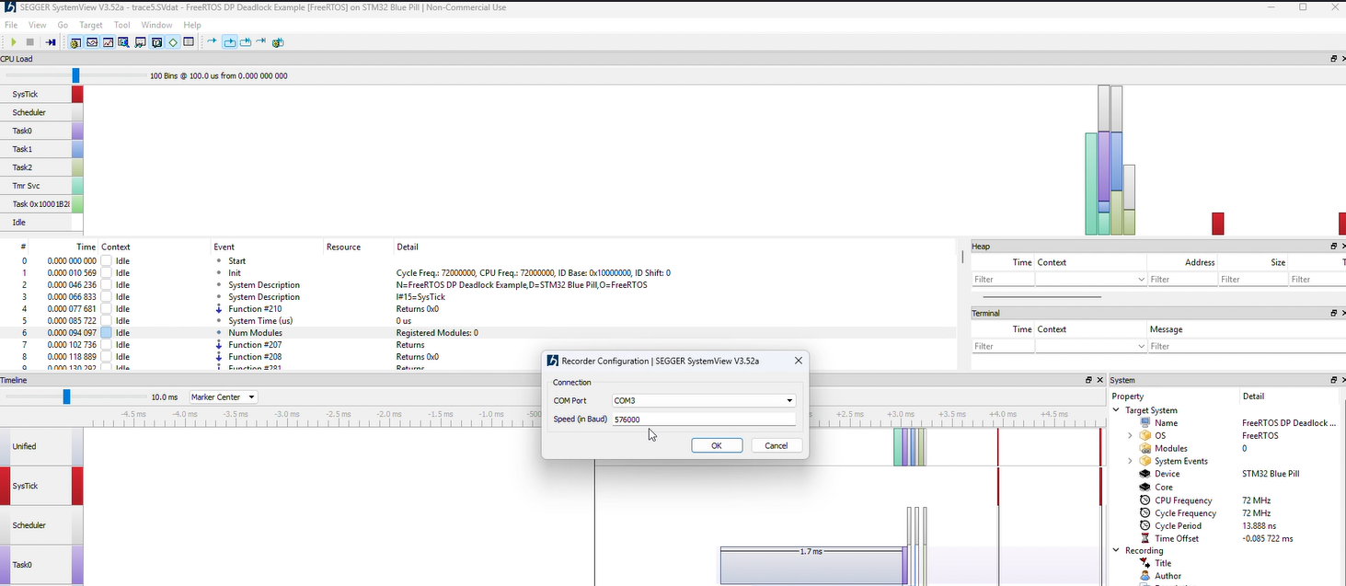

- To start capturing traces, click the “start recording” play button.
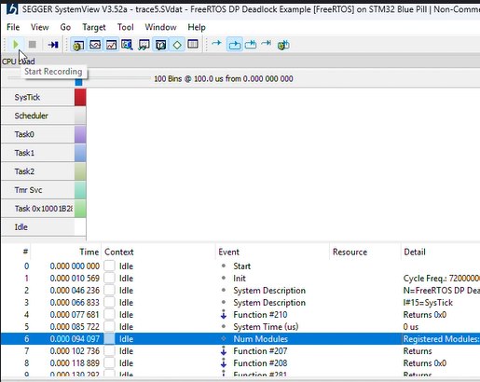

- Traces would now immediately fill up the screen, with much more events that can be captured than one-shot tracing. In one-shot tracing, we can capture the initial stages of the FreeRTOS application but since the buffer is filled up as soon as the program runs, we can’t interact with the program and observe how the tasks handle it. That is the gap that continuous tracing is filling in.
If you are done recording, just click the stop button to stop recording. The trace can also be saved into a file for later loading.
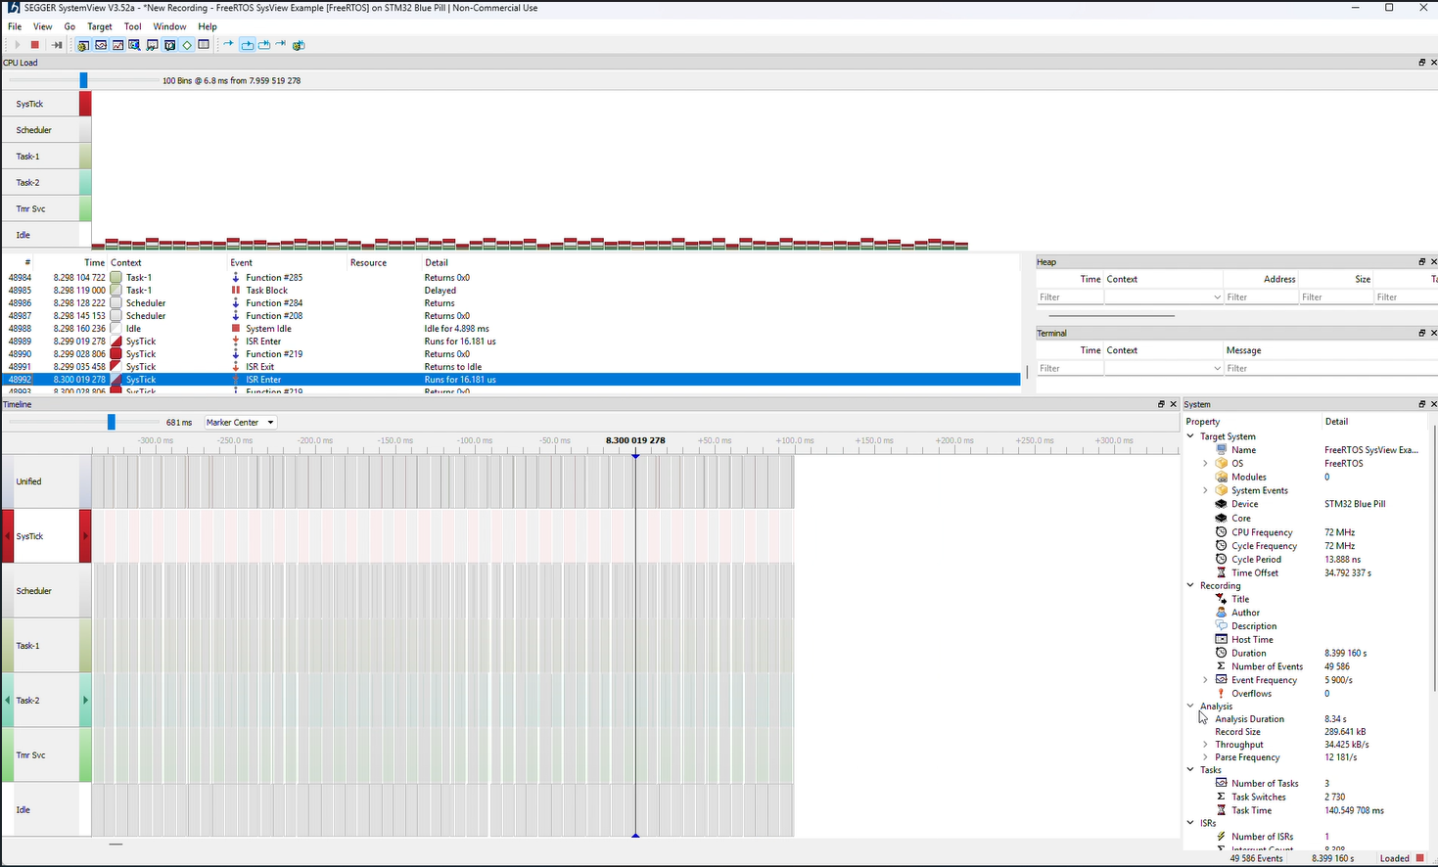

- If errors occur like no traces are being captured, nothing appearing on the timeline, or systemview hangs up, close systemview and re-open it, and make sure to do steps 7 and beyond.

