**Login:**

Email -> required|valid_email

Password -> required|minimal 3 karakter

**Registrasi Forum:**

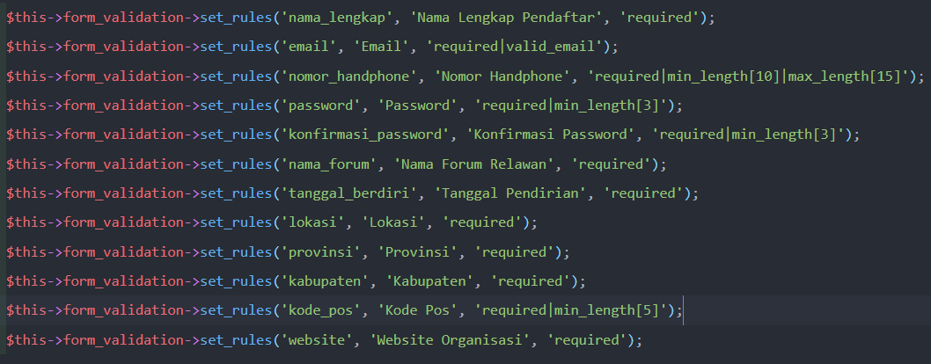

**Registrasi Relawan:**

