# Group MATLAB Assignment 2 – Modelling Arsenic in Tailings Pond

In this assignment, you are going to consider an expanded version of the Tailings Pond model seen in the lecture notes.

We imagine the pond as a series of 6 different sub-ponds, aligned in a sequence.

* Water flows into the first sub-pond from the processing site at a rate of 2,000 cubic meters per day.
* Water flows out of the **last** sub-pond, out to a river, at 2,000 cubic meters per day.
* Between the series of sub-ponds there is a large forward flow, but also a moderate back flow. See the diagram below for the flow rates.

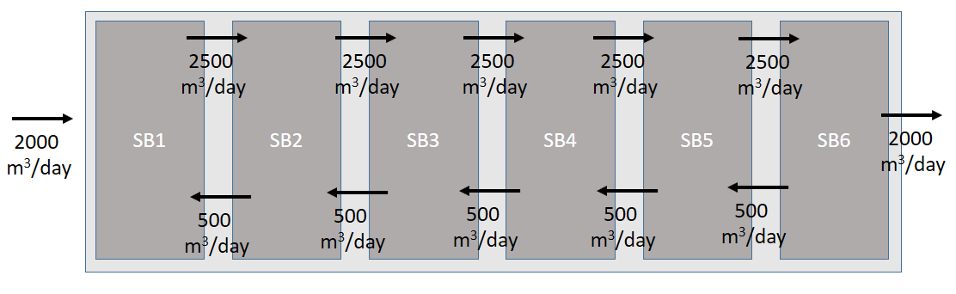

The incoming water has arsenic in it, at a concentration of 600 micrograms per cubic meter (ug/m3). Each sub-pond has a volume of 50,000 m3.

Note: In this model, there is only an exchange of water and solutes dissolved in the water, and no filling by sediments.

**Assignment:**

1. Write the differential equation system for the **amount** of arsenic in each sub-pond. (These can be hand-written and scanned if it is easier than using a word processor.)
2. Convert your answer to Part 1 to the differential equation system for the **concentration** of arsenic in each sub-pond.
3. Use MATLAB to generate a simulation of the concentration of arsenic in each sub-pond over time.
4. If the mine has to stop flow into the tailings pond when the **outflow water** reaches a concentration above **100 ug/m3**, how long can this tailings pond be used?
5. If the mine has to stop flow into the tailings pond when the **average concentration across the whole pond** reaches **300 ug/m3**, how long can this tailings pond be used?

**Submission:** You can submit your assignment solutions as a Word or a PDF document. You should also submit any MATLAB scripts you wrote as part of your analysis.