**PRISON ESCAPE**



**Session 2023 - 2027**

**Submitted by:**

Abdul Rehman 2023-CS-73

**Supervised by:**

Dr. Muhammad Awais Hassan

**Course:**

CSC-102 Programming Fundamentals

Department of Computer Science

**University of Engineering and Technology**

**Lahore Pakistan**

Table of Contents

1. Overview of Game: 3

2. Game Characters: 3

Player: 3

Enemies: 3

Guard: 3

Officer: 3

Special guard: 4

Boss: 4

3. Game Objects Description: 4

3.1 Health Increment: 4

3.2 Guns: 4

4. Rules & Interactions: 4

5. Goal of the Game: 4

6. Wireframes of the Game: 4

Front Menu: 4

7. Data Structures: 6

8. Function prototypes 7

9. Conclusion 8

# Overview of Game:

It is a story of a person who was kept in jail for years once he tries to escape the prison. The jail at which he is kept has high security so if he has to escape it, he must kill all the officers and guards.

# Game Characters:

Here are the game characters

## Player:

The player is a prisoner who is a convicted criminal. He has to escape the jail in order to win the game. Its health is 100% and its health decreases by 5 if bullet hits it!

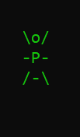

## **Enemies:**

There are 4 enemies in the game:

### Guard:

A guard has the health of 100% and decreases by 10 if player hits it. It can fire in 3 directions. It has highest fire rate but lowest health.

### Officer:

An officer has the health of 150% and decreases by 10 if player hits it. It can fire in all directions. It has medium fire rate and medium health.

### Special guard:

A special guard has a health of 200% and decreases by 10 if player hits it. It has highest health and lowest fire rate.

### Boss:

Boss arrives if player kills 2 enemies. It has a health of 500%. If player kills it, he wins the game. It can fire in all directions.

Enemies fire bullets if the find player in their range

# Game Objects Description:

Following is the Objects in the Game

## 3.1 Health Increment:

When the player kills special guard a shield S appears on screen which if kept by player its health increments by 100%.

## 3.2 Guns:

There are two types of guns:

‘G’ the gun with a small fire rate and fires 1 bullet then halts and then fires bullet.

‘M’ the machine gun that fires continuously.

# Rules & Interactions:

Here are the rules of playing the game:

1. Save player from enemy bullets. If bullets hit player health decreases.
2. Kill the boss and all other enemies to win the game
3. If player presses left shift game pauses till the player again presses right shift key.
4. Player cannot fire till he collects the gun ‘G’ or ‘M’
5. Press left shift to pause the game and right shift to again start playing the game.

# Goal of the Game:

The goal of the game is for the player controlling the character prisoner to kill all the enemies then get key from the boss, open the door and escape the jail.

# Wireframes of the Game:

Following are the wireframes of my game:

## Front Menu:

It is the first menu shown to the user. In first menu 3 options are given to user.

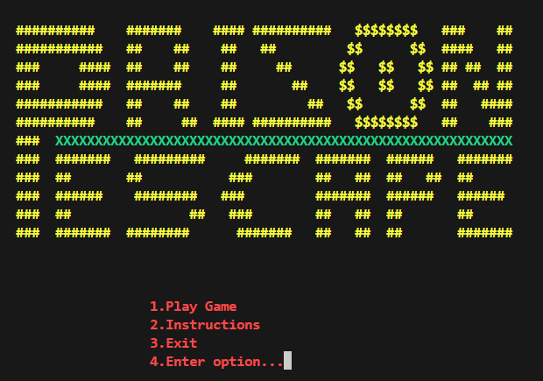

**Figure.1 Menu**

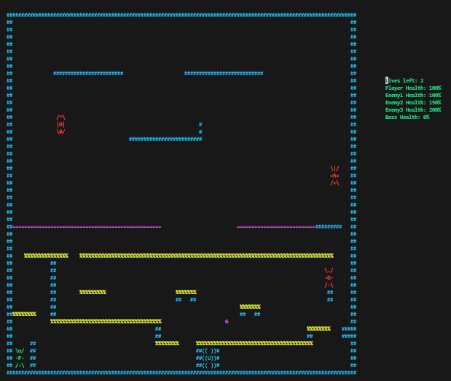

**Figure.2: Game screenshot**

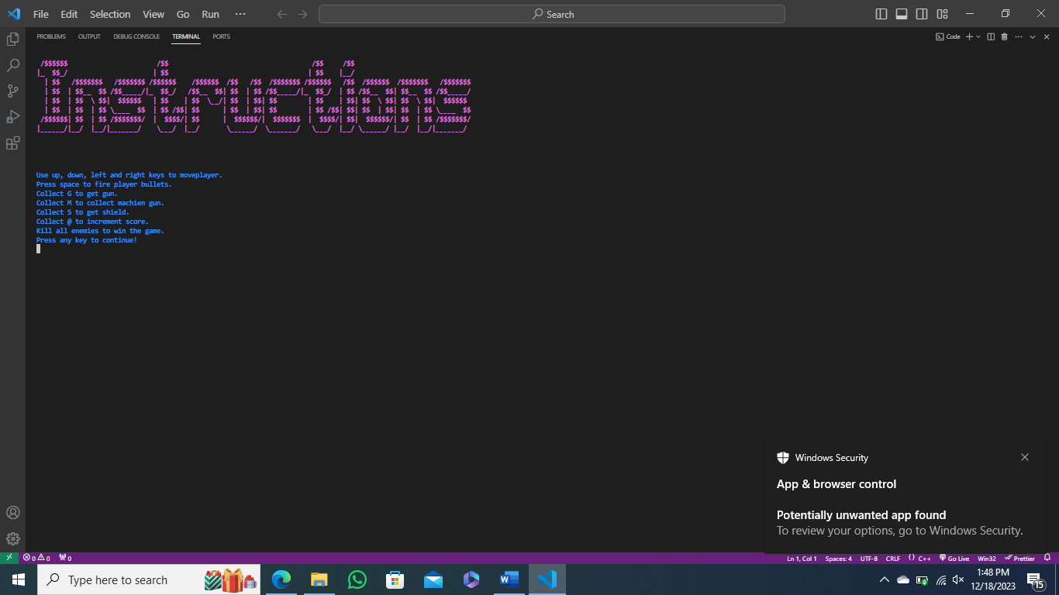

**Figure.3: Instruction Panel**

# Data Structures:

Here are the data structures used in the game:

char bullet[5] = {'|', '<', '>', '^', 'v'};            // bullets fired by players and enemies

int eX1 = 40, eY1 = 35;                                                 // coordinates of enemy 1

int eX2 = 10, eY2 = 7;                                                   // coordinates of enemy 2

int eX3 = 111, eY3 = 1;                                                 // coordinates of enemy 3

int pX = 3, pY = 46;                                                       // coordinates of player

int playerHealth = 100;                                                   // health of the player

int eBX = 50, eBY = 12;                                                  // coordinates of the boss

char playerGun = 'I';                                                      // player gun

int health[4] = {100, 150, 200, 0};                                  // enemies health

bool bosshealth = false;                                                   // boss health check variable

bool hasKey = false;                                                       // key check

bool isDoorOpen = false;                                                 // door open check

int lives = 2;                                                             // player lives

bool en1 = true;                 // enemy 1 health check

bool en2 = true;                 // enemy 2 health check

bool en3 = true;                 // enemy 3 health check

bool bossArrival = false;        // boss health check

int enemy1FireCount = 0;         // enemy 1 bullets timer

int enemy2FireCount = 0;         // enemy 2 bullets timer

int enemy3FireCount = 0;         // enemy 3 bullets timer

int bossFireCount = 0;           // boss bullets timer

bool enemy1FireFlag = false;     // enemy 1 fire flag check

bool enemy2FireFlag = false;     // enemy 2 fire flag check

bool enemy3FireFlag = false;     // enemy 3 fire flag check

bool playerGunPlacement = false; // player gun placement check

bool playerShootType = false;    // player fire timer in case player has simple gun

bool printed = false;            // checks if the user instructions printed to open the door

# Function prototypes

Here the prototypes of all the functions used in the game:

void header();

void printBoard();

void printEnemy1();

void eraseEnemy1();

void moveEnemy1(string);

string changeDirectionEnemy1(string);

void printEnemy2();

void eraseEnemy2();

void moveEnemy2(string);

string changeDirectionEnemy2(string);

void printEnemy3();

void eraseEnemy3();

void moveEnemy3(string);

string changeDirectionEnemy3(string);

void printBoss();

void eraseBoss();

void moveBoss(string);

string changeBossDirection(string);

void printPlayer();

void erasePlayer();

void movePlayer();

void movePlayerLeft();

void movePlayerRight();

void movePlayerUp();

void movePlayerDown();

void generateGun(int);

string printMenu();

void gameWin();

void InstructionsMenu();

void playerBulletsFiring();

void moveBullet(string directionEnemey1, string directionEnemy2, string directionEnemy3);

void enemy1BulletFiring(string directionEnemey1, string directionEnemy2, string directionEnemy3);

void bulletCollisionEnmeies(int, int, string directionEnemey1, string directionEnemy2, string directionEnemy3);

void bulletCollisionPlayer(int, int);

void gameWin();

void gamelose();

void reloadGame();

bool winPosition();

void openDoor();

# Conclusion

The Prison Escape game helped me develop strong programming and logic-building skills. By designing characters, handling game mechanics, and implementing enemy interactions, this project enhanced my understanding of game development, problem-solving, and valuable experience in both coding and logic formulation.