ABSTARCT

Speech writing machine is a device which is nowhere designed previously and is only one of its kind. Many people who are born without hands take their life as a challenge and try to prove themselves. Though they don’t have hands they keep trying to write with their legs, mouth, etc. to reach their desired position in life.

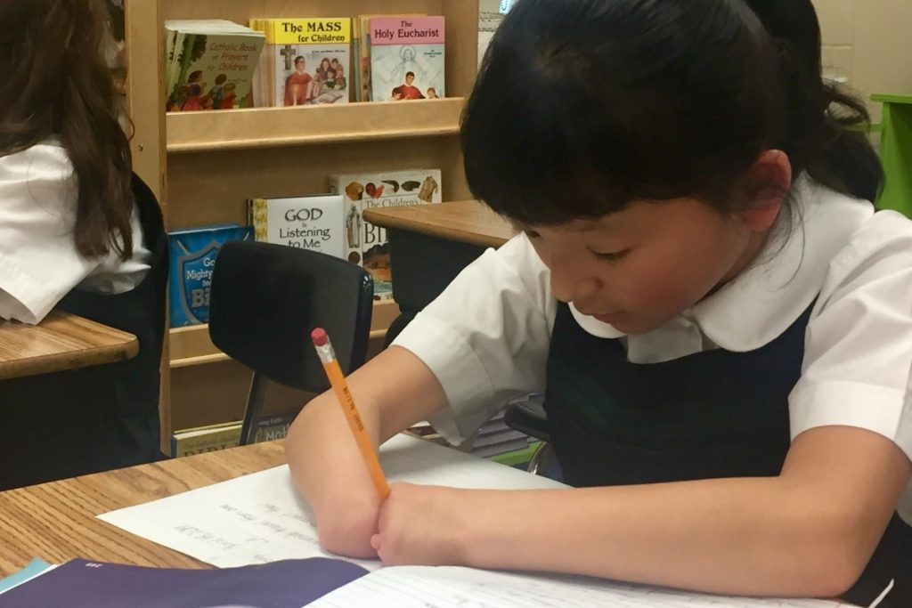

And here is the device which will help them achieve their goals. This device converts all the speech that is said by the user into text and then writes the same on a paper.As of now there is no such project that has been designed to provide such benefits.

**Introduction**

Purpose of plan:

The main purpose of doing this project is to make the disabled (handless) people to write through their speech

This process involves conversion of speech to text and that converted text is to be written on the paper.

a) This is to build a better society

b) This acts as an artificial hand to the handless people.

**Software required:**

**Python IDE**: python is a high level programming language because of its extended libraries and uses we used python language as a platform for our program we developed our program in anaconda software .It is specially designed for handling large volumes of data processing. We imported some predefined libraries from Google cloud for speech to text conversion and for writing letters we defined functions for each letter to access easily within no time. All the machine learning process is available as a library that is provided by google.

**Project description:**

1. **Raspberry pi3:** The **Raspberry Pi** is a low cost, credit-card sized computer that plugs into a computer monitor or TV, and uses a standard keyboard and mouse. It is a capable little device that enables people of all ages to explore computing, and to learn how to program in languages like Scratch and Python.

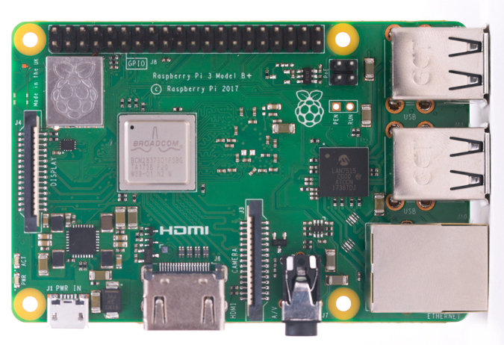

Both horizontal and vertical movements of rollers are indirectly controlled by the GPIO pins of raspberry pi.

1. **Horizontal roller :** this is a motor controlled gear mechanism which allows the pen to move horizontally .
2. **Vertical roller:** this is also a dc motor control gear mechanism which combined with the horizontal roller allows to create any kind of text, design, and pictorial data.

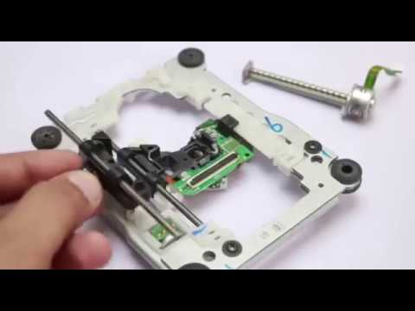

1. **Motor driver:** this device is combination of many integrated circuits which are assembled on a board which is known as motor driver. Motor driver allows to control the motor rotation in both clockwise and anticlockwise direction and such horizontal and vertical rollers can be moved.

**CONTROLLING MOTORS**

**L293D DRIVER:**

**L293D** is a typical **Motor driver** or **Motor Driver** IC which allows DC **motor** to drive on either direction. **L293D** is a 16-pin IC which can control a set of two DC **motors** simultaneously in any direction. It means that you can control two DC **motor** with a single **L293D** IC. Dual H-bridge **MotorDriver** integrated circuit (IC)

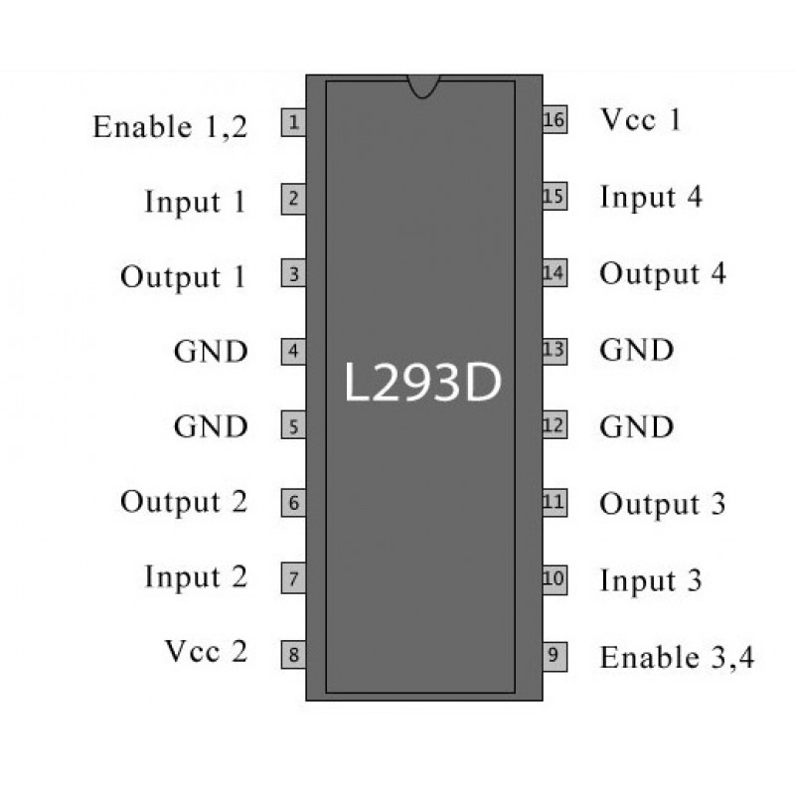

L293D IC generally comes as a standard **16**-pin DIP (dual-in line package). This motor driver IC can simultaneously control **two** small motors in either direction; forward and reverse with just 4 microcontroller pins.

**L293D DRIVER MODULE:**

This **L293D driver module** is a medium power **motor driver** perfect for driving DC **Motors** and **Stepper Motors**. It uses the popular **L293D motor driver** IC. It can drive 4 DC **motors** in one direction, or drive 2 DC **motors** in both the directions.

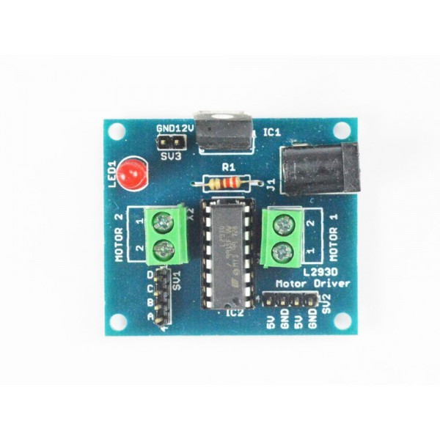

**Hardware requirements:**

1. Horizontal roller
2. Vertical roller
3. Connecting screws
4. Jumper wires
5. Base material(card board)
6. Motor drivers
7. Raspberry pi
8. Pen holder
9. USB microphone

**PROJECT DESIGN AND IMPLIMENTATION**

This device first converts all the voice data that is recorded by the microphone into text format and it is no stored in cache memory. The stored text is again replaced in an array and each letter is separately brought out from that array for its specific execution. Each and every letter is coded manually to get executed.

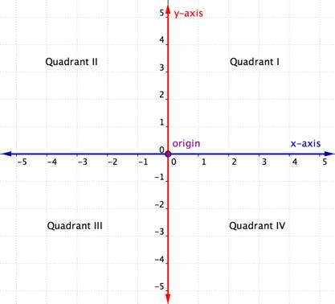

All the letters that are written by this device follow specific path within the given coordinates that are assigned by the programmer. The pen move in its respective co-ordinates as per the instructions given to it by the user.it actually follows a vectorial path that is designed by the programmer. It follows X and Y co-ordinates to trace the path of an alphabet. By coding it can also be used for drawing pictures.

**Program**

**Part 1 (speech recognition) :**

import speech_recognition as sr

r=sr.Recognizer()

with sr.Microphone() as source:

audio=r.listen(source)

try:

print("system predicts:"+r.recognize_google(audio))

except Exception:

print("some thing went wrong")

for i in (r.recognize_google(audio)):

print(i)

All the above program is for converting the recorded speech to text so that the letters will be individually printed for getting executed.

**Part 2 (motion of rollers) :**

GPIO.setmode(GPIO.BOARD)

GPIO.setup(16,GPIO.OUT)

GPIO.setup(18,GPIO.OUT)

GPIO.setup(36,GPIO.OUT)

GPIO.setup(38,GPIO.OUT)

GPIO.output(18,GPIO.LOW)

GPIO.output(16,GPIO.LOW)

GPIO.output(36,GPIO.LOW)

GPIO.output(38,GPIO.LOW)

def horfar1():

GPIO.output(16,GPIO.HIGH)

GPIO.output(18,GPIO.LOW)

sleep(2)

GPIO.output(16,GPIO.LOW)

def horfar2():

GPIO.output(16,GPIO.HIGH)

GPIO.output(18,GPIO.LOW)

sleep(0.25)

GPIO.output(16,GPIO.LOW)

def verfar1():

GPIO.output(36,GPIO.HIGH)

GPIO.output(38,GPIO.LOW)

sleep(0.5)

GPIO.output(36,GPIO.LOW)

def verfar2():

GPIO.output(36,GPIO.HIGH)

GPIO.output(38,GPIO.LOW)

sleep(0.25)

GPIO.output(36,GPIO.LOW)

def horback1():

GPIO.output(16,GPIO.LOW)

GPIO.output(18,GPIO.HIGH)

sleep(0.5)

GPIO.output(18,GPIO.LOW)

def horback2():

GPIO.output(16,GPIO.LOW)

GPIO.output(18,GPIO.HIGH)

sleep(0.25)

GPIO.output(18,GPIO.LOW)

def verback1():

GPIO.output(36,GPIO.LOW)

GPIO.output(38,GPIO.HIGH)

sleep(0.5)

GPIO.output(38,GPIO.LOW)

def verback2():

GPIO.output(36,GPIO.LOW)

GPIO.output(38,GPIO.HIGH)

sleep(0.25)

GPIO.output(38,GPIO.LOW)

All the above declarations of functions are done to perform horizontal (x-axis), vertical (y-axis) movements of the roller.

Similarly all the other letters are also programmed by calling the above functions (part-2).

**CONCLUSION**

As this device is highly portable it can be carried many places like schools, offices, etc.

Thus the device has a capability of writing text by recording speech which can help many handless people who are really enthusiasts and are capable of achieving a greater heights in their life.