ABSTRACT

SOIL MOISTURE SENSOR USING ARDUINO

The project ‘Soil Moisture Meter using Arduino’ uses arduino board, a 16×2 LCD module and soil moisture sensor in order to display the humidity (moisture) of soil.

This project is very useful for farmer, floriculture, researchers etc. in order to know the moisture of soil at different stage. The working principle and circuit description is very simple that anymore can understand who have little knowledge of arduino board. The project is basically an interfacing circuit between arduino board with LCD and sensor.

INTRODUCTION

It uses Arduino Duemilanove microcontroller board. Two wires placed in the soil pot form a variable resistor, whose resistance varies depending on soil moisture. This variable resistor is connected in a voltage divider configuration, and Arduino collects a voltage proportional to resistance between the 2 wires.

Insert the 2 probes (wires, pcb) in the dry soil and measure the resistance value and then pour water and measure it again.

Use a mid value for the resistor (eg: 50kΩ for 100kΩ in dry soil and 10kΩ in wet).

MAIN TEXT

Working of Sensor

The soil moisture sensor consists of two probes which are used to measure the volumetric content of water. The two probes allow the current to pass through the soil and then it gets the resistance value to measure the moisture value.

When there is more water, the soil will conduct more electricity which means that there will be less resistance. Therefore, the moisture level will be higher. Dry soil conducts electricity poorly, so when there will be less water, then the soil will conduct less electricity which means that there will be more resistance. Therefore, the moisture level will be lower.

This sensor can be connected in two modes; Analog mode and digital mode. First, we will connect it in Analog mode and then we will use it in Digital mode.

REQUIRMENTS

1.Arduino uno board

2.Breadboard

3.Jumpers

4.TypeB usb cable

5.Soil moisture Module

6.Nokia 5110 lcd display

the main components of this post is the sensos it can measure the levels of moisture in the soil. So it can be extremely useful if you want to monitor the soil moisture of your plants or automate the watering procedure.

nokia 5110 LCD Display

Adding a Nokia 5110 LCD display makes things more professional since we can visually check the moisture levels of the soil. These displays were used in old Nokia 5110/3310 cell phones. It is a 84x48 pixel monochrome LCD display. These displays are small, but very readable and come with backlight. This display is made of 84x48 individual pixels, so you can use it for graphics, text or bitmaps. so less expensive than using oled display.

Difficulty

Basic

Tutorial Contents

SOFTWARE

we are going to use the arduino ide, to set the sketch for this, if you dont have make sure to download the Arduino IDE for your specific operating system. I’ll leave a link to where you can download this software: https://www.arduino.cc/en/Main/Software

Nokia 5110 LCD display

These displays are inexpensive, easy to use, require only a few digital I/O pins and are fairly low power as well

CIRCUIT DIAGRAM

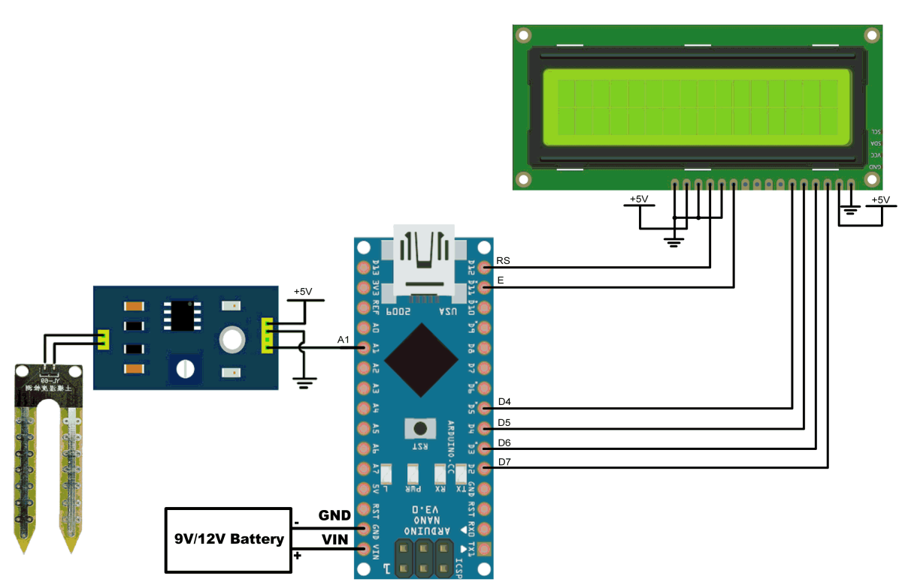

To drive the display, you will need 5 digital output pins. Another pin can be used to control (via on/off or PWM) the backlight, the GND and the LIGht pin should connected to GND on the arduino board, The display driver is a PCD8544 chip, and it runs at 3.3V so you will need a 3V supply handy. Logic levels must be 3V to prevent damage so you must use some kind of levelshifter. or we can use resistor between the light pin and the GNd pin on the arduino. the remaining pin on the LCD will be conneted to the specified digital pin out on the arduino board llisted below.

RST - PIN 12

CE - PIN 11

DC - PIN 10

DIN - PIN9

CLK - PIN 8

To run the display on the code we need to include the Nokia 5110 LCD graph library, This library uses an SPI-like software protocol and does require exclusive access to the pins used. 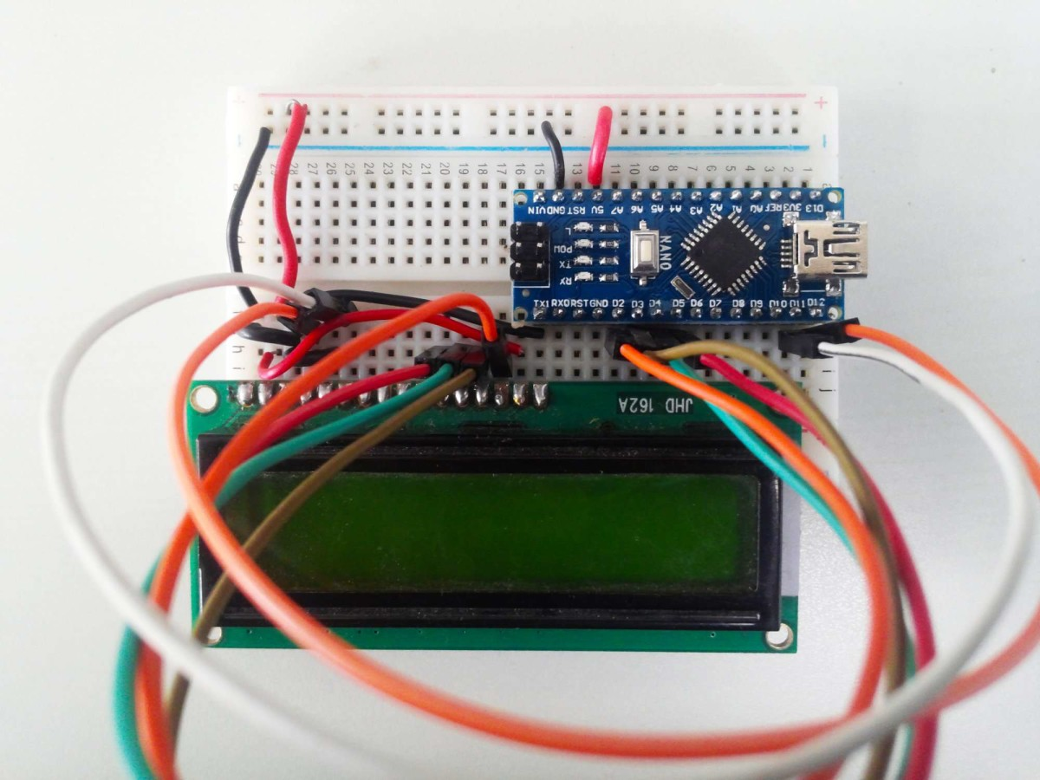

Soil Moisture Sensor module

we will be using a moisture sensor with an analog one, so in the analog output we get a voltage. As the soil gets drier we get more voltage at the analog output since the resistance between the probes gets higher. We can set a threshold in order to enable the digital output at a certain moisture level using this potentiometer on the driver included on the module, by the way i bought mine for just $2 online:)

CIRCUIT DIAGRAM

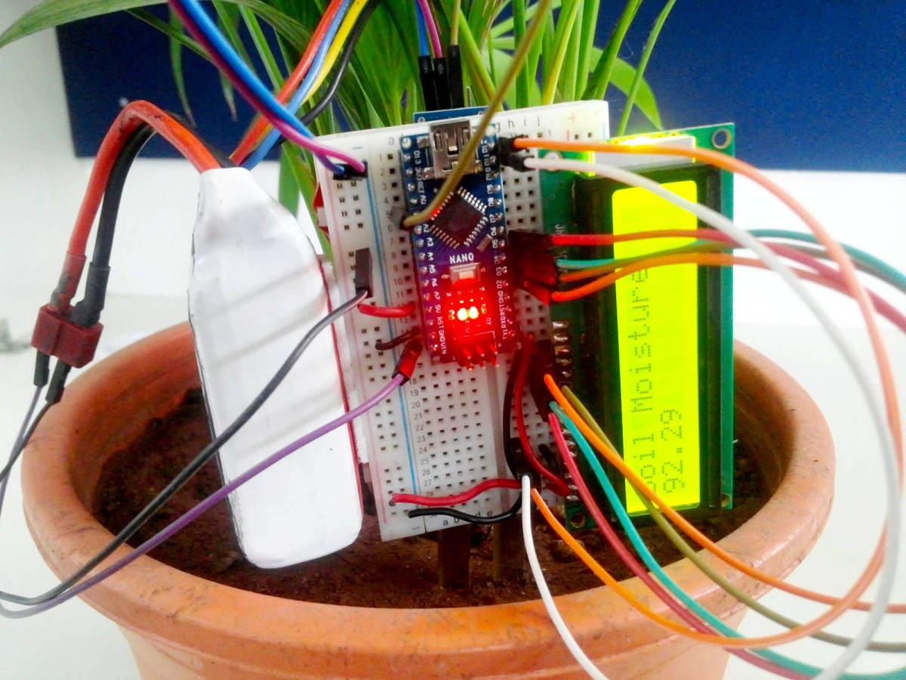

The connection to Arduino is easy. We connect GND to Arduino Ground and Vcc to Arduino 5V. Next we connect the analog output of the sensor to Analog pin 0 of the Arduino board.

connect both Soil Moisture Sensor with a Nokia 5110 LCD display together using jumpers and breadboard.

Connect the arduino uno board to your computer using the Type B usb cable included in the package. open the arduino Desktop IDE locate the TOOLS verify the type of board you are using PORT should be on the COM# and the board should be on the arduino/genuino uno if youre using the same board as mine.

PROGRAMMMING CODE

#include <LCD5110_Graph.h> at the beginning of the code you have to include the nokia graph library that you recently downloaded. to add the library just locate the SKETCH on the IDE select the include library then locate the graph library, that easy.

LCD5110 lcd(8,9,10,12,11); these is the pin out put where the digital pin is located.

int sensorPin = A0;

Define analog pin A0 as the sensor pin out.

setup() method is ran once at the just after the Arduino is powered up and the loop() method is ran continuously afterwards.

setup() is where you want to do any initialisation steps, and in loop() you want to run the code you want to run over and over again.

** SOURCE CODE**

#include <LCD5110_Graph.h>

LCD5110 lcd(8,9,10,12,11);

extern unsigned char BigNumbers[];

extern uint8_t ui[];

int sensorPin = A0;

int sensorValue = 0;

int percent = 0;

String percentString ="0";

int stringLength = 0;

void setup() {

lcd.InitLCD();

lcd.setFont(BigNumbers);

delay(1000);

}

void loop() {

lcd.clrScr();

lcd.drawBitmap(0, 0, ui, 84, 48);

sensorValue = analogRead(sensorPin);

percent = convertToPercent(sensorValue);

percentString = String(percent);

stringLength = percentString.length();

displayPercent(stringLength);

lcd.update();

delay(1000);

}

int convertToPercent(int value)

{

int percentValue = 0;

percentValue = map(value, 1023, 350, 0, 100);

if(percentValue>100)

percentValue = 100;

return percentValue;

}

void displayPercent(int length)

{

switch(length)

{

case 1: lcd.print(percentString,38,19); break;

case 2: lcd.print(percentString,24,19); break;

case 3: lcd.print(percentString,10,19); break;

default: lcd.print(percentString,0,19); break;

ABOUT THE SENSOR

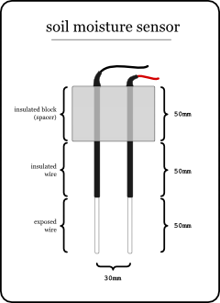

Soil moisture sensors measure the volumetric water content in soil.[1] Since the direct gravimetric measurement of free soil moisture requires removing, drying, and weighting of a sample, soil moisture sensors measure the volumetric water content indirectly by using some other property of the soil, such as electrical resistance, dielectric constant, or interaction with neutrons, as a proxy for the moisture content.

The relation between the measured property and soil moisture must be calibrated and may vary depending on environmental factors such as soil type, temperature, or electric conductivity. Reflected microwave radiation is affected by the soil moisture and is used for remote sensing in hydrology and agriculture. Portable probe instruments can be used by farmers or gardeners.

Soil moisture sensors typically refer to sensors that estimate volumetric water content. Another class of sensors measure another property of moisture in soils called water potential; these sensors are usually referred to as soil water potential sensors and include tensiometers and gypsum blocks.

APPLICATION

Agriculture

Measuring soil moisture is important for agricultural applications to help farmers manage their irrigation systems more efficiently. Knowing the exact soil moisture conditions on their fields, not only are farmers able to generally use less water to grow a crop, they are also able to increase yields and the quality of the crop by improved management of soil moisture during critical plant growth stages.[citation needed]

Landscape irrigation

In urban and suburban areas, landscapes and residential lawns are using soil moisture sensors to interface with an irrigation controller. Connecting a soil moisture sensor to a simple irrigation clock will convert it into a "smart" irrigation controller that prevents irrigation cycles when the soil is already wet, e.g. following a recent rainfall event.

Golf courses are using soil moisture sensors to increase the efficiency of their irrigation systems to prevent over-watering and leaching of fertilizers and other chemicals into the ground.

Research

Soil moisture sensors are used in numerous research applications, e.g. in agricultural science and horticulture including irrigation planning, climate research, or environmental science including solute transport studies and as auxiliary sensors for soil respiration measurements.

Simple sensors for gardeners

Relatively cheap and simple devices that do not require a power source are available for checking whether plants have sufficient moisture to thrive. After inserting a probe into the soil for approximately 60 seconds, a meter indicates if the soil is too dry, moist or wet for plants.

HOW TO INTERFACE WITH THE ARUINO USING LCD 16X2

We come across LCD displays everywhere around us. Computers, calculators, television sets, mobile phones, digital watches use some kind of display to display the time. An LCD is an electronic display module which uses liquid crystal to produce a visible image. The 16×2 LCD display is a very basic module commonly used in DIYs and circuits. The 16×2 translates o a display 16 characters per line in 2 such lines. In this LCD each character is displayed in a 5×7 pixel matrix.

16X2 LCD

16X2 LCD pinout diagram

16x2 LCD Pinout

Pin No.

Advertisement

Function

Name

1

Ground (0V)

Ground

2

Supply voltage; 5V (4.7V – 5.3V)

Vcc

3

Contrast adjustment; the best way is to use a variable resistor such as a potentiometer. The output of the potentiometer is connected to this pin. Rotate the potentiometer knob forward and backwards to adjust the LCD contrast.

Vo / VEE

4 Selects command register when low, and data register when high RS (Register Select )

5 Low to write to the register; High to read from the register Read/write

6 Sends data to data pins when a high to low pulse is given; Extra voltage push is required to execute the instruction and EN(enable) signal is used for this purpose. Usually, we make it en=0 and when we want to execute the instruction we make it high en=1 for some milliseconds. After this we again make it ground that is, en=0. Enable

7 DB0

8 DB1

9 DB2

10 8 BIT DATA PINS DB3

11 DB4

12 DB5

13 DB6

14 DB7

15 Backlight VCC (5V) Led+

16 Backlight Ground (0V) Led-

RS (Register select)

A 16X2 LCD has two registers, namely, command and data. The register select is used to switch from one register to other. RS=0 for command register, whereas RS=1 for data register.

Command Register: The command register stores the command instructions given to the LCD. A command is an instruction given to LCD to do a predefined task like initializing it, clearing its screen, setting the cursor position, controlling display etc. Processing for commands happens in the command register.

Data Register: The data register stores the data to be displayed on the LCD. The data is the ASCII value of the character to be displayed on the LCD. When we send data to LCD it goes to the data register and is processed there. When RS=1, data register is selected.

INTERFACING THE SOIL MOISTURE SENSOR WITH ARDUINO

Digital Mode

To connect the soil moisture sensor FC-28 in the digital mode, we have to use digital output of the sensor and a digital input of Arduino. While monitoring the sensor gives us true or false condition with respect to measured moisture content in a soil. We can adjust the threshold using the potentiometer in the sensor.

When the sensed value is less than the threshold value, then the measured soil moisture content is low and the sensor will give us LOW.

When the sensed value is greater than the threshold value, then the measured soil moisture content is high and the sensor will give us HIGH.

Circuit Diagram

The connections for connecting the soil moisture sensor FC-28 to the Arduino in digital mode are as follows.

VCC of Moisture Sensor to 5V of Arduino

GND of Moisture Sensor to GND of Arduino

D0 of Moisture Sensor to pin 8 of Arduino

LED1 positive to pin 13 of Arduino and negative to GND of Arduino

LED2 positive to pin 12 of Arduino and negative to GND of Arduino

Interfacing Moisture Sensor with Arduino Digital Mode – Circuit Diagram

Software

Arduino Code

int led_pin1 =13;

int led_pin2 =12;

int sensor_pin =8;

void setup()

{

pinMode(led_pin1, OUTPUT);

pinMode(led_pin2, OUTPUT);

pinMode(sensor_pin, INPUT);

}

void loop()

{

if(digitalRead(sensor_pin) == HIGH)

{

digitalWrite(led_pin1, HIGH);

digitalWrite(led_pin2, LOW);

delay(2000);

}

else

{

digitalWrite(led_pin1, LOW);

digitalWrite(led_pin2, HIGH);

delay(2000);

}

}

Code Explanation

First of all, we have initialized two variable for connecting the LED pin and the sensor digital pin.

int led_pin1 =13;

int led_pin2 =12;

int sensor_pin =8;

In the setup function, we have declared the LED pin as the output pin because; we will power the LED through that pin. Then, we declared the sensor pin as an input pin because the Arduino will take the values from the sensor through that pin.

void setup()

{

pinMode(led_pin1, OUTPUT);

pinMode(led_pin2, OUTPUT);

pinMode(sensor_pin, INPUT);

}

In the loop function, we have read from the sensor pin. If the output value of the sensor is higher than the threshold value, then the digital pin will be high and the led_pin1 will light up and led_pin2 will go off. If the sensor value is lower than the threshold value, then the led_pin1 will go off and led_pin2 will light up.

void loop()

{

if(digitalRead(sensor_pin) == HIGH)

{

digitalWrite(led_pin1, HIGH);

digitalWrite(led_pin2, LOW);

delay(2000);

}

else

{

digitalWrite(led_pin1, LOW);

digitalWrite(led_pin2, HIGH);

delay(2000);

}

}

STEP BY STEP PROCEDURE

**Step 1: Gathering Parts**

[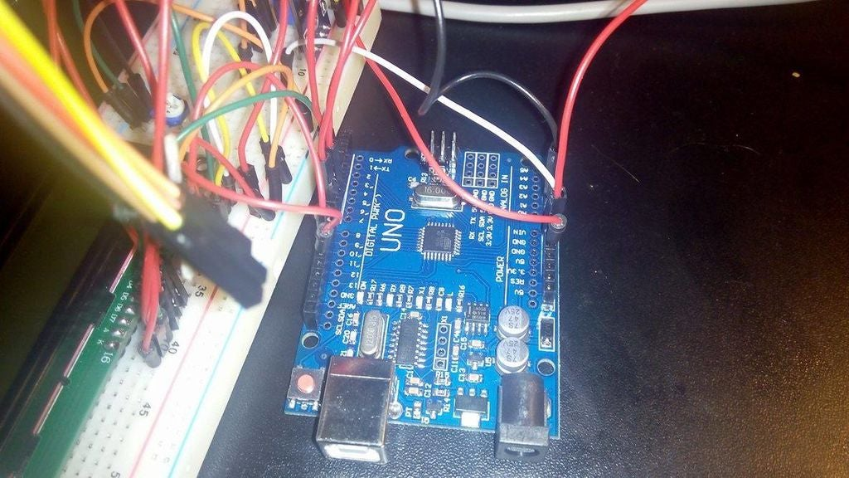](https://cdn.instructables.com/FV0/331T/IIEWO0KU/FV0331TIIEWO0KU.LARGE.jpg)

You neet to gather:

1. LCD 16x2 (White in my case)

2. Potentiometer 47k Ohm (or smaller, I only had that one, but you can also use 10-20k and it should be just fine)

3. Cables, a lot of cables

4. Prototype board

5. Arduino Uno / Arduino Pro mini (with programmer)

6. Power supply (9V battery for example)

7. Moisture sensor (for ex. YL-69)

Add TipAsk QuestionCommentDownload

**Step 2: Connect LCD**

[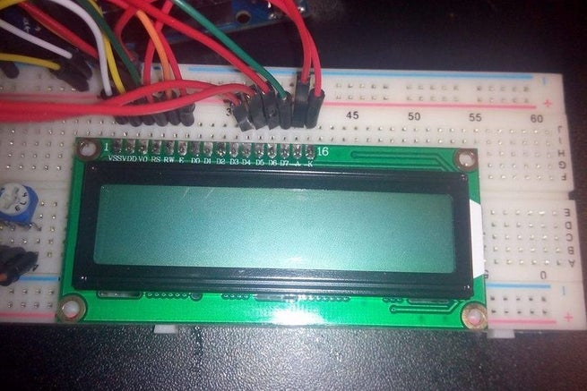](https://cdn.instructables.com/FJB/PPDV/IIEWO0MU/FJBPPDVIIEWO0MU.LARGE.jpg)

[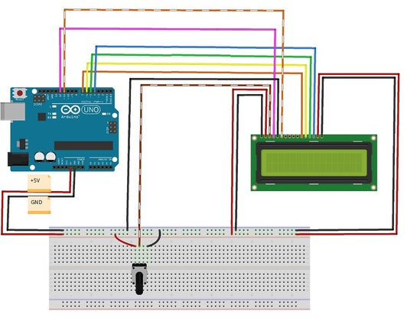](https://cdn.instructables.com/F62/DK80/IIEWO2CW/F62DK80IIEWO2CW.LARGE.jpg)

Connect the LCD with the cables to arduino as it's shown on a shematic. Do not forget the potentiometer.

Add TipAsk QuestionCommentDownload

**Step 3: Connect Moisture Sensor**

[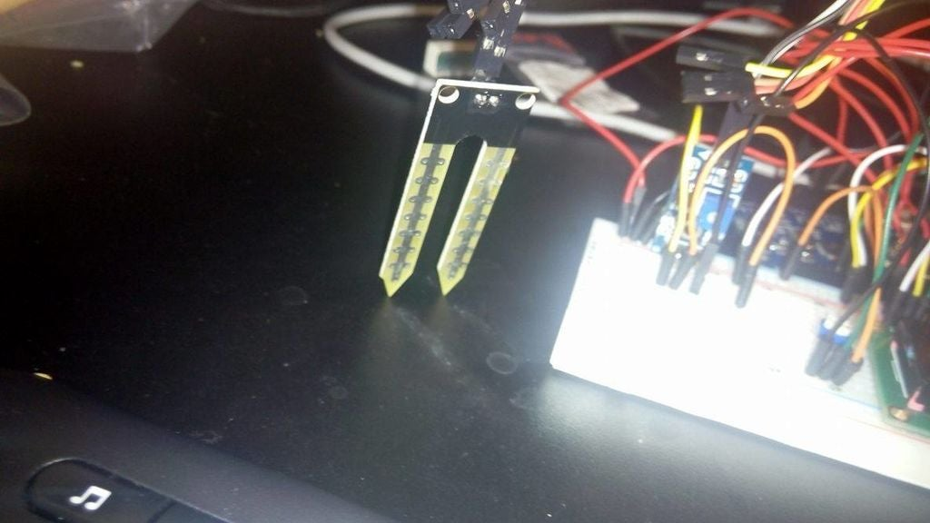](https://cdn.instructables.com/FOE/FCPA/IIEWO0MT/FOEFCPAIIEWO0MT.LARGE.jpg)

Connect the moisture sensor board VCC pin to + rail of the prototype board and GND pin to ground. (I connected to the second ground on the arduino board)

Moisture sensor data pin need to be connected to A0 (in case of YL-69 its the last of 4 pins) on arduino board.

**Step 4: Code**

[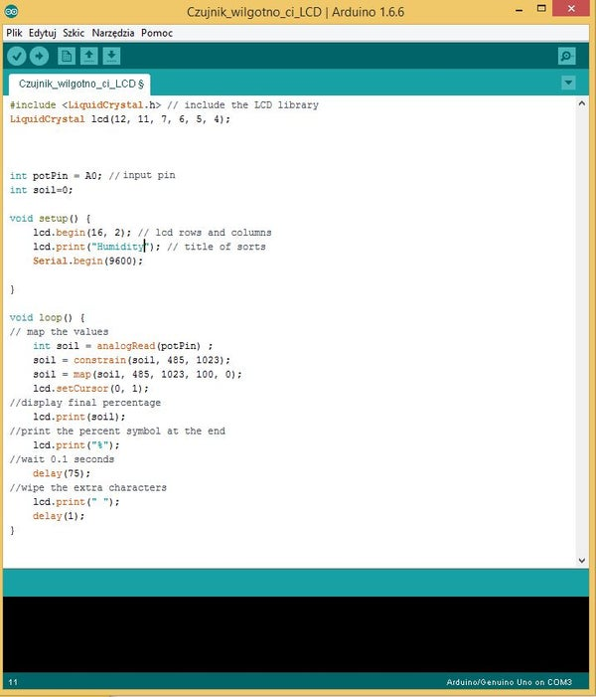](https://cdn.instructables.com/FPL/6BYQ/IIEWO3JV/FPL6BYQIIEWO3JV.LARGE.jpg)

**Step 5: Add the Power Supply**

[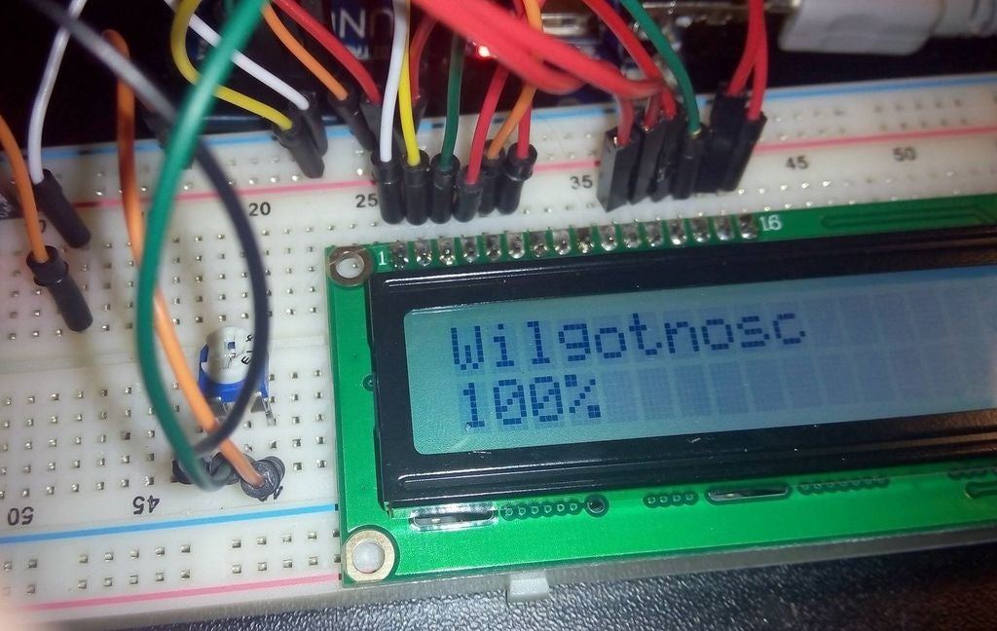](https://cdn.instructables.com/FYD/OHE9/IIEWO4BL/FYDOHE9IIEWO4BL.LARGE.jpg)

Add the proper power supply (5-9V should be fine) and set the contrast of your LCD with the potentiometer. Also set the potentiometer on the YL-69 moisture sensor if the red light on the small board is not on. What you should get is as its shown on the picture, but instead of Wilgotnosc you ll get "Humidity", as Humidity is wilgnotność in my language. Check if the sensor is working properly with a cup of water.

ATTACHMENT

Nokia 5110 lcd working

<https://www.instructables.com/id/How-to-use-a-Nokia-5110-84X48-LCD-display-with-you/>

how an Arduino uno works

<https://www.arduino.cc/en/Guide/ArduinoUno>

advantages of using a soil moisture sensor

<https://www.rfwireless-world.com/Terminology/Advantages-and-Disadvantages-of-Moisture-Sensor.html>

pin diagram

<https://steemitimages.com/640x0/https://res.cloudinary.com/hpiynhbhq/image/upload/v1518079940/o2x7xgmu2xshr6zh7dxm.png>