**Quackers**

**User Manual**

**\*Note that anything highlighted in yellow has not yet been implemented.**

**Contents**

* The Story

- System requirements

- Getting started

o Downloading & running the game

o Main menu

o In-game menu

o How to play

o In-game screen

- Enemies

- Obstacles

- Items

- Contact us

**The Story**

The nefarious supervillain known as Goosey Goose has taken over the University of York. He has enslaved all the students and staff using the mind controlling device known as B.R.A.I.N (Brain Altering Interface Network). You, as an agent of B.E.A.K (Best Ever Agent Korporation) , are tasked to stop Goosey and his evil henchmen. You must destroy the B.R.A.I.N’s and free the humans.

**System Requirements**

- **Operating System:** Windows 7 onwards/Linux

-  **Disk Space:** 10Mb

- **RAM:** Up to 100Mb

**Getting Started**

**Downloading and running the game**

1. Download the game .zip file from:<http://teal-duck.github.io/teal-duck/>

2. Extract the game files from the .zip folder

3. Run “quackers.exe”

**Controls**

**Menu**

Mouse/WASD/Arrows - Navigate

Enter - Select

Back - Back

**In-game**

Mouse - Direction

WASD/Arrows- Move

P - Pause/Resume

Shift - Sprint

Space/Left click - Beak Bullet Attack (Shoot)

Right click - Quack Hack

R - Reload

**Main Menu**

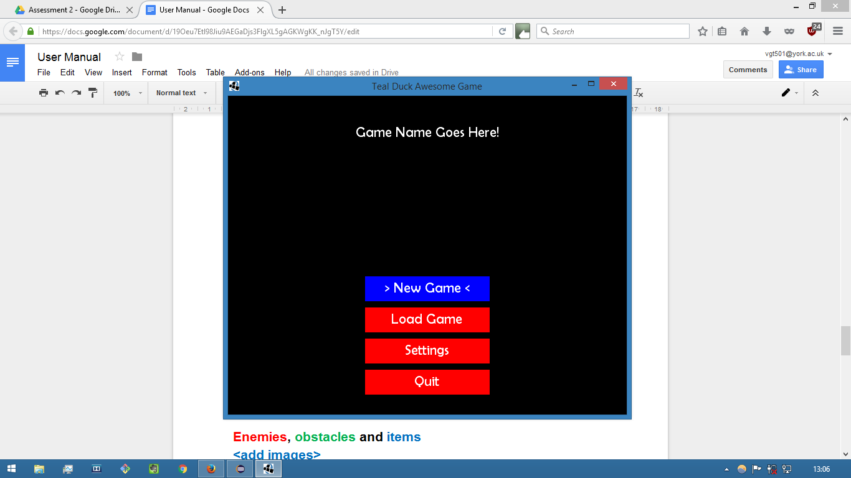

1. **New Game:** Start a new game in the chosen mode.

2. **Load Game:** Load previous saved game.

3. **Settings:** Change settings/view instructions.

4. **Quit:** Exits the game.

**In-game Menu**

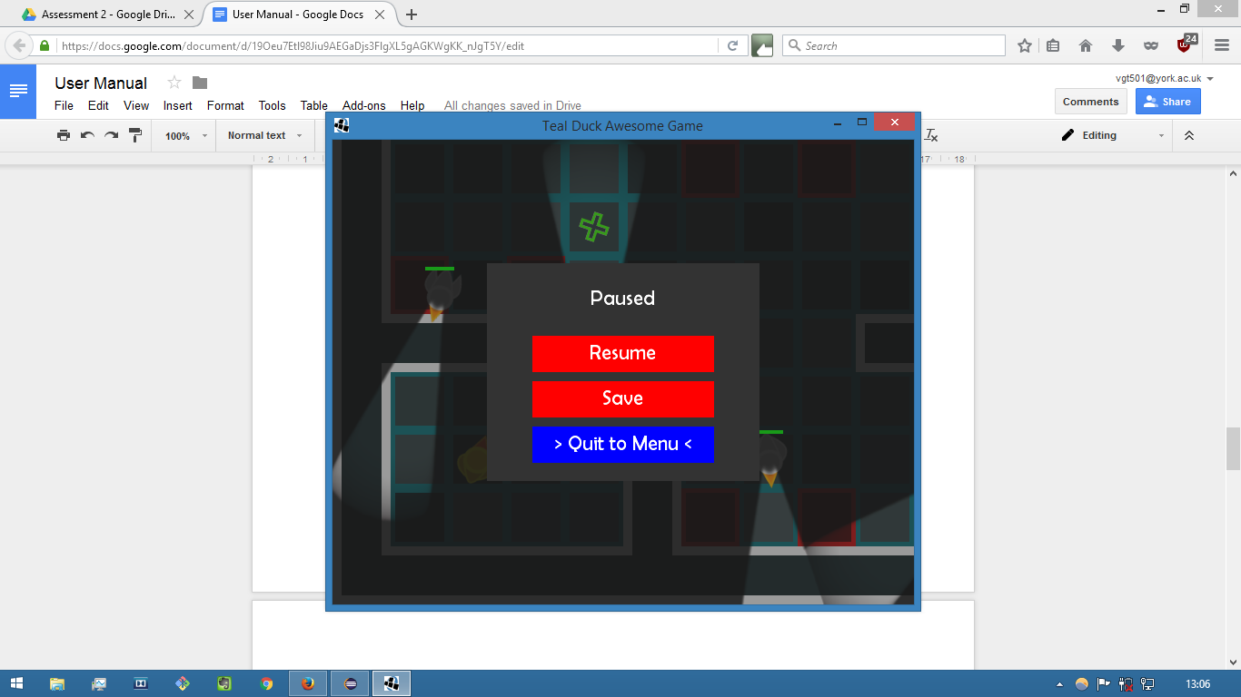

1. **Resume :** continue playing the game.

2. **Save :** save the current game in 1/3 slots.

3. **Quit to Main Menu:** return to the main menu.

**How to play**

* Navigate through overworld map to reach a level.
* Reach the goal (B.R.A.I.N device) to complete the level. Destroy the B.R.A.I.N found in each level to complete the game.Must use combination of Quack Hack and Beak Bullet.
* Kill enemies in order to increase your score

**In-game screen**

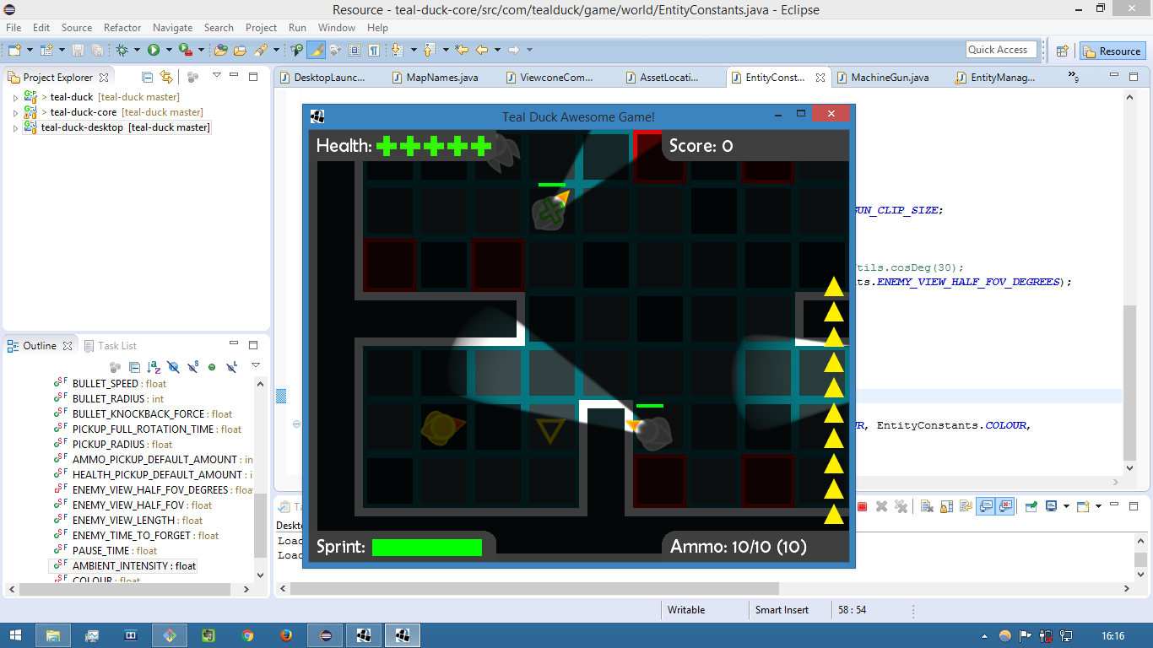

1. **Player:** Yellow duck

2. **Health bar:** Displays your health (5 lives max)

3. **Stamina bar:** Displays your sprint level

4. **Score:** Displays score (get combos by defeating enemies in rapid succession)

5. **Ammo:** Amount of ammo left

**Enemies**

**Normal Geese:**

- Levels: ALL

- Movement: Fixed path

- Action: One life of damage

**Red Geese:**

- Levels: ALL

- Movement: Random

- Action: One life of damage

**Purple Geese**

* Levels: 3+
* Movement: Fixed spot
* Action: Alerts nearby geese to attack player

**Humans**

* Levels: 2+
* Movement: Fixed path
* Action: One life of damage, it is game over if you hit them.

**Overworld only enemies**

**Geese Flock:**

- Levels: 6+

- Movement: 3 geese-wide back and forth

- Action: Takes 3 lives

**Boomerang:**

- Levels: ALL

- Movement: back and forth

- Action: One life of damage

**Aeroplane:**

- Levels: ALL (but very rare)

- Movement: one-direction sweep across the screen

- Action: Kills player on contact

**Thunderstorm:**

- Levels: 4+

- Movement: static

- Action: lightning strike can cause one life of damage if player is in an adjacent tile

**Obstacles**

All obstacles do not appear in the overworld.

**Lasers**

- Levels: ALL

- Action: One life of damage

**Doors** (The greatest threat to all duck-kind)

* Levels: All
* Action: Must be opened by a human

**Items**

**Ammo**

* Replenish +10 ammo

**Health**

* Replenish +1 health

**Overworld only Items**

**White cloud:**

- starts coin mini-game

**Contact us**

Visit our website at:<http://teal-duck.github.io/teal-duck/>

For any further enquiries, email us at: tealduckteam@gmail.com